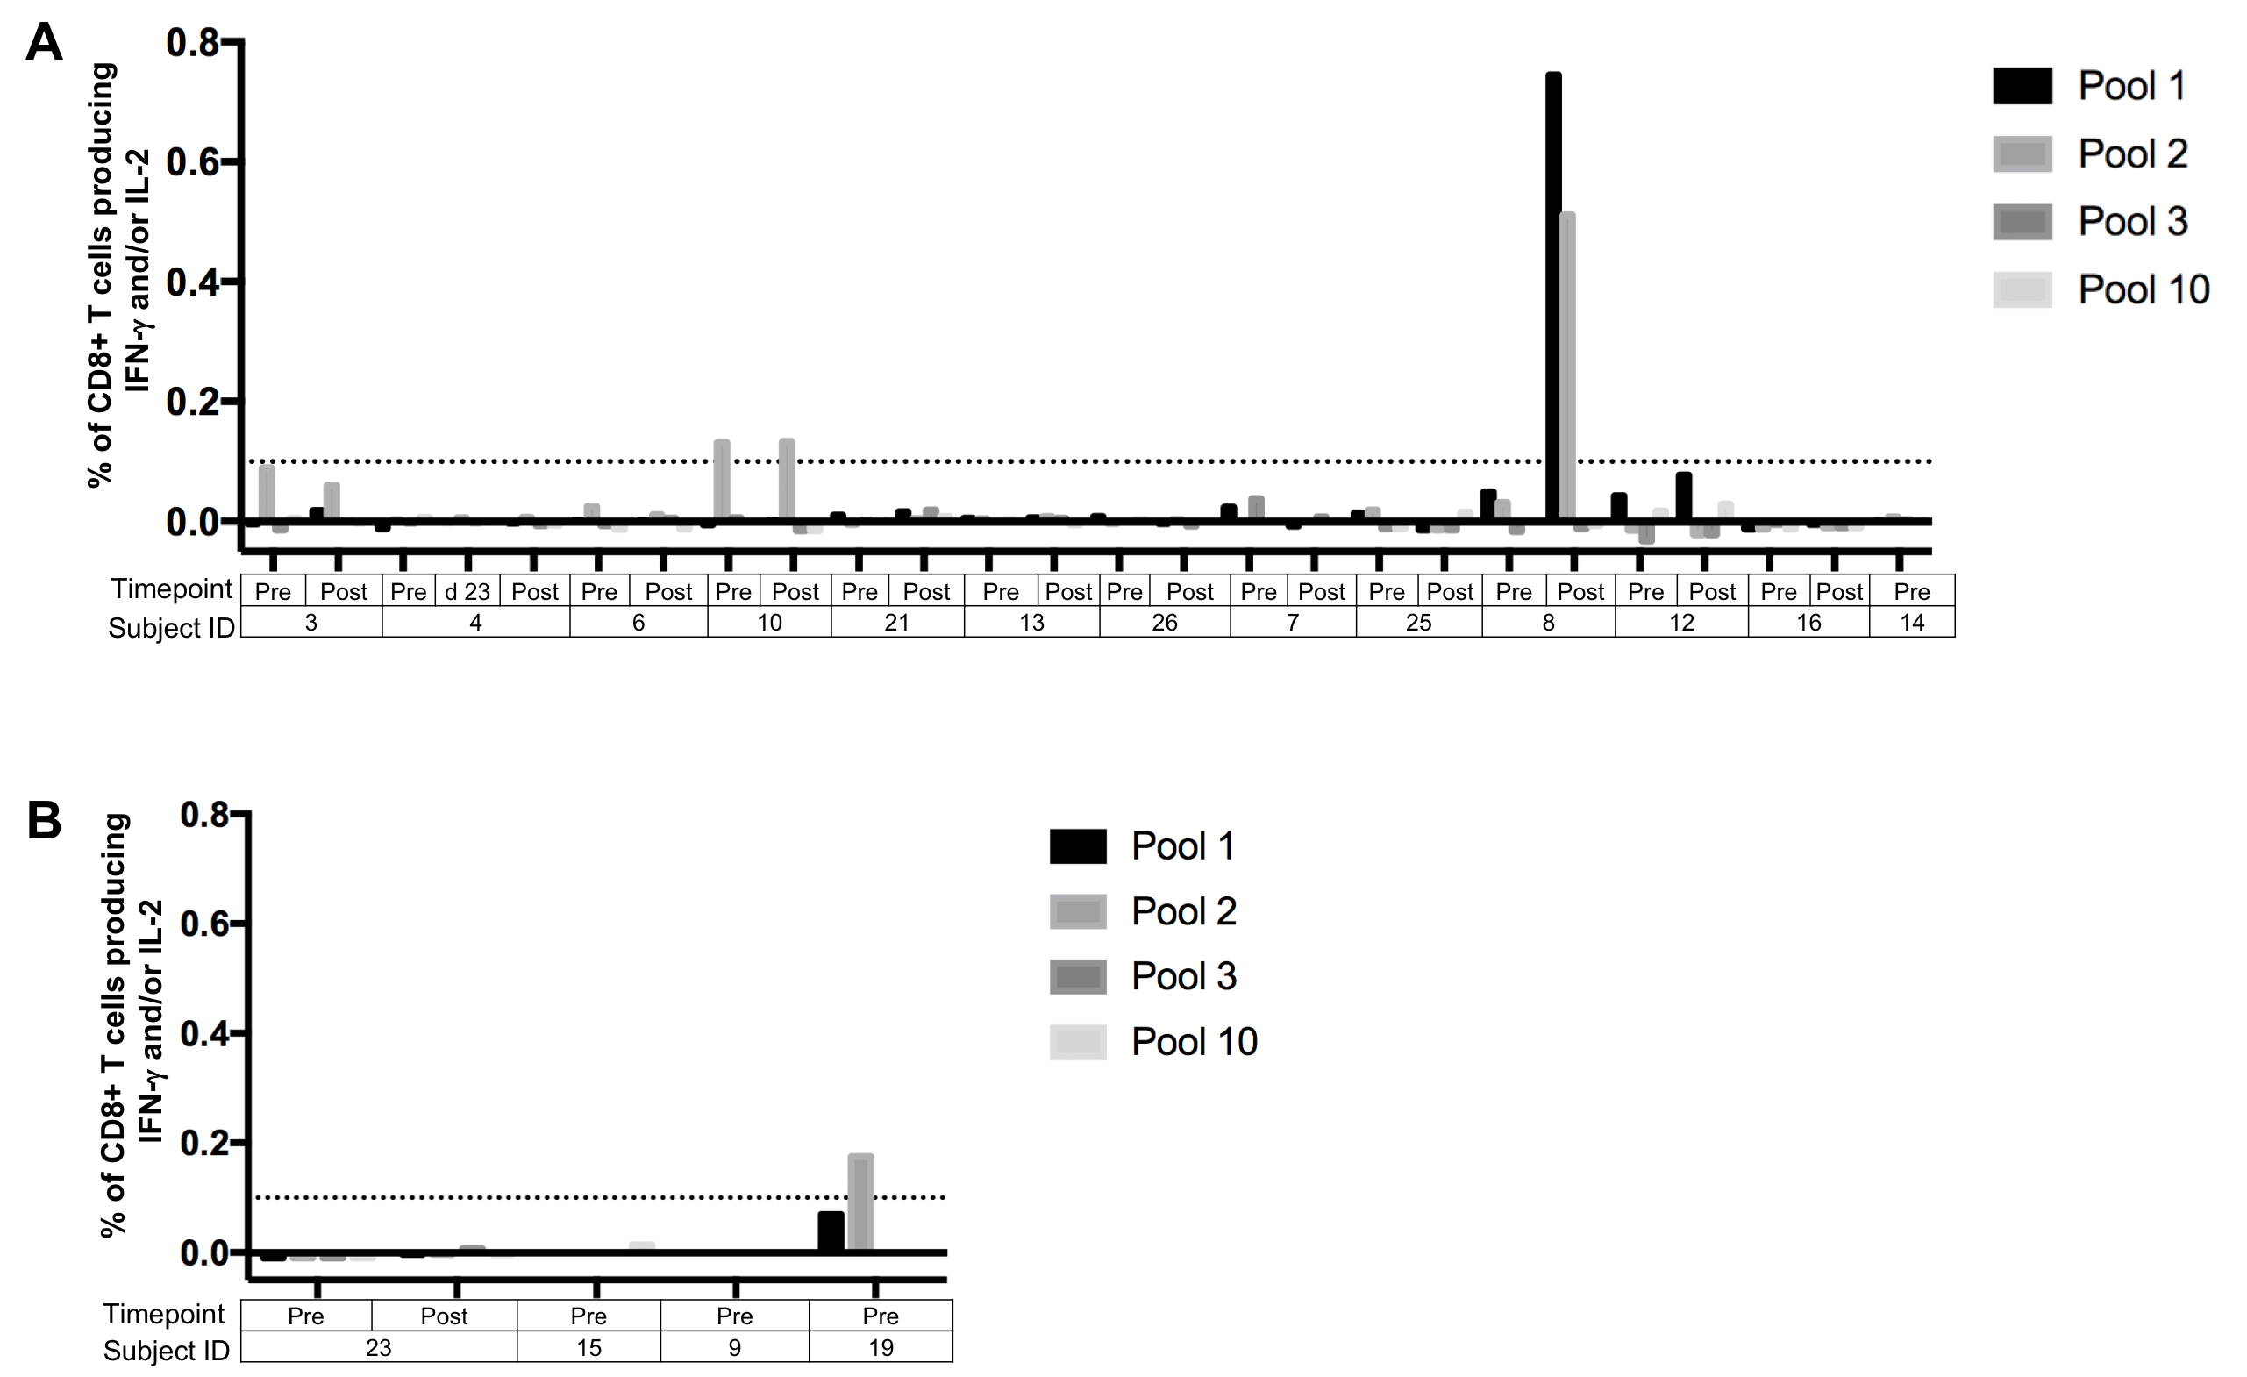
Additional file 4: Frequency of IFNγ and/or IL-2 secreting CD8 T cells in response to Merkel polyomavirus peptide pools.
IFNg and/or IL-2 in (A) 2 of 13 VP-MCC responders and (B) 1 of 4 VP-MCC non-responders was detectible via flow cytometry after a 16 hour stimulation with MCPyV peptide pools. Dotted line represents background signal cutoff. *Post = first blood draw after initiation of treatment

