Additional File 5: Supplementary Figure S5

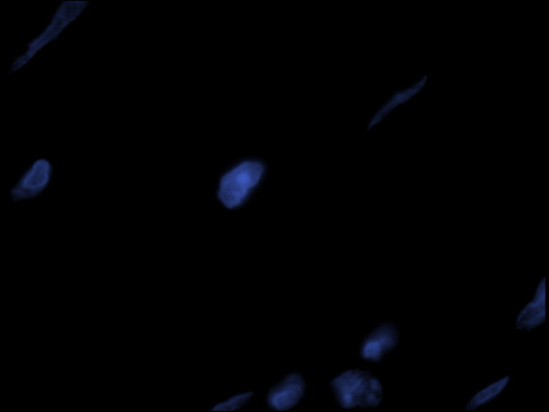
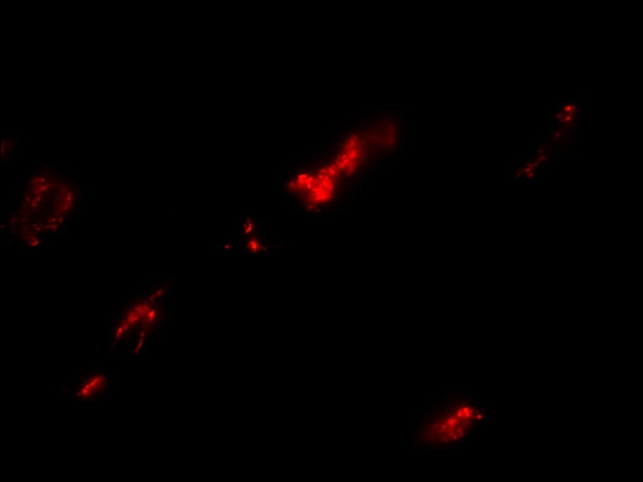
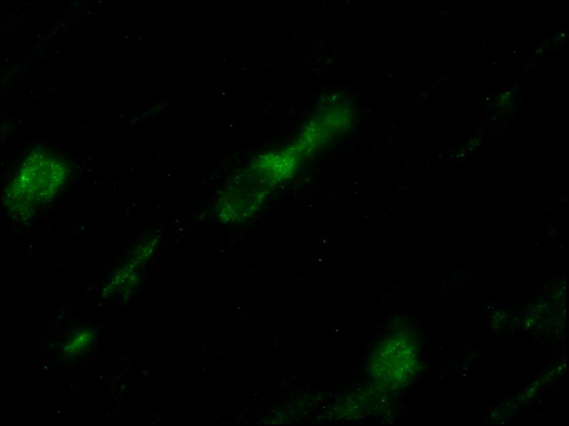
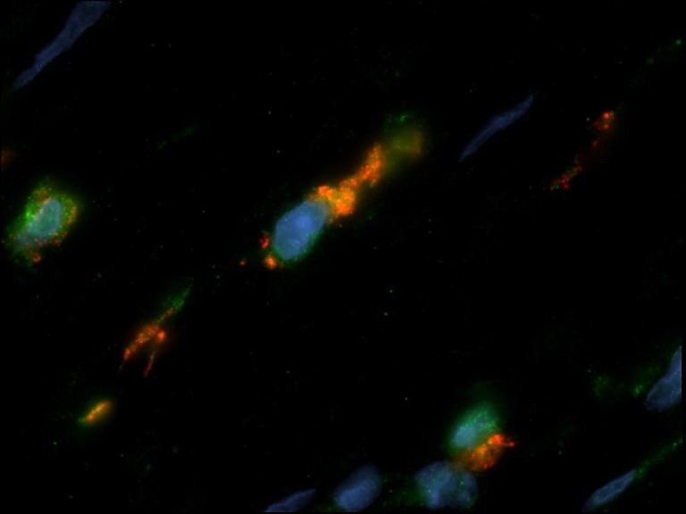
1000x
1000x
1000x
1000x
DAPI
CD163
IL-1β
Merge
Figure S5. IL-1β expression in the stroma is mainly supported by TAMs. Immunofluorescence
staining was performed to identify IL-1β secreting cells in the tumor stroma. TAM are stained in
red (i.e., CD163), IL-1β in green.

