Supplementary materials

Fig S1
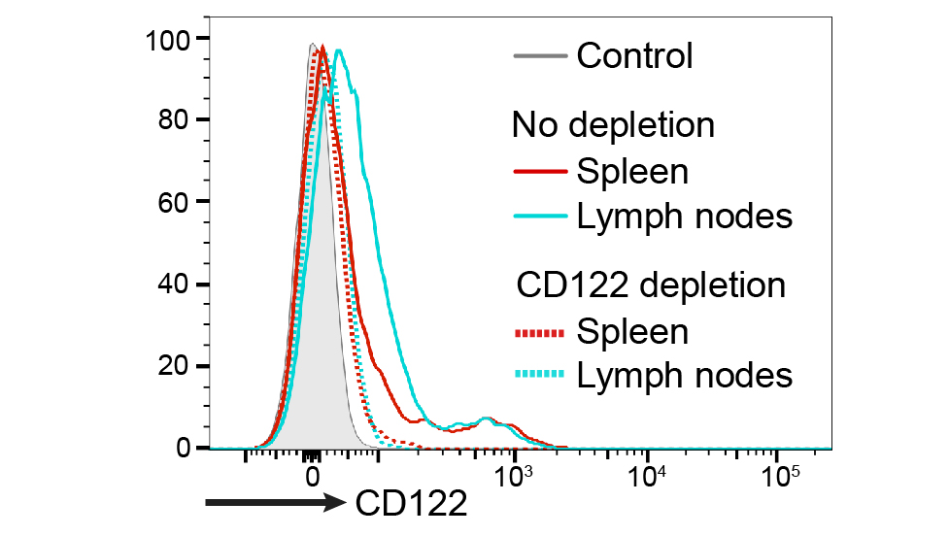
Fig S1. Flow cytometry results showing the successful depletion of CD122-positive cells in spleen and lymph nodes 24 h after i.p. injection of CD122-depleting antibodies.

