JITC-D-18-00507
OVERALL SURVIVAL BY CLINICAL RISK CATEGORY FOR HIGH DOSE INTERLEUKIN-2 (HD IL-2) TREATED PATIENTS WITH METASTATIC RENAL CELL CANCER (mRCC): DATA FROM THE PROCLAIMSM REGISTRY
M Fishman¹, JP Dutcher ², JI Clark³, A Alva⁴, GP Miletello⁵, B Curti⁶, Neeraj Agarwal⁷, R Hauke⁸, KM Mahoney⁹, H Moon¹⁰, J Treisman¹¹, SS Tykodi¹², G Daniels¹³, MA Morse¹⁴, MKK Wong¹⁵, H Kaufman¹⁶, N Gregory¹⁷, DF McDermott⁹

SUPPLEMENTAL MATERIALS
Supplemental Table S1a: Median Survival (months) by Risk Group and Therapy Sequence
Supplemental Table S1b: Two Year Overall Survival by Risk Group and Treatment Sequence
Supplemental Table S2: Ongoing Trials of IL-2 and Checkpoint Inhibitors

SUPPLEMENTAL FIGURE LEGENDS
Figure S1: Overall Survival by RCC Risk: All Patients with 6 IMDC Criteria.
Figure S2: Overall Survival by RCC Risk: Post-IL-2 Treatment
Figure S3: Response Duration: All Complete Response Patients
Figure S4: Response Duration: All Partial Response Patients
Figure S5: Response Duration: All Stable Disease Patients
Figure S6: Overall Survival by RCC Risk: Treatment Prior to IL-2 from First Treatment Date

Table S1a: Median Survival (months) by Risk Group and Therapy Sequence
Patient Group Favorable Intermediate Poor Risk
Median Survival Median Survival Median Survival
(95% CI) (95% CI) (95% CI)
All Patients with 6 IMDC criteria  (n=810) | 63.3 mo  (51.2-73) | 42.4 mo  (35.4-56) | 14 mo  (10-24.5)
No Therapy Prior to IL-2 (n= 365) | 60 mo  (51-78) | 41 mo  (33.5-51) | 24.5 mo  (10-30)
Therapy post IL-2  (n= 414) | 60 mo  (51-78) | 41.6 mo  (33.5-51) | 22.5 mo  (10-27.5)
IL-2 Alone  (n= 356) | 64.5 mo  (39.4-112) | 57.6 mo  (34.5-62) | 14 mo  (4-58)
95% CI-- 95% confidence intervals

Table S1b: Two Year Overall Survival by Risk Group and Treatment Sequence
Patient Group Favorable Intermediate Poor Risk Total
All patients  (n=810) | 77.6% | 68.2% | 40.4% | 68.2%
No therapy prior to IL-2  (n=365) | 83.6% | 71.6% | 53.3% | 73.9%
Therapy Prior to IL-2  (n=89) | 70.6% | 50.9% | 93.3% | 61.8%
Therapy Post  IL-2  (n=414) | 81.0% | 72.0% | 46.8% | 72.4%
IL-2 Alone  (n=356) | 73.8% | 63.7% | 39.8% | 64.5%

Table S2: Ongoing Trials of IL-2 and Checkpoint Inhibitors

mRCC
NCT02964078 | 4 Blocks of 9 wks each:  Pembro wk 1,4,7  HD IL-2, 5 doses over 33 hrs, wks 2,3, 5,6 starting second 9 wk block | Ref 28
NCT02989714 | Wk 1, HD IL-2, cycle 1  Wk 2, Nivo  Wk 3, HD IL-2, cycle 2  Wk 4 and every 2 wks, Nivo
NCT03111901 | Cycle 1: LD IL-2, Day 1-5, Day 8-12; Pembro D2  Cycle 2 and beyond up to 2 years:  Pembro d 1 every 21 days; LD IL-2, D 1-5, D8-12
NCT03260504 | Pembro, wk 1 and every 3 weeks;  IL-2 – Cohort 1, SQ low dose wks 1-6;  IL-2 – Cohort 2, low dose IV, wks 1 and 4  IL-2 – Cohort 3, HD IL-2, IV wks 1 and 4
mMelanoma
NCT02748564 | Pembro, wk 0 and every 3 wks;  IL-2 – Cohort 1, LD IV, wk 3 and 5  IL-2 – Cohort 2, Int Dose IV, wk 3 and 5  IL-2 - Cohort 3, HD IL-2 IV, wk 3 and 5
NCT03476174 | Pembro every 3 wks x 2 doses  HD IL-2 – 2 cycles
NCT03111901 | As above

SUPPLEMENTAL FIGURES

Figure S1: Overall Survival by RCC Risk: All Patients
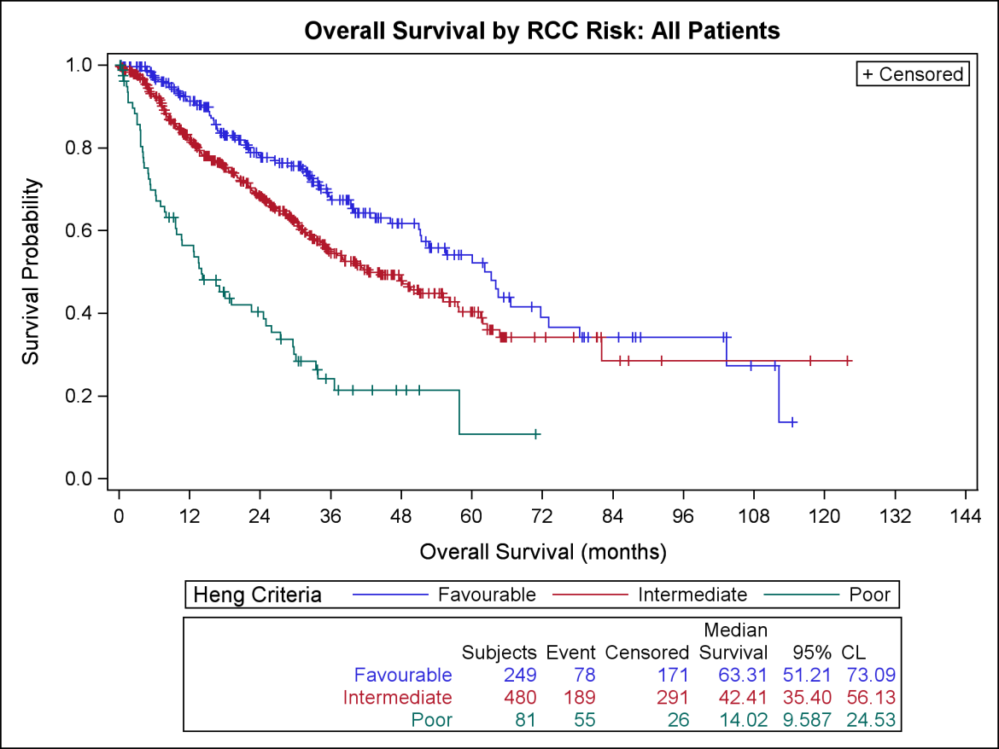

Figure S2: Overall Survival by RCC Risk: Post IL-2 Treatment
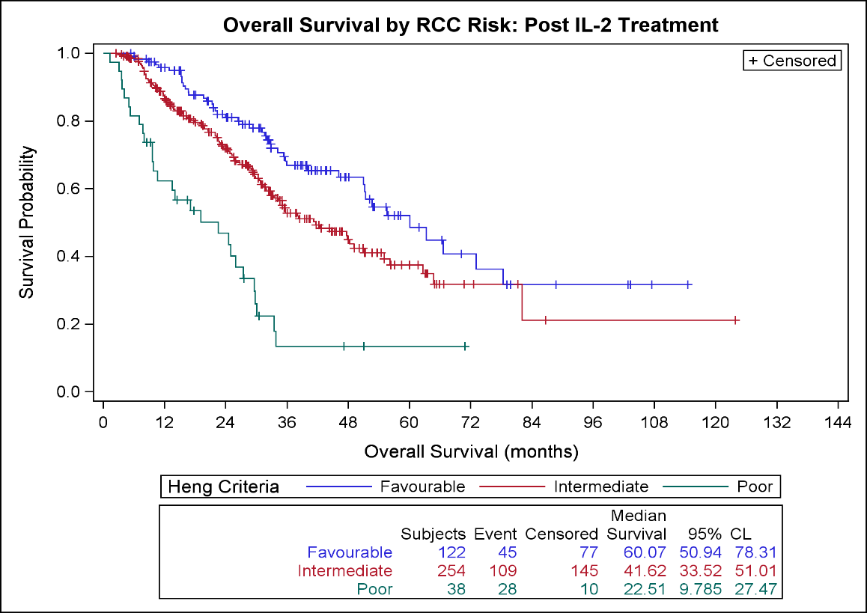

Figure S3: Response Duration: All Complete Response Patients
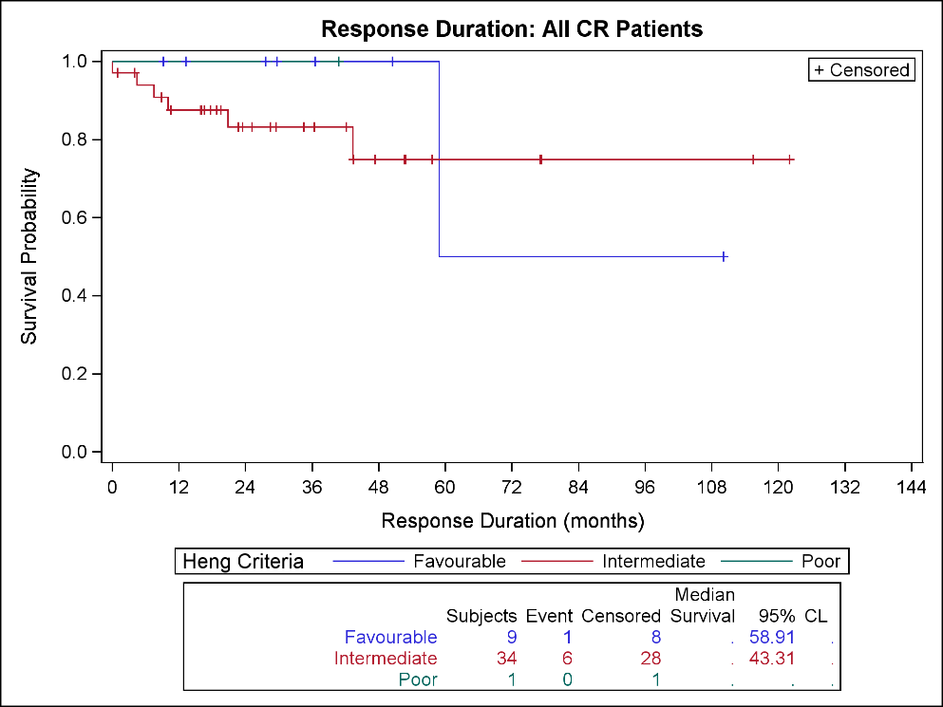

Figure S4: Response Duration: All Partial Response Patients
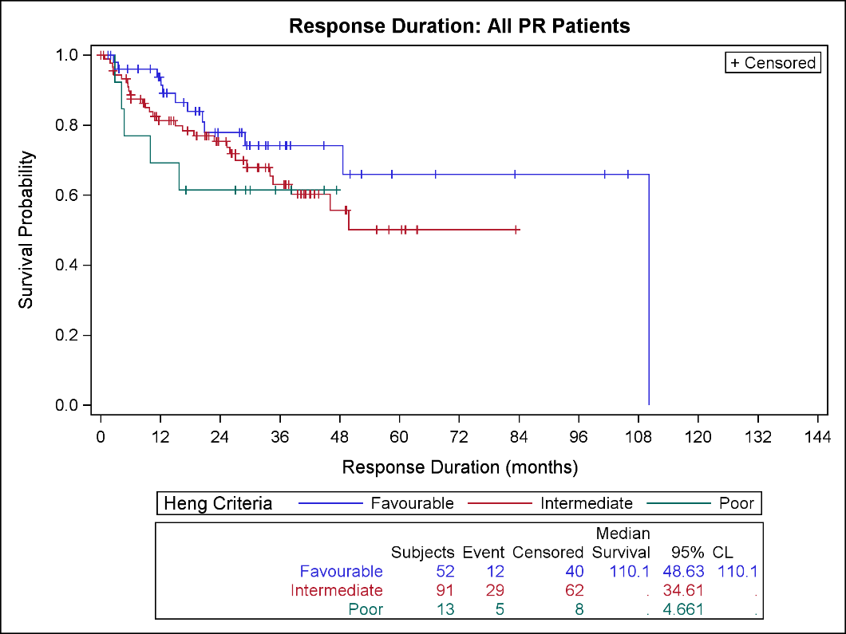

Figure S5: Response Duration: All Stable Disease Patients
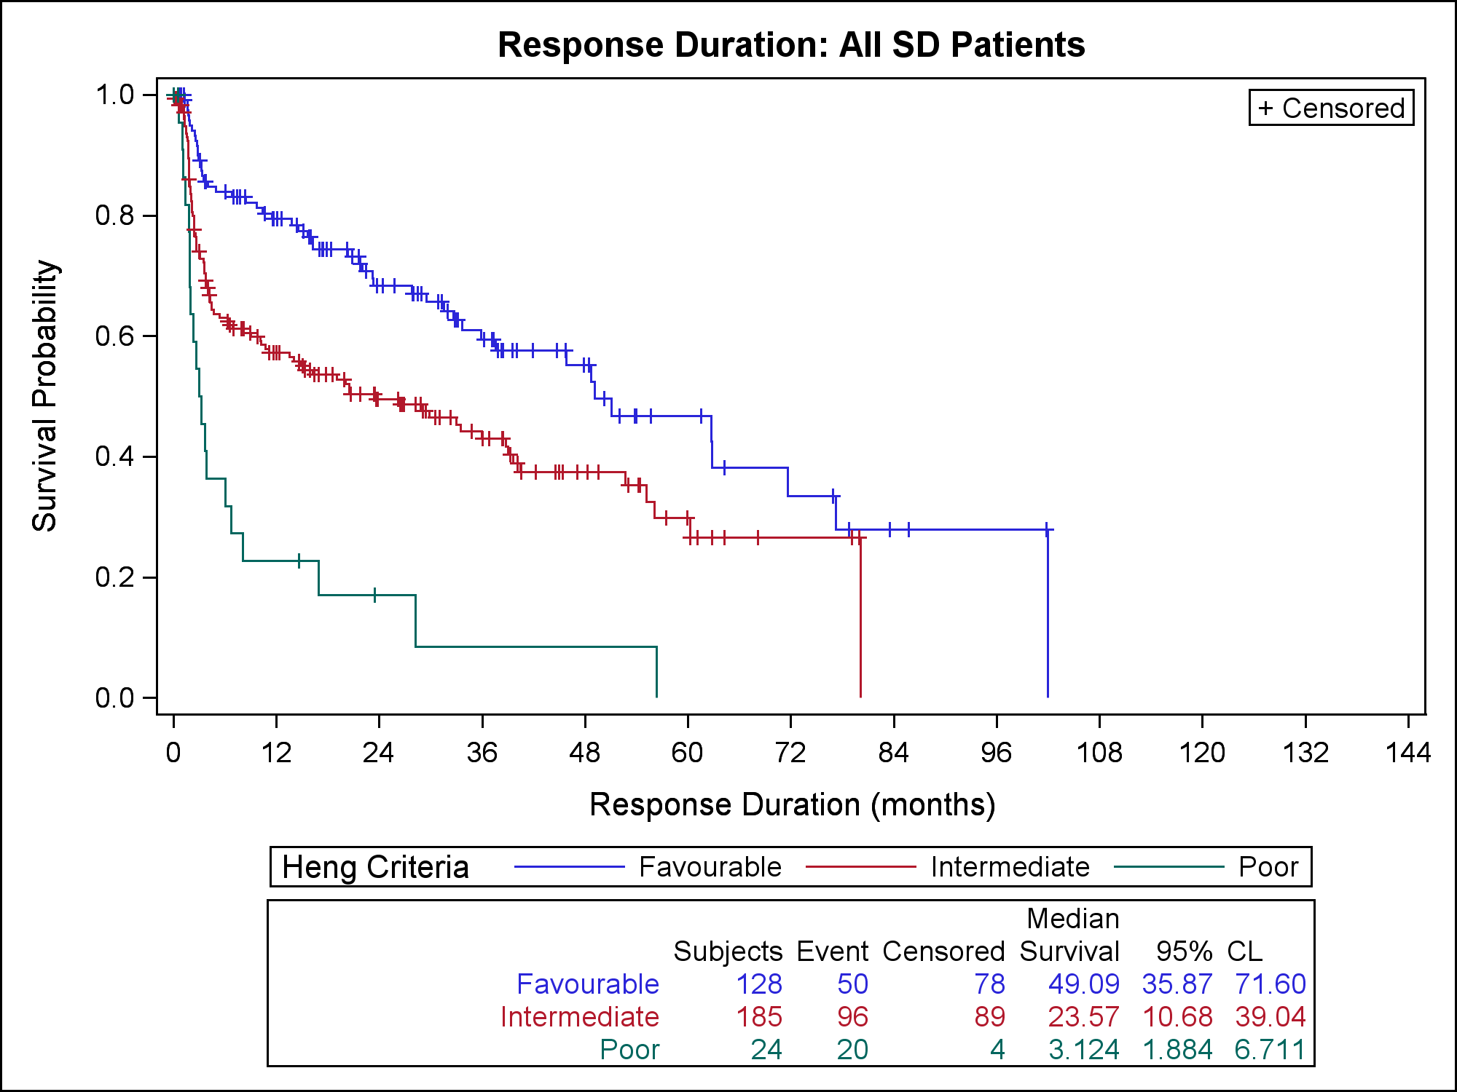

Figure S6: Overall Survival by RCC Risk: Treatment Prior to IL-2 from First Treatment Date
