Safety and Enhanced Immunostimulatory Activity of the DRD2 Antagonist ONC201 in Advanced Solid Tumor Patients with Weekly Oral Administration

Mark N. Stein, MD¹, Jyoti Malhotra,MD¹, Rohinton S. Tarapore, PhD², Usha Malhotra, MD¹, Ann W. Silk, MD¹, Nancy Chan, MD¹, Lorna Rodriguez, MD, PhD¹, Joseph Aisner, MD¹, Robert D. Aiken, MD¹, Tina Mayer, MD¹, Bruce G. Haffty, MD¹, Jenna H. Newman, AB¹, Salvatore M. Aspromonte, BS¹, Praveen K. Bommareddy, MS¹, Ricardo Estupinian, MS¹, Charles B. Chesson, PhD¹, Evita T. Sadimin, MD¹, Shengguo Li, PhD¹, Daniel J. Medina, PhD¹, Tracie Saunders, RN, MS¹, Melissa Frankel¹, Aparna Kareddula¹, Sherrie Damare¹, Elayne Wesolowsky¹, Christian Gabel¹, Wafik S. El-Deiry, MD, PhD³, Varun V. Prabhu, PhD², Joshua E. Allen, PhD², Martin Stogniew, PhD², Wolfgang Oster, MD, PhD², Joseph R. Bertino, MD¹, Steven K. Libutti, MD¹, Janice M. Mehnert, MD¹, and Andrew Zloza, MD, PhD^{1,4}

Supplemental Materials

Supplemental Figure Legends

Figure S1: Ratio of cleaved:total cytokeratin 18 (M30/M65 ELISA assay) in patients treated with weekly ONC201. Patients 1-3 received 375 mg of ONC201 while the remaining patients received 625 mg of ONC201. Each error bar indicates SEM.

Figure S2: Maximum fold change over baseline of immune cytokines and effector molecules in all ONC201-treated patients in the two dosing cohorts (once every three weeks and weekly dosing schedules). Each error bar indicates SEM.

Figure S3: (A) Maximum fold change of serum prolactin levels in the serum relative to baseline when compared to maximum concentration of ONC201 in the serum of the patients treated on a weekly schedule.

Figure S4: Maximum fold induction of caspase-cleaved cytokeratin 18 levels in the serum relative to baseline when compared to maximum concentration of ONC201 in the serum of the patients treated on a weekly schedule.

Figure S5: Timing of maximum fold-induction of immune cytokines and effects. Each dot represents the time when maximum induction was observed for the top five patients who had the highest immune induction.

Figure S6: Serum PSA (ng/mL) of ONC201-treated prostate cancer patients.
Supplemental Figures 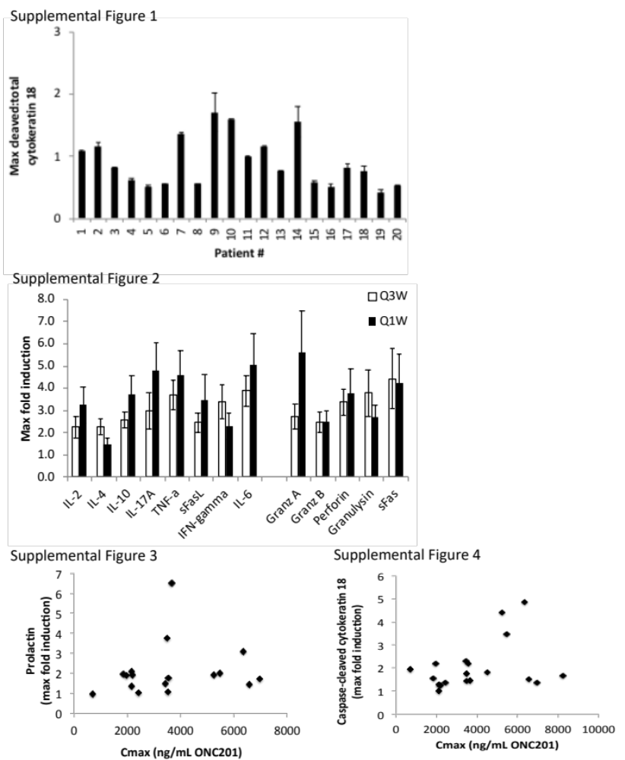
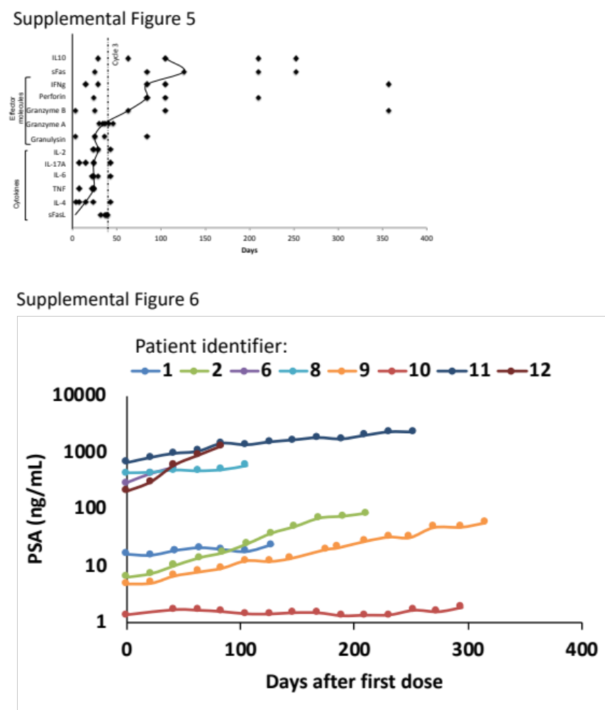

Table S1: Treatment-related adverse events (AEs) in patients treated with ONC201 on a weekly schedule. Those AEs attributed that are at least possibly related to the study drug are listed and all are Grade 1.

No. of Patients | 20
Nausea | 1 (5%)
Vomiting | 1 (5%)
Fatigue | 2 (10%)
Stomach Pain | 1 (5%)
Cognitive Disturbance | 1 (5%)
Tinnitus | 1 (5%)
Dysgeusia | 1 (5%)

Table S2: Pharmacokinetic parameters for 625 mg of ONC201 after the first dose of cycle 1 and after the first dose of cycle 2 (n = 17).
