Anti-pancreatic tumor efficacy of a Listeria-based, Annexin A2-targeting immunotherapy in combination with anti-PD-1 antibodies

Authors: Victoria Kim^{1,2,3}†, Alex Blair^{1,2,3,4}†, Peter Lauer⁵, Kelly Foley^{1,2}, Xu Che^{1,2,4}, Kevin Soares^{1,2,3}, Tao Xia^{1,2,4}, Stephen Muth^{1,2,4}, Jennifer Kleponis^{1,2}, Todd Armstrong^{1,2}, Christopher Wolfgang^{1,2,3,4}, Elizabeth M. Jaffee^{1,2,4}, Dirk Brockstedt⁵, Lei Zheng^{1,2,3,4*}
†VK and ABB contributed equally to this manuscript

Affiliations:
¹The Sidney Kimmel Comprehensive Cancer Center, The Johns Hopkins University School of Medicine, Baltimore, Maryland, 21287, USA.
²Department of Oncology, The Johns Hopkins University School of Medicine, Baltimore, Maryland, 21287, USA.
³Department of Surgery, The Johns Hopkins University School of Medicine, Baltimore, Maryland, 21287, USA.
⁴The Pancreatic Cancer Precision Medicine Program of Excellence, The Johns Hopkins University School of Medicine, Baltimore, Maryland, 21287, USA
⁵Aduro Biotech, Inc., Berkeley, California, USA.

*Corresponding Author:
Lei Zheng, M.D., Ph.D., 1650 Orleans Street, CRB1 Room 488, Baltimore, MD 21042. Tel: 410-5026241, Fax: 410-614-8216, Email: lzheng6@jhmi.edu

Running title: Annexin A2 expressing Listeria-based immunotherapy

Supplementary Tables and Figures

Figure S1
hANXA2 MSTVHEILCKLSLEGDHSTPPSAYGSVKAYTNFDAERDALNIETAIKTKGVDEVTIVNIL 60

MSTVHEILCKLSLEGDHSTPPSAYGSVK YTNFDAERDALNIETA+KTKGVDEVTIVNIL
mANXA2 MSTVHEILCKLSLEGDHSTPPSAYGSVKPYTNFDAERDALNIETAVKTKGVDEVTIVNIL 60

hANXA2 TNRSNAQRQDIAFAYQRRTKKELASALKSALSGHLETVILGLLKTPAQYDASELKASMKG 120

TNRSN QRQDIAFAYQRRTKKEL SALKSALSGHLETVILGLLKTPAQYDASELKASMKG
mANXA2 TNRSNVQRQDIAFAYQRRTKKELPSALKSALSGHLETVILGLLKTPAQYDASELKASMKG 120

hANXA2 LGTDEDSLIEIICSRTNQELQEINRVYKEMYKTDLEKDIISDTSGDFRKLMVALAKGRRA 180

LGTDEDSLIEIICSRTNQELQEINRVYKEMYKTDLEKDIISDTSGDFRKLMVALAKGRRA
mANXA2 LGTDEDSLIEIICSRTNQELQEINRVYKEMYKTDLEKDIISDTSGDFRKLMVALAKGRRA 180

hANXA2 EDGSVIDYELIDQDARDLYDAGVKRKGTDVPKWISIMTERSVPHLQKVFDRYKSYSPYDM 240

EDGSVIDYELIDQDAR+LYDAGVKRKGTDVPKWISIMTERSV HLQKVF+RYKSYSPYDM
mANXA2 EDGSVIDYELIDQDARELYDAGVKRKGTDVPKWISIMTERSVCHLQKVFERYKSYSPYDM 240

hANXA2 LESIRKEVKGDLENAFLNLVQCIQNKPLYFADRLYDSMKGKGTRDKVLIRIMVSRSEVDM 300

LESI+KEVKGDLENAFLNLVQCIQNKPLYFADRLYDSMKGKGTRDKVLIRIMVSRSEVDM
mANXA2 LESIKKEVKGDLENAFLNLVQCIQNKPLYFADRLYDSMKGKGTRDKVLIRIMVSRSEVDM 300

hANXA2 LKIRSEFKRKYGKSLYYYIQQDTKGDYQKALLYLCGGDD 339

LKIRSEFKRKYGKSLYYYIQQDTKGDYQKALLYLCGGDD
mANXA2 LKIRSEFKRKYGKSLYYYIQQDTKGDYQKALLYLCGGDD 339​

Figure S1 Comparison between murine and human ANXA2 protein sequences. Edited peptide sequences to demonstrate difference between murine and human ANXA2 with brackets. They are 98% homologous.

Figure S2

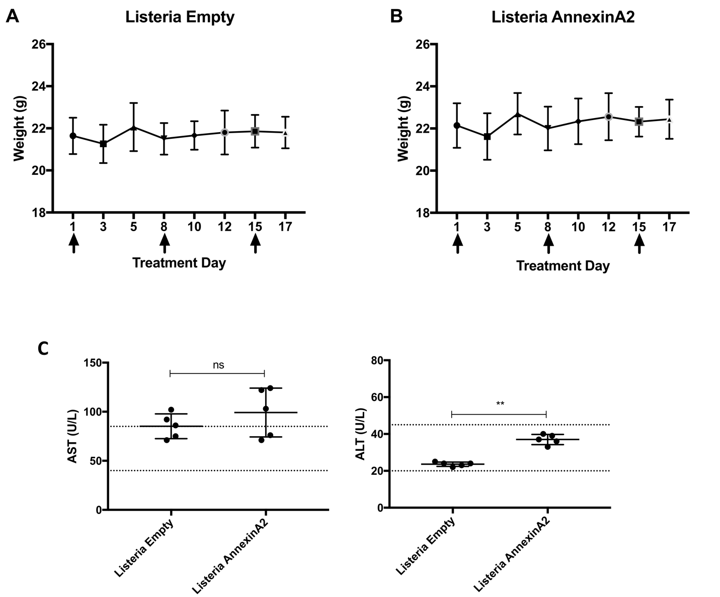

Figure S2 Toxicity analysis of Lm-ANXA2 and Empty Lm in mice. Sequential weights of C57Bl/6 mice (n=5) following treatment with Empty Lm (A) or Lm-ANXA2 (B). Weight in grams. Arrows indicate treatment days. (C) Serum AST and ALT levels in C57Bl/6 mice (n=5) following treatment with Empty Lm (Listeria Empty) or Lm-ANXA2 (Listeria AnnexinA2) were measured at SRI Biosciences’ Clinical Analysis Laboratory. Dashed line represents 95% CI of normal serum values in C57Bl/6 mice. ns=not significant; **=p<0.01. Note that ALT in all mice was within normal limit even though it was significantly higher in the Lm-ANXA2 group than the Empty Lm group.

Figure S3

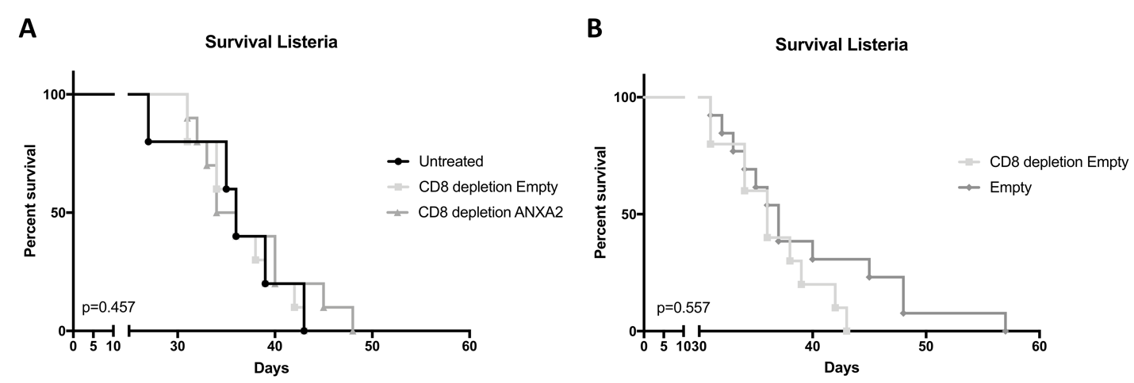

Figure S3. Listeria based immunotherapy with concomitant CD8+ T cell depletion. Mice implanted with KPC PDAC cells on day 0 underwent treatment with Empty Lm or Lm-ANXA2 as previously described (n=10-12 mice per group). CD8+ depletion was started on day 2 via anti-CD8a antibody (10mg/kg IP; 2.43, BioXcell) until day 30 and was given in both control groups. (A) Kaplan-Meier curves reveal there is no statistically significant difference in survival comparing untreated mice to mice treated with Empty Lm and CD8+ depletion or mice treated with Lm-ANXA2 and CD8 depletion (p=0.457). (B) No statistically significant difference in survival was appreciated in PDAC bearing mice treated with Empty Lm without CD8+ depletion compared to mice treated with Empty Lm and CD8+ T cell depletion (p=0.557).

Figure S4

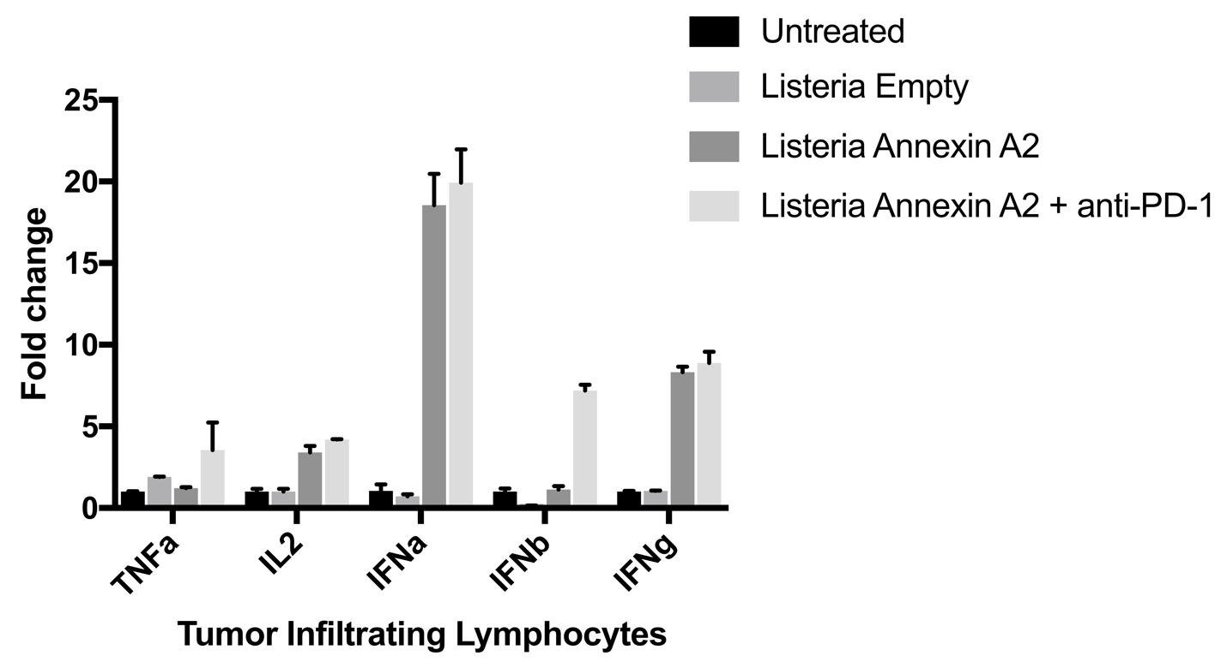

Figure S4. Cytokine expression of infiltrating immune cells in the tumor microenvironment of PDAC following Lm-ANXA2 treatment. Gene expression analysis via aPCR of inflammatory cytokines of tumor infiltrating immune cells isolated from spontaneously developed PDACs in the genetically engineered KPC mice (n=4) following treatment with Untreated, Empty Lm, Lm-ANXA2 and Lm-ANXA2 + anti-PD-1. No statistical significance is noted comparing Untreated and Empty Lm in all genes of interest. Similarly, no statistical significance is noted comparing Lm-ANXA2 and Lm-ANXA2 + anti-PD-1 in all genes, except for IFNb (p=0.004).

Figure S5
Figure S5. Ultrasound measurement of the PDAC tumors in KPC mice. (A) Ultrasound measurements of untreated mice, (B) mice treated with Empty Lm and (C) mice treated with Lm-ANXA2 followed by anti-PD1 antibodies. Trend lines indicate Day 22.

Figure S6

Figure S6. Maximal tumor volume reduction in KPC mice treated with Lm-ANXA2 followed by anti-PD-1 antibodies. The maximal tumor volume reduction from the peak tumor size to the lowest post-peak size of the tumor was measured and compared between untreated KPC mice (n=10), KPC mice treated with Empty Lm followed by IgG (n=12), and KPC mice treated with Lm-ANXA2 followed by anti-PD-1 antibodies (n=12).

Figure S7
Figure S7. Expression of ANXA2 in KPC tumor. Immunohistochemistry for ANXA2 was performed in 10 KPC mice. Analysis reveals heterogenic expression of ANXA2, with 40% of KPC tumors having low expression and 60% having high expression.

Figure S8

Figure S8. Examination of T cell response to ANXA2 overlapping peptide groups in the tumor microenvironment. CD8+ T cells were isolated and purified from livers on day 14 after hemispleen implantation of KPC tumor cells. Tumor-bearing mice were treated with Cy, either Empty Lm or Lm-ANXA2, and either anti-PD-1 antibody or IgG as in prior study schemes. ELISA assays were performed by co-culturing the CD8+ T cells with Kb or Db T2 cells that were exposed to one of four different peptide sequence groups. Each experimental group consisted of 5 mice, pooled, and analyzed individually in triplicates. Data represent mean + SEM from one representative experiment that was repeated twice. IFNγ expression of the treatment groups (Empty Lm vs. Lm-ANXA2) exposed to (A) Kb T2 and (B) Db T2 cells that were stimulated with Peptide Groups #1, #2, #3, or #4, was shown. Additional experiment performed with the addition of either anti-PD-1 antibody or IgG as in prior study schemes were performed with the same ELISA protocol. IFNγ expression of the treatment groups exposed to Kb T2 and (C) peptide group #1, (D) #2 or (E) #4 is shown. Simiarly, Db T2 cells that were stimulated with (F) peptide groups #1, (G) #2, (H) #3, or (I) #4 is shown.

Supplementary Table S1 Overlapping peptide groups of ANXA2

