Electronic supplementary material

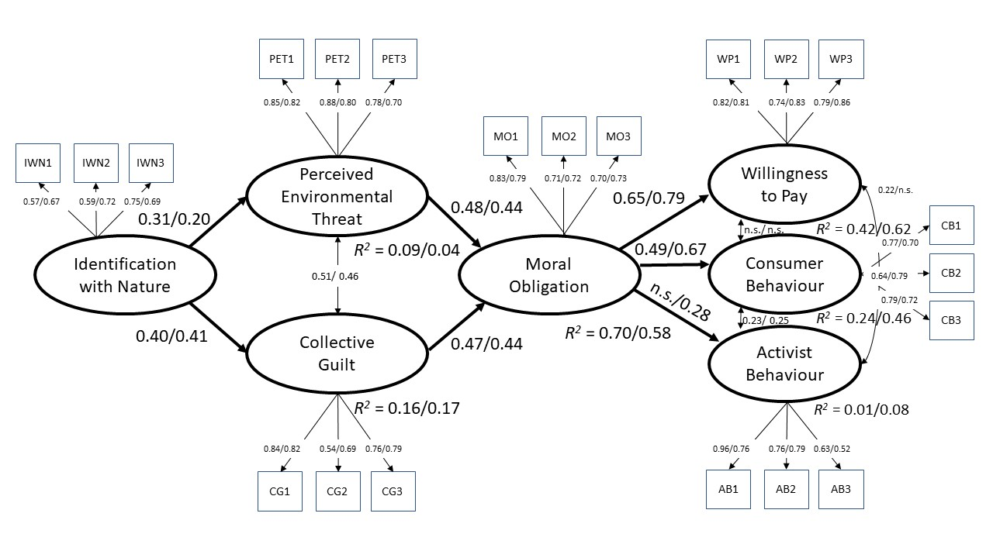
Figure 1.
Results on structural equal model for subgroup academic discipline (N = 568). Figure shows standardized significant parameters (p < 0.05) for academic disciplines (economy with n = 150 / engineering with n = 418), except for labelling n.s.

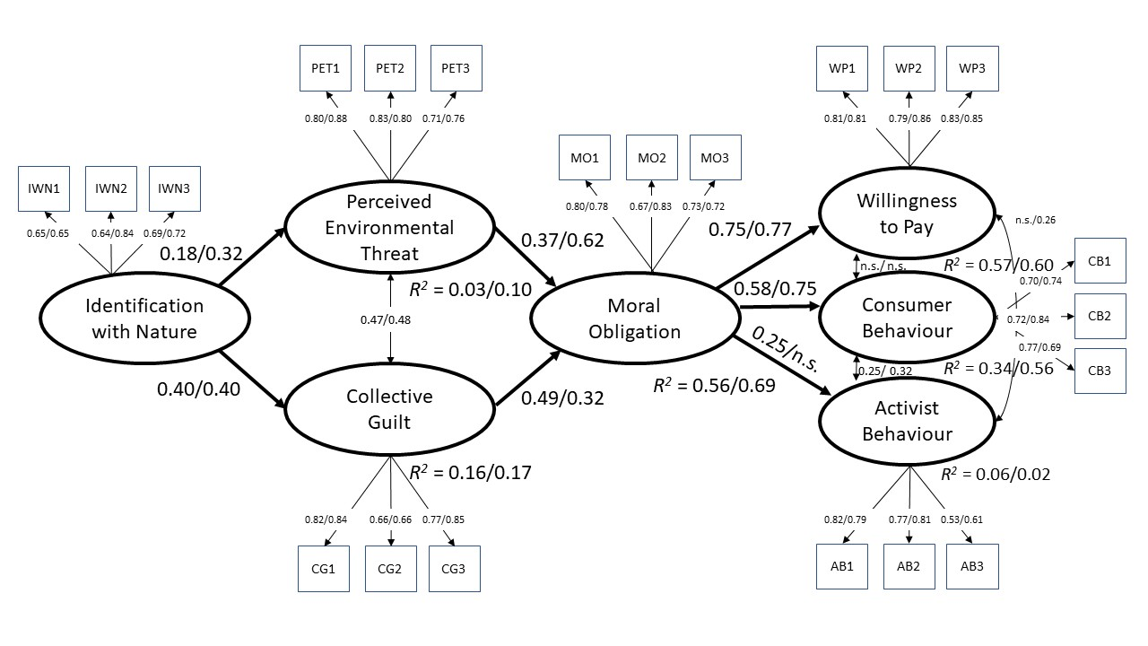
Figure 2.
Results on structural equal model for subgroup completed vocational training (N = 568). Figure shows standardized significant parameters (p < 0.05) for completed vocational training (no completed vocational training with n = 409 / completed vocational training with n = 159), except for labelling n.s.

