Supplementary material
S1. Descriptive statistics on the individual and control variables for individuals with a refugee background and those from the majority population
 | Individuals with a refugee background |  |  | Individuals from the majority population
Variables | Mean (SD) / Share | Proportion of missing values | N | Mean (SD) / Share | Proportion of missing values | N
Applied for different training occupations (Ref. no)  Yes | 25.9% | 3.3% | 2,014 | 44.1% | 1.0% | 3,934
Completed a voluntary internship (Ref. no)  Yes | 43.3% | 3.3% | 2,014 | 40.2% | 1.0% | 3,934
Participated in application training (Ref. no)  Yes | 18.7% | 4.3% | 1,994 | 22.9% | 0.7% | 3,946
Visited a career fair (Ref. no)  Yes | 22.1% | 4.3% | 1,994 | 49.8% | 0.7% | 3,946
Sought information on the website of the FEA (Ref. no)  Yes | 29.7% | 4.3% | 1,994 | 46.8% | 0.7% | 3,946
Received help from family in finding a training place (Ref. no)  Yes | 11.1% | 4.3% | 1,994 | 67.1% | 0.7% | 3,946
Discussed career choices with friends (Ref. no)  Yes | 36.2% | 4.3% | 1,994 | 39.9% | 0.7% | 3,946
School-leaving qualification  - no (recognized) school-leaving certificate  - lower secondary school-leaving certificate  - intermediate secondary school-leaving certificate  - upper secondary school-leaving certificate | 17.1%  48.5%  22.5%  12.0% | 25.7% | 1,548 | 1.1%  19.9%  57.3%  21.7% | 1.3% | 3,922
Age | 22.1 (3.5) | – | 2,083 | 18.1 (2.3) | – | 3,972
Survey year (Ref. 2018)  2020 | 9.7% | – | 2,083 | 59.2% | – | 3,972
Source: Own calculations based on data from the BA/BIBB Applicants Survey (2018, 2020) and the BA/BIBB Refugee Migration Study (2018).

Fig. S1. Distribution of the occupation-specific average gross monthly salary in the sample (in Euro)
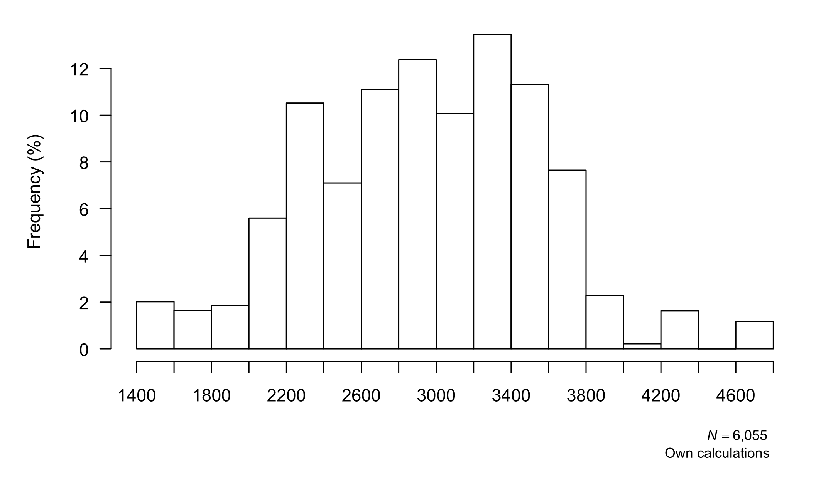

Fig. S2. Distribution of the occupation-specific average unemployment rate in the sample (in percent)
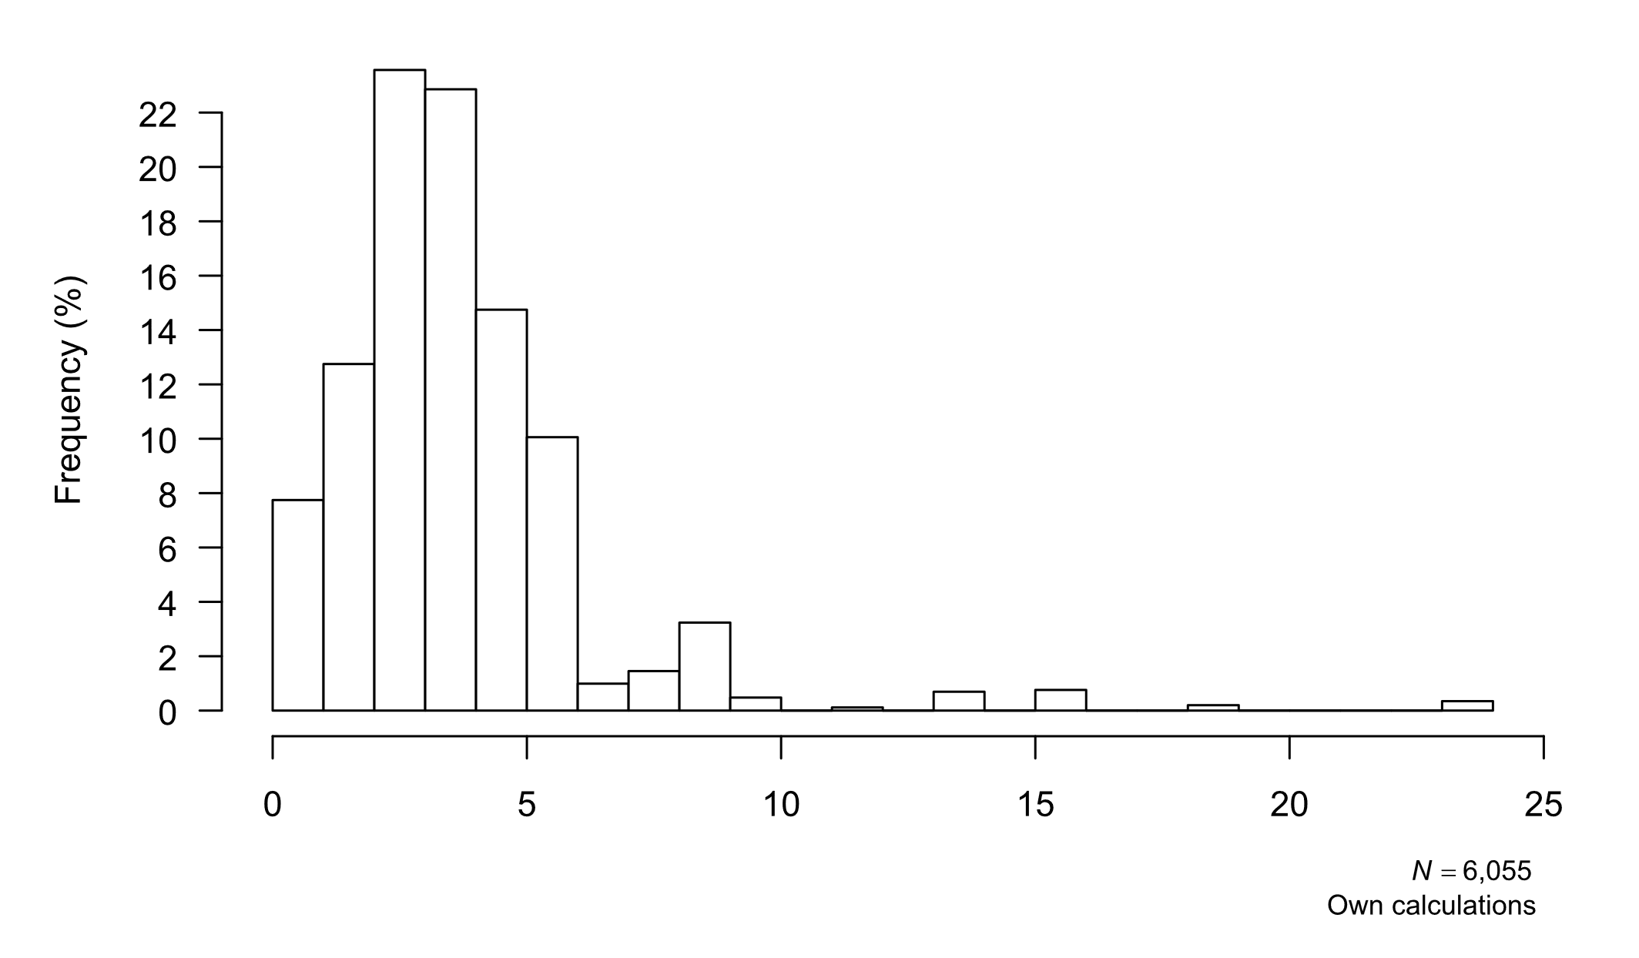

S2. Detailed mediation analysis of the effect of refugee background on the average occupation-specific monthly gross salary in entered training positions, by gender
 | Men |  | Women
 | $β$ (SE) | Proportion mediated | $β$ (SE) | Proportion mediated
Total effect | -351.18*** (45.90) | – | -508.46*** (66.25) | –
Indirect effects
Via search and application strategies, network resources
Applied for different training occupations (ref. no)  Yes | -16.55* (7.20) | 4.7% | -27.98* (11.17) | 5.5%
Completed a voluntary internship (ref. no)  Yes | 0.53 (0.81) | -0.2% | 0.07 (.79) | -0.0%
Participated in application training (ref. no)  Yes | -1.46 (1.55) | 0.4% | -1.29 (4.41) | 0.3%
Visited a career fair (ref. no)  Yes | -18.68** (6.02) | 5.3% | -47.38*** (12.66) | 9.3%
Sought information on the website of the FEA (ref. no)  Yes | 3.10 (7.59) | -0.9% | 34.25* (13.78) | -6.7%
Received help from family members in finding a training place (ref. no)  Yes | 9.03 (11.57) | -2.6% | 13.33 (10.34) | -2.6%
Discussed career choices with friends (ref. no)  Yes | -0.02 (2.40) | 0.0% | -10.38 (7.97) | 2.0%
Via school-leaving qualification
Lower secondary school-leaving certificate (ref. no (recognized) school-leaving qualification)  Yes | 31.27 (25.96) | -8.9% | 35.51 (40.45) | -7.0%
Intermediate secondary school-leaving certificate (ref. no (recognized) school-leaving qualification)  Yes | -86.98*** (19.40) | 24.8% | -72.54 (45.58) | 14.3%
Upper secondary school-leaving certificate (ref. no (recognized) school-leaving qualification)  Yes | -208.80*** (26.16) | 59.5% | -350.12*** (54.8) | 68.9%
Direct effect | -62.62 (48.61) | – | -81.93 (72.50) | –
Observations | 4621 |  | 2541
Source: Own calculations based on data from the BA/BIBB Applicants Survey (2018, 2020) and the BA/BIBB Refugee Migration Study (2018). Standard errors in parentheses; * p < 0.05, ** p < 0.01, *** p < 0.001.

S3. Detailed mediation analysis of the effect of refugee background on the log-transformed average occupation-specific unemployment rate in entered training positions, by gender
 | Men |  | Women
 | $β$ (SE) | Proportion mediated | $β$ (SE) | Proportion mediated
Total effect | 0.17*** (0.03) | – | 0.02 (0.06) | –
Indirect effects
Via search and application strategies, network resources
Applied for different training occupations (ref. no)  Yes | 0.00 (0.01) | 1.4% | 0.03* (0.01) | > 100%
Completed a voluntary internship (ref. no)  Yes | -0.00 (0.00) | -0.8% | 0.00 (0.00) | 6.4%
Participated in application training (ref. no)  Yes | -0.00 (0.00) | -0.5% | 0.00 (0.01) | 25.4%
Visited a career fair (ref. no)  Yes | 0.00 (0.01) | 2.0% | 0.01 (0.02) | 59.4%
Sought information on the website of the FEA (ref. no)  Yes | -0.01 (0.01) | -6.2% | -0.03 (0.01) | < -100%
Received help from family members in finding a training place (ref. no)  Yes | 0.01 (0.01) | 5.7% | -0.01 (0.01) | -47.5%
Discussed career choices with friends (ref. no)  Yes | 0.00 (0.00) | 1.5% | 0.02 (0.01) | 97.5%
Via school-leaving qualification
Lower secondary school-leaving certificate (ref. no (recognized) school-leaving qualification)  Yes | -0.05 (0.03) | -32.7% | -0.20*** (0.06) | < -100%
Intermediate secondary school-leaving certificate (ref. no (recognized) school-leaving qualification)  Yes | 0.07*** (0.02) | 44.3% | 0.09 (0.06) | > 100%
Upper secondary school-leaving certificate (ref. no (recognized) school-leaving qualification)  Yes | 0.18*** (0.03) | >100% | 0.41*** (0.06) | > 100%
Direct effect | -0.03 (0.04) | – | -0.31*** (0.07) | –
Observations | 4621 |  | 2541
Source: Own calculations based on data from the BA/BIBB Applicants Survey (2018, 2020) and the BA/BIBB Refugee Migration Study (2018). Standard errors in parentheses; * p < 0.05, ** p < 0.01, *** p < 0.001.

Fig. S3. Total, direct, and indirect effects of refugee background on the average occupation-specific gross monthly salary of training positions, by gender
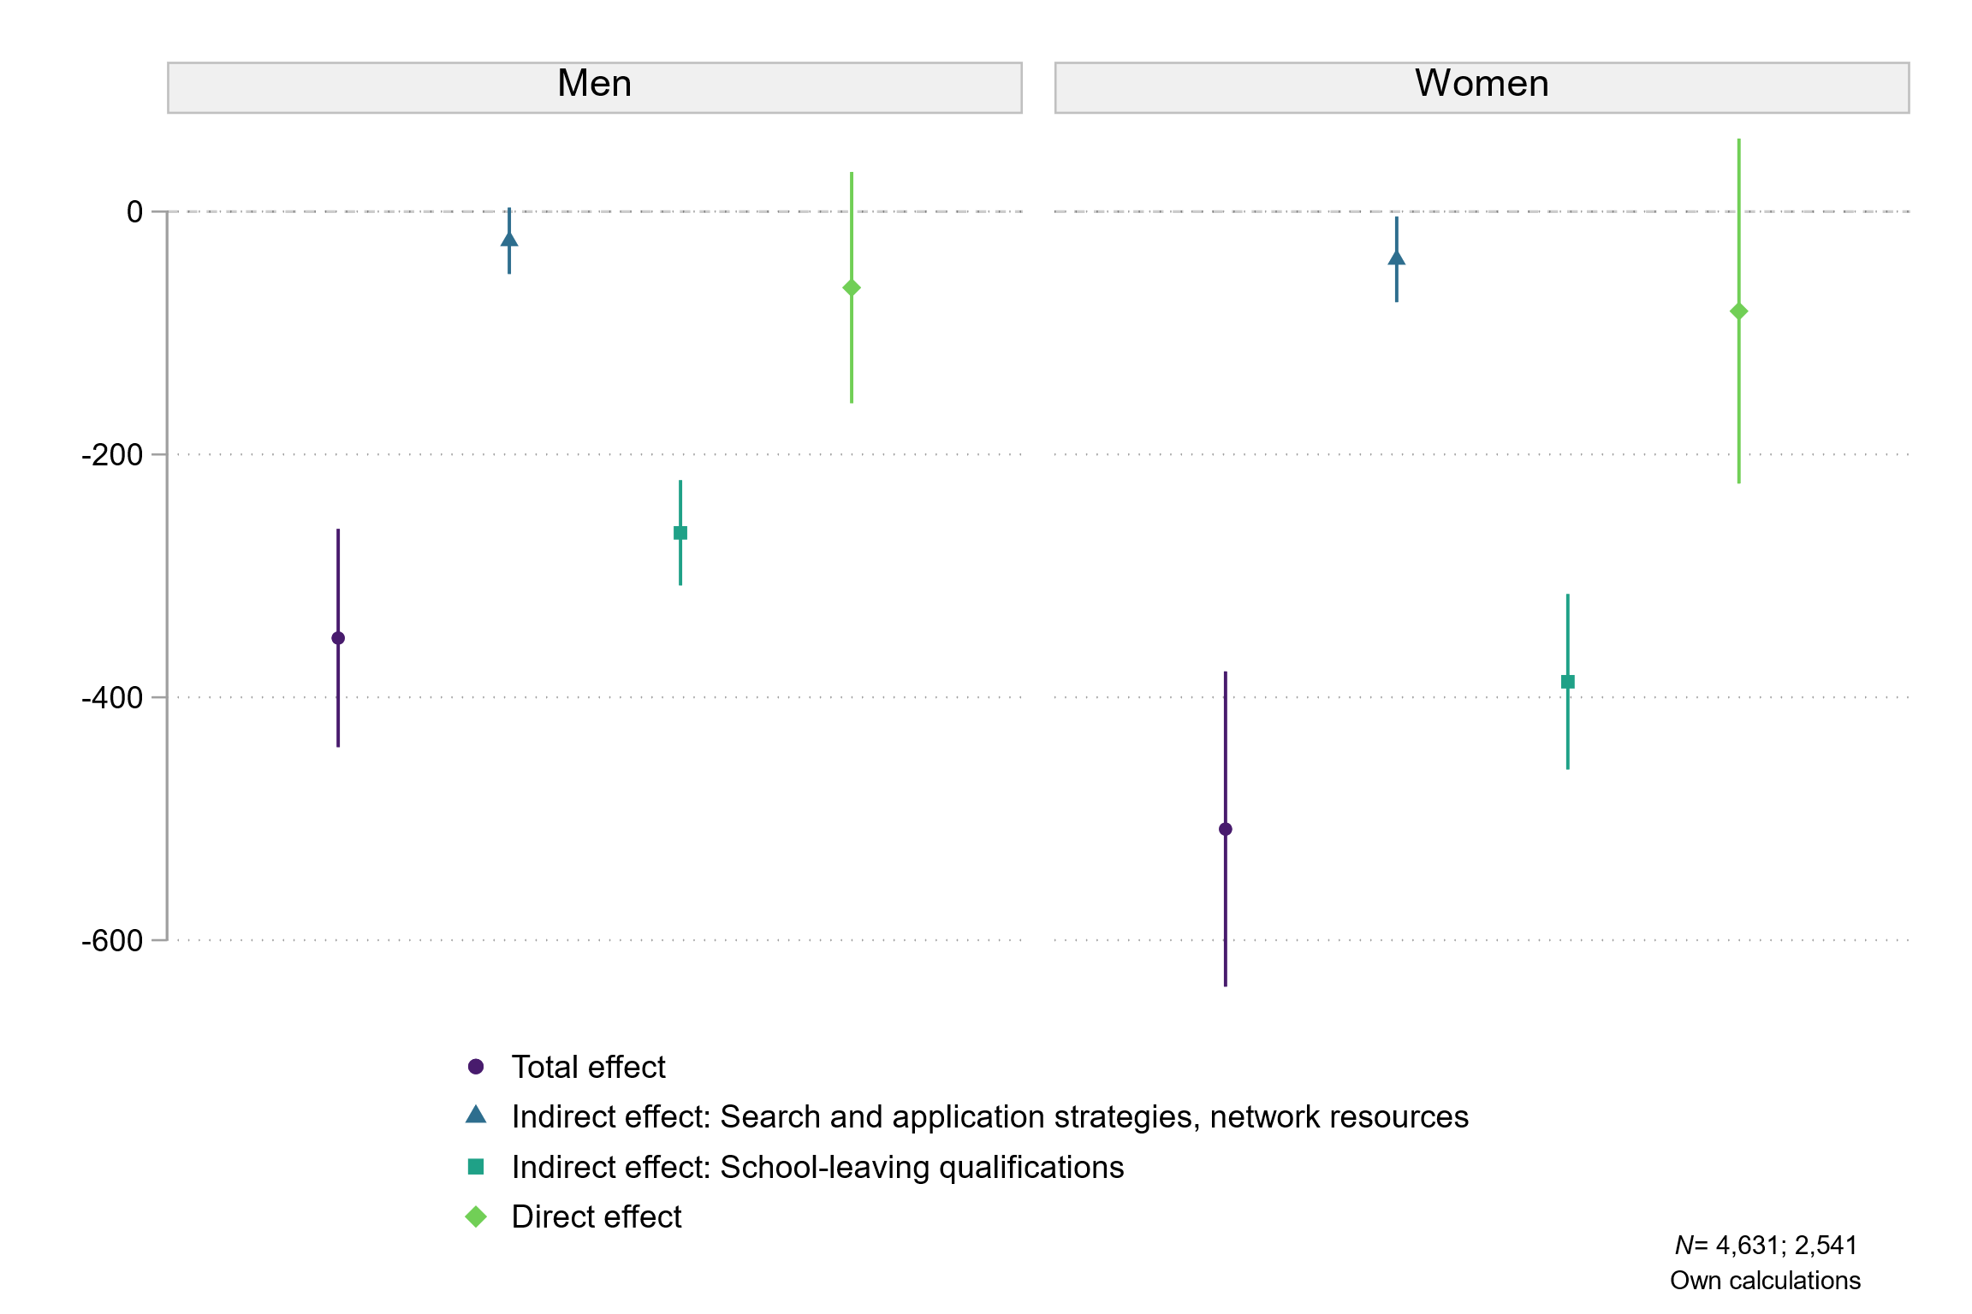

Fig. S4. Total, direct, and indirect effects of refugee background on the average occupation-specific log. unemployment rate of training positions, by gender
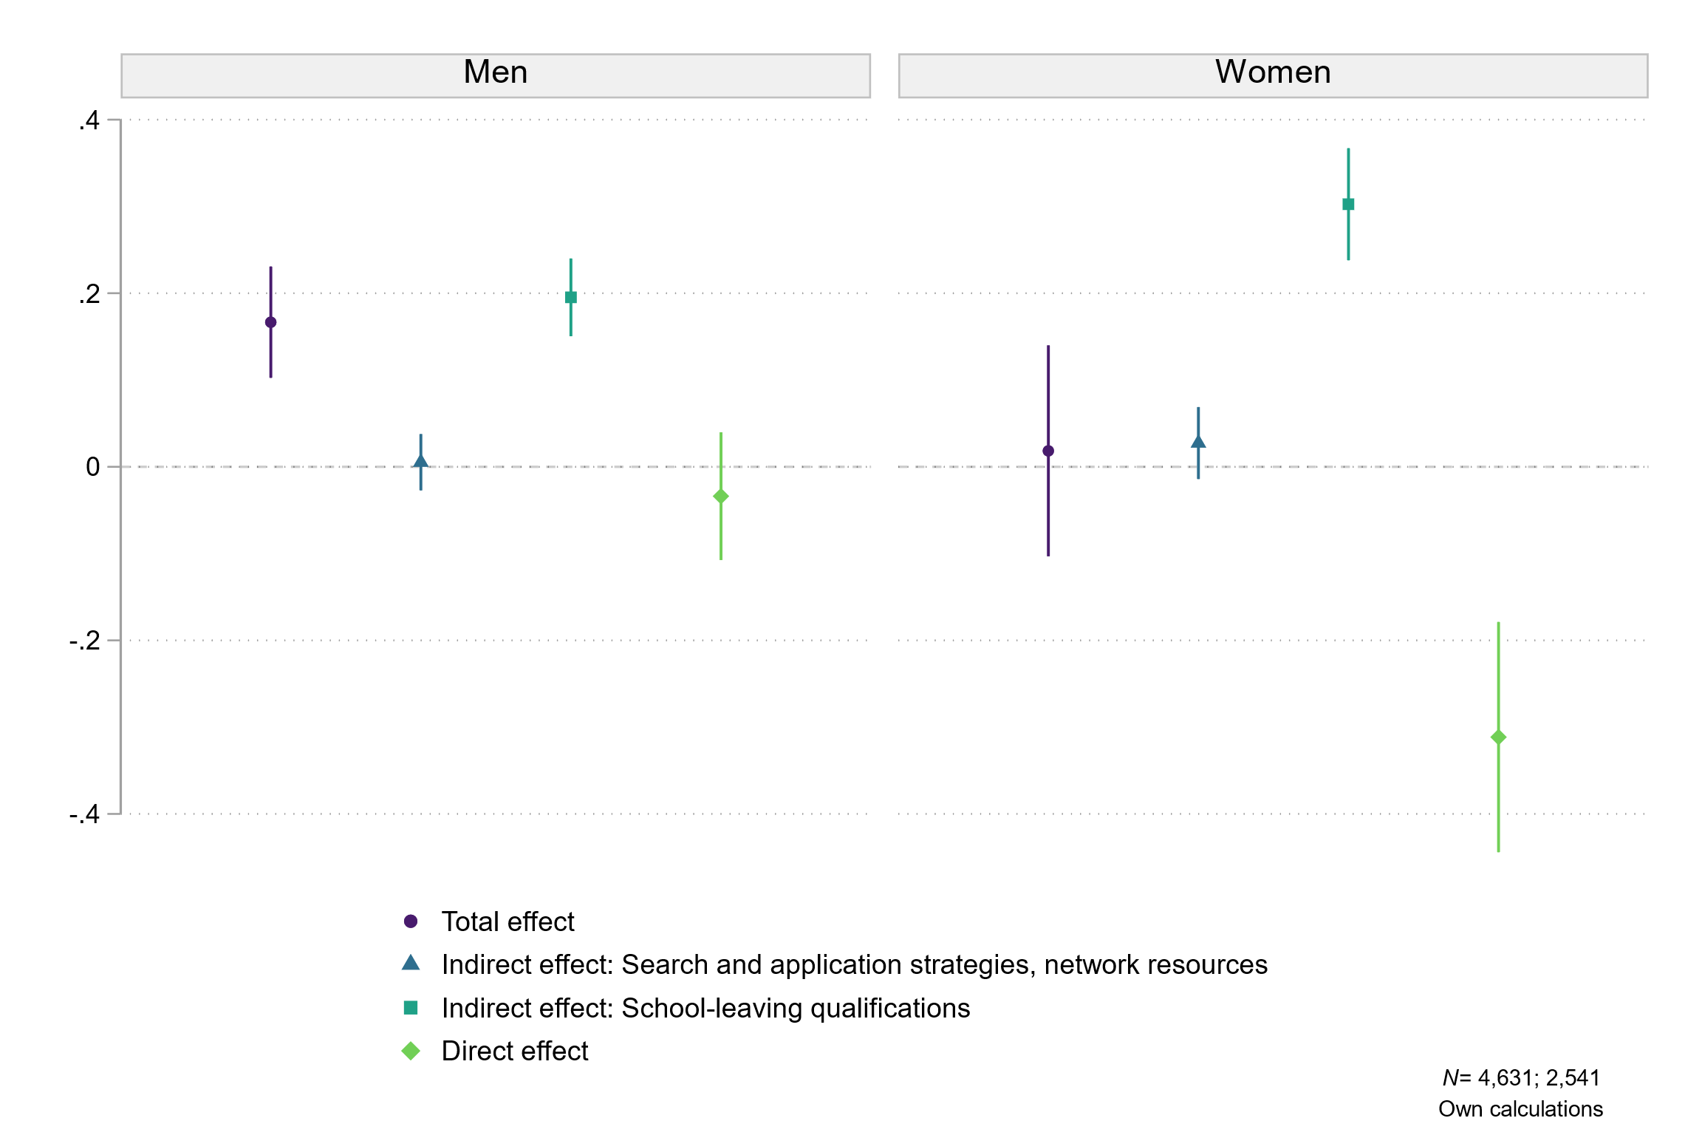

S4. Distribution of refugee women by educational level and entered training position in the occupational group of doctors’ receptionists and assistants or occupations in body care
Educational level | Doctors’ receptionists and assistants |  | Occupations in body care
Educational level | Count | Share | Count | Share
No (recognized) school-leaving qualification | 1 | 1.22% | 5 | 20%
Lower secondary school-leaving certificate | 40 | 48.8% | 18 | 72%
Intermediate secondary school-leaving certificate | 33 | 40.3% | 1 | 4%
Upper secondary school-leaving certificate | 8 | 9.8% | 1 | 4%
Total | 82 | 100% | 25 | 100%
Source: Own calculations based on data from the BA/BIBB Applicants Survey (2018, 2020) and the BA/BIBB Refugee Migration Study (2018).

