a. Definitions (illustrated for the "Eating" behavior)  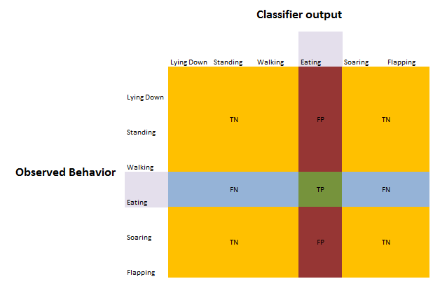 | c. Accuracy: $\frac{TP+TN}{TP+TN+FP+FN}$
   | Lying Down | Standing | Walking | Eating | Soaring | Flapping | weighted average
  ANN | 97 | 96 | 91 | 92 | 98 | 96 | 94
  Decision Tree | 97 | 93 | 87 | 87 | 98 | 93 | 92
  LDA | 96 | 92 | 91 | 91 | 97 | 94 | 92
  Linear SVM | 97 | 95 | 87 | 90 | 97 | 94 | 93
  Nearest Neighbors | 97 | 94 | 89 | 88 | 98 | 95 | 92
  Random Forest | 98 | 95 | 92 | 90 | 99 | 94 | 94
  RBF SVM | 97 | 95 | 89 | 90 | 98 | 96 | 93
  mean | 97 | 94 | 90 | 90 | 98 | 95 | 93
b. Precision: $\frac{TP}{TP+FP}$ | d. Recall: $\frac{TP}{TP+FN}$
   | Lying Down | Standing | Walking | Eating | Soaring | Flapping | weighted average
  ANN | 63 | 94 | 67 | 80 | 87 | 84 | 85
  Decision Tree | 50 | 93 | 54 | 70 | 86 | 67 | 78
  LDA | 44 | 87 | 75 | 81 | 71 | 77 | 80
  Linear SVM | 63 | 94 | 52 | 79 | 79 | 73 | 81
  Nearest Neighbors | 57 | 90 | 60 | 70 | 93 | 94 | 81
  Random Forest | 89 | 91 | 76 | 72 | 96 | 87 | 85
  RBF SVM | 53 | 94 | 60 | 77 | 93 | 80 | 83
  mean | 60 | 92 | 63 | 76 | 86 | 80 | 82
   | Lying Down | Standing | Walking | Eating | Soaring | Flapping | weighted average
  ANN | 59 | 96 | 67 | 84 | 84 | 72 | 85
  Decision Tree | 59 | 92 | 52 | 72 | 78 | 70 | 78
  LDA | 41 | 96 | 57 | 79 | 91 | 60 | 81
  Linear SVM | 59 | 94 | 64 | 72 | 72 | 70 | 80
  Nearest Neighbors | 47 | 97 | 55 | 80 | 78 | 60 | 81
  Random Forest | 47 | 99 | 61 | 91 | 81 | 52 | 84
  RBF SVM | 47 | 93 | 64 | 79 | 81 | 82 | 83
  mean | 51 | 95 | 60 | 80 | 81 | 67 | 82
Table 3. Recall, Precision and Accuracy for each of the models and behaviors.

