Supplemental material
Calculation of height from pressure recordings
Formula for calculating flight altitude from barometric pressure (p) measured by the data logger. Sea level pressure (p₀) was set to 1013.25 hPa, and sea level temperature (T) was set to 15°C.
$$h=\frac{\left[{\left(\frac{p_{0}}{p}\right)}^{\frac{1}{5.255}}-1\right]×\left(T+273.15\right)}{0.0065}$$

Tables
Table S1: Overview of mean flight altitudes per species and season. Mean heights per individual were derived from the means per flight bouts weighted by the duration of the flight bout.
 |  |  | mean flight altitude [m asl]
 |  | N | min | 25% | median | 75% | max
overall | Great Reed warbler | 13 | 1245 | 1372 | 1454 | 1545 | 1712
 | European Hoopoe | 5 | 1327 | 1340 | 1385 | 1466 | 1583
post-breeding | Great Reed warbler | 13 | 840 | 1061 | 1174 | 1256 | 1711
<1.11.15 | European Hoopoe | 5 | 937 | 1092 | 1113 | 1402 | 1453
intratropical | Great Reed warbler | 13 | 431 | 798 | 990 | 1359 | 1516
1.11.15 - 31.1.16 | European Hoopoe | 5 | - | - | - | - | -
pre-breeding | Great Reed warbler | 12 | 1346 | 1543 | 1654 | 1857 | 2036
>31.1.16 | European Hoopoe | 5 | 1454 | 1479 | 1610 | 1744 | 1781

Table S2: Overview of the sum of ascents per species and migration period. Given are range, 50% quantile and median.
 | species | sum of climbs [m]
 |  | min | 25% | median | 75% | max
overall | Great Reed warbler | 73830 | 79673 | 88670 | 104599 | 119731
 | European Hoopoe | 74207 | 87402 | 93754 | 96903 | 100490
post-breeding | Great Reed warbler | 20988 | 23559 | 28790 | 31843 | 39846
<1.11.15 | European Hoopoe | 16389 | 28435 | 34603 | 35304 | 57024
innertropical | Great Reed warbler | 199 | 3038 | 7191 | 10756 | 22904
1.11.15 - 31.1.16 | European Hoopoe | 0 | 414 | 827 | 5124 | 9422
pre-breeding | Great Reed warbler | 23907 | 48723 | 57086 | 71318 | 75399
>31.1.16 | European Hoopoe | 39604 | 42500 | 51935 | 60938 | 62538

Figures:
Figure S1: Recording and data compression of acceleration data. The graph shows a continuous measurement of 12 seconds with a frequency of 10 Hz. For logging year-round data a sample of 3.2 seconds taken every 5min. and compressed by onboard calculation to achieve the mean and the sum of the absolute differences between consecutive points.
$activity = \sum_{i=1}^{31}{{abs(x}_{i}-x_{i+1)}}$
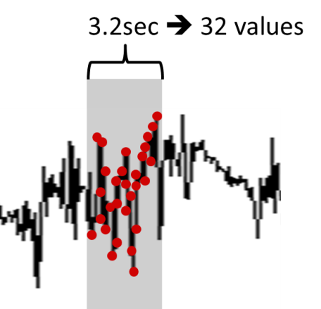
Figure S2: Example of the frequency distribution of the activity recordings (definition see Fig. S1) across the whole sampling period (15.07.2015 – 28.05.2016) for a single tag (14HC). The red line indicates the first minimum, which is taken as the threshold for differentiating between flight and other activities.
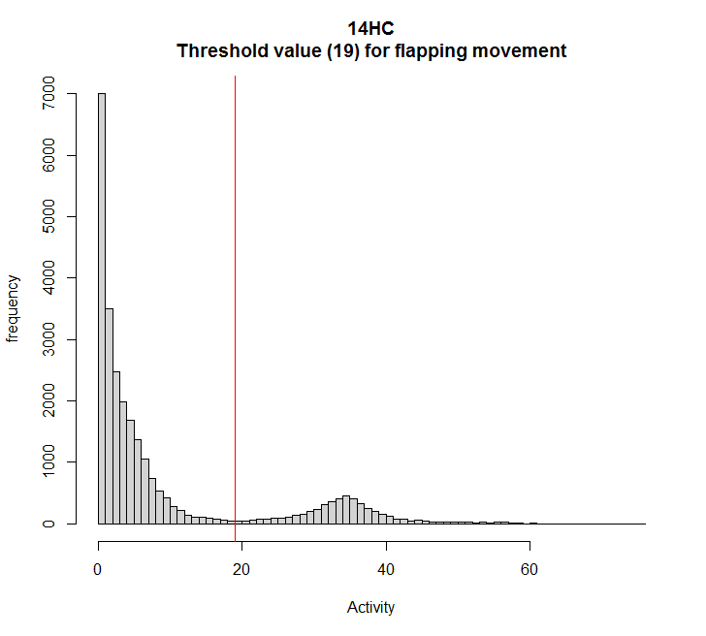
Figure S3: Great circle distances between seasonal residence areas in relation to flight time. Distances are calculated from the median position of the longest staging period within the specific residency.
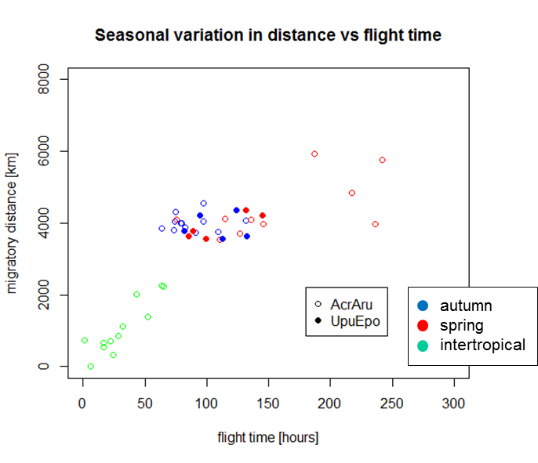

Figure S4: Height distribution of European Hoopes and Great Reed warblers during migration. Shown are the relative frequencies of all individual 30 minutes recordings.

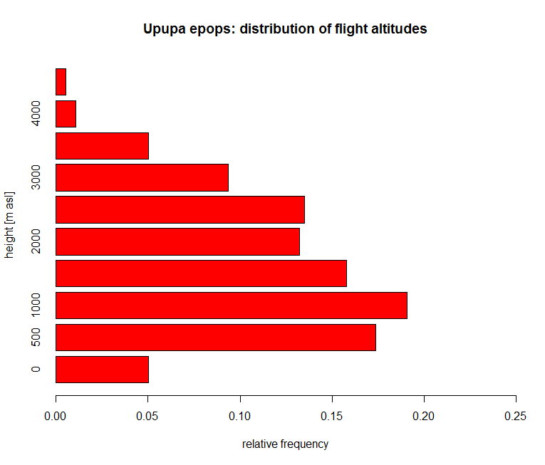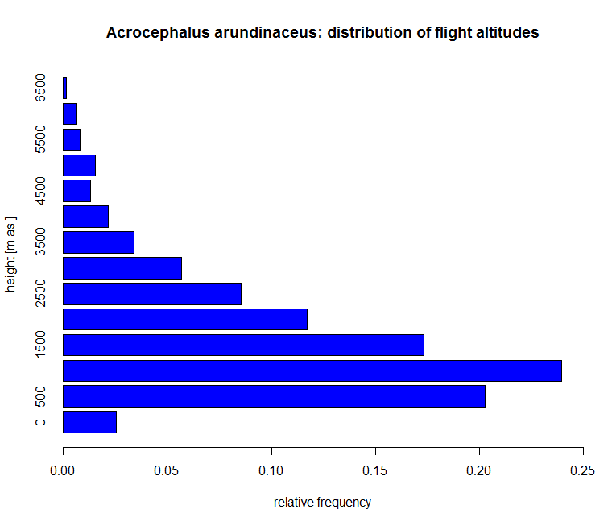

Figure S5: Standardized residual plot of the generalized linear mixed effect model evaluating the difference in climb rates between migratory seasons and species. Model structure: climb-rate ~ time-of-flight + species + (1|species:id).

