Supplementary materials
Table S1 The DNA sample collection that have been used for SNP genotyping in this study, including the sample sizes, sample sources, sampling year and origin.
Country | Sample size | Sample sources | Sampling year
Sweden | 85 | The southern and northern populations are from blood, of which 21 individuals also have feather samples | 1997-2010
Norway | 13 | Extracted DNA from Blood | 2006
Denmark | 23 | Extracted DNA from Blood | 2005
Finland | 13 | Extracted DNA from Blood | 2003
Portugal | 40 | Feather | 2009-2010
Italy | 44 | 25 from feather sample, 19 from blood | 2012-2013
Bulgaria | 40 | Extracted DNA from Blood | 2010
Zambia | 15 | Blood | 2012
Cameron | 27 | Extracted DNA from Blood | 2014
Tanzania | 4 | Feather | 2002
South Africa | 8 | Feather | 2002
Ivory Coast | 12 | Feather | 1999
Kenya | 3 | Feather | 2000

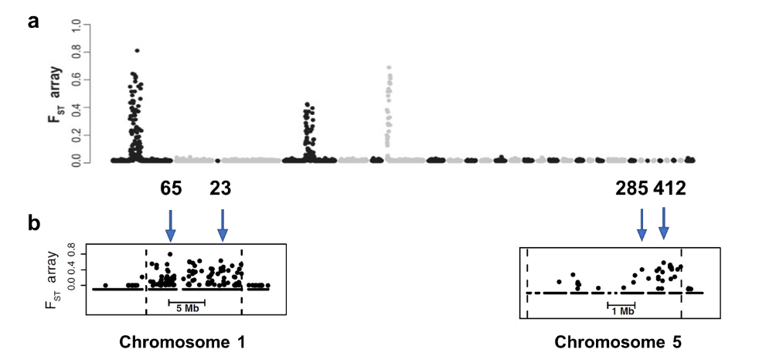
Fig. S1 F_{ST}-array results illustrating the genetic differentiation of ~4000 SNPs throughout the genome of willow warblers with the positions of the qPCR primers indicated.

Table S2. The sequences of primers and probes for the four selected SNPs on chromosome 1
and 5.
Chromosome | SNP names |  | Base sequences | Region length
Chr_1 | 23 | Forward primer | TGAAACAGAATTTTGCAGTACTTCTACCT | 112
Chr_1 | 23 | Reverse primer | GTGCTTTCTAGTATATGGAAAAAAGAGGGA | 112
Chr_1 | 23 | VIC probe (North) | ATTGAAATCAAGAATTCAG | 112
Chr_1 | 23 | FAM probe (South) | ATTGAAATCAATAATTCAG | 112
Chr_1 | 65 | Forward primer | ACAACAACATGTAAAGCAGGAACCT | 96
Chr_1 | 65 | Reverse primer | ACCTGTTGTTAAAGGTTATGTCAATTCCT | 96
Chr_1 | 65 | VIC probe (North) | ACTAAATAACACTAAAATTTT | 96
Chr_1 | 65 | FAM probe (South) | ACTAAATAACACTAACATTTT | 96
Chr_5 | 412 | Forward primer | CATCTGGGCTCCACTTGCT | 144
Chr_5 | 412 | Reverse primer | TGTTGCCTAAATCCTGGGTTTCC | 144
Chr_5 | 412 | VIC probe (North) | TGCCCGGATTTTT | 144
Chr_5 | 412 | FAM probe (South) | TGCCCAGATTTTT | 144
Chr_5 | 285 | Forward primer | CACATTTATTAGTATTATGCCCCCAGGTA | 95
Chr_5 | 285 | Reverse primer | TATTGATTTAACAACACAGAATGCATGTGA | 95
Chr_5 | 285 | VIC probe (North) | CTGCATATAATCTTACCTTTC | 95
Chr_5 | 285 | FAM probe (South) | TGCATATAATCTTGCCTTTC | 95

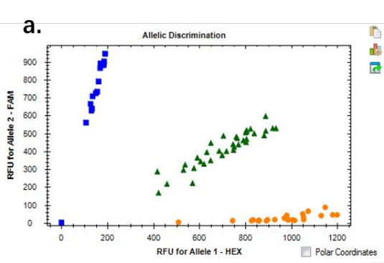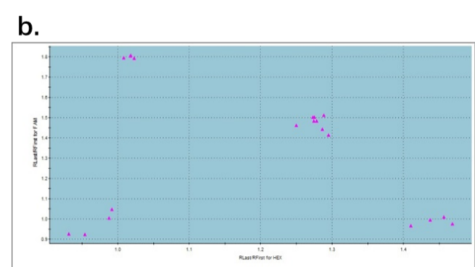
Fig. S2 Examples of sample dual scatterplot of SNP genotyping results.

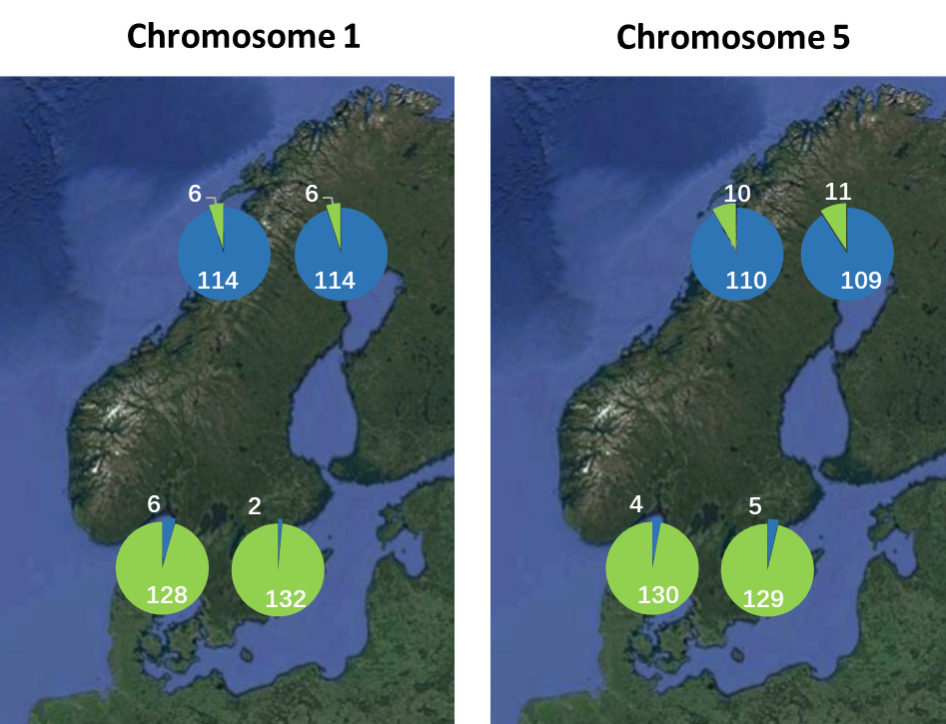
Fig. S3 Allele frequencies of the four selected SNPs on chromosome 1 and 5 in northern (upper pie charts) and southern populations (lower pie charts) in Scandinavia.

Table S3 Comparison between SNP genotype results from this study and the whole-block genotype results from Lundberg et al.
SNP | chr_1 |  | chr_5
SNP | 23 | 65 | 285 | 412
counts | 93/97 | 96/97 | 95/97 | 95/97
consistency ratio | 95.9% | 99.0% | 97.9% | 97.9%

Table S4 SNP genotyping results from sites in Scandinavia. Sites with latitude < 60° are regarded as southern population. Sites with latitude > 65° are regarded as northern population.
Sample name | Site name | Latitude | Longitude | SNP genotype
 |  |  |  | 23 | 65 | 285 | 412
01Q/01 | Gräsmarö | 58.28 | 16.98 | H | H | S | S
05B/08 | Kasted_Mose | 56.17 | 10.05 | H | S | S | S
05B/12 | Kasted_Mose | 56.17 | 10.05 | H | S | S | S
01A/13 | Stensoffa | 55.70 | 13.46 | H | S | S | S
97E/02 | Tåkern | 58.32 | 14.82 | S | S | H | H
03K/06 | Gräsmarö | 58.28 | 16.98 | S | S | H | H
08A/18 | Stensoffa | 55.70 | 13.46 | S | S | H | S
05C/02 | Gadevang_Mose | 55.83 | 12.47 | S | S | S | H
08B/06 | Stensoffa | 55.70 | 13.46 | S | S | S | H
03K/01 | Gräsmarö | 58.28 | 16.98 | S | S | S | S
97A/09 | Haganäs | 56.25 | 14.67 | S | S | S | S
08A/04 | Stensoffa | 55.70 | 13.46 | S | S | S | S
03A/08 | Stensoffa | 55.70 | 13.46 | S | S | S | S
05B/06 | Kasted_Mose | 56.17 | 10.05 | S | S | S | S
05C/01 | Gadevang_Mose | 55.83 | 12.47 | S | S | S | S
05C/08 | Gadevang_Mose | 55.83 | 12.47 | S | S | S | S
03A/06 | Stensoffa | 55.70 | 13.46 | S | S | S | S
01A/12 | Stensoffa | 55.70 | 13.46 | S | S | S | S
96A/05 | Stensoffa | 55.70 | 13.46 | S | S | S | S
97E/04 | Tåkern | 58.32 | 14.82 | S | S | S | S
97A/08 | Haganäs | 56.25 | 14.67 | S | S | S | S
01A/02 | Stensoffa | 55.70 | 13.46 | S | S | S | S
02A/08 | Stensoffa | 55.70 | 13.46 | S | S | S | S
03K/02 | Gräsmarö | 58.28 | 16.98 | S | S | S | S
08B/05 | Stensoffa | 55.70 | 13.46 | S | S | S | S
08XA/07 | Stensoffa | 55.70 | 13.46 | S | S | S | S
10A/07 | Stensoffa | 55.70 | 13.46 | S | S | S | S
97A/11 | Haganäs | 56.25 | 14.67 | S | S | S | S
97E/05 | Tåkern | 58.32 | 14.82 | S | S | S | S
97E/10 | Tåkern | 58.32 | 14.82 | S | S | S | S
97E/09 | Tåkern | 58.32 | 14.82 | S | S | S | S
01Q/04 | Gräsmarö | 58.28 | 16.98 | S | S | S | S
96A/15 | Stensoffa | 55.70 | 13.46 | S | S | S | S
02A/02 | Stensoffa | 55.70 | 13.46 | S | S | S | S
02A/09 | Stensoffa | 55.70 | 13.46 | S | S | S | S
97A/12 | Haganäs | 56.25 | 14.67 | S | S | S | S
05B/01 | Kasted_Mose | 56.17 | 10.05 | S | S | S | S
05B/02 | Kasted_Mose | 56.17 | 10.05 | S | S | S | S
05B/03 | Kasted_Mose | 56.17 | 10.05 | S | S | S | S
05B/04 | Kasted_Mose | 56.17 | 10.05 | S | S | S | S
05B/05 | Kasted_Mose | 56.17 | 10.05 | S | S | S | S
05B/07 | Kasted_Mose | 56.17 | 10.05 | S | S | S | S
05B/09 | Kasted_Mose | 56.17 | 10.05 | S | S | S | S
05B/10 | Kasted_Mose | 56.17 | 10.05 | S | S | S | S
05B/11 | Kasted_Mose | 56.17 | 10.05 | S | S | S | S
05C/03 | Gadevang_Mose | 55.83 | 12.47 | S | S | S | S
05C/04 | Gadevang_Mose | 55.83 | 12.47 | S | S | S | S
05C/05 | Gadevang_Mose | 55.83 | 12.47 | S | S | S | S
05C/06 | Gadevang_Mose | 55.83 | 12.47 | S | S | S | S
05C/07 | Gadevang_Mose | 55.83 | 12.47 | S | S | S | S
05C/09 | Gadevang_Mose | 55.83 | 12.47 | S | S | S | S
05C/10 | Gadevang_Mose | 55.83 | 12.47 | S | S | S | S
05C/11 | Gadevang_Mose | 55.83 | 12.47 | S | S | S | S
08A/06 | Stensoffa | 55.70 | 13.46 | S | S | S | S
08B/08 | Stensoffa | 55.70 | 13.46 | S | S | S | S
02A/03 | Stensoffa | 55.70 | 13.46 | S | S | S | S
02A/11 | Stensoffa | 55.70 | 13.46 | S | S | S | S
02A/13 | Stensoffa | 55.70 | 13.46 | S | S | S | S
08A/05 | Stensoffa | 55.70 | 13.46 | S | S | S | S
08A/13 | Stensoffa | 55.70 | 13.46 | S | S | S | S
96B/08 | Kvismaren | 59.17 | 15.42 | S | S | S | S
96B/05 | Kvismaren | 59.17 | 15.42 | S | S | S | S
03J/06 | Smedstorp | 59.58 | 14.98 | S | S | S | S
03J/07 | Smedstorp | 59.58 | 14.98 | H | S | H | H
02F/09 | Smedstorp | 59.58 | 14.98 | S | H | S | S
03J/02 | Smedstorp | 59.58 | 14.98 | H | S | S | S
01P/02 | Stensoffa | 55.70 | 13.46 | S | S | S | S
06D/06 | Kjöllefjord | 70.94 | 27.42 | H | H | H | H
01J/09 | Krokvik | 67.95 | 20.02 | H | H | N | N
01J/05 | Krokvik | 67.95 | 20.02 | H | H | N | N
06D/04 | Kjöllefjord | 70.94 | 27.42 | H | H | N | N
06D/07 | Kjöllefjord | 70.94 | 27.42 | H | H | N | N
06D/05 | Kjöllefjord | 70.94 | 27.42 | H | H | N | N
96M/05 | Ammarnäs | 65.95 | 16.12 | N | N | H | H
01O/03 | Kallax | 65.53 | 22.13 | N | N | H | H
03I/03 | Lurio | 67.23 | 27.55 | N | N | H | H
06E/08 | Tana_Bru | 70.18 | 28.20 | N | N | H | H
01K/01 | Tornehamn | 68.43 | 18.58 | N | N | H | H
01M/03 | Kaisepakte | 68.28 | 19.32 | N | N | H | H
01N/07 | Altajärvi | 67.83 | 20.53 | N | N | H | H
03I/02 | Lurio | 67.23 | 27.55 | N | N | H | H
10K/07 | Ekorrsjö | 64.49 | 19.07 | N | N | H | H
96M/01 | Ammarnäs | 65.95 | 16.12 | N | N | N | H
97N/14 | Gällivare | 67.22 | 20.80 | N | N | N | N
01N/05 | Altajärvi | 67.83 | 20.53 | N | N | N | N
03H/01 | Ruka | 66.18 | 29.42 | N | N | N | N
03H/06 | Ruka | 66.18 | 29.42 | N | N | N | N
03I/01 | Lurio | 67.23 | 27.55 | N | N | N | N
03I/10 | Lurio | 67.23 | 27.55 | N | N | N | N
06D/03 | Kjöllefjord | 70.94 | 27.42 | N | N | N | N
01K/05 | Tornehamn | 68.43 | 18.58 | N | N | N | N
03H/04 | Ruka | 66.18 | 29.42 | N | N | N | N
03H/08 | Ruka | 66.18 | 29.42 | N | N | N | N
97L/06 | Piteå | 65.03 | 21.45 | N | N | N | N
03I/04 | Lurio | 67.23 | 27.55 | N | N | N | N
01M/08 | Kaisepakte | 68.28 | 19.32 | N | N | N | N
01L/19 | Stordalen | 68.33 | 19.10 | N | N | N | N
01L/20 | Stordalen | 68.33 | 19.10 | N | N | N | N
97N/04 | Gällivare | 67.22 | 20.80 | N | N | N | N
01J/07 | Krokvik | 67.95 | 20.02 | N | N | N | N
01K/08 | Tornehamn | 68.43 | 18.58 | N | N | N | N
01N/08 | Altajärvi | 67.83 | 20.53 | N | N | N | N
97M/03 | Kukkola | 65.96 | 24.03 | N | N | N | N
97N/03 | Gällivare | 67.22 | 20.80 | N | N | N | N
01L/14 | Stordalen | 68.33 | 19.10 | N | N | N | N
01J/04 | Krokvik | 67.95 | 20.02 | N | N | N | N
01K/10 | Tornehamn | 68.43 | 18.58 | N | N | N | N
01O/01 | Kallax | 65.53 | 22.13 | N | N | N | N
03H/09 | Ruka | 66.18 | 29.42 | N | N | N | N
03I/06 | Lurio | 67.23 | 27.55 | N | N | N | N
03I/07 | Lurio | 67.23 | 27.55 | N | N | N | N
06D/02 | Kjöllefjord | 70.94 | 27.42 | N | N | N | N
06D/10 | Kjöllefjord | 70.94 | 27.42 | N | N | N | N
06E/01 | Tana_Bru | 70.18 | 28.20 | N | N | N | N
06E/02 | Tana_Bru | 70.18 | 28.20 | N | N | N | N
06E/04 | Tana_Bru | 70.18 | 28.20 | N | N | N | N
06E/05 | Tana_Bru | 70.18 | 28.20 | N | N | N | N
06E/07 | Tana_Bru | 70.18 | 28.20 | N | N | N | N
97M/01 | Kukkola | 65.96 | 24.03 | N | N | N | N
97L/03 | Piteå | 65.03 | 21.45 | N | N | N | N
97M/07 | Kukkola | 65.96 | 24.03 | N | N | N | N
01O/08 | Kallax | 65.53 | 22.13 | N | N | N | N
10J/09 | Granö | 64.27 | 19.42 | N | N | N | N
10L/02 | Gunnarn | 65.00 | 17.71 | N | N | N | N
01N/12 | Altajärvi | 67.83 | 20.53 | N | N | N | N
01O/04 | Kallax | 65.53 | 22.13 | N | N | N | N
03H/10 | Ruka | 66.18 | 29.42 | N | N | N | N

Table S5 SNP genotyping results from southern Europe in autumn (August–October).
Sample name | Country | SNP genotypes |  |  |  | Assignment
Sample name | Country | 23 | 65 | 285 | 412 | Assignment
6G0646 | Italy |  | N | N |  | northern pop.
6G0653 | Italy |  | N | N |  | northern pop.
1A78028 | Italy | S | S | N | N | F2
6G0640 | Italy |  | N | H |  | northern pop.
6G0622 | Italy |  | H | N |  | northern pop.
6G0639 | Italy |  | H | N |  | northern pop.
6G0603 | Italy |  | N | N |  | northern pop.
6G0606 | Italy |  | N | N |  | northern pop.
6G0607 | Italy |  | N | N |  | northern pop.
6G0619 | Italy |  | N | N |  | northern pop.
6G0644 | Italy |  | N | N |  | northern pop.
6G0616 | Italy |  | S | H |  | southern pop.
6G0636 | Italy |  | N | H |  | northern pop.
3A15807 | Italy |  | S | S |  | southern pop.
6G0623 | Italy |  | H | N |  | northern pop.
6G0615 | Italy |  | H | N |  | northern pop.
6G0656 | Italy |  | H | N |  | northern pop.
6G0612 | Italy |  | N | N |  | northern pop.
6G0618 | Italy |  | N | N |  | northern pop.
6G0654 | Italy |  | N | N |  | northern pop.
6G0655 | Italy | S | S | N | N | F2
1A78029 | Italy |  | S | H |  | southern pop.
6G0601 | Italy | H | H | H | H | heterozygote
6G0649 | Italy | H | H | H | H | heterozygote
6G0611 | Italy | H | H | H | S | Undefined
659 | Italy |  | N | N |  | northern pop.
621 | Italy |  | H | N |  | northern pop.
508 | Italy | S | S | N | H | Undefined
515 | Italy | H | H | H | H | heterozygote
658 | Italy | H | H | H | H | heterozygote
517 | Italy | H | H | H | H | heterozygote
625 | Italy |  | N | N |  | northern pop.
637 | Italy |  | N | N |  | northern pop.
657 | Italy |  | N | N |  | northern pop.
509 | Italy |  | S | S |  | southern pop.
502 | Italy |  | N | N |  | northern pop.
510 | Italy |  | N | N |  | northern pop.
511 | Italy |  | N | N |  | northern pop.
512 | Italy |  | N | N |  | northern pop.
634 | Italy |  | N | N |  | northern pop.
660 | Italy |  | N | N |  | northern pop.
503 | Italy |  | S | H |  | southern pop.
506 | Italy | H | H | H | H | heterozygote
504 | Italy |  | S | H |  | southern pop.
079807 | Portugal |  | S | S |  | southern pop.
089873 | Portugal |  | S | S |  | southern pop.
079874 | Portugal |  | S | S |  | southern pop.
079808 | Portugal |  | S | S |  | southern pop.
072387 | Portugal |  | S | S |  | southern pop.
072389 | Portugal |  | S | S |  | southern pop.
079810 | Portugal |  | S | S |  | southern pop.
079873 | Portugal |  | S | S |  | southern pop.
079809 | Portugal |  | S | S |  | southern pop.
072392 | Portugal |  | S | S |  | southern pop.
079871 | Portugal |  | S | S |  | southern pop.
089868 | Portugal |  | S | S |  | southern pop.
089869 | Portugal |  | S | S |  | southern pop.
079875 | Portugal | H | H | H | H | heterozygote
079872 | Portugal |  | S | S |  | southern pop.
079811 | Portugal |  | S | H |  | southern pop.
089875 | Portugal | H | H | H | H | heterozygote
089874 | Portugal |  | S | S |  | southern pop.
072390 | Portugal |  | S | S |  | southern pop.
072388 | Portugal |  | S | S |  | southern pop.
079765 | Portugal |  | H | S |  | southern pop.
079766 | Portugal |  | S | S |  | southern pop.
079767 | Portugal |  | S | S |  | southern pop.
079768 | Portugal |  | S | S |  | southern pop.
079769 | Portugal |  | S | S |  | southern pop.
079912 | Portugal |  | S | S |  | southern pop.
079913 | Portugal |  | S | S |  | southern pop.
079914 | Portugal |  | S | S |  | southern pop.
079915 | Portugal |  | S | S |  | southern pop.
079916 | Portugal |  | S | S |  | southern pop.
089840 | Portugal |  | S | S |  | southern pop.
089841 | Portugal |  | S | S |  | southern pop.
089842 | Portugal |  | S | S |  | southern pop.
089843 | Portugal |  | S | S |  | southern pop.
089844 | Portugal |  | S | H |  | southern pop.
089846 | Portugal |  | S | S |  | southern pop.
089847 | Portugal |  | S | S |  | southern pop.
089848 | Portugal |  | S | S |  | southern pop.
089849 | Portugal | S | S | N | N | F2
089850 | Portugal | S | S | N | N | F2
44 | Bulgaria |  | N | H |  | northern pop.
45 | Bulgaria |  | N | N |  | northern pop.
48 | Bulgaria |  | N | N |  | northern pop.
54 | Bulgaria |  | N | N |  | northern pop.
58 | Bulgaria |  | N | N |  | northern pop.
62 | Bulgaria |  | N | N |  | northern pop.
80 | Bulgaria |  | N | N |  | northern pop.
91 | Bulgaria |  | N | N |  | northern pop.
94 | Bulgaria |  | N | N |  | northern pop.
98 | Bulgaria |  | N | H |  | northern pop.
101 | Bulgaria |  | N | N |  | northern pop.
107 | Bulgaria |  | N | N |  | northern pop.
145 | Bulgaria |  | N | N |  | northern pop.
146 | Bulgaria |  | N | N |  | northern pop.
148 | Bulgaria |  | N | N |  | northern pop.
150 | Bulgaria |  | S | H |  | southern pop.
151 | Bulgaria |  | N | N |  | northern pop.
165 | Bulgaria |  | N | N |  | northern pop.
173 | Bulgaria |  | N | N |  | northern pop.
188 | Bulgaria |  | N | N |  | northern pop.
209 | Bulgaria |  | N | N |  | northern pop.
212 | Bulgaria |  | N | N |  | northern pop.
213 | Bulgaria |  | N | N |  | northern pop.
214 | Bulgaria |  | N | N |  | northern pop.
219 | Bulgaria |  | N | N |  | northern pop.
222 | Bulgaria |  | N | N |  | northern pop.
226 | Bulgaria |  | N | N |  | northern pop.
234 | Bulgaria |  | N | N |  | northern pop.
243 | Bulgaria |  | N | N |  | northern pop.
244 | Bulgaria |  | N | N |  | northern pop.
248 | Bulgaria |  | N | N |  | northern pop.
251 | Bulgaria |  | N | N |  | northern pop.
254 | Bulgaria |  | N | N |  | northern pop.
257 | Bulgaria |  | N | N |  | northern pop.
262 | Bulgaria |  | N | N |  | northern pop.
264 | Bulgaria |  | N | N |  | northern pop.
271 | Bulgaria |  | N | N |  | northern pop.
268 | Bulgaria |  | N | N |  | northern pop.
275 | Bulgaria | N | N | S | H | Undefined
278 | Bulgaria |  | N | H |  | northern pop.

Table S6 SNP genotyping results from Africa in winter.
Sample name | Country | SNP genotypes |  | Assignment
Sample name | Country | 65 | 285 | Assignment
Z69 | Zambia | N | N | northern pop.
Z74 | Zambia | N | H | northern pop.
Z60 | Zambia | N | N | northern pop.
Z65 | Zambia | N | N | northern pop.
Z72 | Zambia | N | N | northern pop.
Z73 | Zambia | N | N | northern pop.
Z61 | Zambia | N | N | northern pop.
Z62 | Zambia | N | N | northern pop.
Z63 | Zambia | N | N | northern pop.
Z64 | Zambia | N | N | northern pop.
Z67 | Zambia | N | N | northern pop.
Z68 | Zambia | N | N | northern pop.
Z71 | Zambia | H | N | northern pop.
Z75 | Zambia | N | N | northern pop.
Z76 | Zambia | N | N | northern pop.
K39204 | Kenya | N | N | northern pop.
K39205 | Kenya | N | N | northern pop.
8N 55600 | Kenya | N | N | northern pop.
446 | Tanzania | N | N | northern pop.
T33467 | Tanzania | N | N | northern pop.
T33468 | Tanzania | H | N | northern pop.
448 | Tanzania | N | N | northern pop.
AE28933 | South Africa | N | N | northern pop.
AE28932 | South Africa | N | H | northern pop.
AE28954 | South Africa | N | N | northern pop.
AF60012 | South Africa | N | N | northern pop.
W17819 | South Africa | N | N | northern pop.
W17824 | South Africa | N | H | northern pop.
W17825 | South Africa | N | N | northern pop.
W17826 | South Africa | N | N | northern pop.
BE7350 | Ivory Coast | S | S | southern pop.
BE7351 | Ivory Coast | S | S | southern pop.
BE7352 | Ivory Coast | S | S | southern pop.
BE7353 | Ivory Coast | N | N | southern pop.
BE7354 | Ivory Coast | S | S | southern pop.
BE7355 | Ivory Coast | S | S | southern pop.
BE7356 | Ivory Coast | S | S | southern pop.
BE7357 | Ivory Coast | S | H | southern pop.
BE7358 | Ivory Coast | S | S | southern pop.
BE7359 | Ivory Coast | S | S | southern pop.
BE7360 | Ivory Coast | S | S | southern pop.
BE7361 | Ivory Coast | S | H | southern pop.
405 | Cameron | S | S | southern pop.
411 | Cameron | S | S | southern pop.
412 | Cameron | H | S | southern pop.
420 | Cameron | S | S | southern pop.
425 | Cameron | S | S | southern pop.
426 | Cameron | S | H | southern pop.
427 | Cameron | H | S | southern pop.
429 | Cameron | H | S | southern pop.
432 | Cameron | S | H | southern pop.
438 | Cameron | S | S | southern pop.
439 | Cameron | S | S | southern pop.
442 | Cameron | S | H | southern pop.
443 | Cameron | S | S | southern pop.
444 | Cameron | S | H | southern pop.
448 | Cameron | S | S | southern pop.
449 | Cameron | S | S | southern pop.
452 | Cameron | S | H | southern pop.
456 | Cameron | S | S | southern pop.
466 | Cameron | S | S | southern pop.
468 | Cameron | S | H | southern pop.
491 | Cameron | S | S | southern pop.
494 | Cameron | H | S | southern pop.
501 | Cameron | S | H | southern pop.
502 | Cameron | S | S | southern pop.
505 | Cameron | S | S | southern pop.
509 | Cameron | S | S | southern pop.
518 | Cameron | S | S | southern pop.

