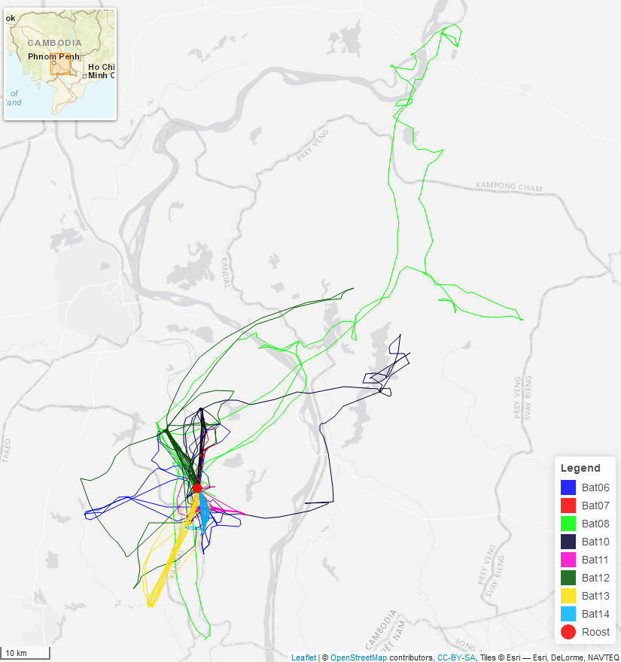

Fig. S1. Foraging tracks of 8 individuals of Pteropus lylei equipped with GPS loggers, in Cambodia. GPS devices were programmed to record one location every 5 minutes over several nights (see the Methods for more details). For each individual (see the legend of the different colors on the figure) and night, the departure site and the last location was the roost site (red point).

