Additional File 2 – Stan model details
Cameron, MD, JM Eisaguirre, GA Breed, K Joly, & K Kielland. 2021. Mechanistic movement models identify continuously updated autumn migration cues in Arctic caribou. Movement Ecology. DOI: 10.1186/s40462-021-00288-0.

Full model statement for the hierarchical, continuous-time movement model with a dynamic behavioral parameter:
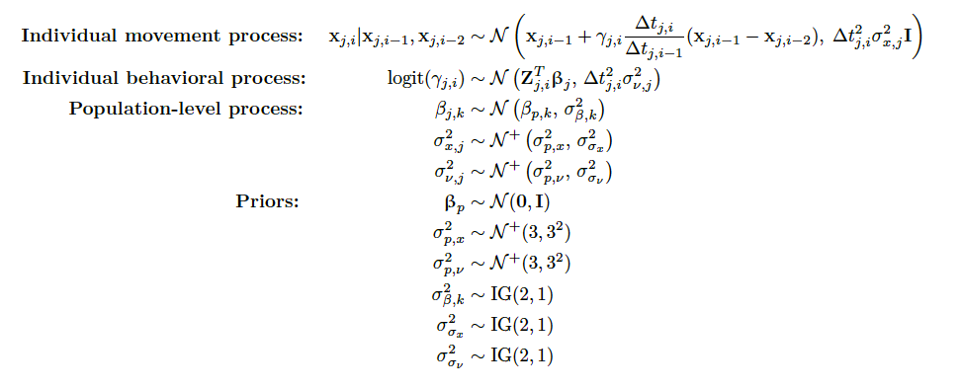

Stan code for the continuous time, dynamic parameter correlated random walk movement model. Corresponding Stan-type file available from co-authors upon request.

data {
int N; // # of fixes in track
vector[N] x; // x coordinates
vector[N] y; // y coordinates
vector[N] dt; // time intervals

vector[N] cov_1; // covariates
vector[N] cov_2;
vector[N] cov_3;
vector[N] cov_4;
vector[N] cov_5;
}

parameters {

vector[N] gamma_raw; // logit behavior parameter -- time-varying, correlates steps
real<lower=0> sigmax; // movement process noise in x
real<lower=0> sigmav; // behavior process noise
vector[7] beta; // covariate coefficients

}

transformed parameters{

// Introduce the logit link on the behavior parameter
vector<lower=0,upper=1>[N] gamma;

for(j in 1:N){
gamma[j] = inv_logit( gamma_raw[j] );

}

}

model {

// Prior on behavior process noise -- assume there is variability in behavior
sigmav ~ inv_gamma( 2 , 5 );

// Priors on movement process noise -- close to zero
sigmax ~ inv_gamma( 3 , 1 );

// Priors on coefficients -- null model is no effect of covariates on behavior
beta ~ normal( 0 , 1 );

for (i in 3:N) {

// Behavior is a linear combination of covariates
gamma_raw[i] ~ normal( beta[1] + beta[2] * cov_1[i] + beta[3] * cov_2[i] + beta[4] * cov_1[i]*cov_2[i] + beta[5] * cov_3[i] + beta[6] * cov_4[i] + beta[7] * cov_5[i], dt[i] * sqrt(sigmav) );

// Movement process is independent in x and y
x[i] ~ normal( x[i-1] + gamma[i] * ( dt[i] / dt[i-1] ) * ( x[i-1] - x[i-2] ) , dt[i] * sqrt(sigmax) );
y[i] ~ normal( y[i-1] + gamma[i] * ( dt[i] / dt[i-1] ) * ( y[i-1] - y[i-2] ) , dt[i] * sqrt(sigmax) );

}

}

