Supplementary material

Table S1. Sampled numbers of migrant and resident individuals in four populations of the Eurasian blackbirds (Turdus merula). The counts are broken down by sex and age with migrants listed in boldface.

Population | Strategy | Sex | Age | # Birds
Germany | Migratory | Female | Adult | 55
Germany | Migratory | Female | Juvenile | 25
Germany | Migratory | Male | Adult | 43
Germany | Migratory | Male | Juvenile | 6
Germany | Migratory | Unknown | Juvenile | 7
Germany | Resident | Female | Adult | 114
Germany | Resident | Female | Juvenile | 13
Germany | Resident | Male | Adult | 211
Germany | Resident | Male | Juvenile | 31
Germany | Resident | Unknown | Juvenile | 22
Finland | Migratory | Female | Adult | 12
Finland | Migratory | Male | Adult | 14
Finland | Migratory | Male | Juvenile | 1
Finland | Resident | Female | Juvenile | 1
Finland | Resident | Male | Adult | 5
Finland | Resident | Male | Juvenile | 1
Russia | Migratory | Female | Adult | 7
Russia | Migratory | Male | Adult | 22
Russia | Migratory | Male | Juvenile | 1
Poland | Migratory | Female | Adult | 4
Poland | Migratory | Male | Adult | 15

Table S2. Time window of recorded Eurasian blackbird (Turdus merula) migration for all included sites and years with corresponding first/last departure (in Julian day) and sample size within specific years. The coefficient of variance for departure is based on all departure dates across all year within each population.

Site | Year | First departure | Last departure | Length of migration window | Number of Birds | Coefficient of variance for departure
Finland | 2014 | 289 | 290 | 1 | 3 | 8.3
Finland | 2015 | 272 | 300 | 28 | 8 | 8.3
Finland | 2016 | 274 | 294 | 20 | 16 | 8.3
Germany | 2009 | 262 | 305 | 43 | 14 | 10.6
Germany | 2010 | 275 | 313 | 38 | 18 | 10.6
Germany | 2011 | 266 | 300 | 34 | 26 | 10.6
Germany | 2012 | 272 | 317 | 45 | 13 | 10.6
Germany | 2013 | 290 | 315 | 25 | 7 | 10.6
Germany | 2014 | 275 | 301 | 26 | 9 | 10.6
Germany | 2015 | 272 | 299 | 27 | 13 | 10.6
Germany | 2016 | 279 | 325 | 46 | 18 | 10.6
Germany | 2017 | 274 | 318 | 44 | 18 | 10.6
Germany | 2018 | 289 | 304 | 15 | 7 | 10.6
Poland | 2015 | 270 | 303 | 33 | 11 | 11.4
Poland | 2016 | 256 | 287 | 31 | 8 | 11.4
Russia | 2014 | 261 | 295 | 34 | 13 | 11.1
Russia | 2015 | 245 | 279 | 34 | 5 | 11.1
Russia | 2016 | 265 | 283 | 18 | 12 | 11.1

Table S3. Comparison of top time-dependent Cox proportional hazards models to assess the effects of weather variables on birds’ departure probability (night-to-night departure decision). Models’ coefficients and presence of factors are given. Degrees of freedom (df), second-order Akaike’s information criterion values (AICc), AICc differences (Δi) and AICc weights (ωi).
Model | Residual air temperature | Atmospheric pressure | Crosswind | Day length | Tailwind assistance | Cloud cover | Site x atmos. press. | Site x crosswind | Site x daylength | Site x tailw. assist. | Site x cloud cover | df | logLik | AICc | Δi AICc | weight
1 | -0.1856 | 0.282 | 0.624 | -3.492 | 0.236 | -0.470 | + | + | + | + |  | 18 | -811.453 | 1662.3 | 0.00 | 0.368
2 | -0.1495 | 0.311 | 0.607 | -3.705 | 0.282 | -0.388 | + | + | + | + | + | 21 | -807.828 | 1662.3 | 0.02 | 0.364
3 |  | 0.291 | 0.535 | -3.784 | 0.358 | -0.406 | + | + | + | + | + | 20 | -809.359 | 1663.0 | 0.63 | 0.268

Table S4. Results of the Schoenfeld test for correlations between all used variables in the initial time-dependent Cox proportional hazards model. Chi-squared values (chisq), degrees of freedom (df) and significance level (p)
Variable | chisq | df | p
Day length | 2.529 | 1 | 0.11
Residual air temperature | 1.423 | 1 | 0.23
Cloud cover | 1.342 | 1 | 0.25
Atmospheric pressure | 0.044 | 1 | 0.83
Tailwind assistance | 1.348 | 1 | 0.25
Crosswinds | 0.953 | 1 | 0.33
Site x daylength | 3.351 | 3 | 0.34
Site x residual air temperature | 5.298 | 3 | 0.15
Site x cloud cover | 0.759 | 3 | 0.86
Site x atmospheric pressure | 5.496 | 3 | 0.14
Site x tailwind | 6.137 | 3 | 0.11
Site x crosswind | 0.897 | 3 | 0.83
GLOBAL | 30.724 | 24 | 0.16

Table S5. Variation in explanatory variables used to explain night-to-night departure decisions in Eurasian blackbirds (Turdus merula). Given are the minimum (min.), 10th, 25th, 50th, 75th and 90th percentile as well as the maximum (max.) of each variable and population during nights with departures.
Population | Variable | Min. | 10th  percentile | 25th  percentile | Median | 75th  percentile | 90th  percentile | Max.
Germany | Day length [h/day] | 9.0 | 10.1 | 10.4 | 10.6 | 10.9 | 11.4 | 12.3
Germany | Air temperature [°C] | -5.0 | -0.7 | 0.6 | 3.5 | 7.9 | 11.1 | 13.6
Germany | Atmospheric pressure [mbar] | 913 | 940 | 942 | 948 | 953 | 955 | 959
Germany | Total cloud cover [%] | 2.4 | 11.3 | 18.8 | 28.1 | 43.3 | 51.4 | 69.6
Germany | Tailwind assistance [m/s] | -5.3 | -3.3 | -1.6 | 0.3 | 1.5 | 3.3 | 6.7
Germany | Crosswind [m/s] | -3.1 | -0.5 | 0.0 | 1.0 | 2.4 | 3.5 | 5.1
Finland | Day length [h/day] | 8.9 | 9.6 | 9.8 | 10.5 | 10.9 | 11.3 | 11.5
Finland | Air temperature [°C] | -3.3 | -1.6 | 0.3 | 1.9 | 3.6 | 7.8 | 12.2
Finland | Atmospheric pressure [mbar] | 913 | 940 | 942 | 948 | 953 | 955 | 959
Finland | Total cloud cover [%] | 5.4 | 7.9 | 10.6 | 21.3 | 24.8 | 36.0 | 47.2
Finland | Tailwind assistance [m/s] | -7.3 | -0.9 | 0.6 | 2.7 | 3.5 | 5.6 | 6.9
Finland | Crosswind [m/s] | -4.9 | -4.0 | -2.2 | 0.5 | 0.8 | 2.5 | 3.2
Russia | Day length [h/day] | 9.9 | 10.8 | 10.8 | 11.1 | 11.3 | 12.2 | 13.7
Russia | Air temperature [°C] | -9.6 | 0.8 | 3.5 | 3.6 | 8.6 | 10.7 | 15.1
Russia | Atmospheric pressure [mbar] | 913 | 940 | 942 | 948 | 953 | 955 | 959
Russia | Total cloud cover [%] | 1.8 | 10.9 | 11.6 | 32.0 | 53.1 | 81.9 | 81.9
Russia | Tailwind assistance [m/s] | -3.0 | -0.7 | 1.5 | 2.9 | 7.4 | 7.5 | 7.5
Russia | Crosswind [m/s] | -6.2 | -3.9 | -2.8 | -0.2 | 1.3 | 1.5 | 2.2
Poland | Day length [h/day] | 9.5 | 10.9 | 11.1 | 11.5 | 11.7 | 11.8 | 12.8
Poland | Air temperature [°C] | -1.9 | 1.0 | 6.5 | 7.9 | 9.4 | 10.5 | 19.3
Poland | Atmospheric pressure [mbar] | 913 | 940 | 942 | 948 | 953 | 955 | 959
Poland | Total cloud cover [%] | 9.7 | 15.6 | 16.4 | 20.6 | 41.1 | 42.7 | 78.8
Poland | Tailwind assistance [m/s] | -5.3 | -1.3 | 0.6 | 1.2 | 3.7 | 8.1 | 8.1
Poland | Crosswind [m/s] | -6.3 | -4.8 | -4.6 | -2.5 | -1.7 | 0.5 | 1.4

Table S6. Results of the post-hoc pairwise comparison of environmental influence on individual departure decisions between populations of Eurasian blackbirds (Turdus merula). Post-hoc tests have been performed on the most complex of the three candidate models (Model 2, Table S3). Provided are adjusted standard errors (SE), z-ratios and associated p-values of pairwise comparisons. P-values ≤ 0.05 are given in bold font.

Variable | Population contrast | Estimate ± SE | z ratio | p-value
Day length | Germany - Finland | -0.69 ± 0.55 | -1.25 | 0.25
Day length | Germany - Russia | -2.09 ± 0.79 | -2.63 | 0.02
Day length | Germany - Poland | -1.86 ± 0.65 | -2.86 | 0.02
Day length | Finland - Russia | -1.39 ± 0.54 | -2.57 | 0.02
Day length | Finland - Poland | -1.17 ± 0.60 | -1.93 | 0.08
Day length | Russia - Poland | 0.23 ± 0.72 | 0.32 | 0.75
Atmospheric pressure | Germany - Finland | 0.21 ± 0.38 | 0.55 | 0.58
Atmospheric pressure | Germany - Russia | 0.51 ± 0.33 | 1.55 | 0.18
Atmospheric pressure | Germany - Poland | -0.95 ± 0.42 | -2.28 | 0.05
Atmospheric pressure | Finland - Russia | 0.31 ± 0.45 | 0.68 | 0.58
Atmospheric pressure | Finland - Poland | -1.16 ± 0.53 | -2.18 | 0.06
Atmospheric pressure | Russia - Poland | -1.46 ± 0.49 | -3.01 | 0.02
Cloud cover | Germany - Finland | -0.39 ± 0.44 | -0.90 | 0.47
Cloud cover | Germany - Russia | 0.70 ± 0.30 | 2.30 | 0.10
Cloud cover | Germany - Poland | 0.26 ± 0.45 | 0.58 | 0.56
Cloud cover | Finland - Russia | 1.09 ± 0.52 | 2.11 | 0.10
Cloud cover | Finland - Poland | 0.66 ± 0.61 | 1.07 | 0.47
Cloud cover | Russia - Poland | -0.44 ± 0.51 | -0.86 | 0.47
Tailwind assistance | Germany - Finland | -0.38 ± 0.28 | -1.36 | 0.26
Tailwind assistance | Germany - Russia | -1.47 ± 0.41 | -3.56 | < 0.01
Tailwind assistance | Germany - Poland | -0.11 ± 0.28 | -0.39 | 0.69
Tailwind assistance | Finland - Russia | -1.10 ± 0.47 | -2.32 | 0.04
Tailwind assistance | Finland - Poland | 0.27 ± 0.35 | 0.77 | 0.53
Tailwind assistance | Russia - Poland | 1.37 ± 0.47 | 2.94 | 0.01
Crosswind | Germany - Finland | 0.64 ± 0.25 | 2.57 | 0.02
Crosswind | Germany - Russia | 0.15 ± 0.34 | 0.43 | 0.67
Crosswind | Germany - Poland | 1.29 ± 0.30 | 4.28 | < 0.01
Crosswind | Finland - Russia | -0.50 ± 0.39 | -1.28 | 0.24
Crosswind | Finland - Poland | 0.65 ± 0.35 | 1.87 | 0.09
Crosswind | Russia - Poland | 1.15 ± 0.42 | 2.70 | 0.02

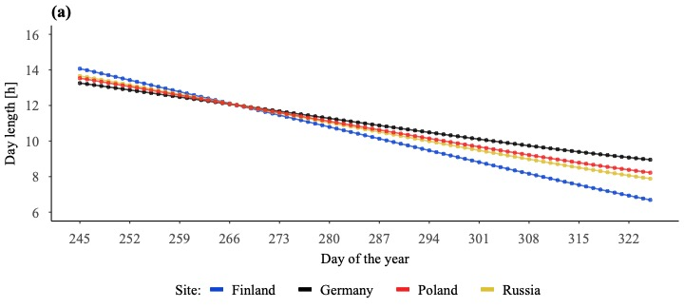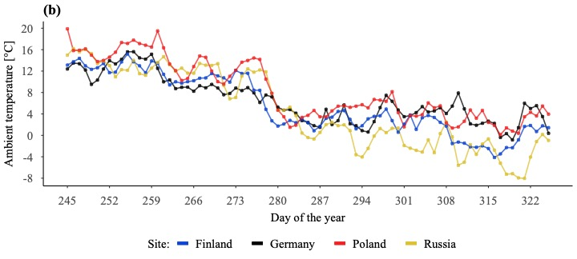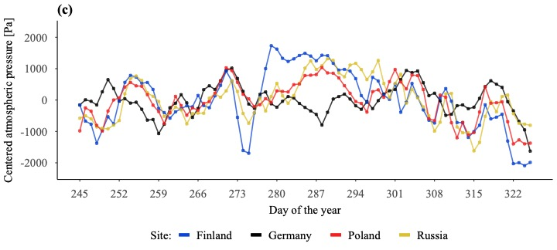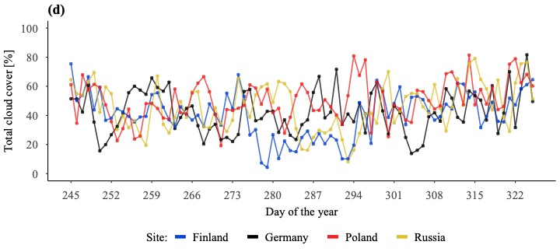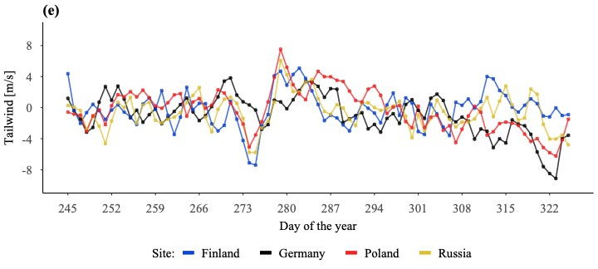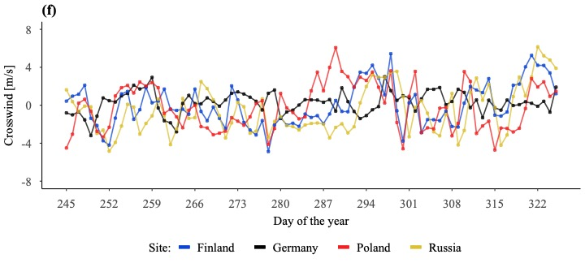
Figure S1a-S1f. (a) Daylength, (b) Ambient temperature, (c) Relative atmospheric pressure, (d) Cloud cover , (e) Tailwind and (f) Crosswind during the overall migration window across all 4 study populations. Shown graphs represent the mean value for each environmental factor across years with observed departures.

