Individuals of a group-living shorebird show smaller home range overlap when food availability is low

He-Bo Peng^{1,2}, Chi-Yeung Choi^{3,4,5*}, Zhijun Ma⁶, Allert I. Bijleveld², David S. Melville⁷, Theunis Piersma^{2,3,8,9}

Table S1. Number of location fixes detected at Yalu Jiang for radio-tracked great knots in 2012 and 2015; only fixes > 30 for a bird are shown.

Year | Bird (tag reference) | Number of fixes
2012 | B12-01 | 108
2012 | B12-03 | 83
2012 | B12-04 | 68
2012 | B12-05 | 78
2012 | B12-07 | 72
2012 | B12-08 | 42
2012 | B12-09 | 93
2012 | B12-10 | 54
2012 | B12-11 | 72
2012 | B12-12 | 75
2012 | B12-13 | 48
2012 | B12-15 | 118
2012 | B12-16 | 69
2012 | B12-17 | 71
2012 | B12-18 | 67
2012 | B12-19 | 76
2012 | B12-20 | 57
2012 | B12-21 | 69
2012 | B12-22 | 60
2012 | B12-23 | 47
2015 | B15-140s | 94
2015 | B15-180s | 55
2015 | B15-270s | 93
2015 | B15-351s | 67
2015 | B15-421s | 93
2015 | B15-461s | 76
2015 | B15-480s | 70
2015 | B15-510s | 52
2015 | B15-591s | 87
2015 | B15-691s | 78
2015 | B15-711q | 43
2015 | B15-711s | 37
2015 | B15-751s | 99
2015 | B15-820s | 78

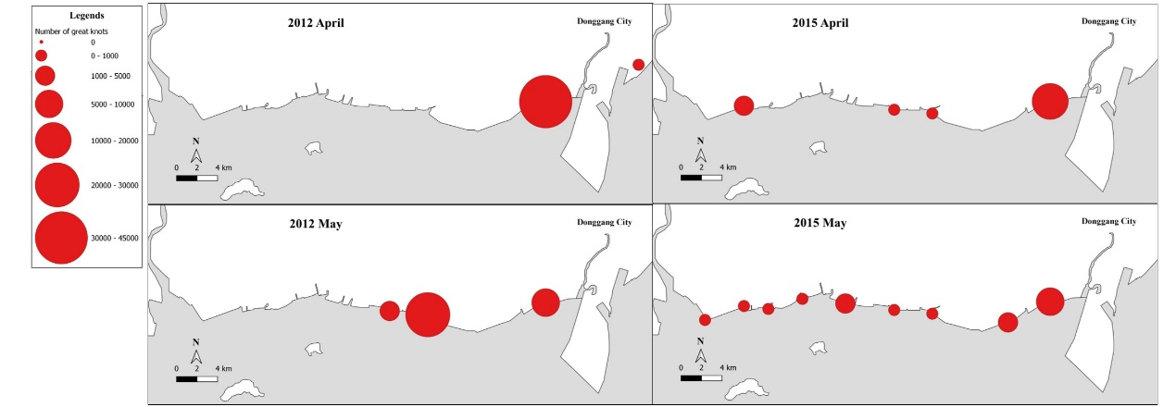
Figure S1. The distribution of great knots recorded in the bird count in 2012 and 2015, only the highest number was shown for each month.

