Appendix

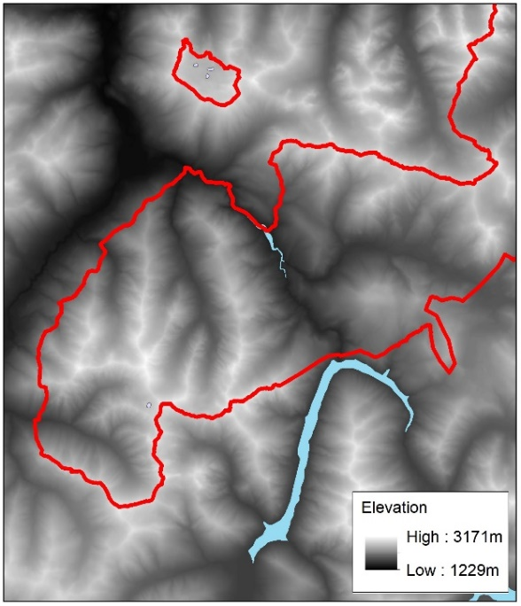 | 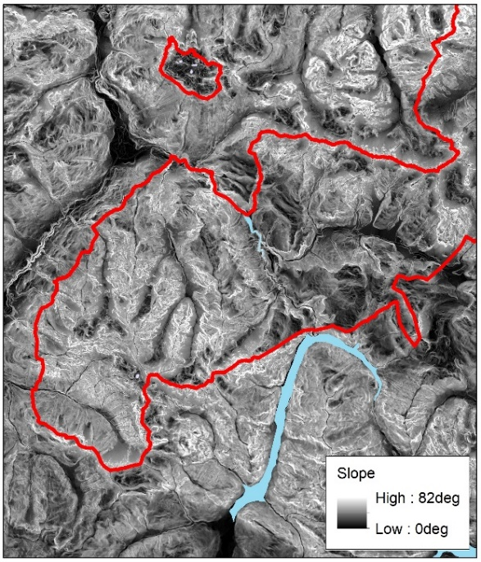
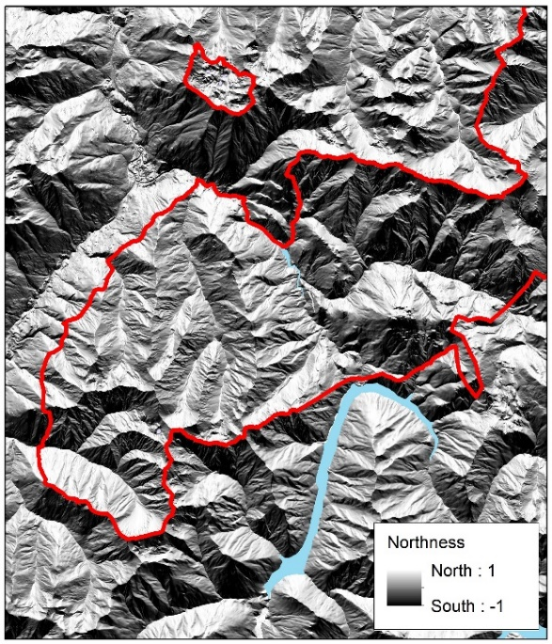 | 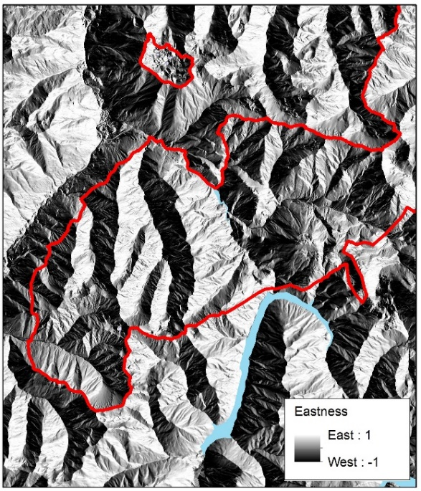
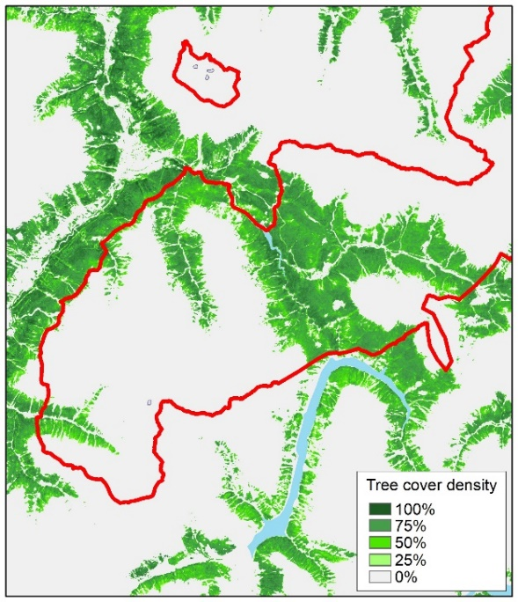 | Figure A1. Environmental variables for  the study area used in the models for chamois habitat use. The red line  represents the boundary of the Swiss National Park, light blue areas  represent lakes.
Table A1. Pearson’s correlation coefficients between explanatory variables for the summer (upper right diagonal) and winter (lower left diagonal) model. As p-values in correlations strongly depend on sample sizes, only the coefficients without p-values are indicated here.

 | step length | elevation | slope | tcd | north-ness | east-  ness | precipitation | temperature | wind
step length | - | 0.100 | -0.015 | -0.016 | 0.055 | 0.036 | 0.002 | 0.025 | 0.015
elevation | 0.124 | - | 0.211 | -0.616 | 0.153 | 0.232 | -0.017 | 0.111 | 0.021
slope | -0.055 | 0.268 | - | -0.255 | -0.033 | 0.044 | -0.003 | -0.008 | -0.024
tcd | 0.019 | -0.469 | -0.253 | - | -0.009 | -0.240 | -0.001 | -0.033 | 0.007
northness | 0.121 | 0.008 | -0.078 | 0.133 | - | 0.015 | -0.004 | 0.055 | 0.008
eastness | -0.021 | 0.139 | 0.149 | -0.148 | -0.014 | - | 0.015 | 0.001 | -0.008
precipitation | -0.002 | -0.038 | -0.011 | 0.018 | 0.008 | 0.017 | - | -0.064 | 0.011
temperature | 0.014 | 0.032 | -0.014 | -0.042 | <0.001 | -0.003 | 0.073 | - | 0.481
wind | 0.011 | -0.037 | -0.017 | 0.010 | -0.003 | 0.005 | 0.102 | 0.403 | -
snow | 0.008 | -0.093 | 0.033 | 0.031 | -0.089 | 0.068 | 0.018 | -0.214 | 0.040

