Supporting Information
Seabirds show foraging site and route fidelity but demonstrate flexibility in response to local information
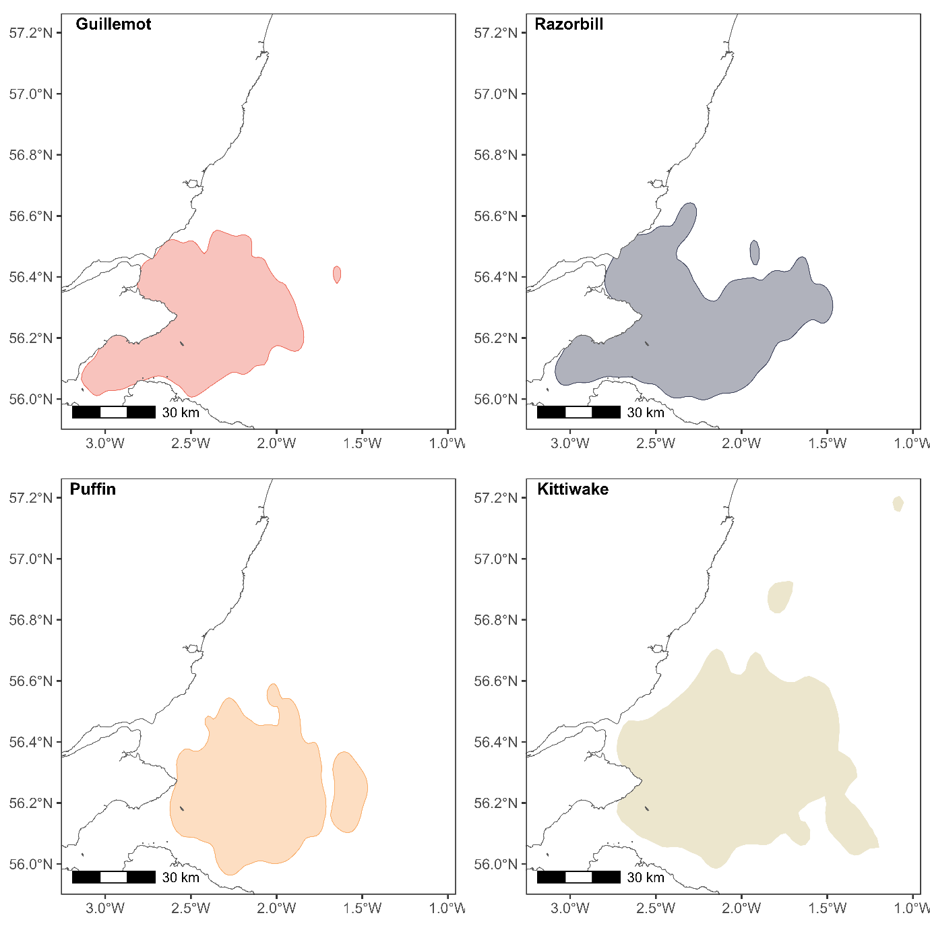
Charlotte. E. Regan, Maria. I. Bogdanova, Mark Newell, Carrie Gunn, Sarah Wanless, Mike. P. Harris, Samuel Langlois Lopez, Ella Benninghaus, Francis Daunt & Kate. R. Searle
Figure S1. Foraging ranges for guillemots, razorbills, puffins and kittiwakes breeding on the Isle of May. Shown are 90% utilisation distribution kernel contours calculated using adehabitatHR on at sea locations for individuals tracked in all years between 2010 and 2021.

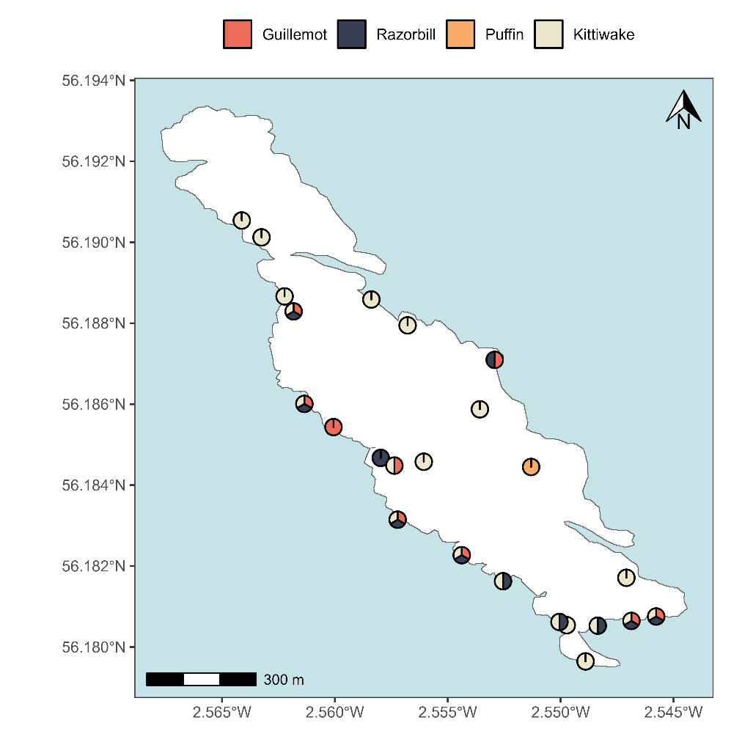
Figure S2. Capture areas used for GPS tagging on the Isle of May, with colours illustrating the species captured at each site
Table S1. Details on the tagging protocol for birds of the four species tagged on the Isle of May, whose data were used in the associated analyses.
Year | Species | Capture areas | # birds |  | Capture method | Tag type* | Weight & dimensions | Attachment method | Fix schedule | Tracking duration (days) |  | Tracking period
2010 | Guillemot | 3 | 33 |  | Noose pole | IgotU | 15.0g; 40x22x11 | Taped to back feathers | 1 min | 0.94 – 2.83 |  | 10th June - 18th June
2010 | Kittiwake | 10 | 33 |  | Noose pole | IgotU/GiPSy | 15.0g/11.5g;  40x22x11/48x20x9 | Taped to back feathers | 1 min/1 min on 5 min off | 0.66 – 2.76 |  | 29th May – 27th June
2010 | Razorbill | 6 | 17 |  | Noose pole | IgotU | 15.0g; 40x22x11 | Taped to back feathers | 1 min | 0.38 – 2.79 |  | 8th June – 18th June
2010 | Puffin | 1 | 4 |  | In burrow | IgotU/GiPSy | 15.0g/11.5g;  40x22x11/48x20x9 | Taped to back feathers | 1 min/1 min on 5 min off | 1.04 – 2.46 |  | 19th June – 25th June
2012 | Guillemot | 5 | 17 |  | Noose pole | IgotU | 17.1g; 40x22x11 | Taped to back feathers | 2 min | 0.60 – 3.86 |  | 11th June – 19th June
2012 | Kittiwake | 6 | 17 |  | Noose pole | IgotU | 14.2g; 40x22x11 | Taped to back feathers | 2 min | 0.94 – 2.27 |  | 29th May – 9th June
2012 | Razorbill | 8 | 13 |  | Noose pole | IgotU | 17.7g; 40x22x11 | Taped to back feathers | 2 min | 0.62 – 3.01 |  | 11th June – 21st June
2012 | Puffin | 1 | 0 |  | - | - | - | - | - | - |  | -
2013 | Guillemot | 5 | 20 |  | Noose pole | IgotU | 17.8g; 40x22x11 | Taped to back feathers | 2 min | 1.19 – 3.63 |  | 26th June – 2nd July
2013 | Kittiwake | 9 | 21 |  | Noose pole | IgotU | 16.4g; 40x22x11 | Taped to back feathers | 2 min | 0.76 – 2.97 |  | 24th June – 15th July
2013 | Razorbill | 3 | 7 |  | Noose pole | IgotU | 17.7g; 40x22x11 | Taped to back feathers | 2 min | 2.52 – 4.95 |  | 26th June – 2nd July
2013 | Puffin | 1 | 0 |  | - | - | - | - | - | - |  | -
2014 | Guillemot | 4 | 8 |  | Noose pole | IgotU | 17.5g; 40x22x11 | Taped to back feathers | 2 min | 1.87 – 2.84 |  | 22nd June – 27th June
2014 | Kittiwake | 3 | 11 |  | Noose pole | IgotU | 15.3g; 40x22x11 | Taped to back feathers | 2 min | 0.98 – 2.34 |  | 29th June – 8th July
2014 | Razorbill | 2 | 5 |  | Noose pole | IgotU | 17.7g; 40x22x11 | Taped to back feathers | 2 min | 2.38 – 2.93 |  | 18th June – 21st June
2014 | Puffin | 1 | 0 |  | - | - | - | - | - | - |  | -
2018 | Guillemot | 3 | 24 |  | Noose pole | Pathtrack | 11.0g; 50x23x10 | Taped to back feathers | 5 min | 0.54 – 9.98 |  | 26th June – 7th July
2018 | Kittiwake | 3 | 16 |  | Noose pole | Pathtrack | 4.1g; 40x12x10 | Taped to back feathers | 5 min | 1.77 – 4.61 |  | 21st June – 2nd July
2018 | Razorbill | 2 | 13 |  | Noose pole | Pathtrack | 8.2g; 50x13x10 | Taped to back feathers | 10 min | 0.33 – 9.68 |  | 26th June – 6th July
2018 | Puffin | 1 | 17 |  | Mist nets | Pathtrack | 8.2g/4.1g;  50x13x10/40x12x10 | Taped to back feathers | 10 min | 1.65 – 15.34 |  | 20th June – 25th July
2019 | Guillemot | 3 | 23 |  | Noose pole | Pathtrack | 11.0g; 51x24x9 | Taped to back feathers | 5 min | 0.51 – 6.73 |  | 21st June – 4th July
2019 | Kittiwake | 2 | 25 |  | Noose pole | Pathtrack | 4.1g; 42x14x8 | Taped to tail feathers | 5 min/10 min | 0.94 – 9.92 |  | 18th June – 3rd July
2019 | Razorbill | 2 | 13 |  | Noose pole | Pathtrack | 8.2g; 50x15x10 | Taped to back feathers | 10 min | 4.57 – 9.03 |  | 21st June – 30th June
2019 | Puffin | 1 | 23 |  | Purse nets at burrow | Pathtrack | 3.2g; 42x14x8 | Taped to back feathers | 10 min | 1.43 – 5.48 |  | 29th June – 10th July
2020 | Guillemot | 3 | 21 |  | Noose pole | Pathtrack GPS+TDR | 16.5g; 59x24x11 | Taped to back feathers | 5 min | 0.28 – 11.44 |  | 23rd June – 6th July
2020 | Kittiwake | 2 | 22 |  | Noose pole | UvA-BiTS | 9.0g; 62x30x12 | Glued to back feathers | 10 sec or 64 sec in wind farm footprint, 5 min elsewhere at sea, 15 min at colony | 5.40 – 36.75 |  | 27th June – 7th August
2020 | Razorbill | 2 | 13 |  | Noose pole | Pathtrack GPS+TDR | 13.0g; 54x24x10 | Taped to back feathers | 5 min | 0.26 – 12.90 |  | 23rd June – 6th July
2020 | Puffin | 1 | 7 |  | Purse nets at burrow | Pathtrack | 3.4g; 42x14x8 | Taped to back feathers | 10 min | 0.04 – 8.40 |  | 29th June – 11th July
2021 | Guillemot | 2 | 23 |  | Noose pole | Pathtrack GPS+TDR | 16.5g; 59x24x11 | Taped to back feathers | 5 min | 0.85 – 10.09 |  | 21st June – 1st July
2021 | Kittiwake | 4 | 50 |  | Noose pole | Pathtrack/UvA-BiTS | 4.0g/9.0g;  42x14x8/62x30x12 | Taped to tail feathers/ glued to back feathers | 5 min/64 sec in wind farm footprint, 5 min elsewhere at sea, 15 min at colony | 3.42 – 26.27 |  | 28th June – 27th July
2021 | Razorbill | 4 | 11 |  | Noose pole | Pathtrack GPS+TDR | 12.8g; 54x24x10 | Taped to back feathers | 5 min | 2.13 – 10.25 |  | 21st June – 1st July
2021 | Puffin | 1 | 24 |  | Purse nets at burrow | Pathtrack | 3.4g; 42x14x8 | Taped to back feathers | 10 min | 2.14 – 9.33 |  | 2nd July – 13th July
* Tag models used: IgotU GT-120; GiPSy-2 and GiPSy-3; Pathtrack nanoFix-GEO

Table 2. Summary of data used for the between-year fidelity analyses.
Species | Number of individuals | Years | Years between comparison years  Median (range)
Guillemot | 24 | 2010, 2012, 2013, 2014, 2018, 2019, 2020, 2021 | 4.5 (1 – 9)
Razorbill | 5 | 2010, 2012, 2013, 2014, 2018, 2019, 2020, 2021 | 2 (2 – 4)
Kittiwake | 7 | 2012, 2013, 2018, 2019, 2020, 2021 | 1.5 (1 – 3)

Determining flight speed cut-offs
We used data on observed movement speeds to determine a cut-off to exclude improbable movements. In each case, we selected 30 m/s as for each species, movements above this threshold were very rare.
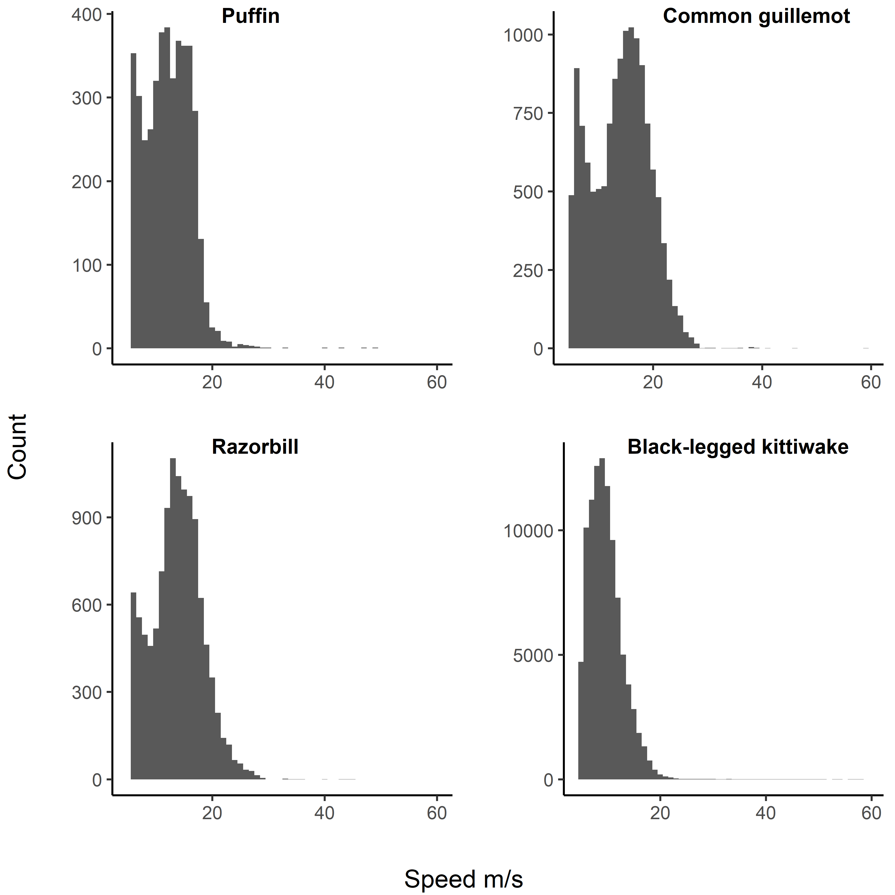
Figure S3. Histograms of individual movement speeds across the tracking period. Speeds less than 5 metres per second and greater than 60 metres per second were excluded to aid clarity.

Within year fidelity model results
Table S3. Model estimates, standard errors, and P values, from models of within-year fidelity including main effect terms only.
 | Guillemot |  |  | Kittiwake |  |  | Razorbill |  |  | Puffin
 | Est | SE | P | Est | SE | P | Est | SE | P | Est | SE |  | P
Nearest neighbour distance
Intercept | 3.932 | 0.140 | <0.001 | 3.976 | 0.091 | <0.001 | 3.887 | 0.234 | <0.001 | 4.074 |  | 0.141 | 0.002
Comparison type (within individual) | -0.827 | 0.049 | <0.001 | -0.426 | 0.018 | <0.001 | -0.564 | 0.045 | <0.001 | -0.675 |  | 0.065 | <0.001
Time difference | 0.200 | 0.046 | <0.001 | 0.008 | 0.009 | 0.391 | -0.011 | 0.030 | 0.697 | 0.007 |  | 0.048 | 0.892
Distance between capture sites | 0.038 | 0.022 | 0.085 | 0.076 | 0.007 | <0.001 | 0.312 | 0.052 | <0.001
 | Var | SD | P | Var | SD | P | Var | SD | P | Var |  | SD | P
Year | 0.131 | 0.363 | <0.001 | 0.042 | 0.205 | <0.001 | 0.405 | 0.637 | <0.001 | 0.062 |  | 0.249 | 0.014
Loggers:Year | 0.094 | 0.307 | <0.001 | 0.088 | 0.297 | <0.001 | 0.122 | 0.349 | <0.001 | 0.060 |  | 0.245 | <0.001
Difference between distal points
Intercept | 5.290 | 0.191 | <0.001 | 5.814 | 0.117 | <0.001 | 5.421 | 0.286 | <0.001 | 5.120 |  | 0.072 | <0.001
Comparison type (within individual) | -1.123 | 0.063 | <0.001 | -0.610 | 0.026 | <0.001 | -0.748 | 0.063 | <0.001 | -0.790 |  | 0.071 | <0.001
Time difference | 0.190 | 0.058 | 0.001 | 0.098 | 0.011 | <0.001 | 0.473 | 0.073 | <0.001 | 0.052 |  | 0.052 | 0.321
Distance between capture sites | 0.066 | 0.028 | 0.019 | -0.004 | 0.013 | 0.746 | -0.059 | 0.041 | 0.152
 | Var | SD | P | Var | SD | P | Var | SD | P | Var | SD |  | P
Year | 0.245 | 0.495 | <0.001 | 0.059 | 0.242 | <0.001 | 0.593 | 0.770 | <0.001 | 0.002 | 0.039 |  | 0.89
Loggers:Year | 0.214 | 0.462 | <0.001 | 0.231 | 0.481 | <0.001 | 0.226 | 0.475 | <0.001 | 0.104 | 0.323 |  | <0.001
Difference in bearing
Intercept | 1.179 | 0.042 | <0.001 | 0.878 | 0.064 | <0.001 | 1.213 | 0.032 | <0.001 | 0.854 | 0.024 |  | <0.001
Comparison type (within individual) | -0.197 | 0.016 | <0.001 | -0.070 | 0.004 | <0.001 | -0.109 | 0.017 | <0.001 | -0.017 | 0.017 |  | 0.326
Time difference | 0.028 | 0.019 | 0.153 | 0.011 | 0.002 | <0.001 | 0.121 | 0.023 | <0.001 | 0.017 | 0.013 |  | 0.193
 | Var | SD | P | Var | SD | P | Var | SD | P | Var | SD |  | P
Year | 0.008 | 0.091 | 0.013 | 0.027 | 0.165 | <0.001 | 0.002 | 0.042 | 0.625 | 0.000 | 0.000 |  | 1
Loggers:Year | 0.043 | 0.208 | <0.001 | 0.027 | 0.166 | <0.001 | 0.030 | 0.174 | <0.001 | 0.022 | 0.148 |  | <0.001

Table S4. Model estimates, standard errors, and P values, from models of within-year fidelity including a first order interaction between the comparison type (within or between individual) and the time between trip starts.
 | Guillemot |  |  | Kittiwake |  |  | Razorbill |  |  | Puffin
 | Est | SE | P | Est | SE | P | Est | SE | P | Est | SE |  | P
Nearest neighbour distance
Intercept | 3.903 | 0.140 | <0.001 | 4.005 | 0.092 | <0.001 | 3.822 | 0.232 | <0.001 | 4.089 |  | 0.151 | 0.002
Comparison type (within individual) | -0.672 | 0.067 | <0.001 | -4.533 | 0.018 | <0.001 | -0.366 | 0.068 | <0.001 | -0.461 |  | 0.104 | <0.001
Time difference | 0.097 | 0.055 | 0.078 | 0.033 | 0.009 | <0.001 | 0.152 | 0.067 | 0.022 | -0.030 |  | 0.050 | 0.545
Distance between capture sites | 0.039 | 0.022 | 0.076 | 0.002 | 0.009 | 0.857 | -0.026 | 0.030 | 0.384
Comparison type*time difference | 0.305 | 0.089 | <0.001 | 0.099 | 0.014 | <0.001 | 0.381 | 0.098 | <0.001 | 0.363 |  | 0.139 | 0.009
 | Var | SD | P | Var | SD | P | Var | SD | P | Var |  | SD | P
Year | 0.129 | 0.360 | <0.001 | 0.044 | 0.209 | <0.001 | 0.394 | 0.628 | <0.001 | 0.075 |  | 0.274 | 0.008
Identity:Year | 0.092 | 0.304 | <0.001 | 0.090 | 0.300 | <0.001 | 0.119 | 0.345 | <0.001 | 0.059 |  | 0.243 | <0.001
Difference between distal points
Intercept | 5.249 | 0.190 | <0.001 | 5.867 | 0.120 | <0.001 | 5.316 | 0.284 | <0.001 | 5.129 |  | 0.080 | <0.001
Comparison type (within individual) | -0.910 | 0.085 | <0.001 | -0.658 | 0.027 | <0.001 | -0.430 | 0.095 | <0.001 | -0.509 |  | 0.115 | <0.001
Time difference | 0.049 | 0.070 | 0.485 | 0.021 | 0.014 | 0.127 | 0.217 | 0.092 | 0.019 | 0.005 |  | 0.055 | 0.933
Distance between capture sites | 0.068 | 0.028 | 0.016 | -0.016 | 0.013 | 0.247 | -0.082 | 0.041 | 0.048
Comparison type*time difference | 0.418 | 0.114 | <0.001 | 0.177 | 0.020 | <0.001 | 0.611 | 0.136 | <0.001 | 0.475 | 0.153 |  | 0.002
 | Var | SD | P | Var | SD | P | Var | SD | P | Var | SD |  | P
Year | 0.241 | 0.491 | <0.001 | 0.062 | 0.248 | <0.001 | 0.577 | 0.759 | <0.001 | 0.006 | 0.075 |  | 0.650
Identity:Year | 0.209 | 0.457 | <0.001 | 0.237 | 0.487 | <0.001 | 0.219 | 0.468 | <0.001 | 0.101 | 0.318 |  | <0.001
Difference in bearing
Intercept | 1.174 | 0.042 | <0.001 | 0.884 | <0.001 | 1.165 | 0.037 | <0.001 |  | 0.854 | 0.024 |  | <0.001
Comparison type (within individual) | -0.169 | 0.025 | <0.001 | -0.075 | <0.001 | 0.024 | 0.029 | 0.410 |  | -0.026 | 0.028 |  | 0.339
Time difference | 0.008 | 0.023 | 0.722 | 0.001 | 0.678 | 0.019 | 0.030 | 0.513 |  | 0.018 | 0.013 |  | 0.169
Comparison type*time difference | 0.058 | 0.038 | 0.127 | 0.023 | <0.001 | 0.242 | 0.044 | <0.001 |  | -0.016 | 0.037 |  | 0.653
 | Var | SD | P | Var | SD | P | Var | SD | P | Var | SD |  | P
Year | 0.008 | 0.091 | 0.013 | 0.027 | 0.165 | <0.001 | 0.003 | 0.060 | 0.371 | 0.000 | 0.000 |  | 1
Identity:Year | 0.043 | 0.208 | <0.001 | 0.028 | 0.166 | <0.001 | 0.030 | 0.172 | <0.001 | 0.022 | 0.148 |  | <0.001

Between year fidelity model results
Table S5. Model estimates, standard errors, and P values, from models of between-year fidelity including main effect terms only.
 | Guillemot |  |  | Kittiwake |  |  | Razorbill
 | Est | SE | P | Est | SE | P | Est | SE | P
Nearest neighbour distance
Intercept | 4.144 | 0.126 | <0.001 | 3.436 | 0.863 | 0.006 | 3.860 | 0.384 | <0.001
Comparison type (within individual) | -1.225 | 0.174 | <0.001 | -1.324 | 0.438 | 0.005 | -1.201 | 0.299 | <0.001
Time difference | 0.140 | 0.137 | 0.310 | 0.404 | 0.229 | 0.087 | 0.164 | 0.241 | 0.497
Year difference | 0.006 | 0.056 | 0.916 | 0.921 | 1.506 | 0.600 | 0.224 | 0.516 | 0.666
Distance between capture sites | 0.016 | 0.079 | 0.843 | -0.129 | 0.315 | 0.686 | -0.284 | 0.151 | 0.063
Difference between distal points
Intercept | 5.583 | 0.210 | <0.001 | 5.741 | 0.872 | <0.001 | 5.040 | 0.575 | <0.001
Comparison type (within individual) | -0.984 | 0.205 | <0.001 | -0.877 | 0.605 | 0.159 | -0.392 | 0.347 | 0.261
Time difference | 0.022 | 0.169 | 0.896 | -0.050 | 0.291 | 0.866 | -0.086 | 0.283 | 0.761
Year difference | 0.046 | 0.090 | 0.610 | 1.658 | 1.050 | 0.338 | 0.394 | 0.621 | 0.528
Distance between capture sites | -0.038 | 0.096 | 0.693 | -0.508 | 0.428 | 0.244 | -0.231 | 0.177 | 0.194
Difference in bearing
Intercept | 1.158 | 0.070 | <0.001 | 0.606 | 0.208 | 0.010 | 1.194 | 0.132 | <0.001
Comparison type (within individual) | -0.226 | 0.067 | <0.001 | -0.124 | 0.128 | 0.342 | -0.092 | 0.108 | 0.396
Time difference | -0.034 | 0.055 | 0.537 | 0.067 | 0.065 | 0.311 | -0.069 | 0.086 | 0.427
Year difference | 0.033 | 0.030 | 0.276 | -0.038 | 0.297 | 0.905 | -0.030 | 0.184 | 0.871
Distance between capture sites | -0.011 | 0.031 | 0.735 | 3.28 × 10⁻⁵ | 0.092 | 0.100 | 0.011 | 0.054 | 0.833

Foraging behaviour model results
Table S6. Model estimates, standard errors, and P values, from models examining relationships between the fidelity shown over consecutive trips and measures of foraging behaviour on the initial trip.
 | Guillemot |  |  | Razorbill
 | Est | SE | P | Est | SE | P
Nearest neighbour distance
Intercept | 3.328 | 0.219 | <0.001 | 1.899 | 0.091 | <0.001
Time difference | 0.097 | 0.113 | 0.392 | 0.091 | 0.034 | 0.009
Proportion time foraging | 0.107 | 0.152 | 0.481 | 0.003 | 0.041 | 0.942
Time to first foraging bout | -0.015 | 0.117 | 0.898 | -0.019 | 0.034 | 0.576
Mean foraging bout duration | -0.249 | 0.144 | 0.086 | -0.131 | 0.040 | 0.001
Total foraging time | 0.235 | 0.119 | 0.049 | 0.065 | 0.037 | 0.081
Year (2021) | -0.405 | 0.296 | 0.181 | -0.203 | 0.128 | 0.130
 | Var | SD | P | Var | SD | P
Identity | 0.263 | 0.513 | 0.013 | 0.055 | 0.236 | <0.001
Difference between distal points
Intercept | 4.482 | 0.251 | <0.001 | 5.225 | 0.413 | <0.001
Time difference | 0.100 | 0.128 | 0.433 | 0.531 | 0.172 | 0.002
Proportion time foraging | -0.015 | 0.172 | 0.929 | 0.047 | 0.208 | 0.823
Time to first foraging bout | -0.054 | 0.132 | 0.684 | -0.099 | 0.174 | 0.568
Mean foraging bout duration | -0.170 | 0.163 | 0.299 | -0.626 | 0.203 | 0.002
Total foraging time | 0.318 | 0.135 | 0.019 | 0.455 | 0.185 | 0.015
Year (2021) | -0.578 | 0.339 | 0.097 | -0.997 | 0.580 | 0.102
 | Var | SD | P | Var | SD | P
Identity | 0.358 | 0.598 | 0.012 | 0.100 | 0.999 | <0.001
Difference in bearing
Intercept | 1.043 | 0.087 | <0.001 | 0.857 | 0.095 | <0.001
Time difference | -0.028 | 0.041 | 0.492 | 0.190 | 0.049 | <0.001
Proportion time foraging | -0.010 | 0.055 | 0.855 | 0.087 | 0.060 | 0.145
Time to first foraging bout | -0.004 | 0.043 | 0.929 | -0.055 | 0.050 | 0.276
Mean foraging bout duration | 0.038 | 0.053 | 0.472 | -0.171 | 0.057 | 0.003
Total foraging time | -0.024 | 0.043 | 0.587 | 0.093 | 0.052 | 0.079
Year (2021) | -0.188 | 0.118 | 0.123 | 0.109 | 0.132 | 0.418
 | Var | SD | P | Var | SD | P
Identity | 0.055 | 0.234 | 0.005 | 0.031 | 0.175 | 0.061
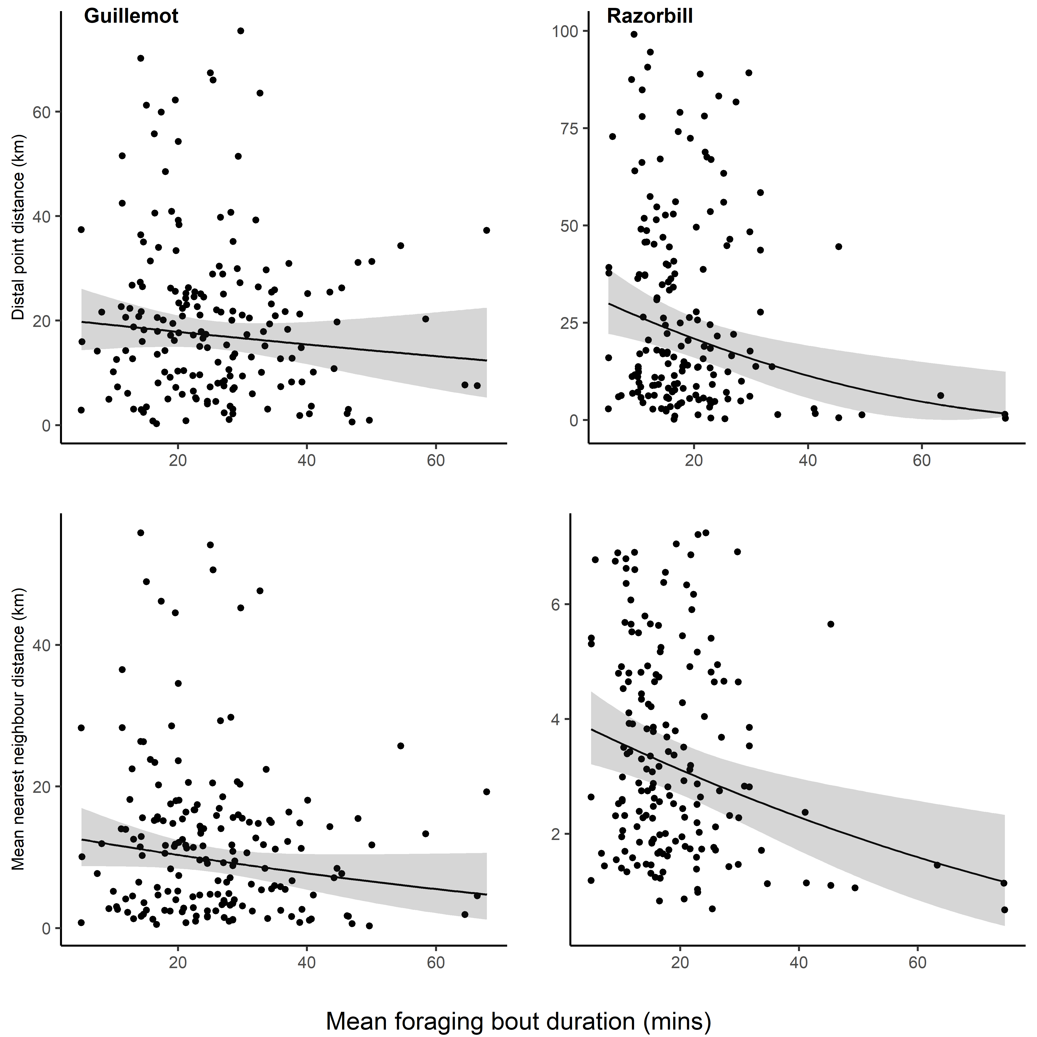
Figure S4. Relationship between the mean length of foraging bouts on the initial trip and the distance between the distal point of the initial trip and the subsequent trip made by an individual (top row) and the mean nearest neighbour distance between consecutive trips (bottom row). Shown are the raw data (points) and model predictions with associated 95% confidence intervals.
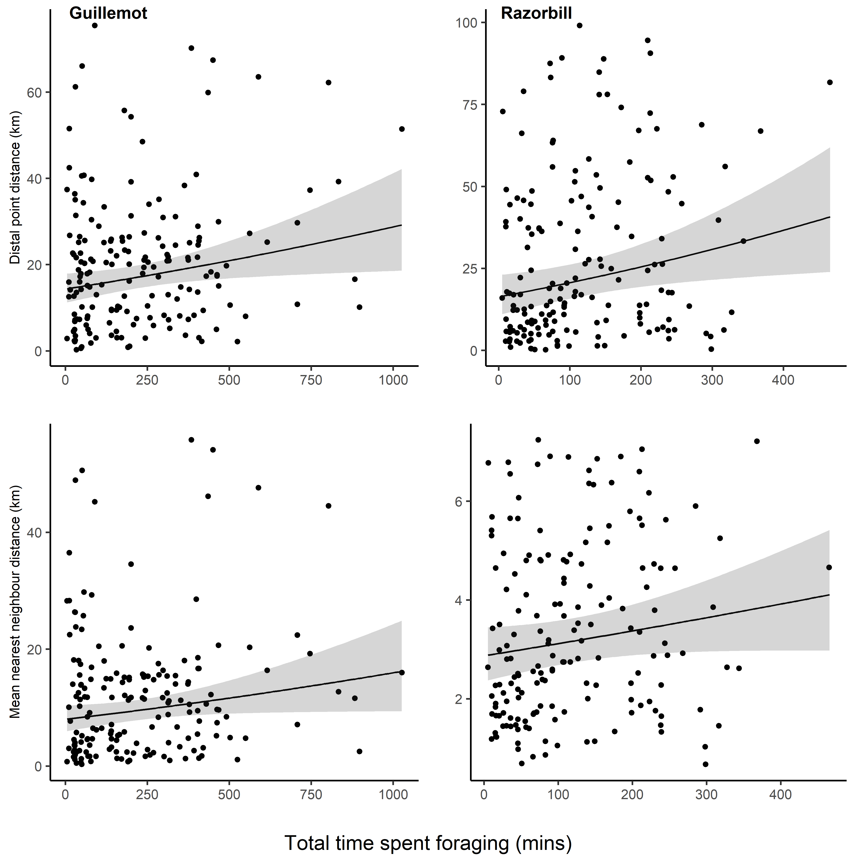
Figure S5. Relationship between the total time spent foraging on a trip and the distance between the distal point of that trip and the subsequent trip. Shown are the raw data (points) and model predictions with associated 95% confidence intervals.

Individual similarity model results
Table S7. Model estimates, standard errors, and P values, from models examining relationships between trip similarity and temporal overlap when examining trips within species only.
 | Guillemot |  |  | Kittiwake |  |  | Razorbill |  |  | Puffin
 | Est | SE | P | Est | SE | P | Est | SE | P | Est | SE |  | P
Nearest neighbour distance
Intercept | 4.002 | 0.114 | <0.001 | 4.325 | 0.219 | <0.001 | 3.789 | 0.240 | <0.001 | 3.519 |  | 0.091 | <0.001
Comparison type (within individual within day) | -0.426 | 0.037 | <0.001 | -0.546 | 0.021 | <0.001 | -0.162 | 0.070 | 0.020 | -0.234 |  | 0.155 | 0.132
Distance between capture sites | 0.048 | 0.019 | 0.011 | -0.040 | 0.010 | <0.001 | -0.015 | 0.037 | 0.678 | 0.028 |  | 0.072 | 0.701
 | Var | SD | P | Var | SD | P | Var | SD | P | Var |  | SD | P
Year | 0.082 | 0.287 | <0.001 | 0.287 | 0.535 | <0.001 | 0.379 | 0.616 | <0.001 | 0.000 |  | 0.000 | 1
Difference between distal points
Intercept | 5.737 | 0.160 | <0.001 | 6.286 | 0.344 | <0.001 | 5.345 | 0.304 | <0.001 | 4.955 |  | 0.162 | <0.001
Comparison type (within individual within day) | -0.773 | 0.052 | <0.001 | -0.693 | 0.031 | <0.001 | -0.299 | 0.095 | 0.002 | -0.637 |  | 0.196 | 0.001
Distance between capture sites | 0.078 | 0.026 | 0.003 | -0.074 | 0.015 | <0.001 | -0.051 | 0.050 | 0.317 | -0.007 | 0.091 |  | 0.938
 | Var | SD | P | Var | SD | P | Var | SD | P | Var | SD |  | P
Year | 0.161 | 0.402 | <0.001 | 0.711 | 0.843 | <0.001 | 0.598 | 0.773 | <0.001 | 0.035 | 0.187 |  | 0.148
Difference in bearing
Intercept | 1.238 | 0.030 | <0.001 | 1.059 | 0.052 | <0.001 | 1.288 | 0.031 | <0.001 | 0.875 | 0.036 |  | <0.001
Comparison type (within individual within day) | -0.055 | 0.016 | <0.001 | -0.269 | 0.007 | <0.001 | -0.083 | 0.028 | 0.003 | 0.038 | 0.061 |  | 0.533
Distance between capture sites | 0.033 | 0.008 | <0.001 | 0.011 | 0.004 | 0.002 | 0.021 | 0.015 | 0.152 | 0.020 | 0.028 |  | 0.476
 | Var | SD | P | Var | SD | P | Var | SD | P | Var | SD |  | P
Year | 0.005 | 0.071 | <0.001 | 0.015 | 0.121 | <0.001 | 0.003 | 0.059 | 0.001 | 0.000 | 0.000 |  | 1

Table S8. Model estimates, standard errors, and P values, from models examining relationships between trip similarity and temporal overlap when examining trips made by different species. Shown are results from models with main effects, only.
 | Guillemot |  |  | Kittiwake |  |  | Razorbill |  |  | Puffin
 | Est | SE | P | Est | SE | P | Est | SE | P | Est | SE |  | P
Nearest neighbour distance
Intercept | 3.636 | 0.125 | <0.001 | 3.933 | 0.222 | <0.001 | 3.649 | 0.269 | <0.001 | 3.472 |  | 0.138 | <0.001
Comparison type (between species within day) | 0.220 | 0.037 | <0.001 | 0.148 | 0.020 | <0.001 | -0.062 | 0.063 | 0.328 | 0.164 |  | 0.154 | 0.286
Species (puffin) | -0.161 | 0.084 | 0.057 | -0.312 | 0.028 | <0.001 | 0.308 | 0.323 | 0.342 | - |  | - | -
Species (razorbill) | -0.079 | 0.055 | 0.152 | 0.066 | 0.035 | 0.060 | - | - | - | 0.114 |  | 0.460 | 0.803
Species (kittiwake) | - | - | - | - | - | - | 0.122 | 0.092 | 0.184 | -0.125 |  | 0.126 | 0.408
Distance between capture sites | -0.011 | 0.020 | 0.588 | -0.044 | 0.011 | <0.001 | 0.014 | 0.035 | 0.682 | 0.013 |  | 0.084 | 0.875
 | Var | SD | P | Var | SD | P | Var | SD | P | Var |  | SD | P
Year | 0.087 | 0.295 | <0.001 | 0.292 | 0.540 | <0.001 | 0.485 | 0.697 | <0.001 | 0.003 |  | 0.059 | 0.819
Difference between distal points
Intercept | 5.174 | 0.176 | <0.001 | 5.883 | 0.338 | <0.001 | 5.086 | 0.330 | <0.001 | 4.509 |  | 0.163 | <0.001
Comparison type (between species within day) | 0.456 | 0.050 | <0.001 | 0.199 | 0.030 | <0.001 | 0.020 | 0.084 | 0.807 | 0.497 |  | 0.191 | 0.010
Species (puffin) | -0.607 | 0.113 | <0.001 | -0.643 | 0.040 | <0.001 | 0.059 | 0.429 | 0.891 | - |  | - | -
Species (razorbill) | -0.324 | 0.074 | <0.001 | 0.157 | 0.051 | 0.002 | - | - | - | 0.162 |  | 0.569 | 0.776
Species (kittiwake) | - | - | - | - | - | - | 0.027 | 0.122 | 0.028 | 0.016 |  | 0.139 | 0.911
Distance between capture sites | -0.011 | 0.027 | 0.69 | -0.075 | 0.016 | <0.001 | 0.006 | 0.047 | 0.900 | -0.025 | 0.105 |  | 0.812
 | Var | SD | P | Var | SD | P | Var | SD | P | Var | SD |  | P
Year | 0.174 | 0.417 | <0.001 | 0.685 | 0.828 | <0.001 | 0.726 | 0.852 | <0.001 | 0.000 | 0.000 |  | 1
Difference in bearing
Intercept | 1.164 | 0.033 | <0.001 | 0.844 | 0.064 | <0.001 | 1.191 | 0.027 | <0.001 | 0.937 | 0.089 |  | <0.001
Comparison type (between species within day) | 0.102 | 0.016 | <0.001 | 0.372 | 0.007 | <0.001 | -0.066 | 0.026 | 0.009 | 0.120 | 0.061 |  | 0.051
Species (puffin) | 0.066 | 0.036 | 0.064 | -0.007 | 0.010 | 0.499 | 0.019 | 0.130 | 0.882 | - | - |  | -
Species (razorbill) | 0.034 | 0.023 | 0.145 | 0.006 | 0.013 | 0.634 | - | - | - | -0.029 | 0.187 |  | 0.875
Species (kittiwake) | - | - | - | - | - | - | 0.007 | 0.036 | 0.851 | 0.001 | 0.067 |  | 0.987
Distance between capture sites | -0.008 | 0.008 | 0.326 | -0.003 | 0.004 | 0.501 | -0.011 | 0.014 | 0.444 | -0.029 | 0.034 |  | 0.396
 | Var | SD | P | Var | SD | P | Var | SD | P | Var | SD |  | P
Year | 0.004 | 0.062 | <0.001 | 0.024 | 0.154 | <0.001 | 0.002 | 0.048 | 0.011 | 0.017 | 0.130 |  | 0.007

Table S9. Model estimates, standard errors, and P values, from models examining relationships between trip similarity and temporal overlap when examining trips made by different species. Shown are results from models including first order interactions between the comparison type (within versus between day) and the species comparison made.
 | Guillemot |  |  | Kittiwake |  |  | Razorbill |  |  | Puffin
 | Est | SE | P | Est | SE | P | Est | SE | P | Est | SE |  | P
Nearest neighbour distance
Intercept | 3.515 | 0.133 | <0.001 | 3.823 | 0.223 | <0.001 | 3.670 | 0.169 | <0.001 | 3.505 |  | 0.168 | <0.001
Comparison type (between species within day) | 0.462 | 0.093 | <0.001 | 0.368 | 0.047 | <0.001 | -0.102 | 0.070 | 0.143 | 0.096 |  | 0.246 | 0.697
Species (puffin) | 0.007 | 0.118 | 0.953 | -0.116 | 0.038 | 0.003 | 0.644 | 0.454 | 0.156 | - |  | - | -
Species (razorbill) | 0.063 | 0.075 | 0.399 | -0.069 | 0.050 | 0.166 | - | - | - | -0.212 |  | 0.647 | 0.743
Species (kittiwake) | - | - | - | - | - | - | -0.002 | 0.121 | 0.988 | -0.165 |  | 0.169 | 0.357
Distance between capture sites | -0.012 | 0.020 | 0.551 | -0.043 | 0.011 | <0.001 | 0.011 | 0.036 | 0.766 | 0.009 |  | 0.085 | 0.911
Comparison type * puffin | -0.335 | 0.167 | 0.044 | -0.393 | 0.053 | <0.001 | -0.670 | 0.638 | 0.293 | - |  | - | -
Comparison type * razorbill | -0.285 | 0.102 | 0.005 | 0.270 | 0.070 | <0.001 | - | - | - | 0.657 |  | 0.915 | 0.473
Comparison type * kittiwake | - | - | - | - | - | - | 0.248 | 0.156 | 0.112 | 0.082 |  | 0.223 | 0.713
 | Var | SD | P | Var | SD | P | Var | SD | P | Var |  | SD | P
Year | 0.087 | 0.295 | <0.001 | 0.293 | 0.541 | <0.001 | 0.483 | 0.695 | <0.001 | 0.004 |  | 0.059 | 0.814
Difference between distal points
Intercept | 4.804 | 0.184 | <0.001 | 5.700 | 0.340 | <0.001 | 5.112 | 0.330 | <0.001 | 4.554 |  | 0.202 | <0.001
Comparison type (between species within day) | 1.196 | 0.124 | <0.001 | 5.640 | 0.069 | <0.001 | -0.030 | 0.092 | 0.748 | 0.407 |  | 0.306 | 0.184
Species (puffin) | 0.012 | 0.159 | 0.940 | -0.291 | 0.056 | <0.001 | 0.781 | 0.601 | 0.194 | - |  | - | -
Species (razorbill) | 0.100 | 0.100 | 0.318 | -0.177 | 0.072 | 0.014 | - | - | - | 0.033 |  | 0.804 | 0.967
Species (kittiwake) | - | - | - | - | - | - | 0.101 | 0.207 | 0.527 | -0.037 |  | 0.197 | 0.850
Distance between capture sites | -0.013 | 0.027 | 0.638 | -0.073 | 0.016 | <0.001 | 0.002 | 0.047 | 0.967 | -0.025 | 0.106 |  | 0.810
Comparison type * puffin | -1.237 | 0.223 | <0.001 | -0.702 | 0.078 | <0.001 | -1.444 | 0.845 | 0.088 | - | - |  | -
Comparison type * razorbill | -0.849 | 0.137 | <0.001 | 0.669 | 0.102 | <0.001 | - | - | - | 0.257 | 1.140 |  | 0.822
Comparison type * kittiwake | - | - | - | - | - | - | 0.335 | 0.207 | 0.105 | 0.105 | 0.278 |  | 0.704
 | Var | SD | P | Var | SD | P | Var | SD | P | Var | SD |  | P
Year | 0.174 | 0.417 | <0.001 | 0.688 | 0.829 | <0.001 | 0.723 | 0.850 | <0.001 | 0.000 | 0.000 |  | 1
Difference in bearing
Intercept | 4.804 | 0.184 | <0.001 | 0.885 | 0.065 | <0.001 | 1.183 | 0.028 | <0.001 | 0.881 | 0.097 |  | <0.001
Comparison type (between species within day) | 1.196 | 0.124 | <0.001 | 0.289 | 0.017 | <0.001 | -0.051 | 0.028 | 0.073 | 0.233 | 0.098 |  | 0.018
Species (puffin) | 0.012 | 0.159 | 0.940 | -0.063 | 0.014 | <0.001 | 0.050 | 0.183 | 0.785 | - | - |  | -
Species (razorbill) | 0.100 | 0.100 | 0.318 | -0.020 | 0.018 | 0.270 | - | - | - | -0.021 | 0.260 |  | 0.936
Species (kittiwake) | - | - | - | - | - | - | 0.047 | 0.048 | 0.320 | 0.067 | 0.081 |  | 0.409
Distance between capture sites | -0.013 | 0.027 | 0.638 | -0.003 | 0.004 | 0.507 | -0.009 | 0.014 | 0.527 | -0.031 | 0.034 |  | 0.369
Comparison type * puffin | -1.237 | 0.223 | <0.001 | 0.113 | 0.019 | <0.001 | -0.063 | 0.258 | 0.809 | - | - |  | -
Comparison type * razorbill | -0.849 | 0.137 | <0.001 | 0.051 | 0.025 | 0.042 | - | - | - | -0.016 | 0.363 |  | 0.966
Comparison type * kittiwake | - | - | - | - | - | - | -0.081 | 0.063 | 0.200 | -0.131 | 0.089 |  | 0.141
 | Var | SD | P | Var | SD | P | Var | SD | P | Var | SD |  | P
Year | 0.004 | 0.062 | <0.001 | 0.024 | 0.154 | <0.001 | 0.002 | 0.048 | 0.010 | 0.017 | 0.130 |  | 0.007

Table S10. Model estimates, standard errors, and P values, from models examining relationships between trip similarity and whether individuals overlapped at the colony or not prior to trip departure.
 | Guillemot |  |  | Kittiwake |  |  | Razorbill |  |  | Puffin
 | Est | SE | P | Est | SE | P | Est | SE | P | Est | SE |  | P
Nearest neighbour distance
Intercept | 3.500 | 0.173 | <0.001 | 3.731 | 0.237 | <0.001 | 3.741 | 0.292 | <0.001 | 3.288 |  | 0.134 | <0.001
Overlap at colony (true) | 0.035 | 0.103 | 0.736 | -0.079 | 0.086 | 0.359 | -0.042 | 0.210 | 0.84 | -0.463 |  | 0.156 | 0.003
 | Var | SD | P | Var | SD | P | Var | SD | P | Var |  | SD | P
Year | 0.074 | 0.272 | 0.365 | 0.202 | 0.449 | 0.127 | 0.316 | 0.562 | 0.010 | 0.000 |  | 0.000 | 1
Day:Year | 0.426 | 0.653 | <0.001 | 0.434 | 0.659 | <0.001 | 0.122 | 0.349 | 0.100 | 0.259 |  | 0.509 | <0.001
Difference between distal points
Intercept | 4.695 | 0.269 | <0.001 | 5.460 | 0.317 | 0.003 | 5.184 | 0.397 | <0.001 | 4.418 |  | 0.147 | <0.001
Overlap at colony (true) | 0.098 | 0.132 | 0.457 | -0.042 | 0.123 | 0.732 | -0.118 | 0.286 | 0.68 | -0.510 |  | 0.186 | 0.006
 | Var | SD | P | Var | SD | P | Var | SD | P | Var |  | SD | P
Year | 0.239 | 0.489 | 0.176 | 0.346 | 0.588 | 0.318 | 0.605 | 0.778 | 0.488 | 0.000 |  | 0.000 | 1
Day:Year | 0.936 | 0.968 | <0.001 | 0.761 | 0.872 | <0.001 | 0.092 | 0.304 | 0.004 | 0.272 |  | 0.522 | <0.001
Difference in bearing
Intercept | 1.188 | 0.099 | <0.001 | 0.857 | 0.062 | 0.002 | 1.132 | 0.077 | <0.001 | 0.854 | 0.047 |  | <0.001
Overlap at colony (true) | 0.014 | 0.044 | 0.749 | -0.026 | 0.023 | 0.256 | -0.054 | 0.074 | 0.471 | -0.119 | 0.056 |  | 0.037
 | Var | SD | P | Var | SD | P | Var | SD | P | Var | SD |  | P
Year | 0.047 | 0.216 | 0.007 | 0.016 | 0.127 | 0.231 | 0.004 | 0.064 | 0.867 | 0.000 | 0.000 |  | 1
Day:Year | 0.053 | 0.231 | <0.001 | 0.011 | 0.107 | <0.001 | 0.052 | 0.227 | 0.003 | 0.030 | 0.173 |  | <0.001
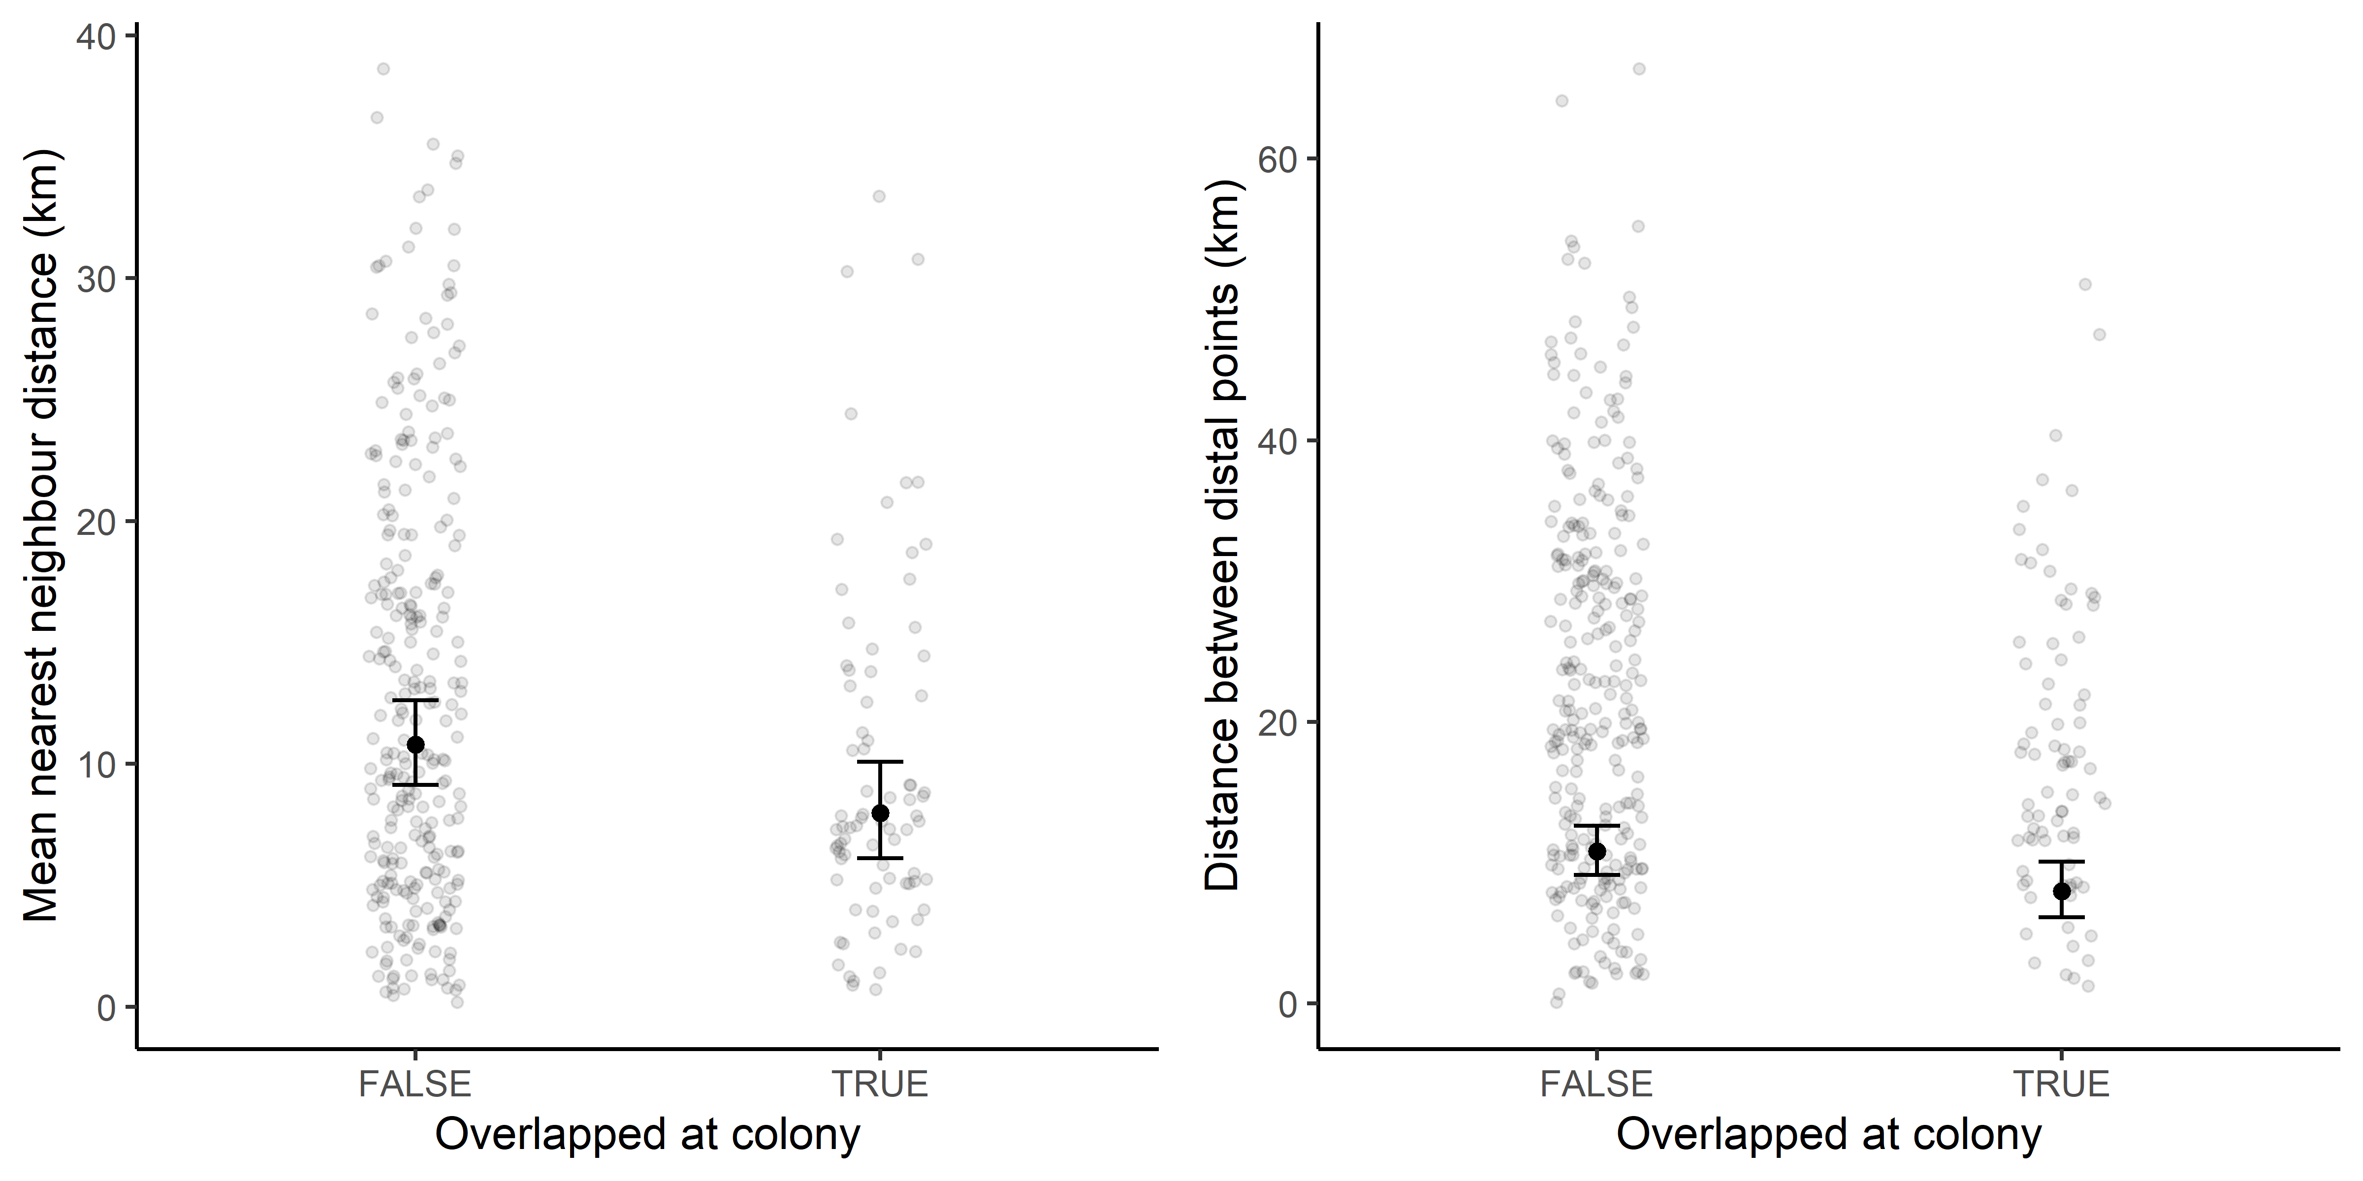
Figure S6. Relationship between the mean nearest neighbour distance between a pair of trips and whether the individuals overlapped at the colony prior to departure for Puffins. Shown are the raw data and model predictions with associated 95% confidence intervals.
Table S11. Model estimates, standard errors, and P values, from models examining relationships between trip similarity and the degree to which individuals overlapped out at sea when making their foraging trips.
 | Guillemot |  |  | Kittiwake |  |  | Razorbill |  |  | Puffin
 | Est | SE | P | Est | SE | P | Est | SE | P | Est | SE |  | P
Nearest neighbour distance
Intercept | 3.664 | 0.175 | <0.001 | 3.854 | 0.156 | 0.014 | 3.264 | 0.308 | <0.001 | 3.338 |  | 0.124 | <0.001
Amount of overlap | -0.200 | 0.032 | <0.001 | -0.218 | 0.022 | <0.001 | -0.251 | 0.075 | <0.001 | -0.378 |  | 0.067 | <0.001
Distance between capture sites | 0.111 | 0.033 | 0.001 | -0.021 | 0.024 | 0.368 | 0.072 | 0.084 | 0.394
 | Var | SD | P | Var | SD | P | Var | SD | P | Var |  | SD | P
Year | 0.151 | 0.388 | 0.017 | 0.068 | 0.260 | 0.334 | 0.538 | 0.734 | <0.001 | 0.000 |  | 0.000 | 1
Identity:Year | 0.287 | 0.536 | <0.001 | 0.287 | 0.536 | <0.001 | 0.182 | 0.427 | 0.002 | 0.180 |  | 0.425 | <0.001
Difference between distal points
Intercept | 5.106 | 0.216 | <0.001 | 5.592 | 0.172 | <0.001 | 4.611 | 0.407 | <0.001 | 4.468 |  | 0.153 | <0.001
Amount of overlap | -0.050 | 0.045 | 0.27 | -0.240 | 0.033 | <0.001 | -0.253 | 0.112 | 0.024 | -0.281 |  | 0.084 | <0.001
Distance between capture sites | 0.205 | 0.047 | <0.001 | -0.068 | 0.035 | 0.055 | 0.161 | 0.125 | 0.199
 | Var | SD | P | Var | SD | P | Var | SD | P | Var |  | SD | P
Year | 0.216 | 0.465 | 0.036 | 0.054 | 0.233 | 0.466 | 0.904 | 0.951 | 0.002 | 2.900× 10⁻¹⁰ |  | 1.703× 10⁻⁵ | 1
Identity:Year | 0.484 | 0.696 | <0.001 | 0.504 | 0.710 | <0.001 | 0.351 | 0.592 | 0.007 | 0.273 |  | 0.523 | <0.001
Difference in bearing
Intercept | 1.147 | 0.044 | <0.001 | 0.729 | 0.024 | <0.001 | 1.035 | 0.045 | <0.001 | 0.712 | 0.101 |  | 0.010
Amount of overlap | -0.045 | 0.015 | 0.003 | -0.032 | 0.006 | <0.001 | -0.116 | 0.031 | <0.001 | -0.082 | 0.030 |  | 0.006
Distance between capture sites | 0.078 | 0.015 | <0.001 | -0.002 | 0.007 | 0.793 | 0.061 | 0.032 | 0.062
 | Var | SD | P | Var | SD | P | Var | SD | P | Var | SD |  | P
Year | 0.007 | 0.081 | 0.262 | 0.001 | 0.034 | 0.296 | 0.003 | 0.055 | 0.669 | 0.022 | 0.149 |  | 0.095
Identity:Year | 0.026 | 0.161 | <0.001 | 0.006 | 0.077 | <0.001 | 0.015 | 0.121 | 0.129 | 0.022 | 0.149 |  | <0.001

