Supplementary materials for: Vegetation cover, topography, and low-traffic roads influence Sonoran desert tortoise (Gopherus morafkai) movement and habitat selection
Sean Sutor^{1,}*, Nancy E. McIntyre¹, Kerry Griffis-Kyle²
¹Department of Biological Sciences, Texas Tech University, 2901 Main Street, Lubbock, Texas 79409-3131, USA.
²Department of Natural Resource Management, Texas Tech University, Goddard Building, Box 42125, Lubbock, Texas 79409-2125, USA.
*Corresponding author: sean.sutor@ttu.edu, (609)-815-1846
Sean Sutor https://orcid.org/0000-0001-5072-1584
Nancy E. McIntyre https://orcid.org/0000-0003-1790-3057
Kerry Griffis-Kyle https://orcid.org/0000-0002-2887-9550
Any use of trade, product, or firm names is for descriptive purposes only and does not imply endorsement by the U.S. Government.

Methods
Stationary GPS tests
To confirm the reported location error of the GPS dataloggers, and to ensure they functioned as expected, we performed four stationary GPS tests by placing GPS dataloggers in places similar to where tortoises might shelter (e.g., in vegetation or a boulder pile). Upon downloading the GPS data, we measured the Euclidean Distance between the location of each GPS datalogger and each point it recorded, then we calculated the average location error for each test. We then removed any locations with an elevational difference greater than 25 meters between the elevation recorded by the GPS datalogger and a 30-meter digital elevation model (DEM), which was one of the criteria we used to identify potentially erroneous locations in our tortoise movement dataset. We then re-calculated the mean location error (Table S1).
Incised wash model
We used raster functions tools in ArcGIS Pro to calculate “Gradient North”, “Gradient East”, “Gradient South”, and “Gradient West” using a 0.5 meter hillshade derived from a DEM provided by the NPS. We then merged these rasters and applied focal statistics to find areas with a high standard deviation, which allowed us to identify steep-walled features indicative of incised washes. This resulted in a raster image with values 0 to 1, where 0 represents flat ground and 1 represents a vertical wall. We then used the classification tool “segment mean shift” to identify areas that are or are not deeply incised washes. Finally, we eliminated all flat areas and converted the wash raster into polygon features. We then used the “Euclidean Distance” tool to calculate for all points on the landscape the distance to the nearest incised wash. The resulting raster was resampled to 30-meter resolution using bilinear interpolation to match the resolution of other predictor variables.

Results
Table S1 Location, number of GPS points collected, and the mean location error (meters) for each stationary GPS test before and after removing potentially erroneous locations. The mean location error prior to screening ranged from 8.44 to 12.34 meters, while the post-screening mean location error ranged from 6.69 to 9.27 meters.
Test ID | Location | Number of GPS points | pre-screen LE | post-screen LE
Test 1 | under palo verde (Parkinsonia microphylla) | 328 | 10.03 | 7.70
Test 2 | in triangle leaf bursage (Ambrosia deltoidea) | 340 | 10.07 | 7.61
Test 3 | in boulder pile | 85 | 12.34 | 9.27
Test 4 | in packrat midden | 184 | 8.44 | 6.69

Table S2 The minimum distance in meters from any recorded tortoise location (GPS location) to the nearest low-traffic road and the number of times each tortoise crossed a low-traffic road for each tortoise included in the low-traffic roads model. Reported distances reflect the linear distance between the GPS position and the nearest road but do not account for the approximate accuracy of the GPS datalogger (~10 meters).
Low-traffic roads model | Tortoise ID | Minimum distance to nearest low-traffic road (meters) | Number of crossing events
Low-traffic roads model | C | 0.00 | 4
Low-traffic roads model | E | 0.00 | 31
Low-traffic roads model | F | 0.00 | 5
Low-traffic roads model | I | 0.00 | 1
Low-traffic roads model | L | 0.00 | 2
Low-traffic roads model | N | 0.81 | 0
Low-traffic roads model | O | 0.00 | 1

Table S3 The minimum distance in meters from any recorded tortoise location (GPS location) to the highway and the number of times each tortoise crossed the highway for each tortoise included in the highway model. Reported distances reflect the linear distance between the GPS position and the nearest road but do not account for the approximate accuracy of the GPS datalogger (~10 meters).
Highway Model | Tortoise ID | Minimum distance to Highway (meters) | Number of crossing events
Highway Model | B | 337.47 | 0
Highway Model | F | 81.28 | 0
Highway Model | H | 240.53 | 0
Highway Model | J | 549.24 | 0
Highway Model | O | 0.00 | 1
Highway Model | Q | 151.05 | 0

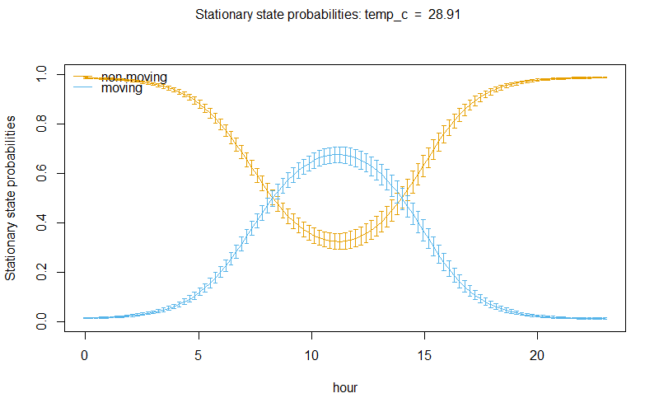
Fig. S1 Stationary state probabilities for the moving and encamped (non-moving) state relative to hour of the day (with temperature held constant). Tortoises were more likely to be in a moving state than in an encamped state during daylight hours.
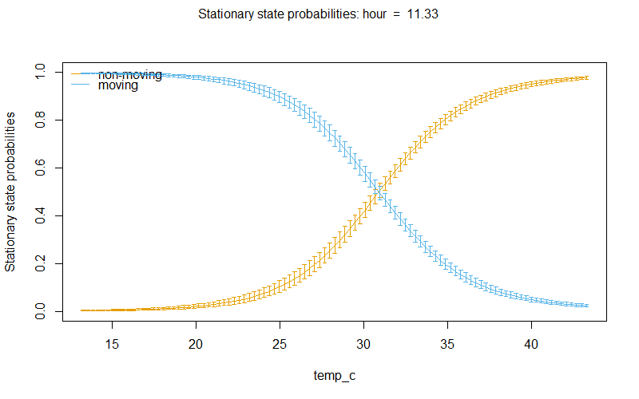
Fig. S2 Stationary state probabilities for the moving and encamped (non-moving) state relative to air temperature (with hour of the day held constant). Tortoises were more likely to be in a moving state in lower temperatures and more likely to transition to an encamped state as temperatures increased.

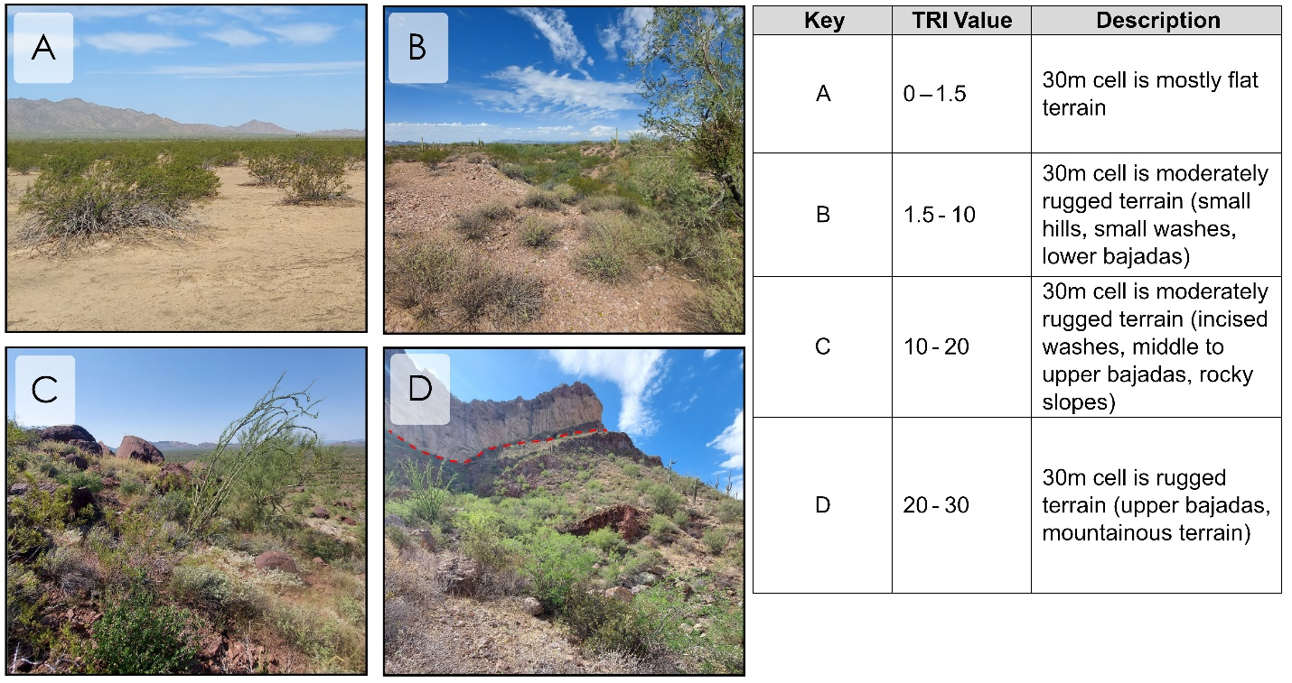
Fig. S3 Aerial images visually depicting examples of terrain in the study areas and the approximate TRI values they fall within. TRI values between 0 and 1.5 indiciate that the majority of the 30-meter cell is in flat terrain (A). TRI values between 1.5 and 10 indicate that the majority of the 30-meter cell is in moderately rugged terrain characterized by small hills, small washes, and lower bajada slopes (B). TRI values between 10 and 20 indicate that the majority of the 30-meter cell is in moderately rugged terrain characterized by incised washes, middle to upper bajada slopes, and rocky slopes and mountainsides (C). TRI values between 20 and 30 indicate that the majority of the 30-meter cell is in rugged terrain characterized by upper bajadas and mountainous slopes (D). Values above 30 TRI are indicative of extremely rugged terrain, like vertical mountain faces and mountaintops (e.g., the area above the red dashed line; D).

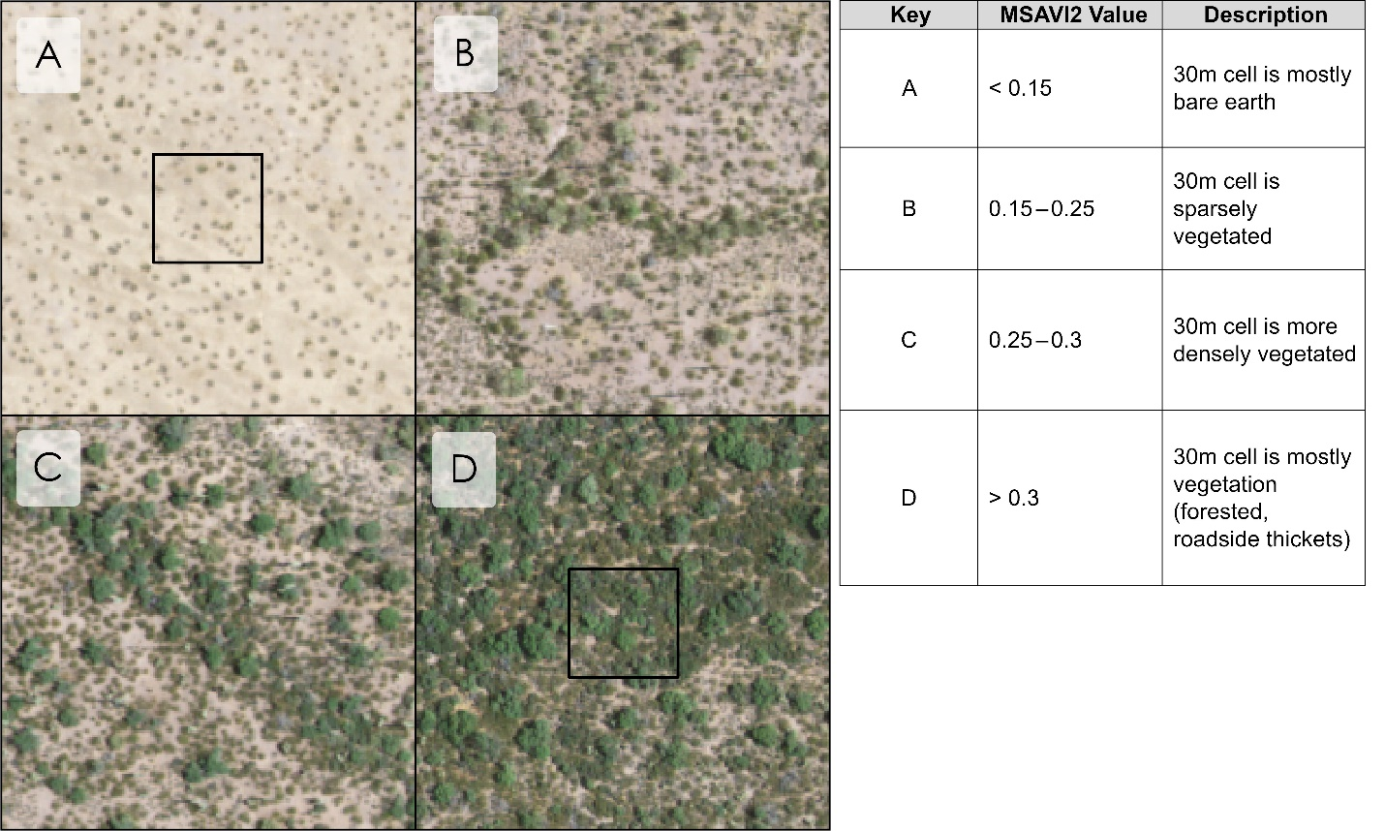
Fig. S4 Aerial images visually depicting examples of vegetation cover in the study areas and the approximate MSAVI2 values they fall within. MSAVI2 values from ~ 0 to 0.15 indicate that the majority of the 30-meter cell is bare earth (A). MSAVI2 values between 0.15 and 0.25 indicate that the majority of the 30-meter cell is sparsely vegetated (B). MSAVI2 values between 0.25 and 0.3 indicate that the majority of the 30-meter cell is more densely vegetated (C). Values above 0.3 indicate that the majority of the 30-meter cell is vegetated (D). Values above 0.3 are characteristic of roadside thickets and forested areas. Aerial images used in the figure are approximately 1-meter resolution images from the National Agricultural Imagery Program (NAIP) and were provided by the NPS.

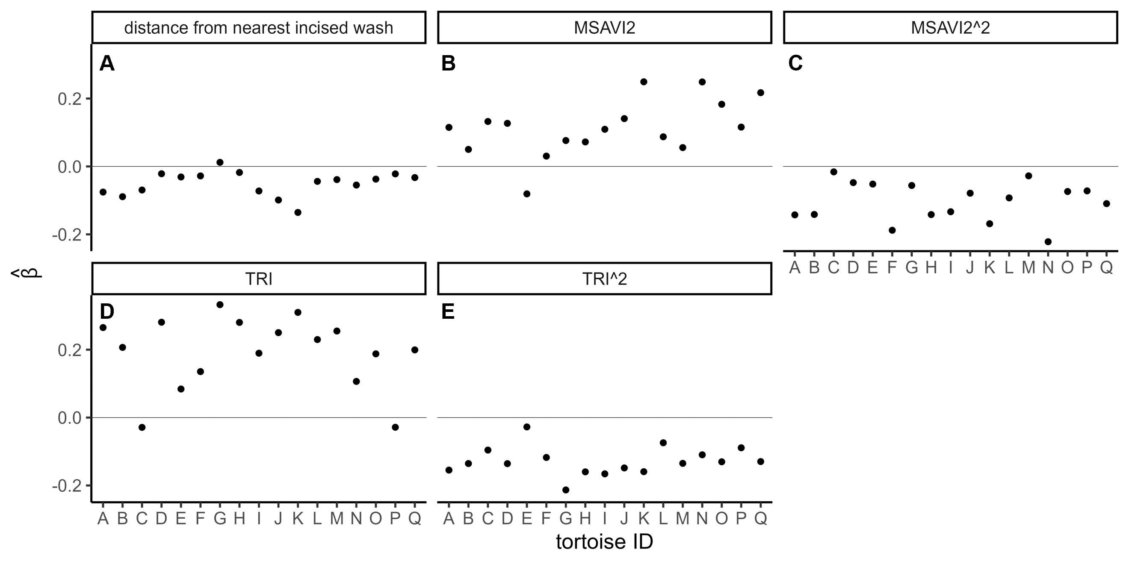
Fig. S5 Selection strength for natural landscape characteristics varies for each individual tortoise. Beta coefficient estimates for selection (y-axis) of predictor variables and individual tortoise ID (A-Q, x-axis). Positive coefficients (above the solid grey line) indicate selection and negative coefficients (below the solid grey line) indicate avoidance. In contrast with most individuals, one tortoise selected to be further from washes (A), another chose more bare areas to vegetated areas (B), and two tortoises selected areas of lower terrain ruggedness than higher terrain ruggedness (D).

