Appendix:
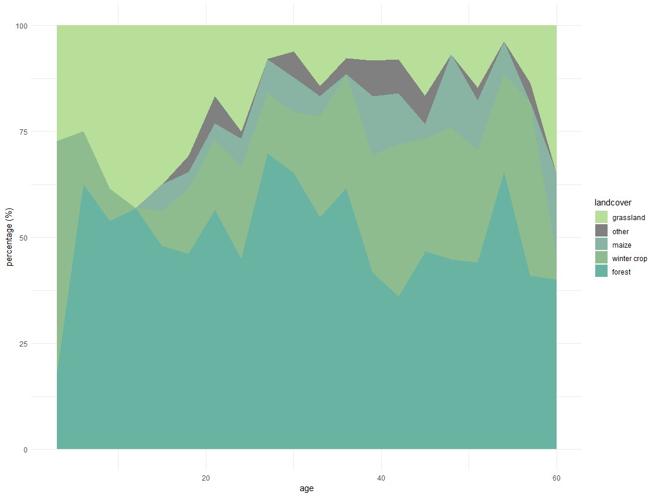
Figure A 1: Proportional use (per 3-day interval) of habitat types by roe deer females and their fawn at the locations of interactions (proximity locations) during the first 60 days of the fawn´s life.

Table A 1: Details of the roe deer female-fawn pairs monitored, in terms of location, year, length of monitoring, and analysis carried out.
 |  |  |  |  |  |  | analysis
year | study area | pairID | age collaring (days) | data length (days) | data type | spatial | temporal | LSD | bins
2021 | Oettingen | i | 2 | 127 | GPS | X |  | X
2021 | Oettingen | n | 17 | 90 | proximity, GPS | X | X | X | X
2021 | Hagenau | q | 18 | 102 | proximity, GPS | X | X | X | X
2021 | Oettingen | v | 10 | 78 | proximity, GPS | X | X | X | X
2021 | Oettingen | h | 11 | 100 | GPS | X |  | X
2021 | Hagenau | l | 4 | 103 | proximity, GPS | X | X | X | X
2021 | Oettingen | t | 2 | 30 | proximity, GPS |  | X | X | X
2021 | Oettingen | k | 7 | 39 | proximity, GPS |  | X | X | X
2021 | Oettingen | p | 15 | 128 | proximity, GPS | X | X | X | X
2021 | Hagenau | r | 9 | 152 | proximity, GPS | X | X | X | X
2022 | Oettingen | f | 2 | 18 | proximity, GPS |  | X | X | X
2022 | Hagenau | d | 2 | 77 | proximity, GPS | X | X | X | X
2022 | Oettingen | b | 6 | 45 | proximity, GPS |  | X | X | X
2022 | Steingaden | c | 4 | 158 | GPS | X |  | X
2022 | Oettingen | a | 15 | 10 | GPS |  |  | X
2022 | Oettingen | zz | 7 | 31 | proximity, GPS |  | X | X | X
2022 | Hagenau | e | 4 | 33 | proximity, GPS |  | X | X | X
2022 | Oettingen | j | 5 | 42 | GPS |  |  | X
2023 | Oettingen | x | 1 | 118 | GPS | X |  | X
2023 | Oettingen | z | 10 | 40 | GPS |  |  | X
2023 | Oettingen | y | 14 | 138 | proximity, GPS | X | X | X | X

Table A 2: Mean values of distance to wooded structures, roads, and unpaved roads of roe deer mothers and fawns per age class.
who | model  age: | distance to wooded structures (m) | distance to roads (m) | distance to unpaved roads (m)
fawn | 1-14 | 2.33 | 364.08 | 143.93
female | 1-14 | -15.38 | 362.54 | 122.14
fawn | 15-30 | -15.54 | 370.20 | 145.54
female | 15-30 | 3.16 | 362.47 | 122.30
fawn | 31-45 | -32.96 | 328.68 | 140.56
female | 31-45 | 1.36 | 315.81 | 126.08
fawn | 46-60 | -33.95 | 302.42 | 125.42
female | 46-60 | -5.65 | 307.18 | 141.82

Table A 3: Latent selection difference (LSD) function contrasting relative habitat use of roe deer mothers (coded as 1) and fawns (coded as 0) during the first 60 days of fawn life (each model describes a 14-day period).
Model 1: age 1-14 | Estimate | Std. Error | Z Value | P value | Sign. code
(Intercept) | -0.013 | 0.057 | -0.223 | 0.823
landcover: other | -0.475 | 0.100 | -4.774 | <0.001 | ***
landcover: forest | 0.072 | 0.067 | 1.073 | 0.283
landcover: unmown grassland | -0.349 | 0.060 | -5.780 | <0.001 | ***
landcover: mown grassland | -0.102 | 0.125 | -0.814 | 0.416
landcover: maize | -0.061 | 0.116 | -0.522 | 0.601
landcover: uncultivated | -0.065 | 0.102 | -0.640 | 0.522
distance to roads | 0.105 | 0.020 | 5.390 | <0.001 | ***
distance to unpaved roads | -0.090 | 0.019 | -4.733 | <0.001 | ***
I(distance to unpaved roads^2) | 0.129 | 0.016 | 8.181 | <0.001 | ***
distance to wooded structures  Model 2: age 15-30 | 0.333 | 0.027 | 12.143 | <0.001 | ***
(Intercept) | -0.172 | 0.034 | -5.057 | <0.001 | ***
landcover: other | 0.658 | 0.071 | 9.304 | <0.001 | ***
landcover: forest | 0.138 | 0.043 | 3.185 | 0.002 | **
landcover: unmown grassland | -0.167 | 0.037 | -4.491 | <0.001 | ***
landcover: mown grassland | 0.170 | 0.070 | 2.418 | 0.016 | *
landcover: maize | -0.267 | 0.053 | -5.027 | <0.001 | ***
landcover: uncultivated | 0.826 | 0.103 | 7.988 | <0.001 | ***
distance to roads | -0.017 | 0.013 | -1.393 | 0.164
I(distance to roads^2) | 0.029 | 0.008 | 3.648 | <0.001 | ***
distance to unpaved roads | -0.176 | 0.013 | -13.961 | <0.001 | ***
I(distance to unpaved roads^2) | 0.093 | 0.009 | 10.083 | <0.001 | ***
distance to wooded structures | 0.165 | 0.019 | 8.832 | <0.001 | ***

Model 3: age 31-45
(Intercept) | -0.115 | 0.040 | -2.871 | 0.004 | **
landcover: other | 0.606 | 0.069 | 8.840 | <0.001 | ***
landcover: forest | 0.152 | 0.050 | 3.037 | 0.002 | **
landcover: unmown grassland | 0.322 | 0.046 | 7.027 | <0.001 | ***
landcover: mown grassland | 0.182 | 0.106 | 1.728 | 0.084 | .
landcover: maize | 0.587 | 0.063 | 9.286 | <0.001 | ***
landcover: uncultivated | 0.388 | 0.168 | 2.307 | 0.021 | *
distance to roads | 0.038 | 0.017 | 2.212 | 0.027 | *
I(distance to roads^2) | 0.020 | 0.017 | 1.173 | 0.241
distance to unpaved roads | -0.015 | 0.015 | -0.982 | 0.326
I(distance to unpaved roads^2) | -0.014 | 0.011 | -1.179 | 0.239
distance to wooded structures | 0.033 | 0.023 | 1.447 | 0.148
I(distance to wooded structures^2)  Model 4: age 46-60 | -0.075 | 0.010 | -7.572 | <0.001 | ***
(Intercept) | 0.096 | 0.061 | 1.567 | 0.117
landcover: other | 0.668 | 0.123 | 5.431 | <0.001 | ***
landcover: forest | -0.002 | 0.074 | -0.026 | 0.979
landcover: unmown grassland | 0.022 | 0.073 | 0.303 | 0.762
landcover: mown grassland | 0.379 | 0.136 | 2.781 | 0.005 | **
landcover: maize | -0.071 | 0.080 | -0.893 | 0.372
landcover: uncultivated | 0.045 | 0.397 | 0.114 | 0.909
distance to roads | 0.030 | 0.024 | 1.290 | 0.197
distance to unpaved roads | 0.068 | 0.022 | 3.083 | 0.002 | **
I(distance to unpaved roads^2) | -0.052 | 0.017 | -3.127 | 0.002 | **
distance to wooded structures | 0.182 | 0.032 | 5.791 | <0.001 | ***
I(distance to wooded structures^2) | 0.042 | 0.017 | 2.523 | 0.012 | *
Sign. codes: 0 '***' 0.001 '**' 0.01 '*' 0.05 '.' 0.1 ' ' 1

Table A 4: P-values from the chi-square tests, which compare the relative proportions of habitat use categories at observed mother-offspring contact locations compared with the available proportions of each habitat use category within the mother-offspring home range during the first 60 days of the fawns’ lives (α = 0.05). For further details, see Figure 7 and the methods section.
age model | 1-14 | 15-30 | 31-45 | 46-60
resource use category 1 | 0.9549 | 0.8927 | 0.9882 | 0.9862
resource use category 2 | 0.9677 | 0.9793 | 0.9874 | 0.8921
resource use category 3 | 0.8921 | 0.9372 | 0.9563 | 0.9777
resource use category 4 | 0.8446 | 0.9393 | 0.9469 | 0.9020
resource use category 5 | 0.9691 | 0.9900 | 0.9452 | 0.9906

