Additional file 4

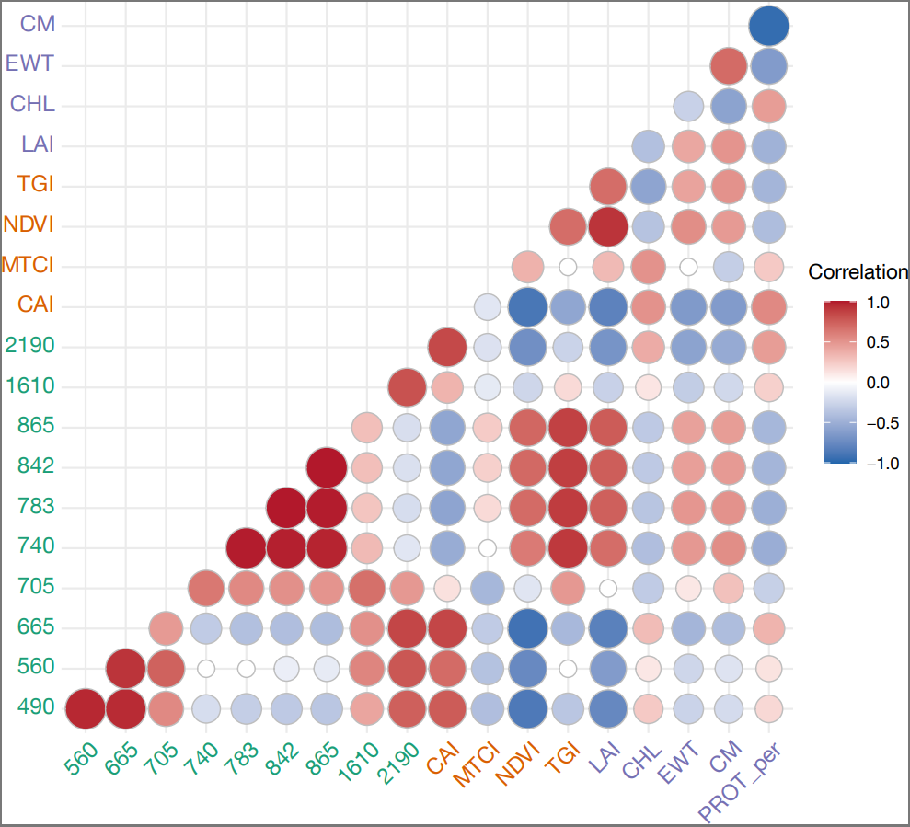
Figure A4. Correlations between predictor variables for the models of biomass and relative nitrogen grouped by types: Sentinel-2 spectral bands (green), vegetation indices (orange), and optical traits (blue). The strengths of correlations are indicated by a colour gradient and by symbol size.

