Additional file 1: SUPPLEMENTAL FIGURES
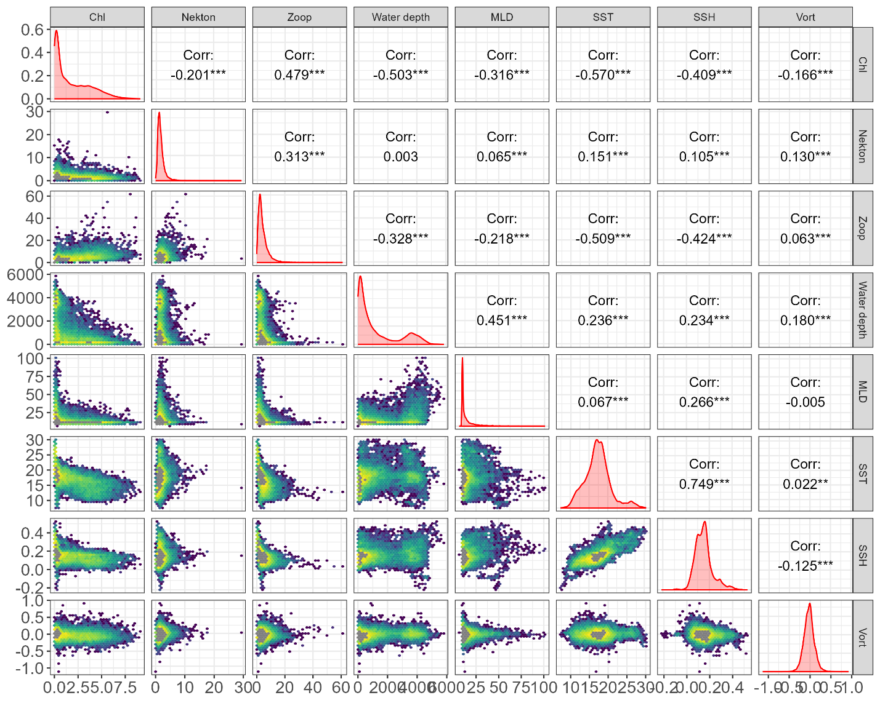
Figure A-1: Distributions and correlations of candidate ecological covariates fitted to blue whale move persistence models.

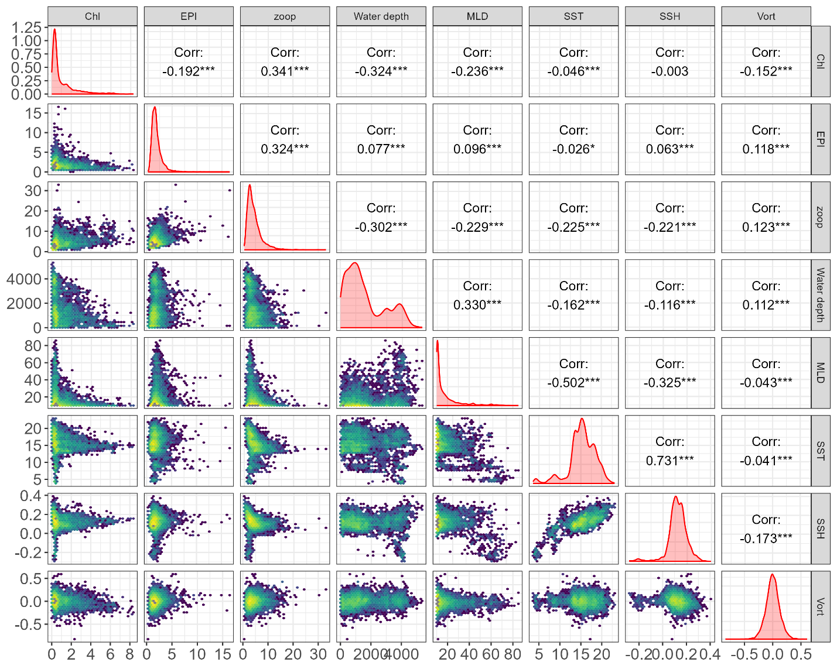
Figure A-2: Distributions and correlations of candidate ecological covariates fitted to fin whale move persistence models.

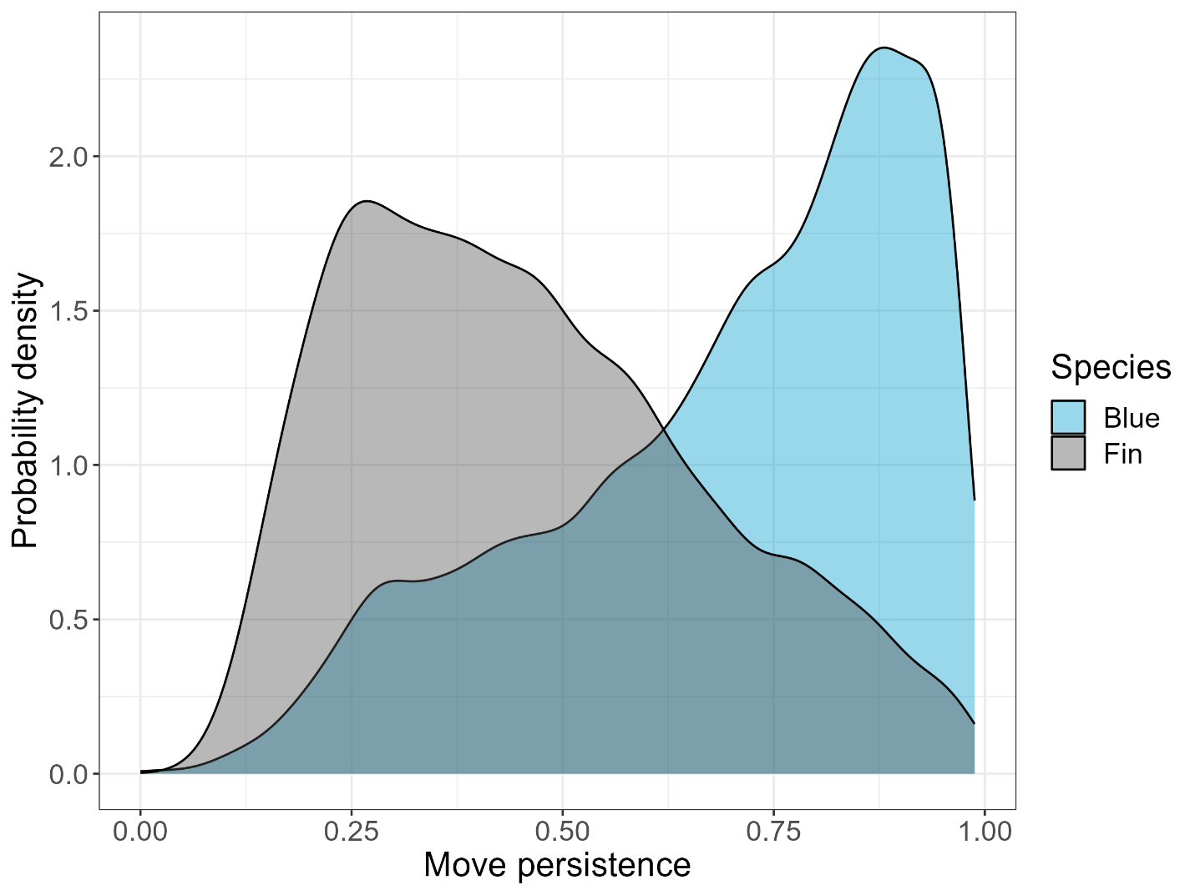
Figure A-3: Probability density distributions of move persistence values for blue and fin whales tracked in the eastern north Pacific Ocean from 1998 - 2018.

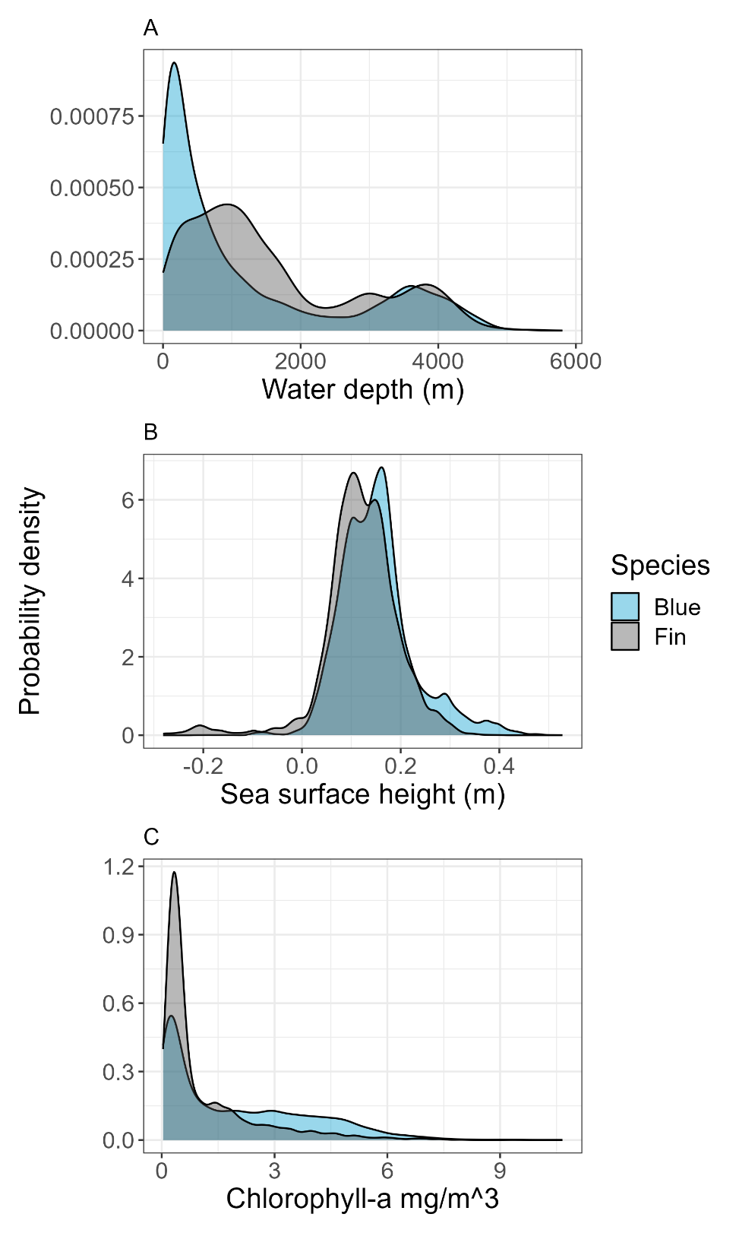
Figure A-4: Distribution of A) water depth, B) sea surface height, and C) Chlorophyll-a concentration values at blue and fin whale tracking locations within the CCE from 1998 - 2018.

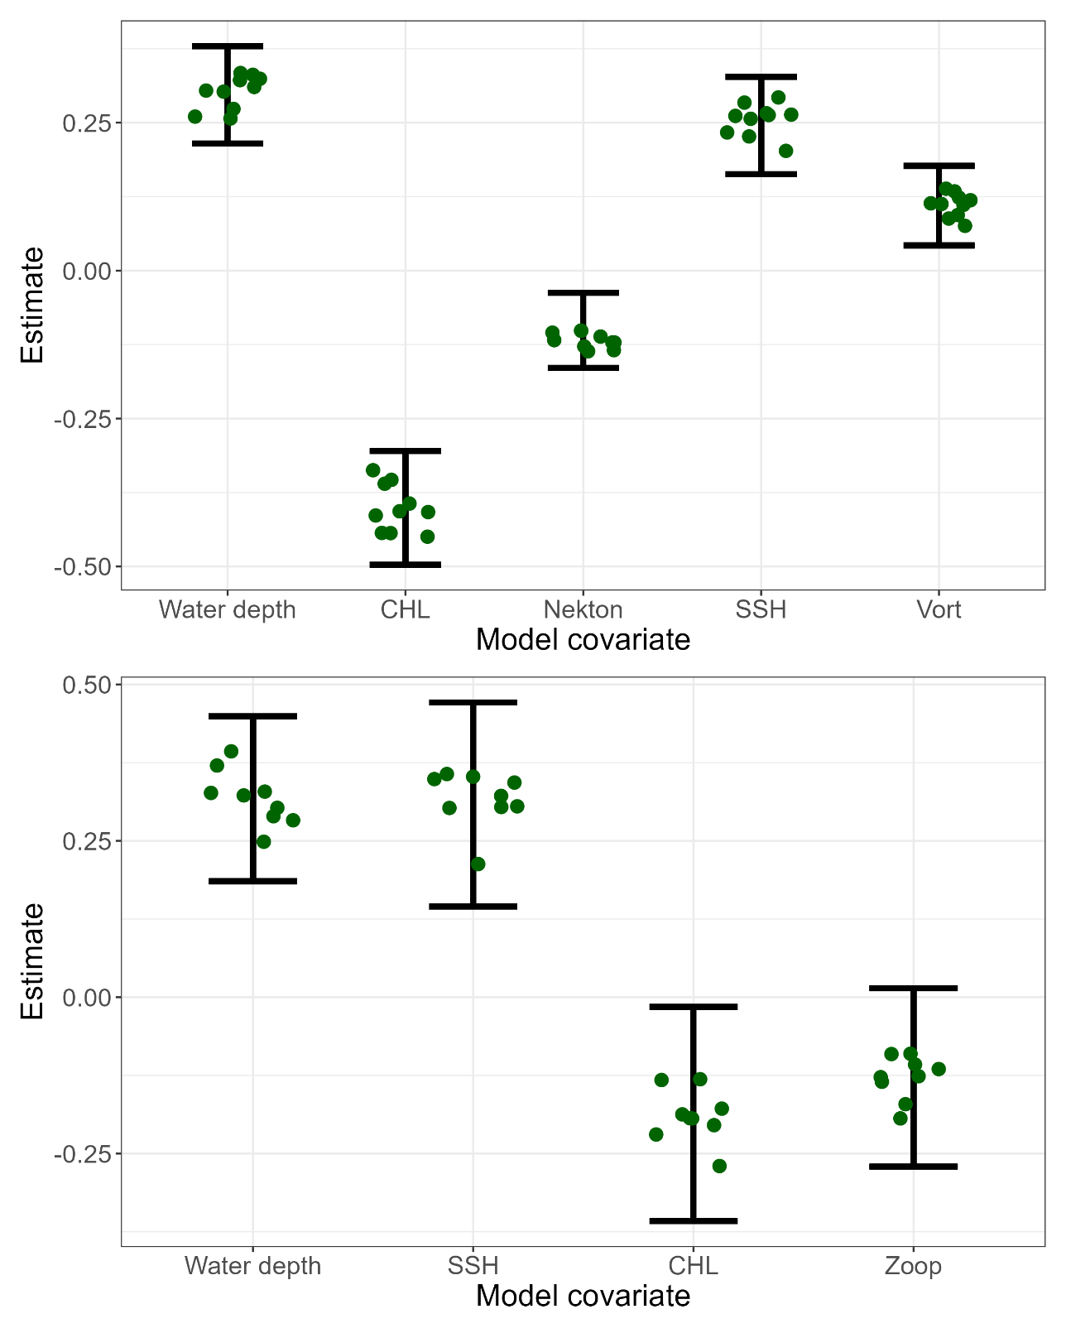
Figure A-5: Move persistence model cross-validation results for blue (top) and fin whales (bottom). Each green point represents a covariate effect estimate generated after having excluded 10% of track segments. Error bars represent the 95% confidence interval of the parameter estimate from the full model. All cross validation estimates should fall within the confidence intervals to indicate robustness.

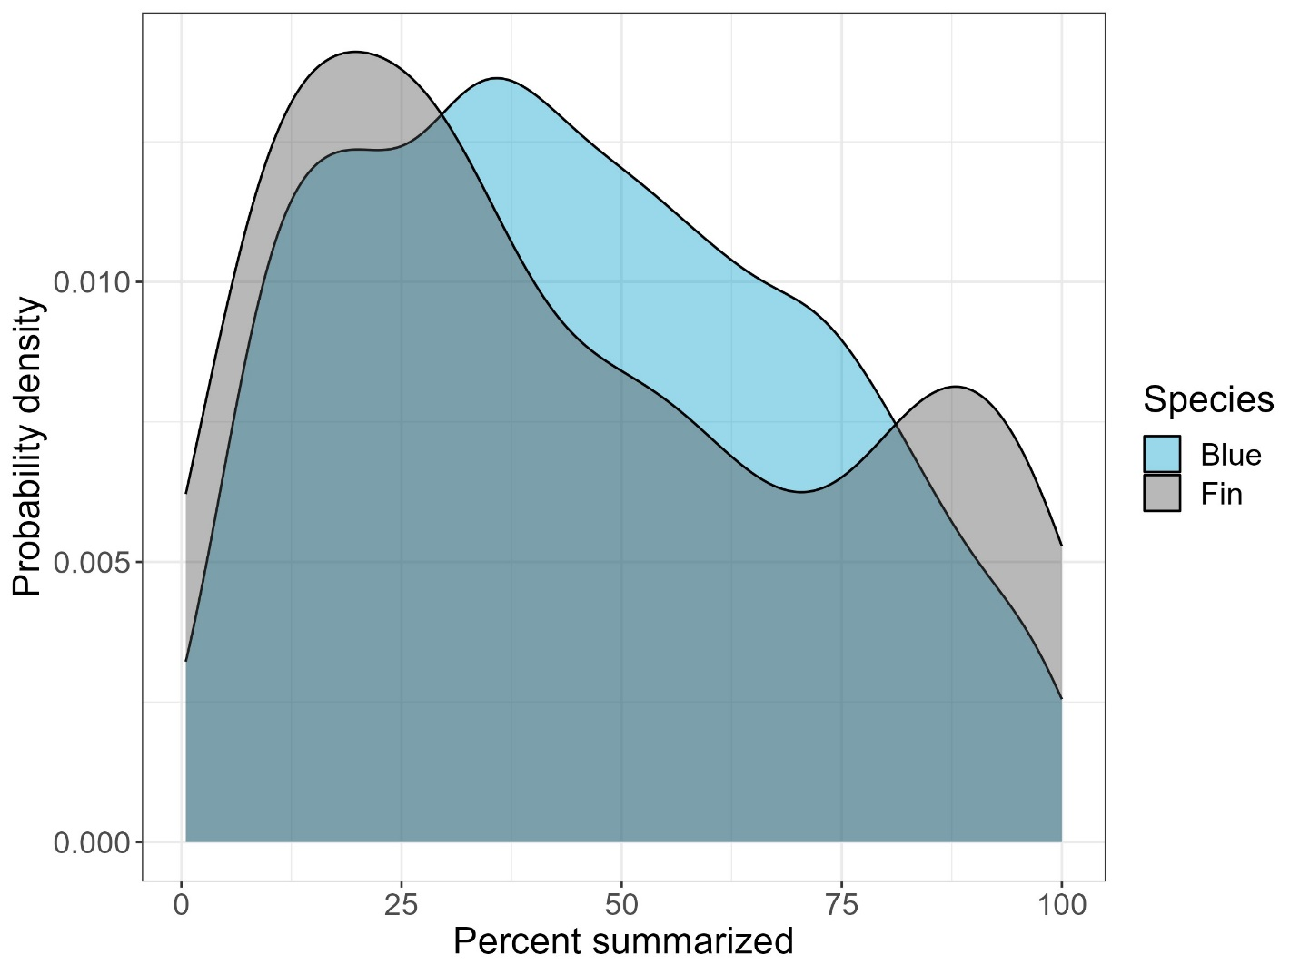
Figure A-6: Percentage of each 12-h RDW-tag location time-step summarized with reported dive behavior data. RDW tags were deployed during summer on blue whales in 2016 and 2017, and fin whales in 2016. The percentage of a time-step summarized was calculated as the sum of all dive durations and post-dive intervals received through Argos for a given time step, divided by the duration of the interval (12 h).

