Additional file 6
Effects of vasectomy on breeding-related movement and activity in free-ranging white-tailed deer
Vickie DeNicola, Stefano Mezzini, Petar Bursać, Pranav Minasandra, and Francesca Cagnacci

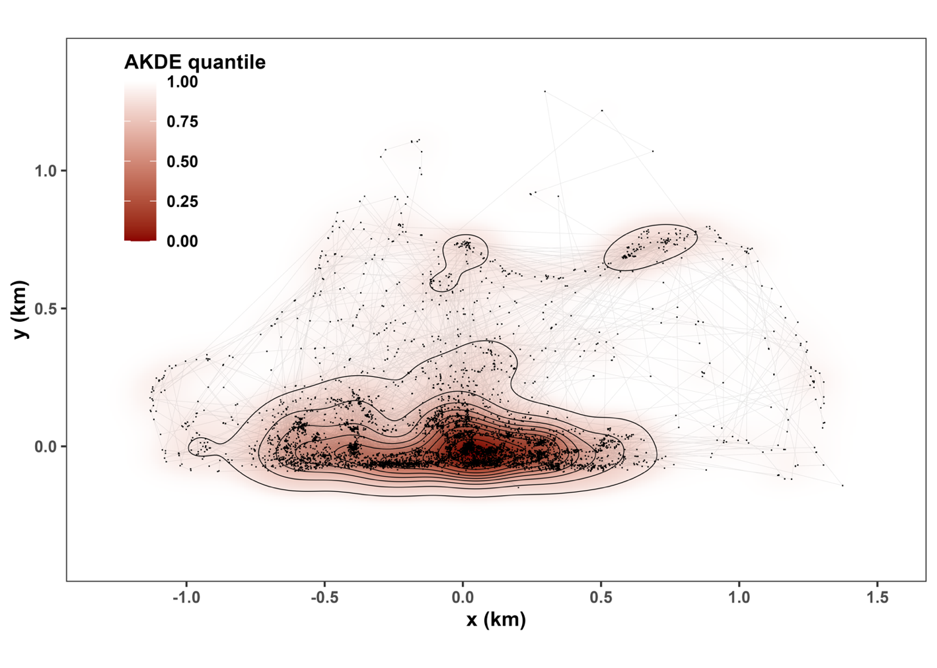

Figure S1. Telemetry data (dots) and autocorrelated kernel density estimate (shading) for deer 148 in Year 1 (2021–22) with a two-point equidistant projection. The contours indicate quantiles at intervals of 0.1. Excursivity was measured by taking the average quantile of the locations for each day. A value close to 0 indicated the deer used high-use areas, whereas a value of 1 indicated that the deer used more “peripheral” areas that were generally only used during excursions.

