Additional Files for:
Changes in waterfowl movement behavior in response to hunting pressure
Karen E. Beatty, Nathaniel R. Huck, Frances E. Buderman

Figure A-1: Aerial imagery map of Pymatuning Wildlife Management Area and the surrounding landscape dated 2022, including an outline of the WMA property boundaries and marked hunting blind locations.

Figure A-2: Aerial imagery map of Middle Creek Wildlife Management Area and the surrounding landscape dated 2022, including an outline of the WMA property boundaries and marked hunting blind locations.

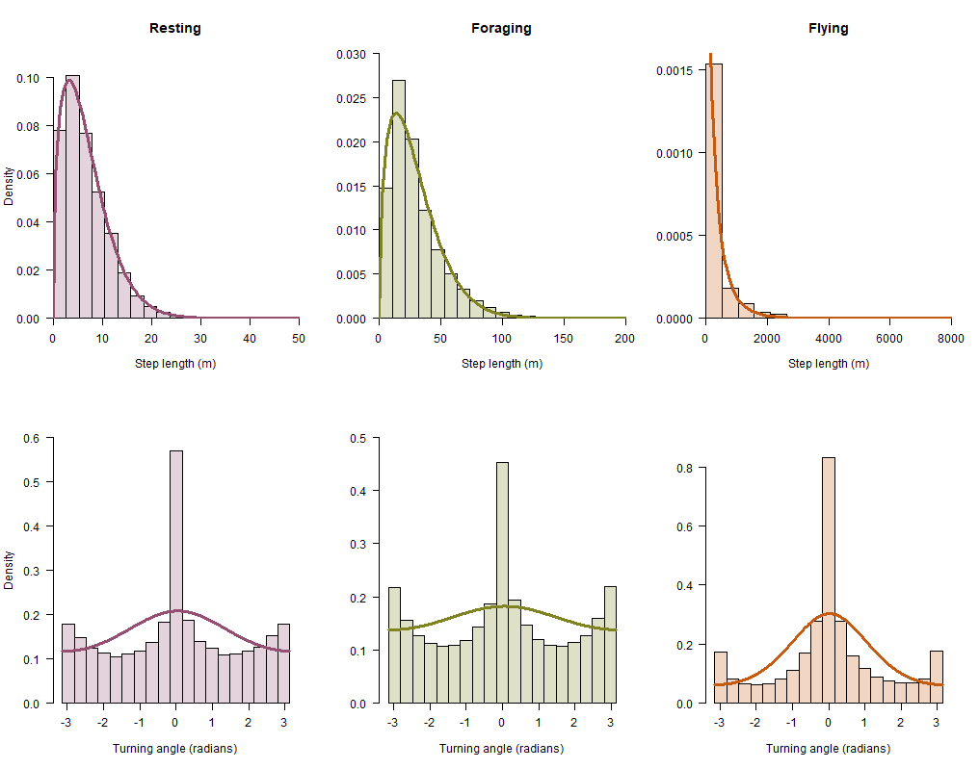

Figure A-3: Fitted step length and turning angle density for each estimated state plotted over observed step lengths and turning angles. Note the different x-axes ranges for step lengths.
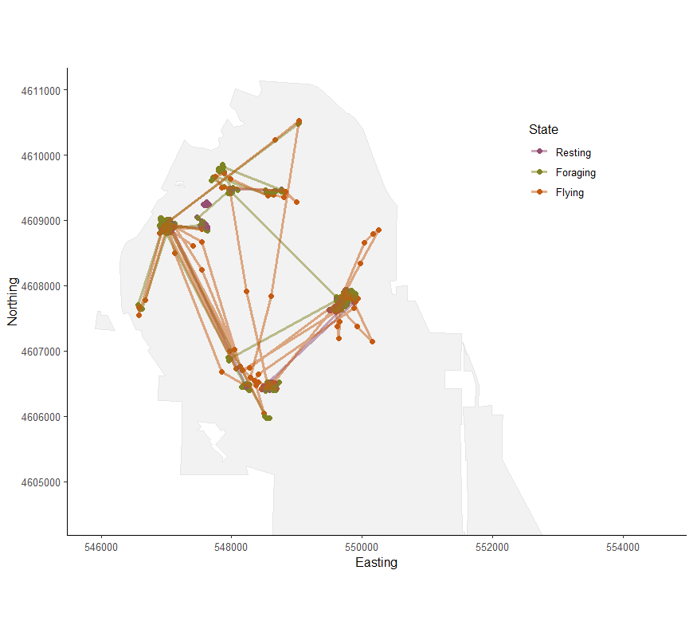
Figure A-4: Most probable state sequence estimated from one individual (ID 1258-83961) at Pymatuning WMA. Each point represents the most likely latent state during that observation within the overall time series. Only 2000 steps are plotted for visualization purposes.

