Supplement to
Wolverines use spatial memory to plan efficient routes through rugged terrain
Thomas W. Glass, Jeffery P. Copeland, Lucretia E. Olson, John S. Waller, John R. Squires
Appendix S1

Step-selection function covariate processing
We generated topographic covariates (elevation, slope angle, and “ridge”) using the 15 arc-second Global Multi-resolution Terrain Elevation Dataset (GMTED; U.S. Geological Survey, 2011), which we resampled to 30 m resolution. We calculated slope using the terra package in R (Hijmans, 2023). To determine whether each pixel fell on a ridge, we calculated topographic position index (TPI) as the difference between a pixel’s elevation and the median elevation within 300 meters and assigned “ridge” as those pixels with TPI > 55. We used the National Hydrography Dataset to identify flowlines of streams and rivers (Moore et al., 2019), and the North American Land Change Monitoring System (NALCMS) – 2015 for land cover class (North American Land Change Monitoring System, 2020). Since all pixels coded “urban” in our study area represented roads or parking lots, we refer to this class as “road.”

Table S1 Sample sizes by individual wolverine and route duration.
Duration (minutes) | F4 | M1 | M19 | M23 | M3 | Total
30 | 30 | 376 | 35 | 98 | 109 | 648
45 | 13 | 190 | 14 | 49 | 58 | 324
60 | 10 | 160 | 13 | 27 | 42 | 252
75 | 7 | 134 | 10 | 24 | 34 | 209
90 | 6 | 91 | 7 | 21 | 23 | 148
105 | 8 | 77 | 5 | 14 | 21 | 125
120 | 3 | 58 | 2 | 10 | 15 | 88
135 | 2 | 54 | 3 | 6 | 15 | 80
150 | 2 | 44 | 4 | 7 | 12 | 69
165 |  | 38 | 2 | 6 | 8 | 54
180 |  | 32 | 2 | 3 | 9 | 46
195 |  | 28 | 2 | 4 | 7 | 41
210 |  | 23 | 2 | 5 | 7 | 37
225 |  | 22 | 1 | 6 | 6 | 35

Table S2 Top 10 models out of all possible covariate combinations, evaluated using Akaike’s Information Criterion (AIC). “X” indicates inclusion of the covariate in the model. Slope, elevation, and distance to streams/rivers (“Streams”) were included as quadratic terms.
AIC | ΔAIC | Slope | Elevation | Ridge | Forest | Shrub | Grass | Barren | Roads | Streams | Energy
13,561.9 | 0.0 | X | X | X |  | X | X |  | X | X | X
13,563.5 | 1.7 | X | X | X |  | X | X | X | X | X | X
13,563.6 | 1.8 | X | X | X | X | X | X |  | X | X | X
13,564.3 | 2.5 | X | X | X |  |  | X |  | X | X | X
13,565.4 | 3.5 | X | X | X | X | X | X | X | X | X | X
13,566.0 | 4.1 | X | X | X |  |  | X | X | X | X | X
13,566.2 | 4.3 | X | X |  |  | X | X |  | X | X | X
13,566.3 | 4.5 | X | X | X | X |  | X |  | X | X | X
13,567.6 | 5.8 | X | X |  |  | X | X | X | X | X | X
13,567.7 | 5.8 | X | X | X |  | X |  |  | X | X | X

Table S3 Distance and number of steps for simulated versus observed routes across route durations (95% interquantile range shown in parentheses).
Route  duration | Median simulated  distance (km) | Median observed  distance (km) | Median  simulated steps | Median  observed steps
30 min | 1.6 (0.4-3.3) | 1.4 (0.4-2.9) | 8 (3-12) | 6 (6-7)
45 min | 2.6 (0.7-4.7) | 2.3 (0.7-4.1) | 10 (4-16) | 9 (9-10)
60 min | 3.1 (1-5.4) | 3.1 (1.2-5.3) | 16 (6-24) | 12 (11-13)
75 min | 3.9 (1.3-7.1) | 3.9 (1.5-6.7) | 20 (7-30) | 15 (13-16)
90 min | 4.7 (1.8-8.3) | 4.9 (2-7.9) | 23 (10-35) | 18 (16-19)
105 min | 5.1 (2.2-9.1) | 5.3 (2.3-9) | 26 (11-40) | 21 (18-22)
120 min | 5.9 (2.9-10.4) | 6.2 (3-9.7) | 29 (14-46) | 23 (21-25)
135 min | 7.3 (3.7-10.4) | 7.3 (3.5-10.8) | 36 (18-51) | 26 (23-28)
150 min | 7.4 (3.6-12.2) | 7.4 (3.6-11.7) | 37 (19-57) | 29 (25-31)
165 min | 8.3 (3.5-12.9) | 8.7 (4-12.6) | 41 (18-62) | 31 (29-34)
180 min | 9.4 (4.4-14.6) | 10 (4.8-14.5) | 45 (22-65) | 34 (31-37)
195 min | 9.6 (5.2-14.3) | 9.8 (5.3-14.2) | 48 (27-72) | 36 (34-40)
210 min | 9.1 (5.1-15) | 11.1 (5.7-15.6) | 46 (27-74) | 40 (36-43)
225 min | 10.3 (5.5-17) | 10.7 (5.8-16.5) | 53 (28-85) | 41 (38-45)

Table S4 Median differences between observed wolverine movement routes and simulated local knowledge routes (see Figure 3 in the main text for confidence intervals). Differences were estimated using paired Wilcoxon signed-rank tests. Energy and efficiency values were standardized prior to analysis to facilitate effect size comparison. Resource efficiency is defined using the inverse of an exponentiated habitat kernel generated from a fitted step selection function. Positive values indicate higher efficiency or total energy in the route taken by the wolverine, negative values indicate lower efficiency or total energy.
Route duration  (min) | Energy efficiency | Resource efficiency | Total energy expenditure
30 | 0.13 | 0.12 | -0.31
45 | 0.11 | 0.09 | -0.33
60 | 0.16 | 0.12 | -0.28
75 | 0.12 | 0.12 | -0.26
90 | 0.15 | 0.15 | -0.31
105 | 0.20 | 0.23 | -0.30
120 | 0.17 | 0.20 | -0.36
135 | 0.20 | 0.26 | -0.38
150 | 0.26 | 0.26 | -0.37
165 | 0.15 | 0.26 | -0.35
180 | 0.19 | 0.25 | -0.39
195 | 0.13 | 0.23 | -0.34
210 | 0.05 | 0.15 | -0.28
225 | 0.05 | 0.14 | -0.29

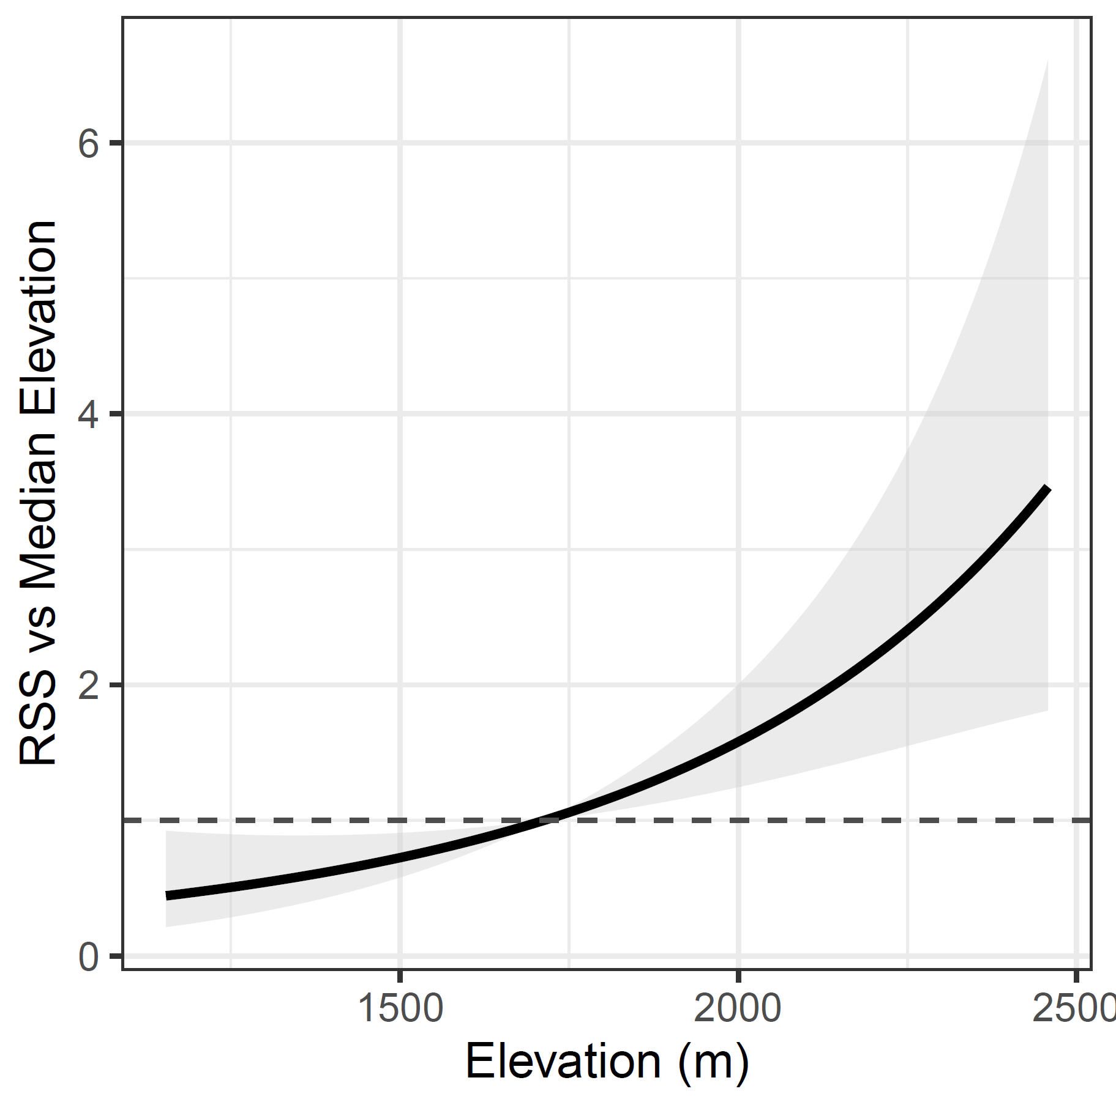
Figure S1 Relative selection strength for elevation, referenced against the median elevation used by study animals (1,713 m).
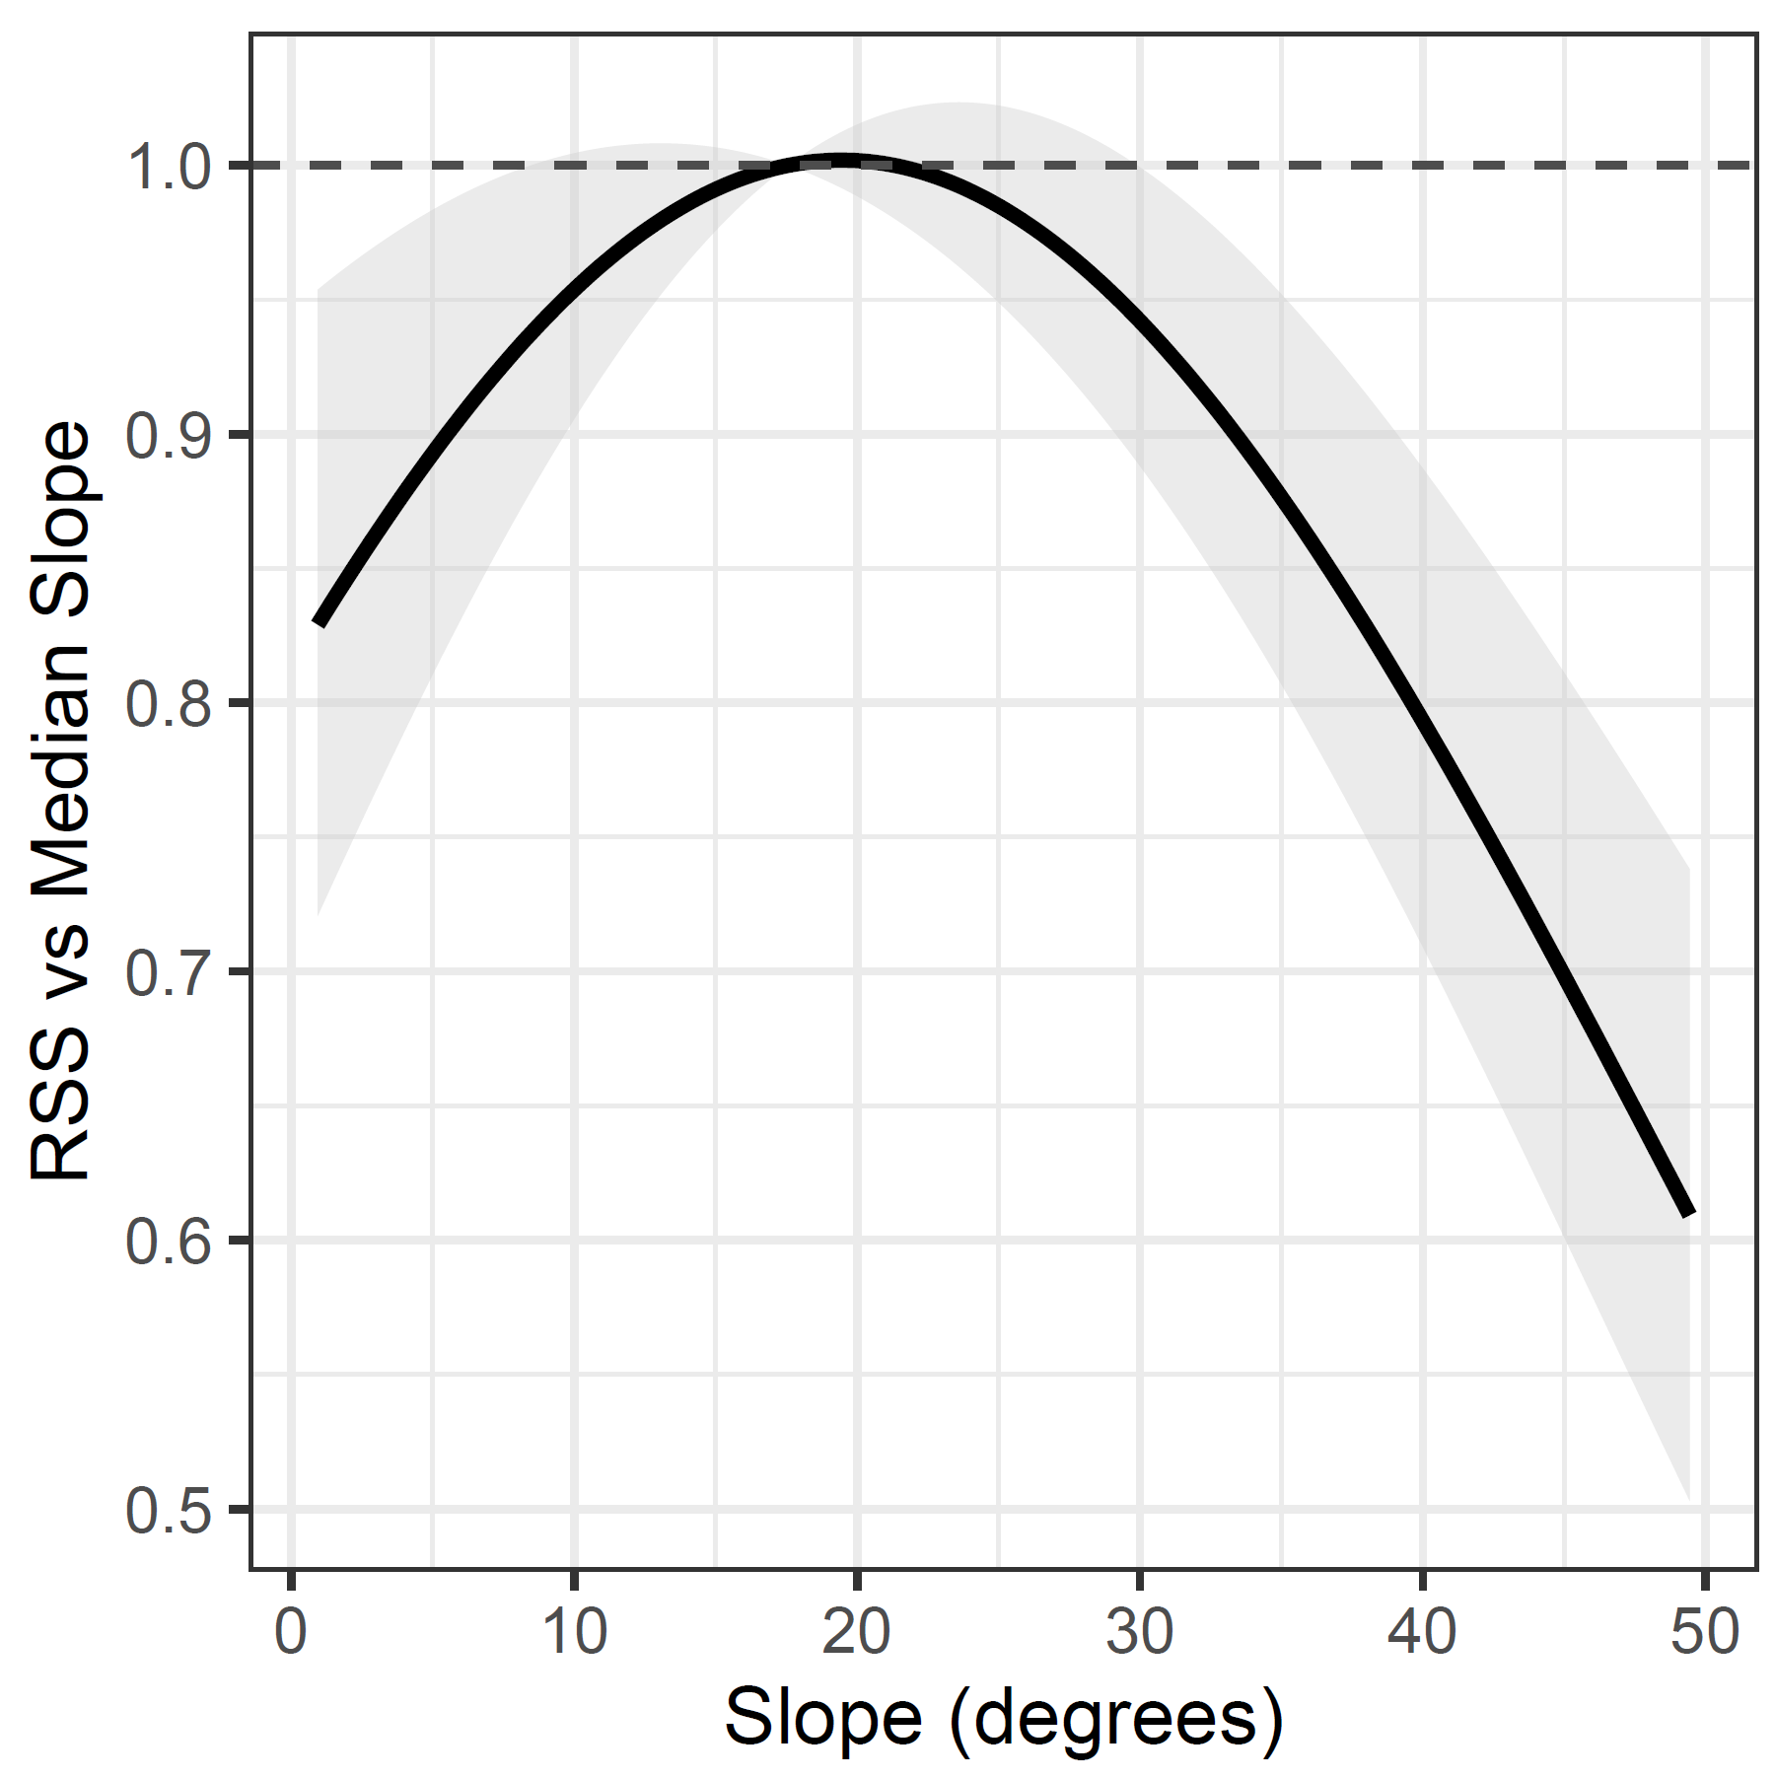
Figure S2 Relative selection strength for slope, reference against the median slope used by study animals (17.6°).

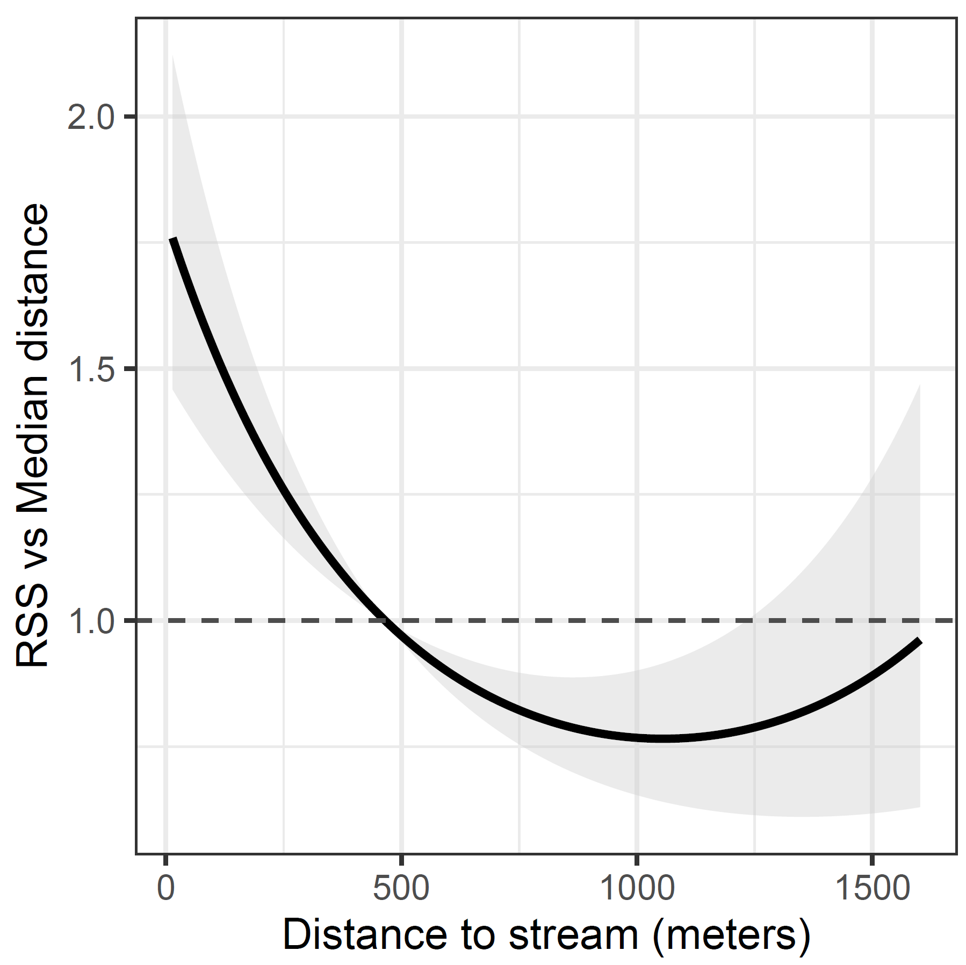
Figure S3 Relative selection strength for “distance to stream”, reference against the median distance used by study animals (465 m).

References
Hijmans, R. J. (2023). terra: Spatial Data Analysis (R Package Version 1.5.34). https://CRAN.R-project.org/package=terra
Moore, R. B., McKay, L. D., Rea, A. H., Bondelid, T. R., Price, C. V., Dewald, T. G., & Johnston, C. M. (2019). User’s guide for the National Hydrography Dataset plus (NHDPlus) High Resolution. Open-File Report - US Geological Survey, 2019–1096, 66.
North American Land Change Monitoring System. (2020). 2015 Land Cover of North America at 30 meters.
U.S. Geological Survey. (2011). Global Multi-resolution Terrain Elevation Data 2010.

