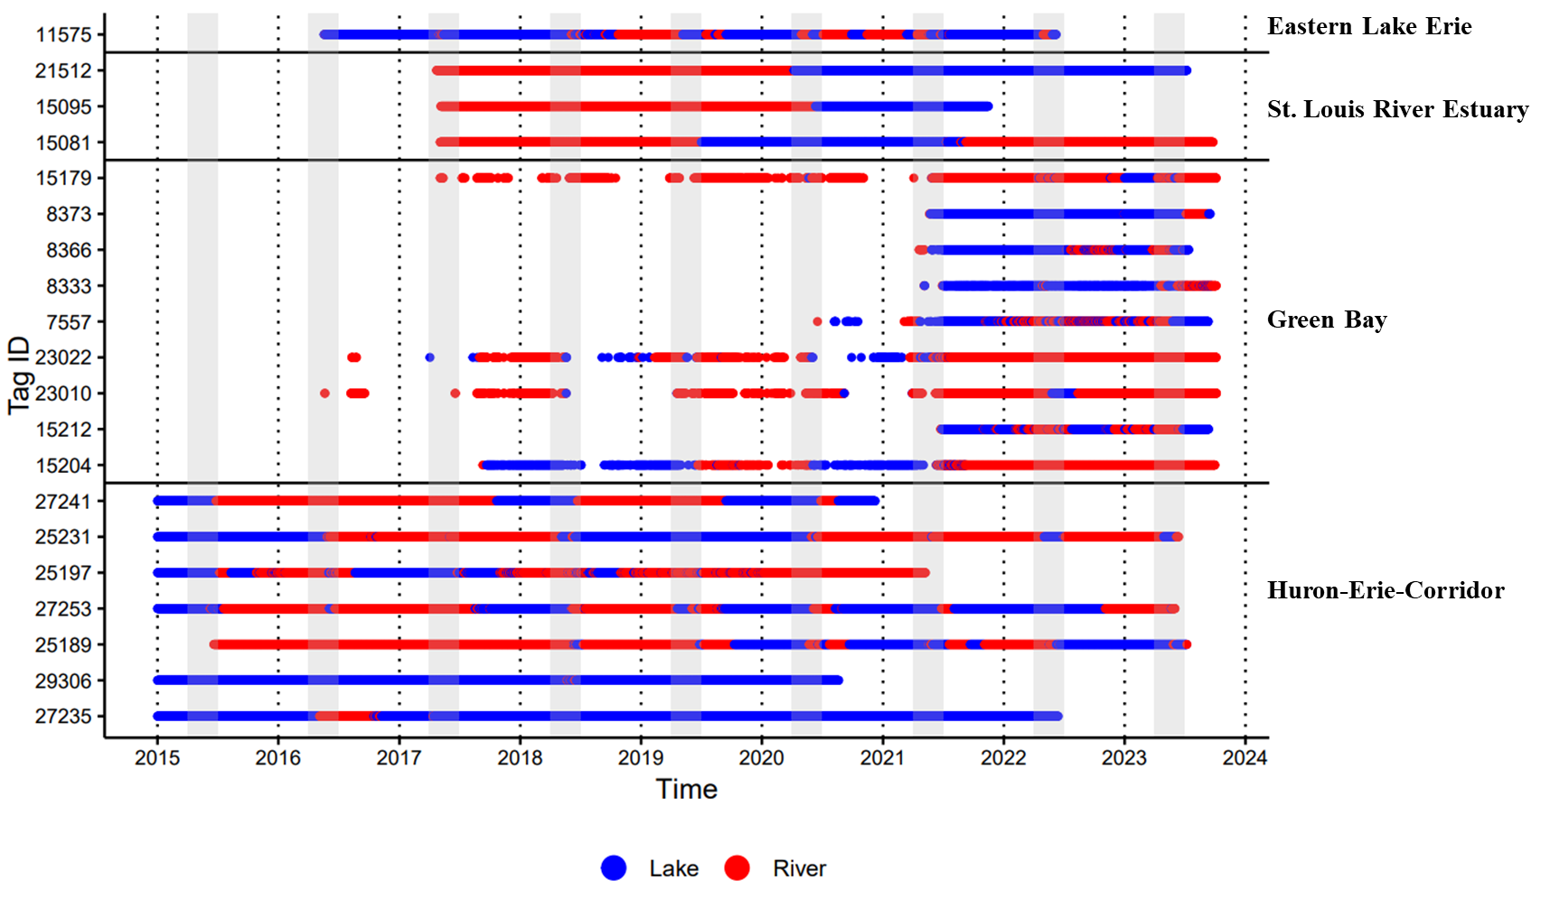
Supplemental File 12. Habitat sequences for unclassified lake sturgeon. Individuals were unable to be classified using agglomerative hierarchical clustering and visual inspection due to behavioral sequences not conforming with one of the seven identified patterns of migratory behavior. Solid horizontal lines delineate populations, and gray bars indicate the typical lake sturgeon spawning season in the Laurentian Great Lakes (April-June).

