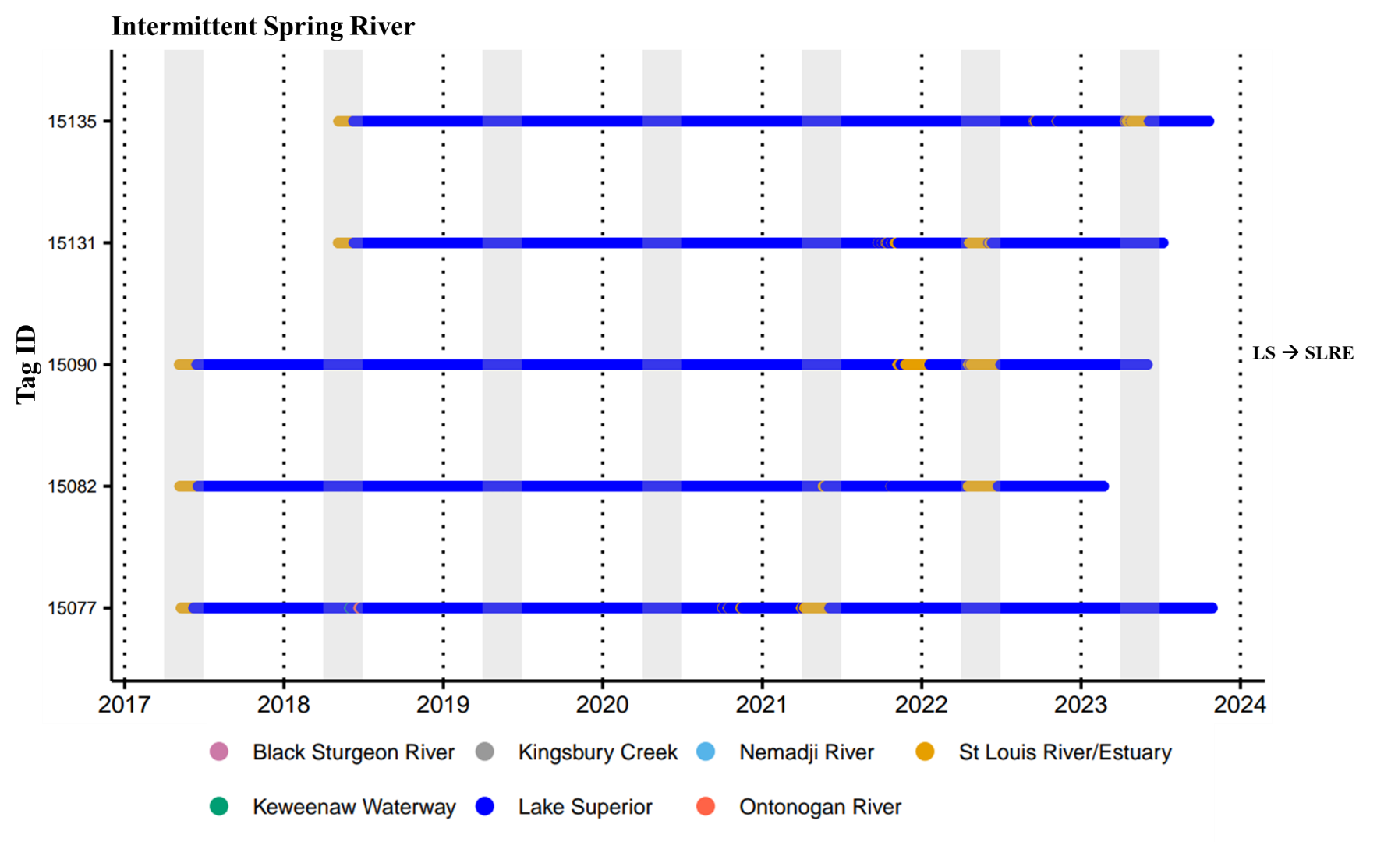
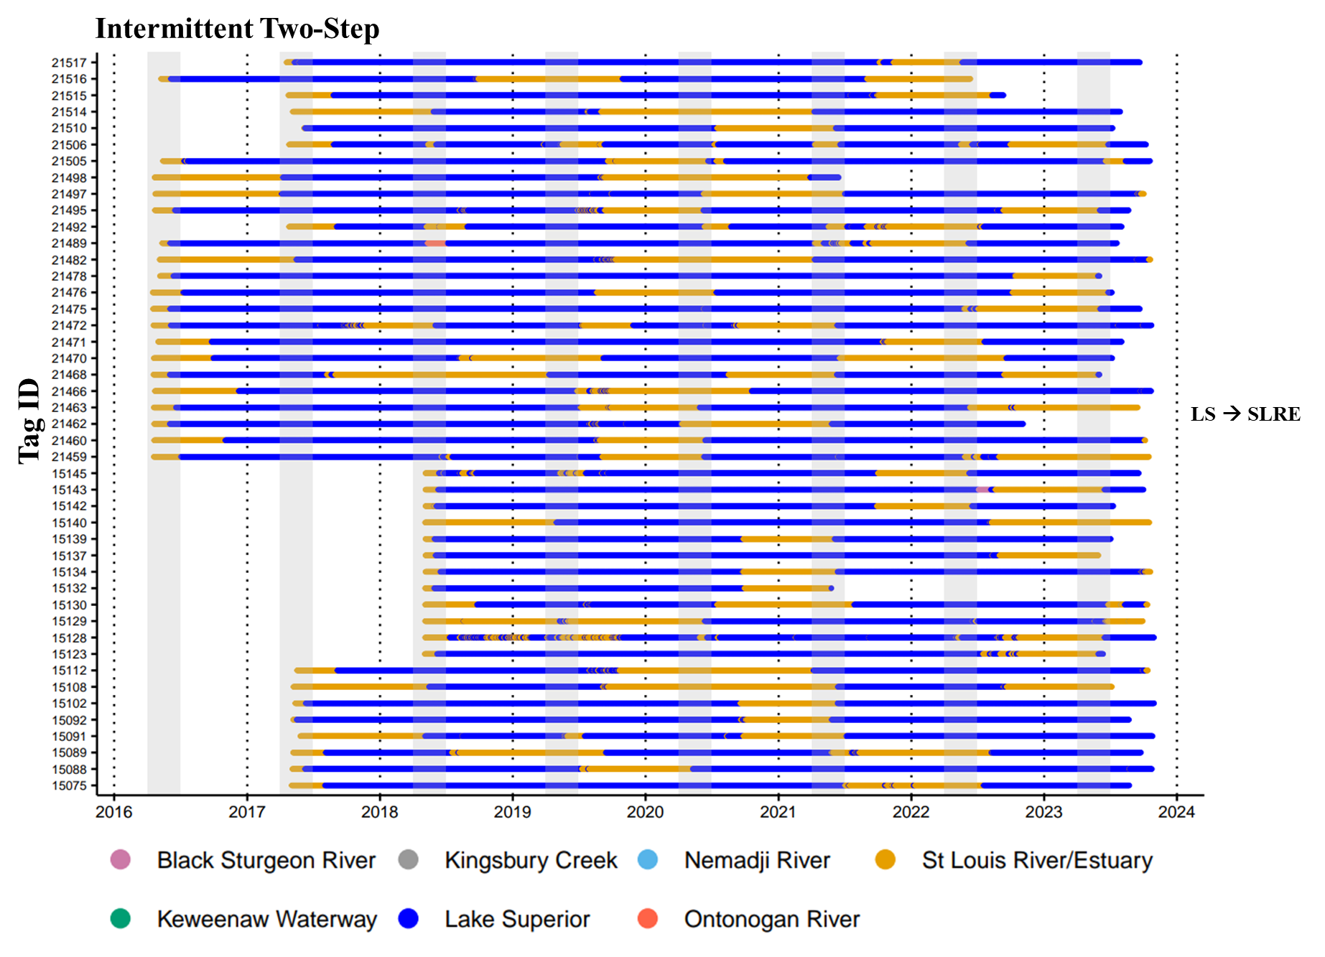
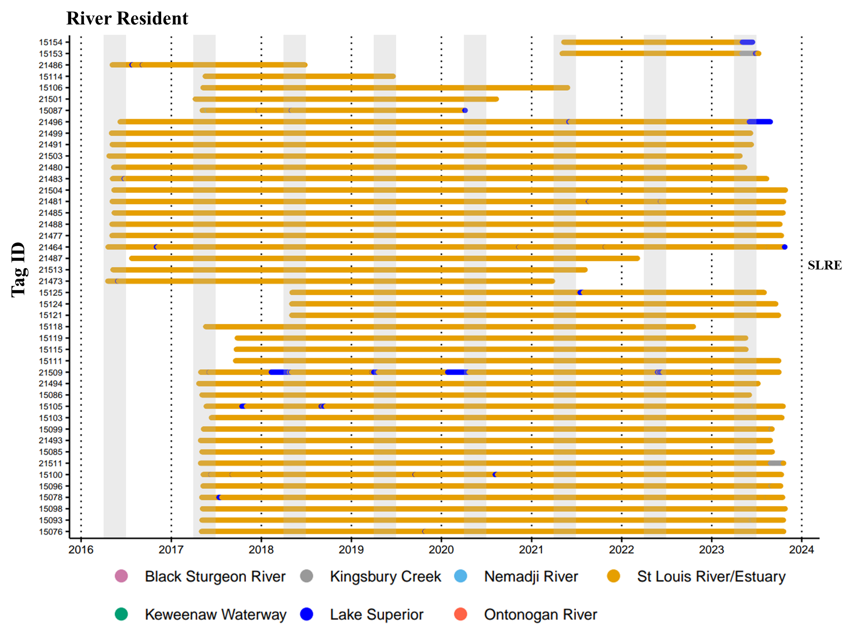
Supplemental Figure 8. Regional sequences displaying the assigned migratory behavior and contingent for all classified individuals (N=94) from the St. Louis River Estuary population. Individuals were classified using agglomerative hierarchical clustering followed by visual inspection of habitat and regional sequences. Contingents are displayed on the right side of each migratory behavior plot, and all regional names used for contingents are abbreviated: Lake Superior (LS) and St. Louis River Estuary (SLRE).

