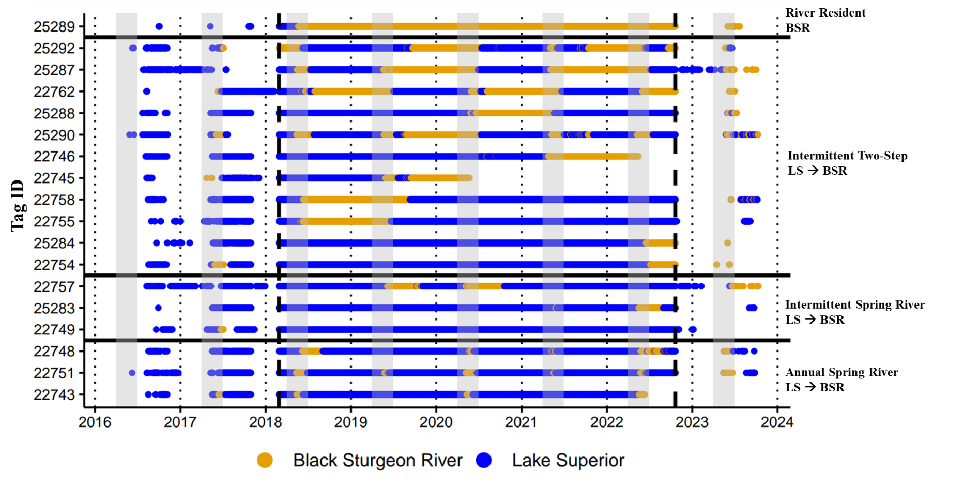
Supplemental File 9. Regional sequences displaying the assigned migratory behavior and contingent for all classified individuals (N=18) from the Black Sturgeon River population. Individuals were classified using agglomerative hierarchical clustering followed by visual inspection of habitat and regional sequences. Migratory behaviors and contingents are displayed on the right side of the plot, and all regional names used for contingents are abbreviated: Lake Superior (LS) and Black Sturgeon R. (BSR). Solid horizontal lines delineate migratory behaviors, gray bars indicate the typical lake sturgeon spawning season in the Laurentian Great Lakes (April-June), and the vertical dashed line denotes the daily location history time frame used for sequence analyses (2/26/2018 – 10/20/2022). Gaps in sequences prior to and after the dashed line did not have last observation carried forward applied and therefore display data based solely on receiver detections.

