Supplementary material
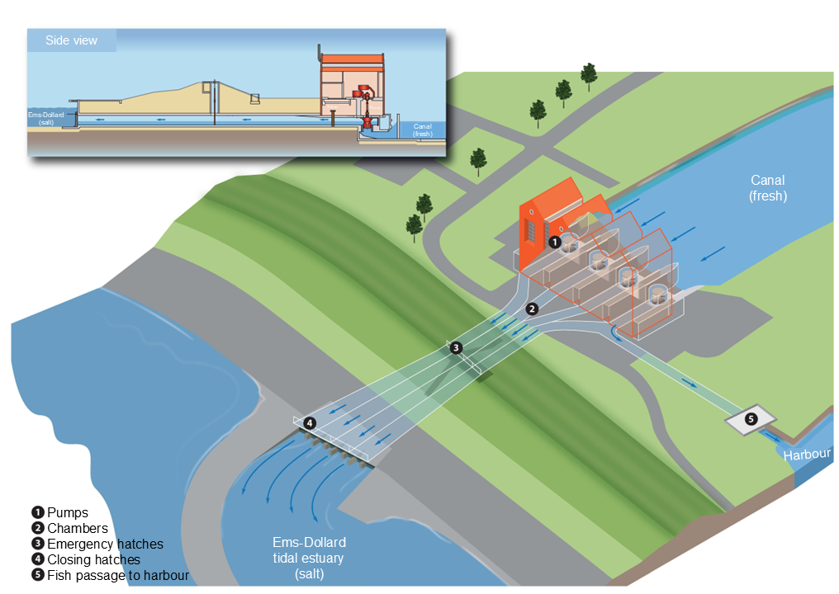
Figure S1. Schematic detailed overview of the Rozema PS.
Table S1 Placement information of the 10 acoustic receivers
Receiver | Location name | Lat | Long | Date placement | Date recovery
R1 | Canal 1 | 53.28213 | 7.004499 | 24-8-2021 | 19-1-2022
R2 | Side canal towards Delfzijl | 53.29359 | 7.000795 | 24-8-2021 | 19-1-2022
R3 | Canal 2 | 53.29602 | 7.024892 | 24-8-2021 | 19-1-2022
R4 | Old sluice | 53.30114 | 7.033437 | 18-8-2021 | 19-1-2022
R5 | Canal 3 | 53.30049 | 7.035373 | 24-8-2021 | 19-1-2022
R6 | Shipping sluice | 53.30148 | 7.036786 | 18-8-2021 | 19-1-2022
R7 | Entrance fish passage | 53.30223 | 7.037271 | 18-8-2021 | 2-2-2022
R8 | Saltwater side | 53.30332 | 7.037069 | 18-8-2021 | 2-2-2022
R9 | Before pumping station Rozema | 53.30307 | 7.038893 | 24-8-2021 | 16-2-2022
R10 | After pumping station Rozema | 53.30307 | 7.038893 | 18-8-2021 | 2-2-2022

Table S2. Number of eels detected on receivers in this and other projects. European Tracking Network – data management platform. Flanders Marine Institute, 2024, http://www.lifewatch.be/etn/, accessed 10-05-2024.
Project area and ETN acronym | Project citation | Latitude | Longitude | Number of eels detected
Termunterzijl- current project RBVV2: Clear way for fish 2 | Huisman, J.; van Eerbeek J.; van der Knaap, I.; Van Hall Larenstein: Ruim baan voor vis 2; 2021. https://marineinfo.org/doc/dataset/7822 | 53.343294 | 6.967318 | 40
Ems-Dollard  RBVV2: Clear way for fish 2 | Huisman, J.; van Eerbeek J.; van der Knaap, I.; Van Hall Larenstein: Ruim baan voor vis 2; 2021. https://marineinfo.org/doc/dataset/7822 | 53.343294 | 6.967318 | 32
Wadden Sea Swimways_2021 | Edwards, J.; 2021; Wadden Tools – Swimway Wadden Sea.  https://marineinfo.org/doc/dataset/8030 | 53.1666050000 | 53.1666050000 | 1
North Sea ORSTEDCOD | Winter, Erwin. (2021). ORSTED COD project.  https://marineinfo.org/doc/dataset/6716 | 51.6070000000 | 3.0300000000 | 2
North Sea  BPNS | Reubens, J.; Hernandez, F; Deneudt, K.; (2017): LifeWatch observatory - Permanent acoustic receiver network in the Belgian Part of the North Sea.  https://marineinfo.org/doc/dataset/5843 | 51.4632100000 | 2.7213200000 | 1

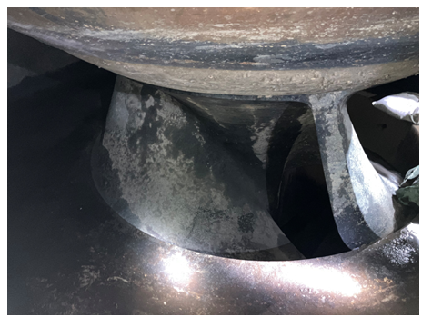
Figure S3. Image of one of the screw pumps at PS Rozema.

