Additional file 2
Pre-dispersal Phase

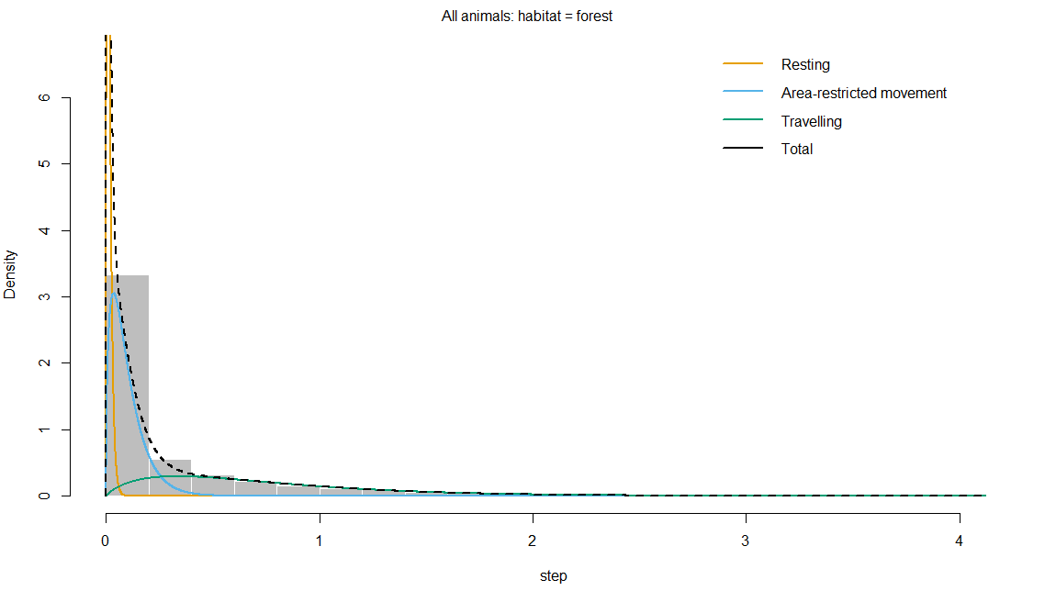
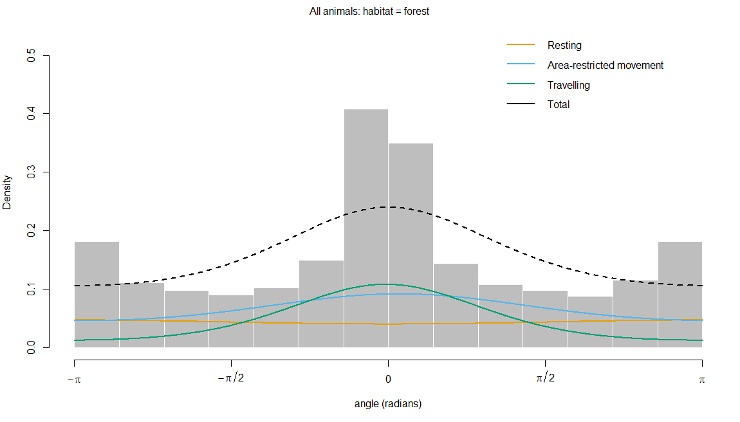

Figure S1: Histograms of observed step lengths (km) and turning angles in a 3-state behaviour model during the pre-dispersal phase. The coloured lines are the estimated densities of movement parameters in each state, and the dotted black line represents the sum of each parameter
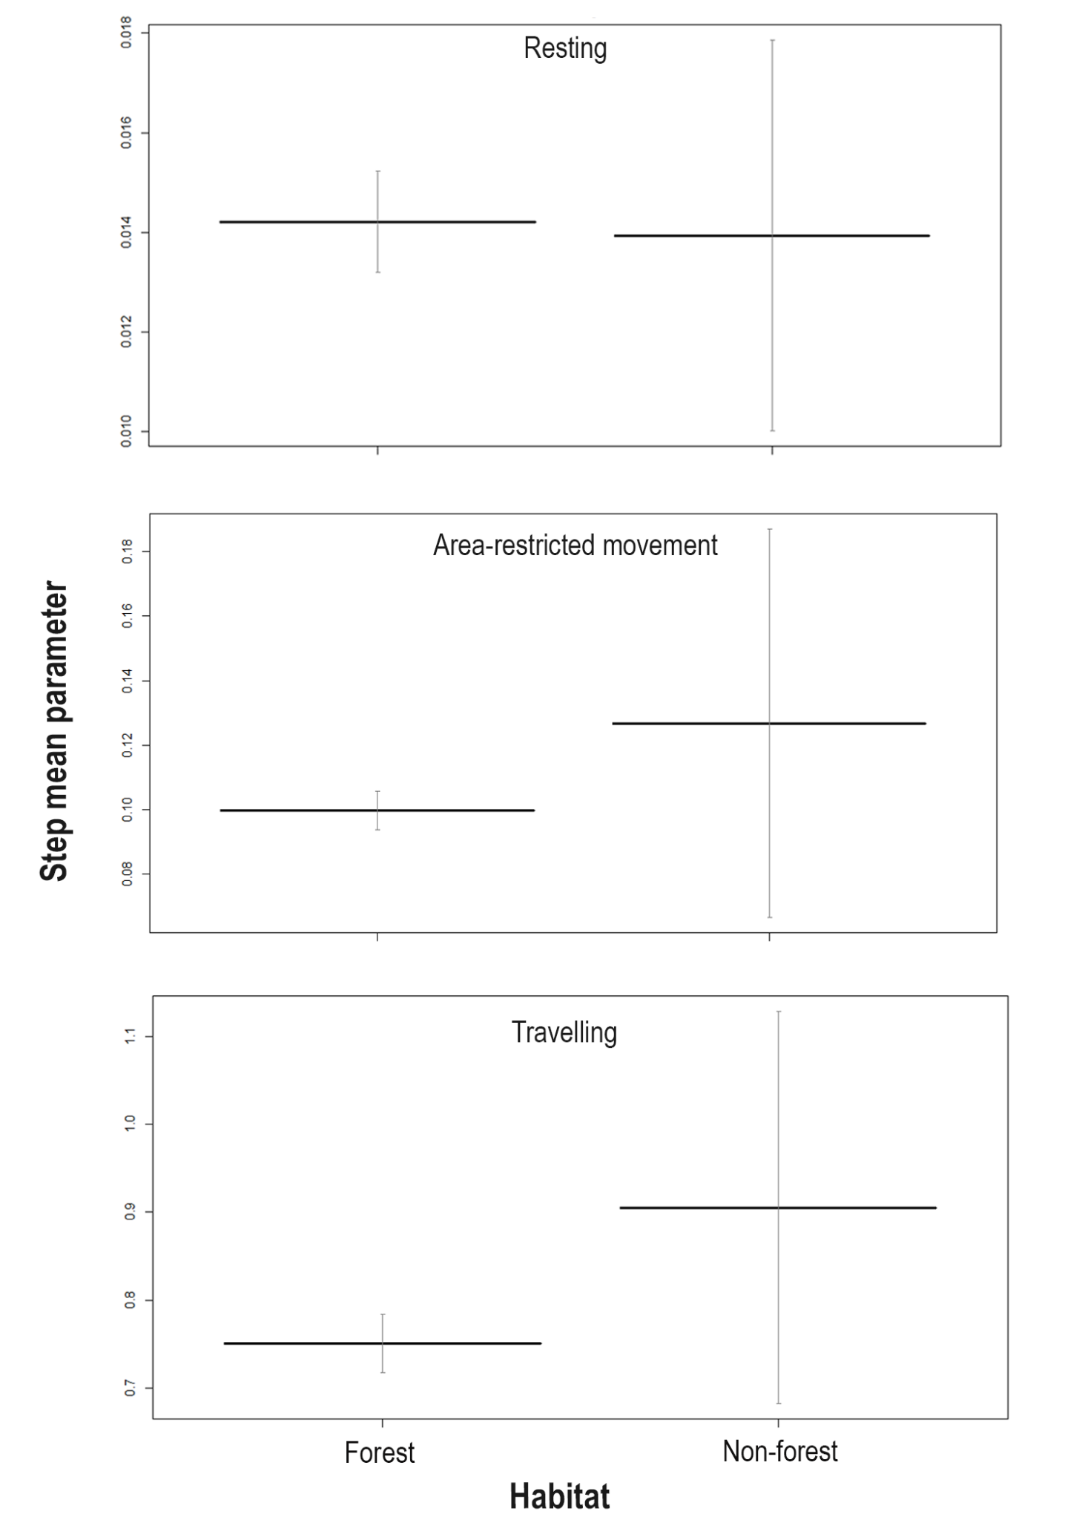
Figure S2: Effect of habitat (forest and non-forest) on the state-dependent distribution parameter, i.e., step length across the 3-state movement behaviour (resting, area-restricted movement, and travelling) during the pre-dispersal phase. Y-axis scales differ across behavioural states to reflect variation in step length distributions. The bold horizontal bar indicates the mean step length, and the vertical error bars represent 95% confidence intervals.
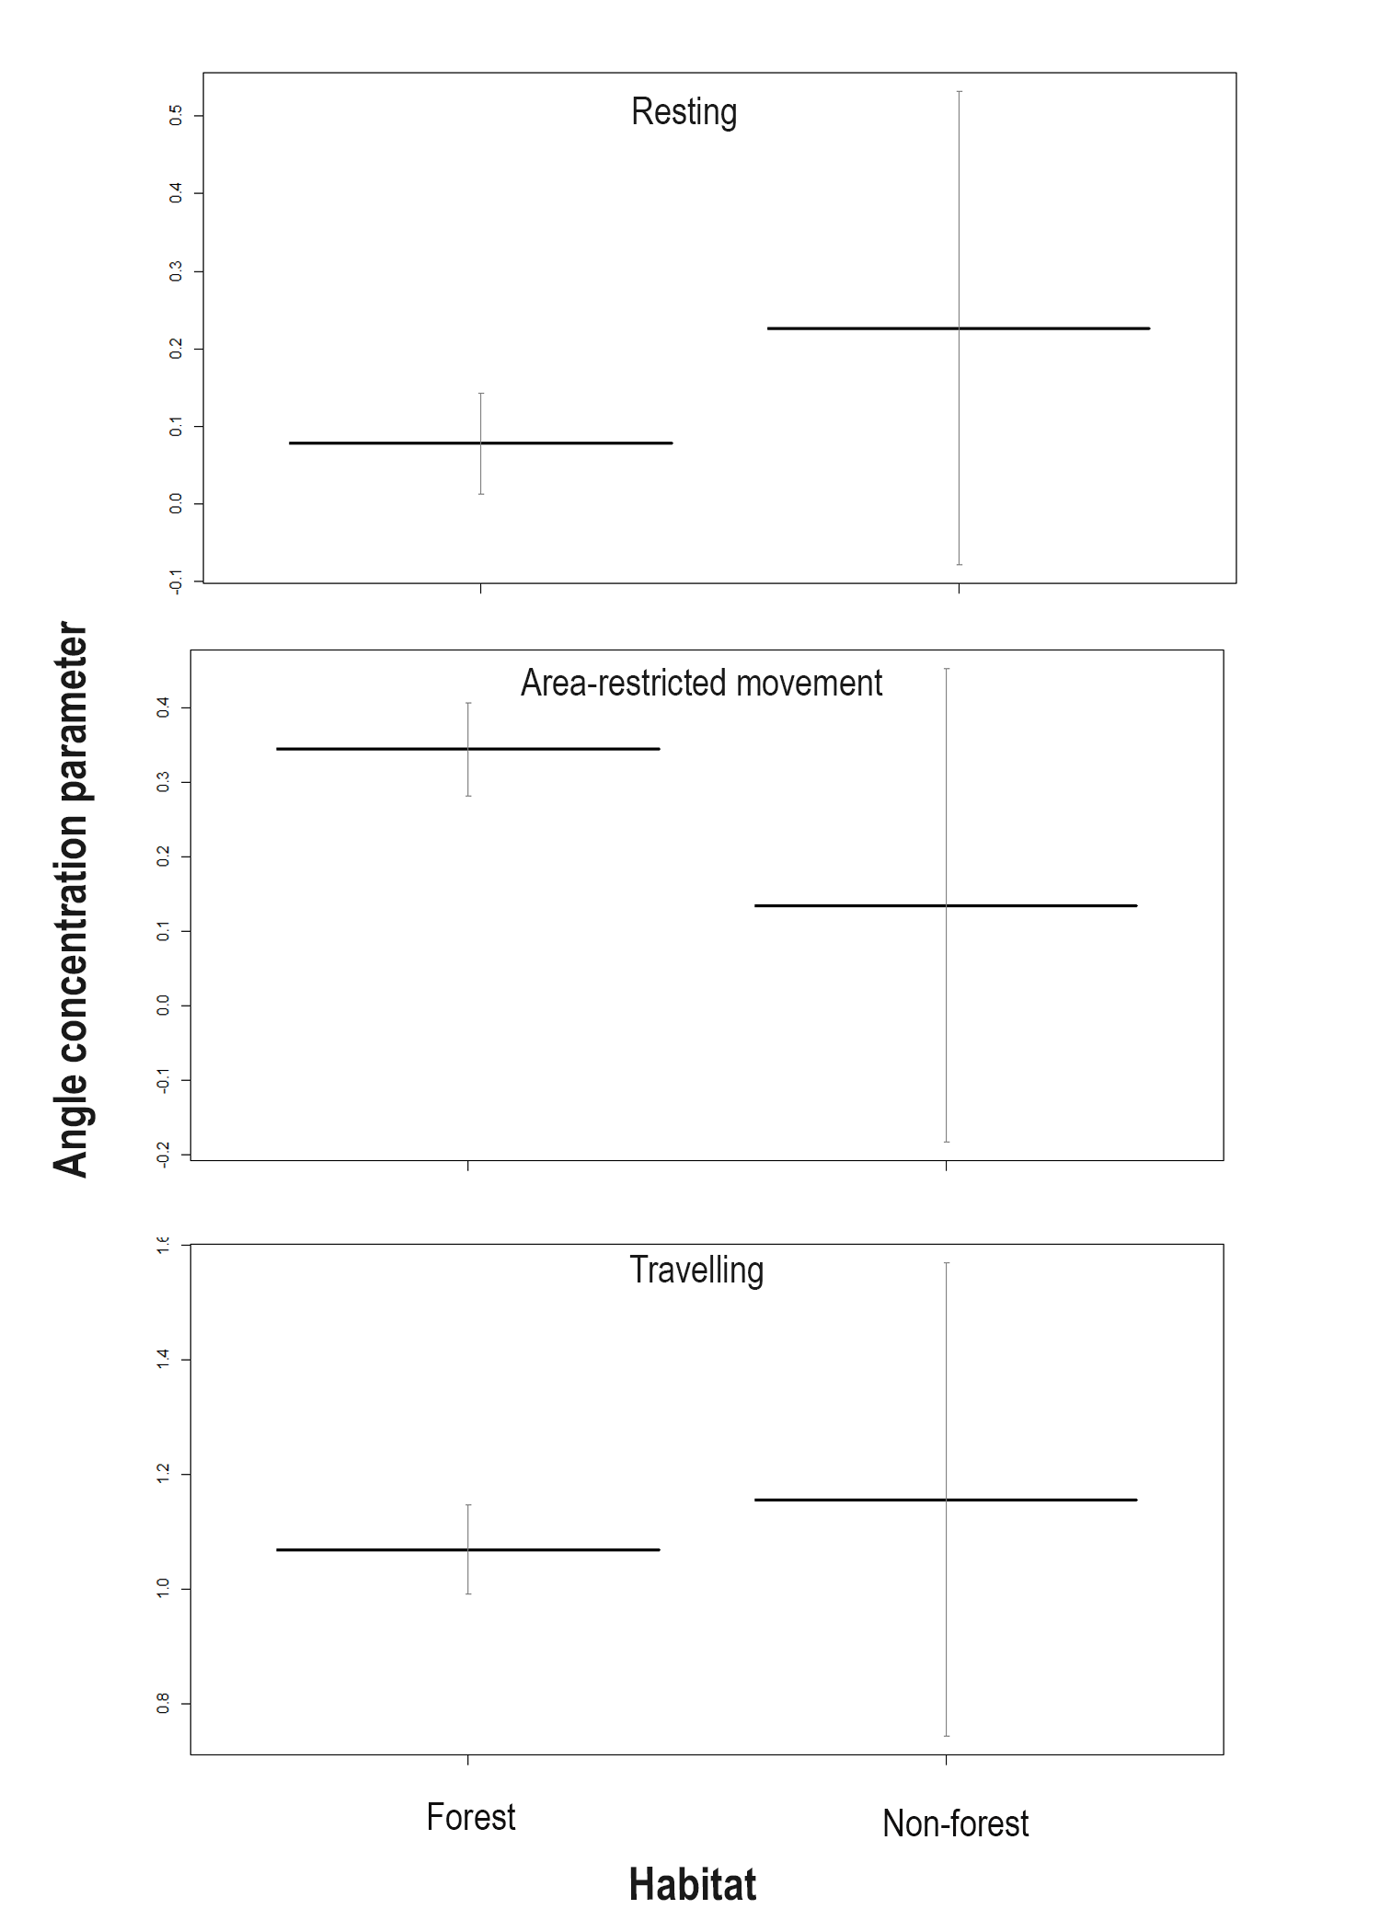
Figure S3: Effect of habitat (forest and non-forest) on the state-dependent distribution parameter, i.e., angle concentration/directional persistence across the 3-state movement behaviour (resting, area-restricted movement, and travelling) during the pre-dispersal phase. Y-axis scales differ across behavioural states to reflect variation in angle concentration distribution. The bold horizontal bar indicates the mean angle concentration, and the vertical error bars represent 95% confidence intervals.
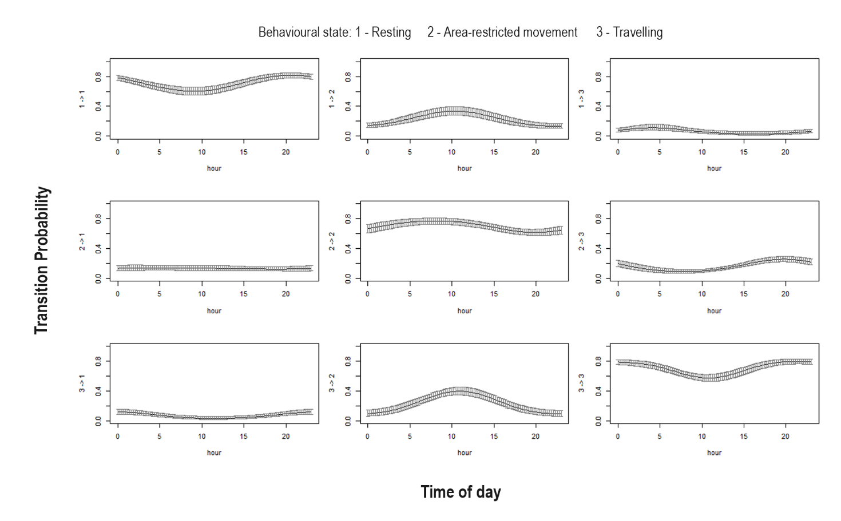
Figure S4: Effect of time of day (hour) on transition probability during the pre-dispersal phase. To visualize the effect of individual covariates on transition probabilities, prediction plots were generated by varying time of day across its range while holding the other covariate (human population density) constant at their mean or a representative biological value.

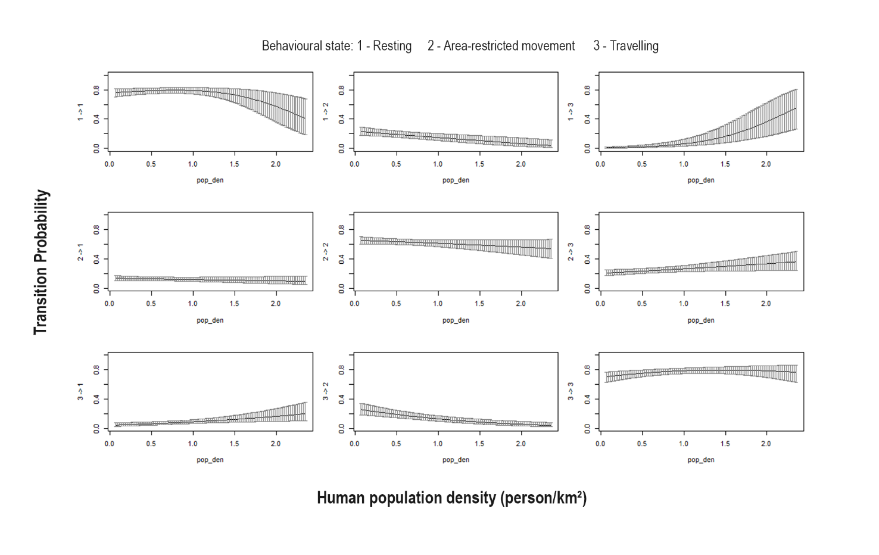
Figure S5: Effect of human population density (person/km²) on transition probability during the pre-dispersal phase. To visualize the effect of individual covariates on transition probabilities, prediction plots were generated by varying population density across its range while holding the other covariate (time of day) constant at their mean or a representative biological value.

