Additional file 3
Dispersal Phase

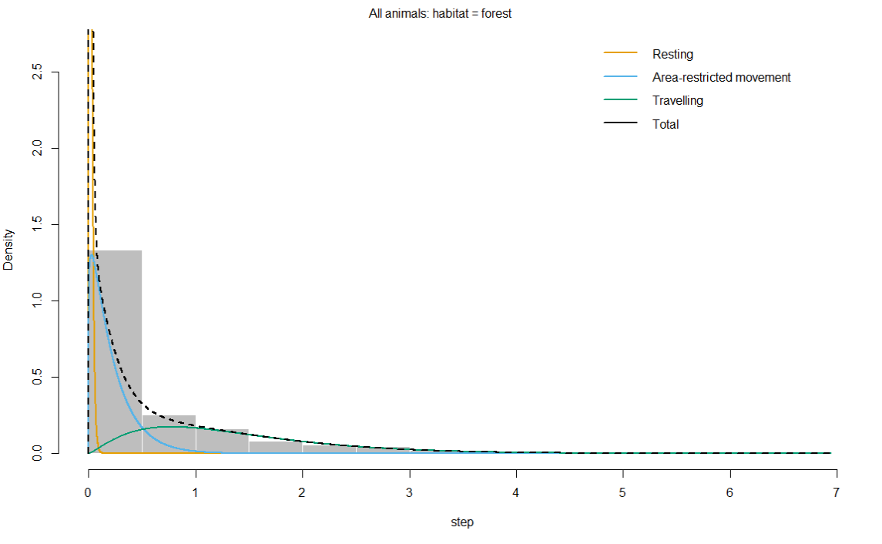

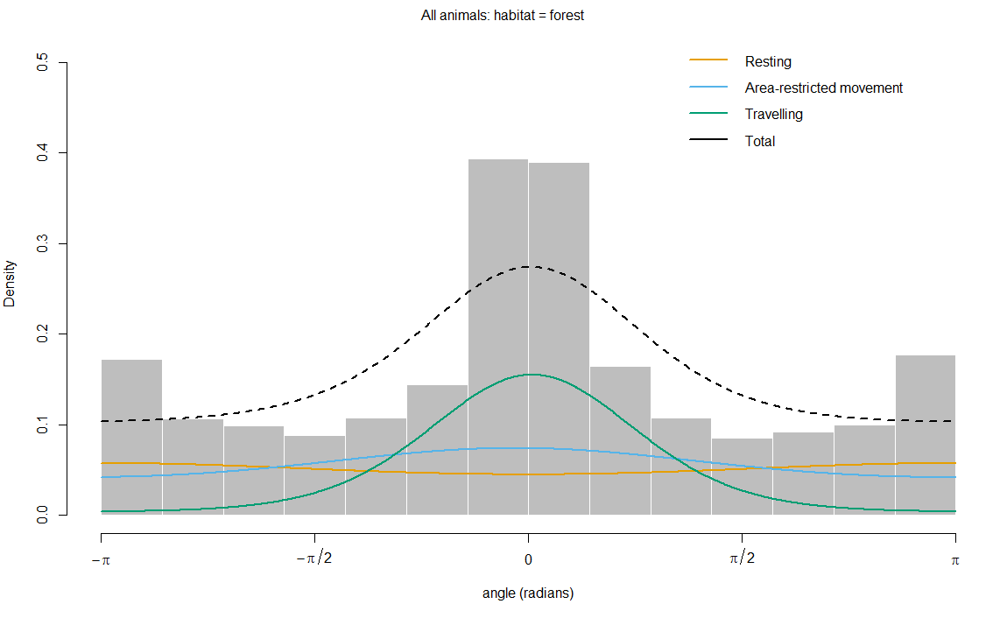

Figure S6: Histograms of observed step lengths and turning angles in a 3-state behaviour model during the dispersal phase. The coloured lines are the estimated densities of movement parameters in each state, and the dotted black line represents the sum of each parameter
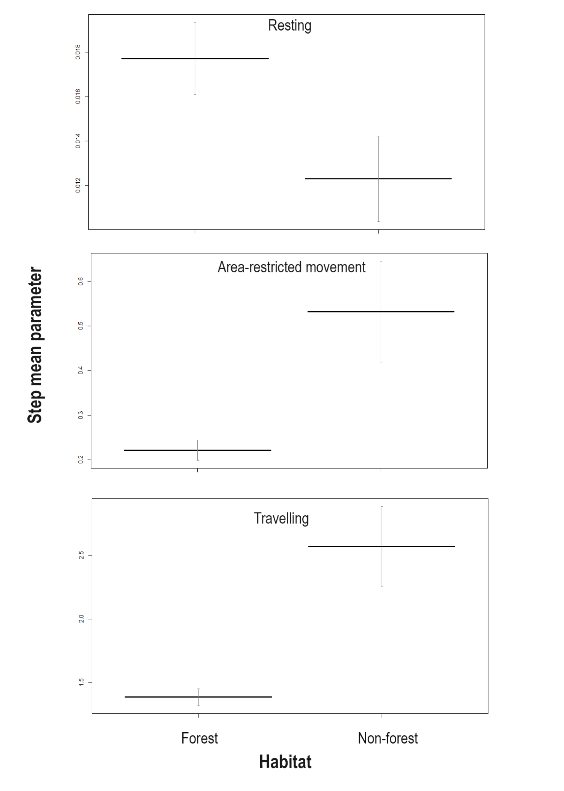
Figure S7: Effect of habitat on the state-dependent distribution parameter, i.e., mean step length across the 3-state movement behaviour (resting, area-restricted movement, and travelling) during the dispersal phase. Y-axis scales differ across behavioral states to reflect variation in step length distributions. The bold horizontal bar indicates the mean step length, and the vertical error bars represent 95% confidence intervals.
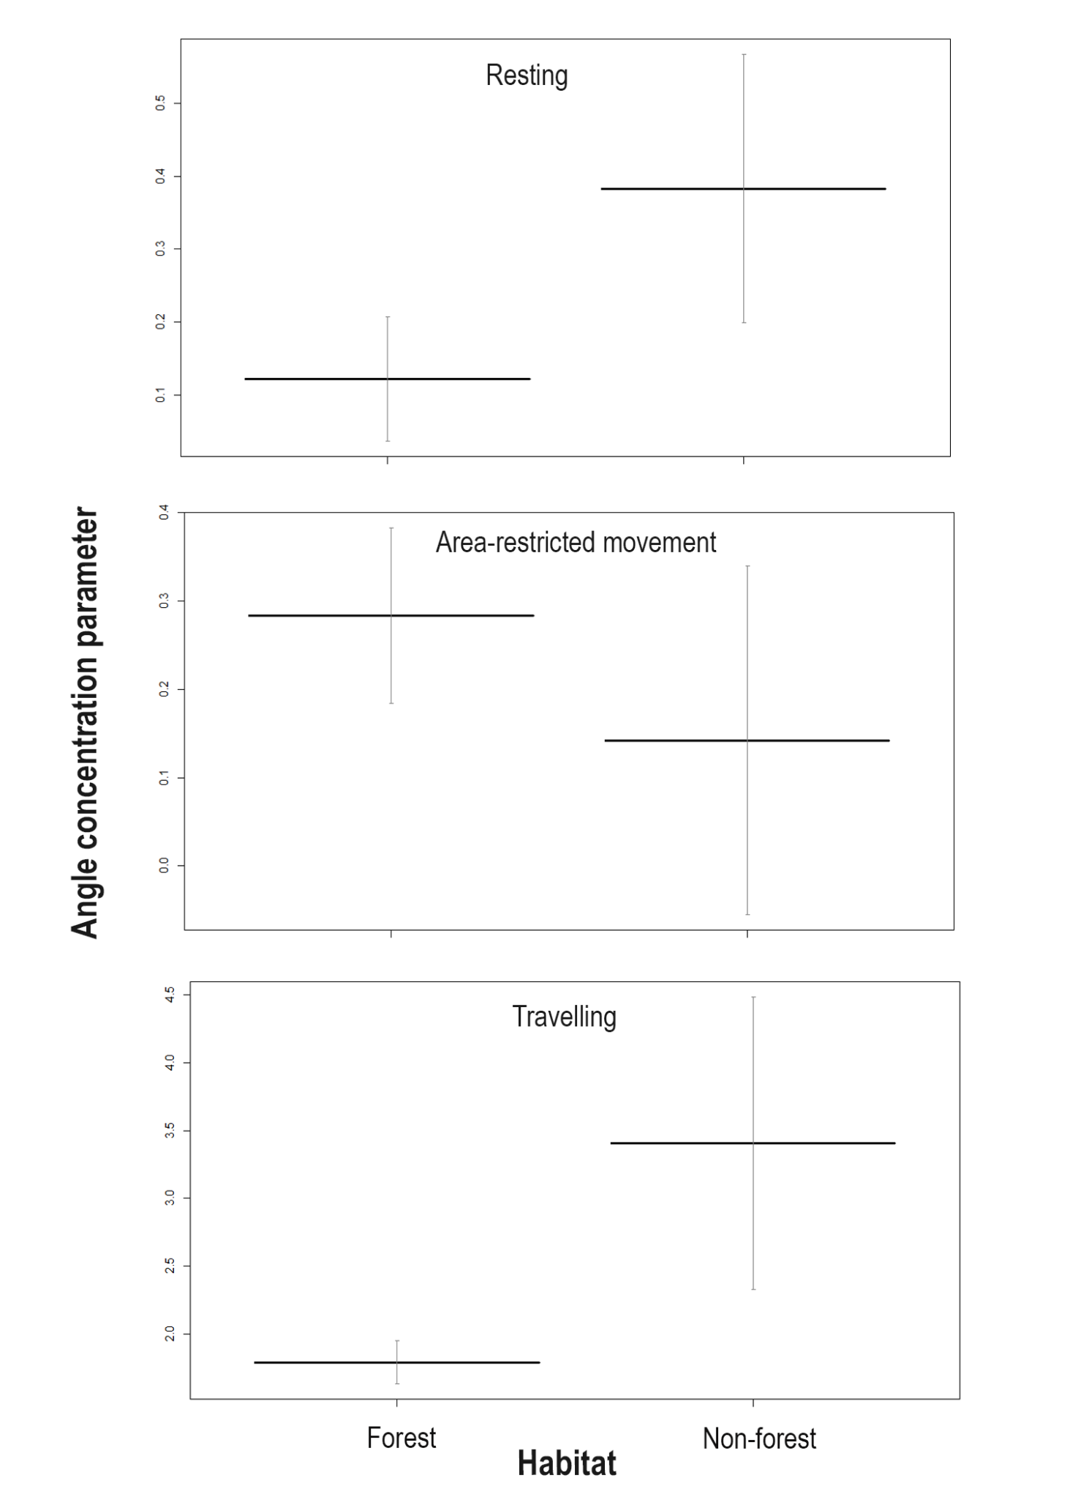
Figure S8: Effect of habitat on the state-dependent distribution parameter, i.e., angle concentration/directional persistence across the 3-state movement behaviour (resting, area-restricted movement, and travelling) during the dispersal phase. Y-axis scales differ across behavioral states to reflect variation in angle concentration distribution. The bold horizontal bar indicates the mean angle concentration, and the vertical error bars represent 95% confidence intervals.
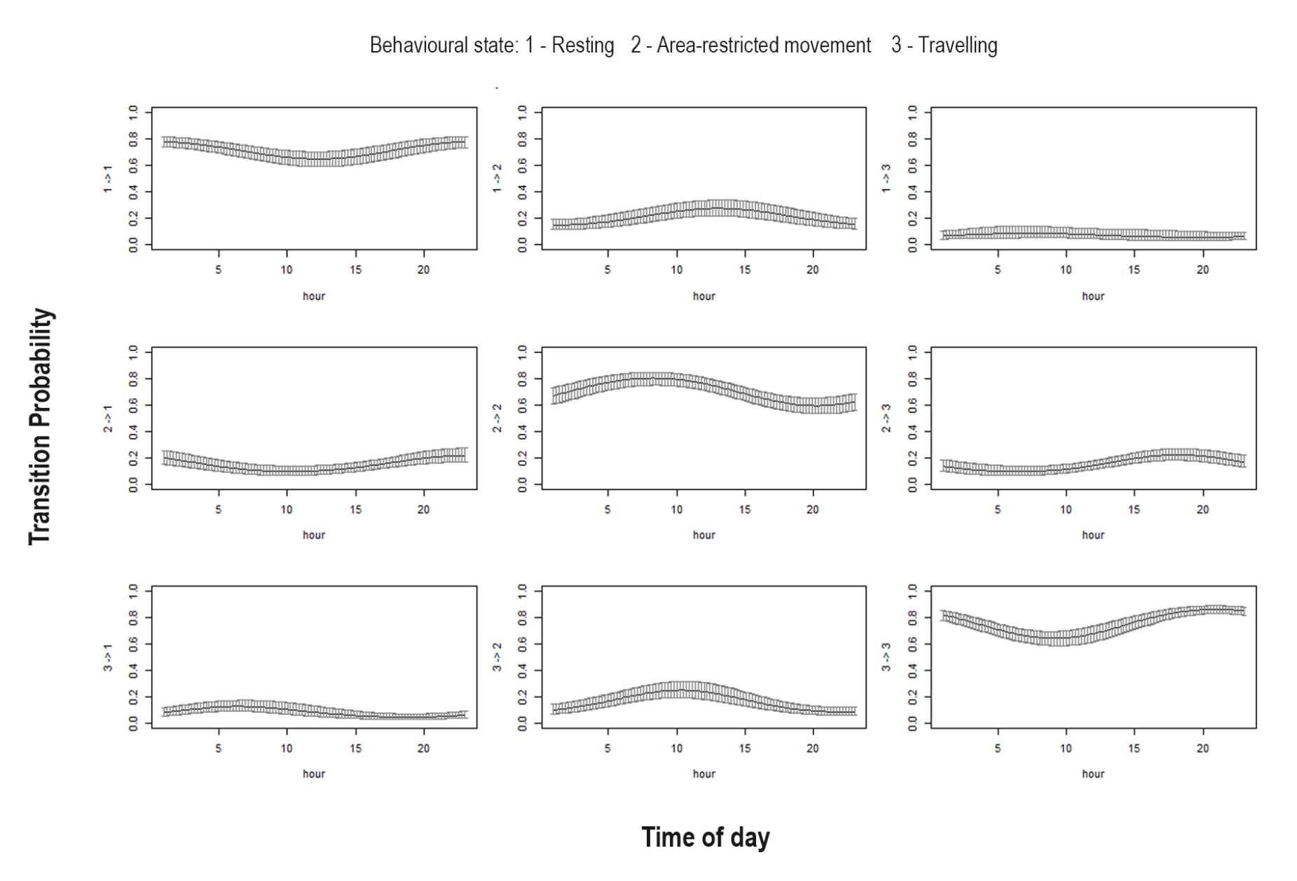
Figure S9: Effect of time of day (hour) on transition probability during the dispersal phase. To visualize the effect of individual covariates on transition probabilities, prediction plots were generated by varying time of day across its range while holding the other covariates (temperature and habitat: forest) constant at their mean or a representative biological value.

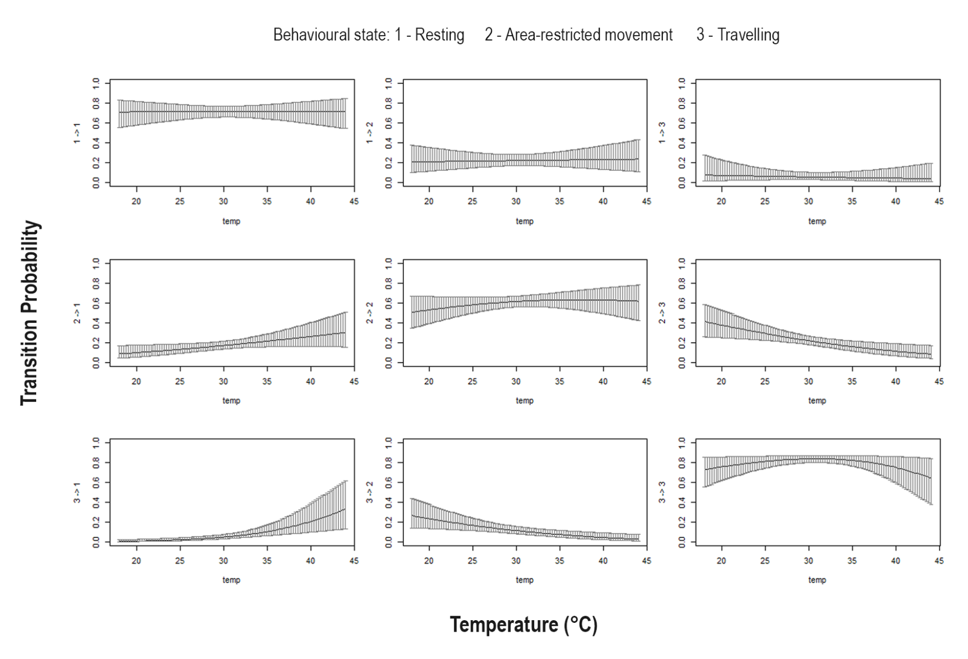
Figure S10: Effect of temperature (°C) on transition probability during the dispersal phase. To visualize the effect of individual covariates on transition probabilities, prediction plots were generated by varying temperature across its range while holding the other covariates (habitat: forest and time of day) constant at their mean or a representative biological value.

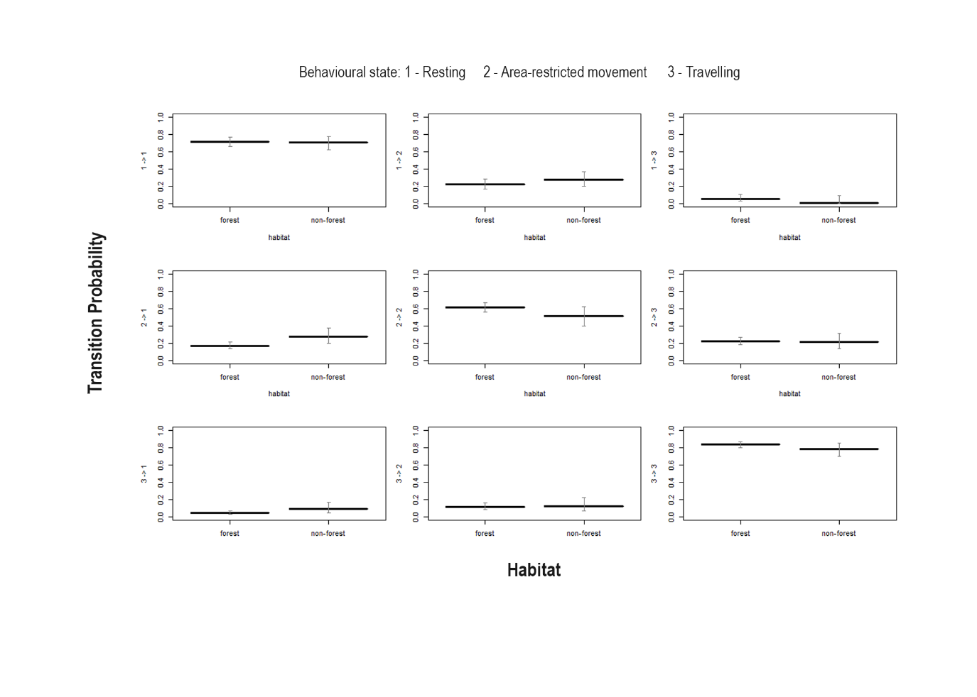
Figure S11: Effect of habitat (forest and non-forest) on transition probability during the dispersal phase. To visualize the effect of individual covariates on transition probabilities, prediction plots were generated by habitat (forest and non-forest) while holding the other covariates (temperature and time of day) constant at their mean or a representative biological value.

