Additional file 4
Post-dispersal Phase

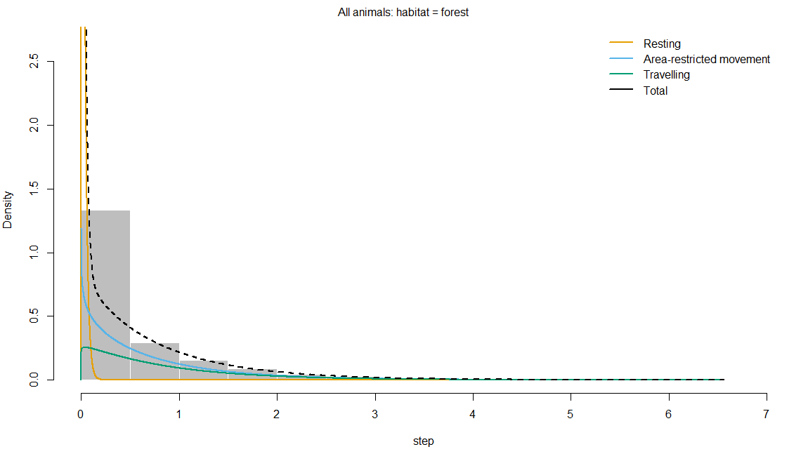
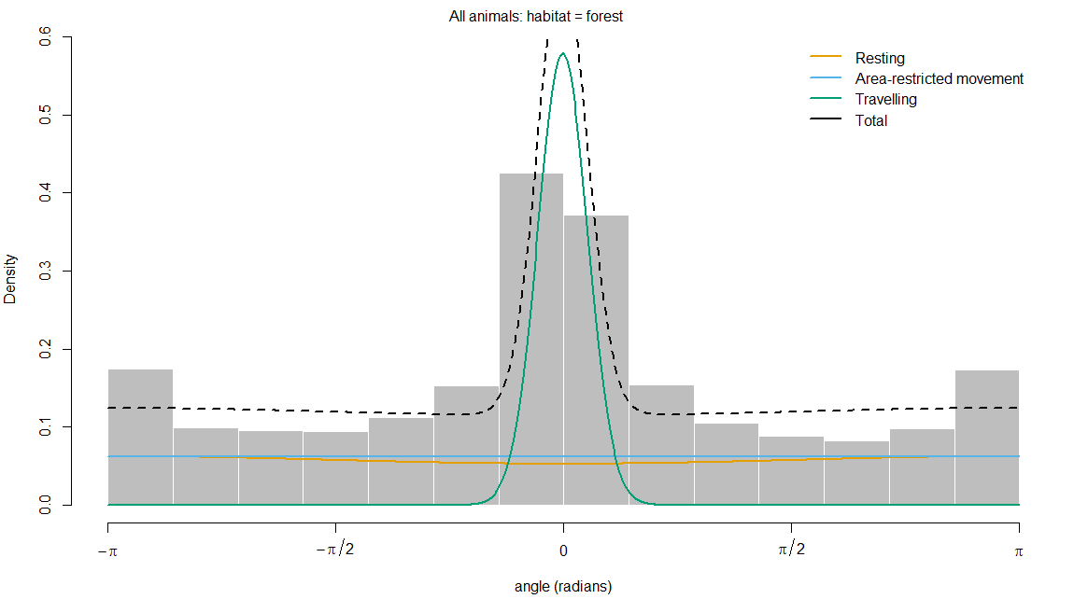

Figure S12: Histograms of observed step lengths and turning angles in a 3-state behaviour model during the post-dispersal phase. The coloured lines are the estimated densities of movement parameters in each state, and the dotted black line represents the sum of each parameter
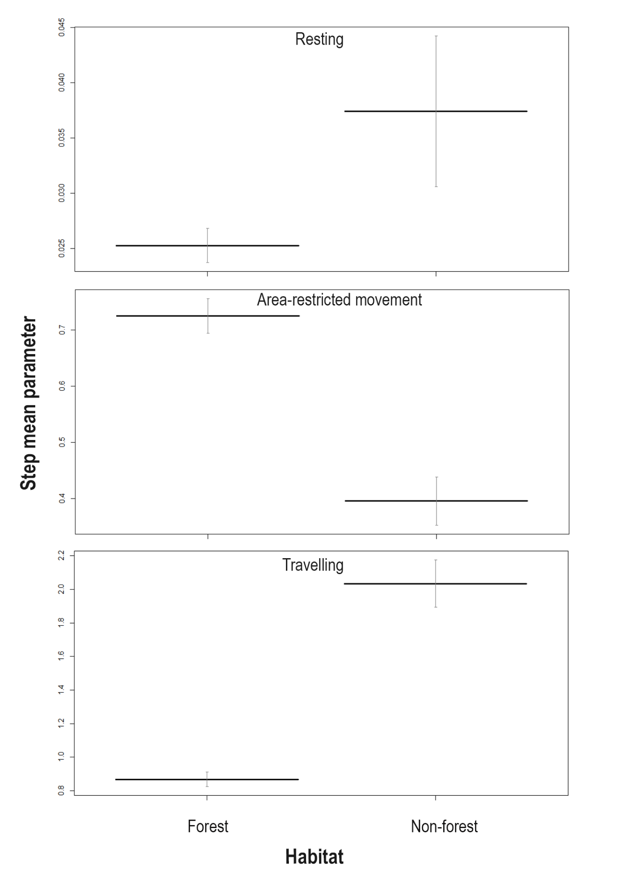
Figure S13: Effect of habitat (forest and non-forest) on the state-dependent distribution parameter, i.e., step length across the 3-state movement behaviour (resting, area-restricted movement, and travelling) during the post-dispersal phase. Y-axis scales differ across behavioural states to reflect variation in step length distributions. The bold horizontal bar indicates the mean step length, and the vertical error bars represent 95% confidence intervals.
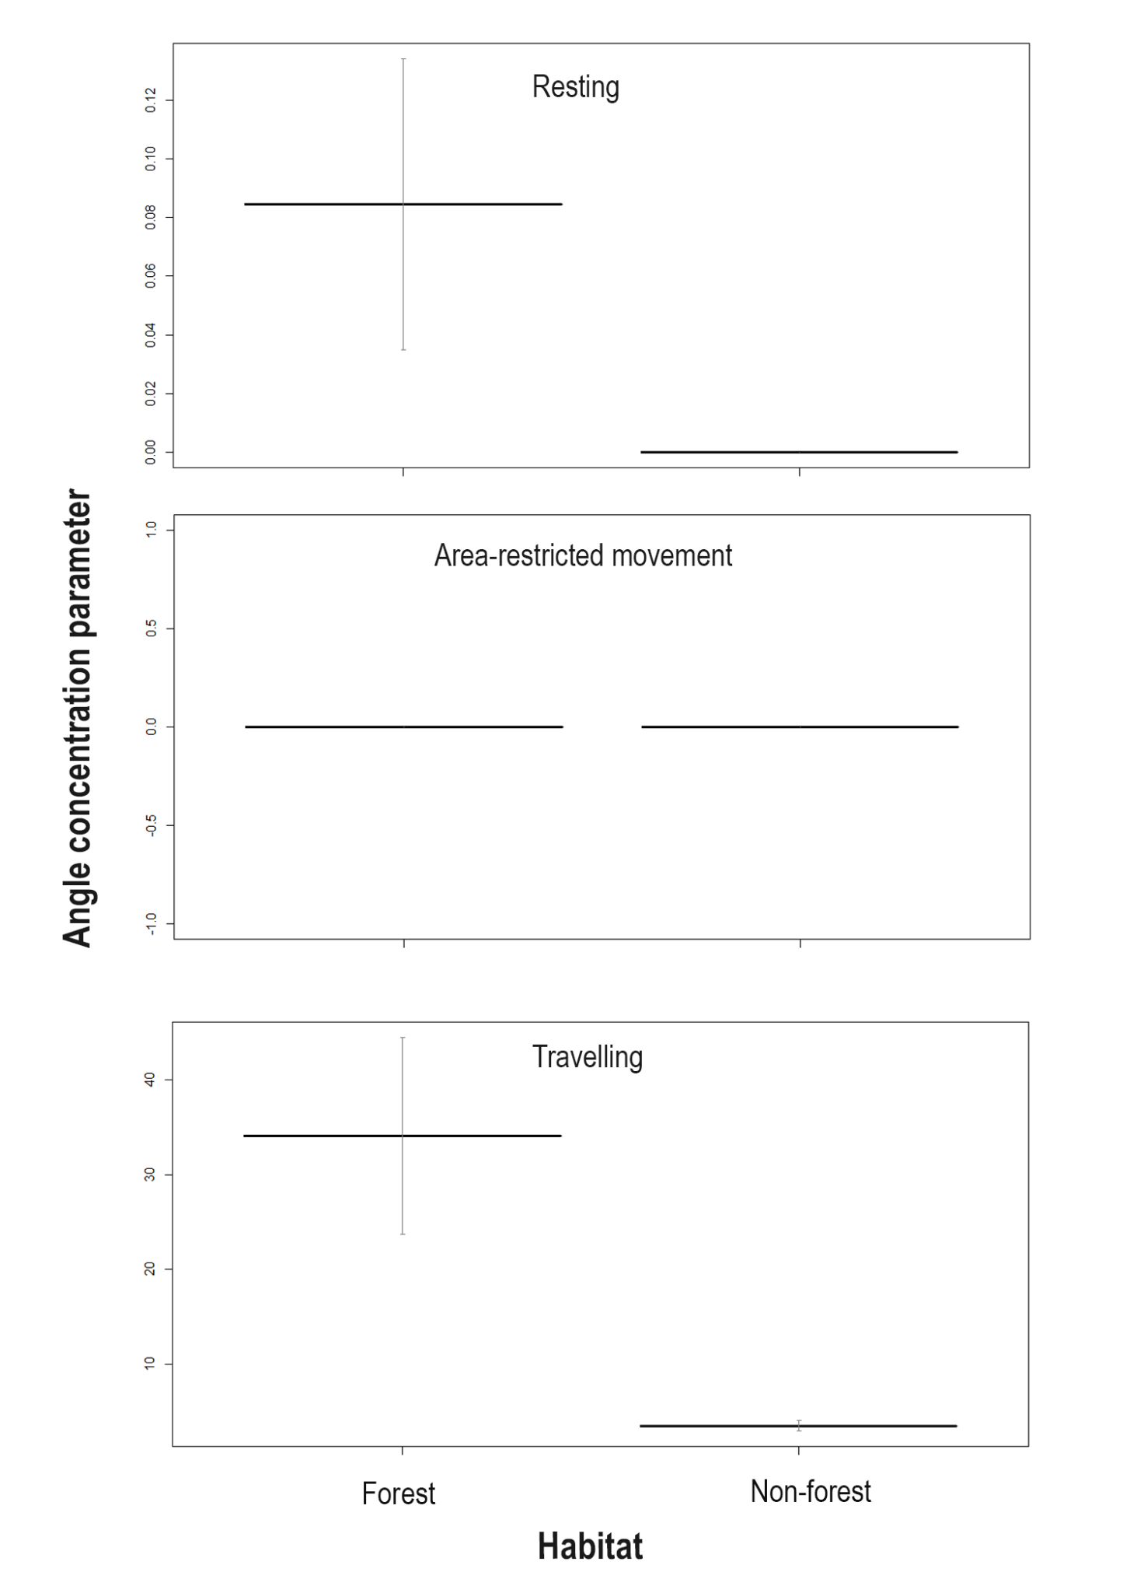Figure S14: Effect of habitat (forest and non-forest) on the state-dependent distribution parameter, i.e., angle concentration/directional persistence across the 3-state movement behaviour (resting, area-restricted movement, and travelling) during the post-dispersal phase. Y-axis scales differ across behavioural states to reflect variation in angle concentration distribution. The bold horizontal bar indicates the mean angle concentration, and the vertical error bars represent 95% confidence intervals.
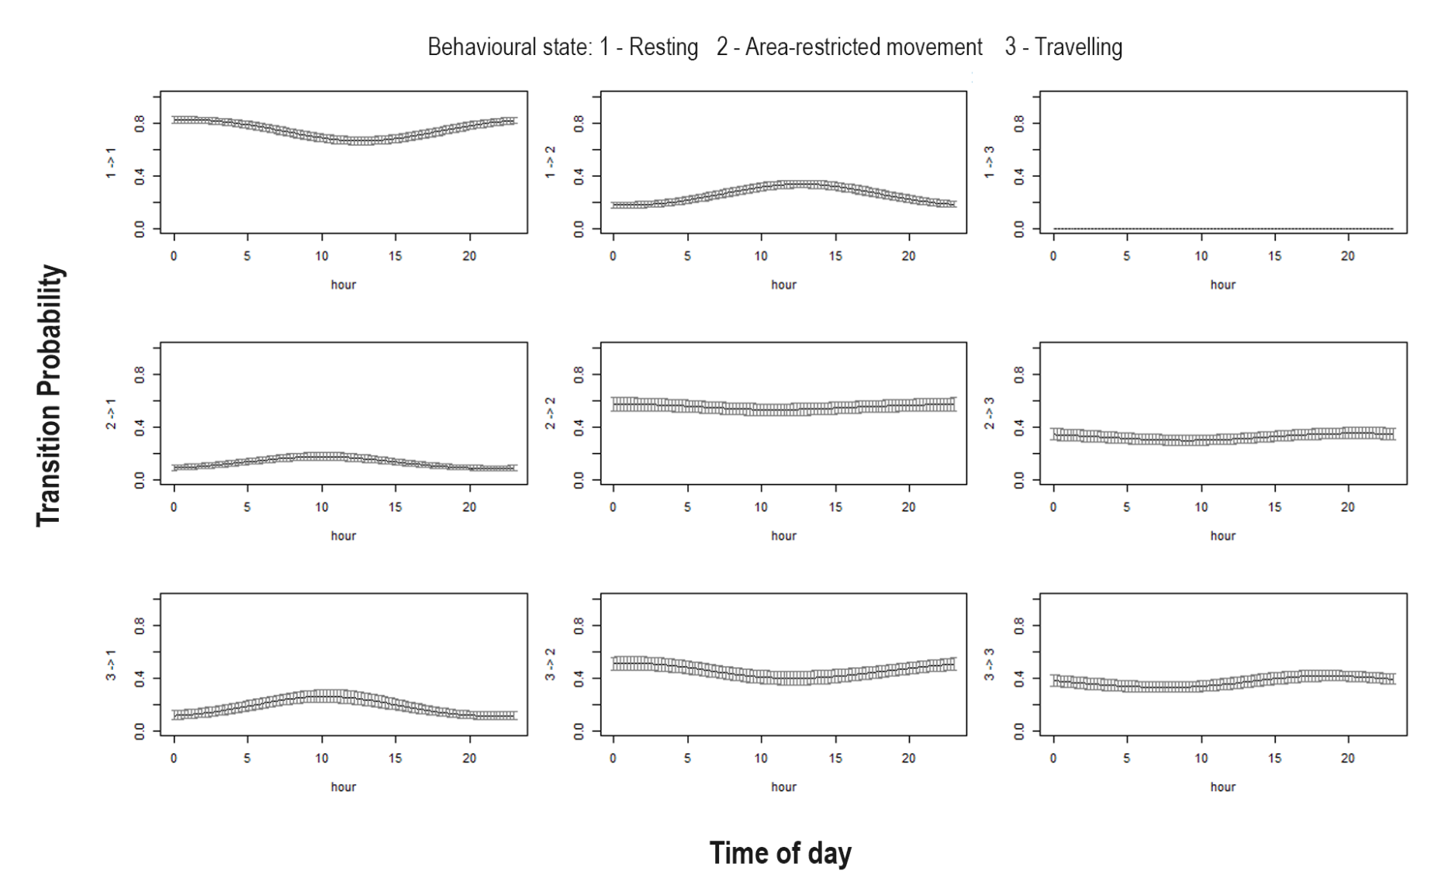
Figure S15: Effect of time of day (hour) on transition probability during the post-dispersal phase. To visualize the effect of individual covariates on transition probabilities, prediction plots were generated by varying time of day across its range while holding the other covariates (temperature and habitat: forest) constant at their mean or a representative biological value.

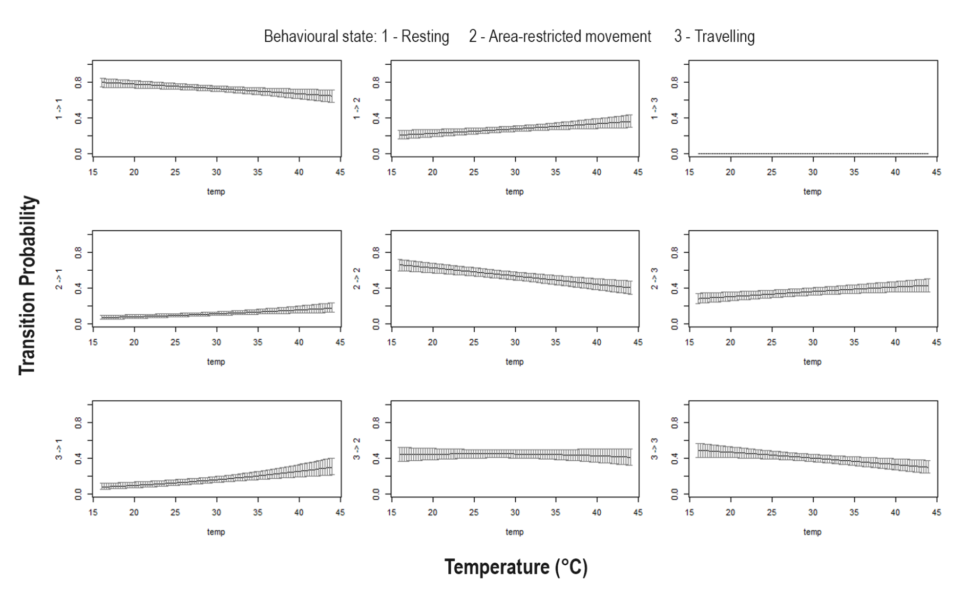
Figure S16: Effect of temperature (°C) on transition probability during the post-dispersal phase. To visualize the effect of individual covariates on transition probabilities, prediction plots were generated by varying temperature across its range while holding the other covariates (habitat: forest and time of day) constant at their mean or a representative biological value.

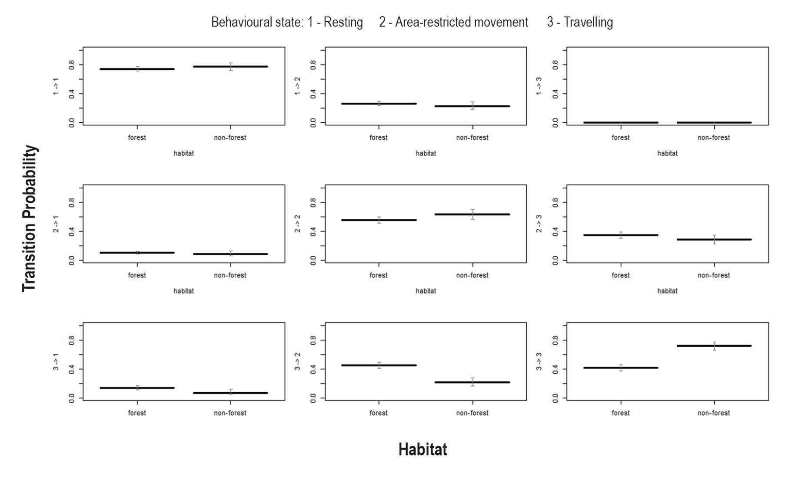
Figure S17: Effect of habitat (forest and non-forest) on transition probability during the post-dispersal phase. To visualize the effect of individual covariates on transition probabilities, prediction plots were generated by habitat (forest and non-forest) while holding the other covariates (temperature and time of day) constant at their mean or a representative biological value.

