Appendix for

ERSF-VIPA Framework: Scalable Wildlife Movement Modelling for Conflict Mitigation

Appendix 1: Environmental impact factor data preprocessing
To construct a robust environmental predictor set for the ERSF-VIPA we integrated terrain, habitat use, distance, and other variables based on their ecological relevance to Asian elephant (Elephas maximus) movement. All spatial data layers were preprocessed using standardized geospatial procedures and resampled to a common spatial resolution to ensure consistency in covariate extraction and subsequent modeling.
1、Initial Processing
Terrain factors were derived from Ziyuan-3 satellite imagery (2016) after geometric correction in ENVI v5.6. A 2 m resolution digital orthophoto map (DOM) was generated through stereo image processing and orthorectification. A 5 m digital elevation model (DEM) was extracted and used to compute slope and slope direction (aspect) in ArcGIS v10.8. These variables serve as proxies for energy expenditure and physical accessibility in elephant movement. Previous research has shown that elephants prefer flat to gently sloped terrain (<15°) and avoid steep slopes, particularly in forested environments (Kumar et al., 2024). This makes topographic constraints important to movement modeling.
Habitat use layers included arable land (China Vegetation Journal, 2022), plantations (tea and coffee), grassland, natural forest, artificial forest, and man-made surfaces. These land cover types were derived from the SinoLC-1 dataset (2023) and the national land use extent database (2020) and were selected due to their differential influence on elephant habitat preference. For instance, elephants tend to avoid intensively cultivated cropland and impervious surfaces but show positive selection for forest–farmland ecotones and forested habitats that provide cover and forage (Zhang et al., 2022).
Distance-based features were included to represent anthropogenic disturbance and resource accessibility. Euclidean distances to the nearest water sources and roads were computed using OpenStreetMap data (2016), while distances to human activity areas were derived from WorldPop datasets (100 m resolution). These metrics reflect both attraction to essential resources and avoidance of human presence, as elephants often exhibit spatial trade-offs between resource use and human disturbance (Selier et al., 2015).
Tree height, sourced from Global Forest Watch (2024), was included as an indicator of vegetation structure, which has been linked to both visibility and forage access in large herbivores (Coverdale et al., 2024). Normalized Difference Vegetation Index (NDVI), calculated from Ziyuan-3 imagery, was used to reflect vegetation productivity and seasonal habitat quality. NDVI has been widely used in habitat modeling to quantify food resource abundance (White et al., 2022). In addition, distance to salt sources, locally known as nitrate ponds and a key source of supplemental minerals, was included based on a dataset developed by Huang (2021), acknowledging elephants’ year round reliance on such nutrient sources (Darker et al., 2022).
2、Data Overlay
All raster data were projected into a consistent coordinate system (WGS 1984 UTM Zone 48N) and spatially aligned. Raster layers were resampled to a uniform 2 m resolution using bilinear interpolation to match the native resolution of the DOM and NDVI products. This spatial harmonization minimized georeferencing errors, facilitated accurate overlay operations, and enhanced the precision of cell-based environmental attribute extraction on the hexagonal grid used in the ERSF-VIPA framework (Li, 2023). The final set of covariates was clipped to the study extent and used as input for model training and simulation.

Appendix 2: Classical Resource Selection Function (RSF) Overview
Traditional RSF (Boyce et al., 2002) are widely used to quantify the relationship between environmental variables and the probability of species occurrence. In their most basic form, RSFs are formulated using logistic regression to compare environmental attributes at known presence locations (used sites) against those at available but unused sites (pseudo-absences or background):
where:
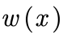 is the resource selection weight for a location with covariate vector;
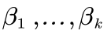 are regression coefficients estimated from data;
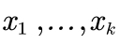 are environmental predictors (e.g., distance to road, NDVI, elevation).
This log-linear formulation assumes a monotonic and additive relationship between predictors and the response. While interpretable, this assumption often fails to capture nonlinear ecological responses or interactions. For this reason, we adopted a non-parametric alternative in our ERSF framework, replacing the log-linear model with a random forest classifier (see Section 2.3.1).

Appendix 3: Generation and Sensitivity Analysis of Absence Points
Pseudo-absence points were generated to facilitate the construction of ERSF. Given the absence of confirmed true-absence data for this Asian elephant population, we adopted a presence–pseudo-absence approach, a widely accepted method in species distribution modeling (Senay et al., 2013). To ensure a representative contrast between used and unused habitats, pseudo-absence points were randomly sampled across the study region using the following protocol.
For each presence point, five pseudo-absence points were generated, resulting in a 1:5 ratio of presences to absences. A minimum exclusion distance of 1 km was imposed around all presence points to avoid spatial overlap and minimize potential commission errors. To reduce commission errors and improve ecological validity, pseudo-absence points were only sampled from habitat types theoretically accessible but unoccupied by Asian elephants. This constraint was operationalized based on a combination of environmental variables and ecological knowledge:
Specifically, elevation data were used to exclude high-altitude regions above 2500 m a.s.l., aligning with the species' known altitudinal constraints in Yunnan Province (Kumar et al., 2023). Furthermore, pseudo-absences were excluded from areas with excessively high human activity (above the 95th percentile), to minimize sampling in urbanized or heavily disturbed landscapes where elephants are seldom found (Yang et al., 2022). Lastly, environmental productivity thresholds were applied using NDVI data, removing locations with NDVI values below 0.1, which represent unvegetated or highly degraded surfaces unlikely to be used by elephants (Du et al., 2023).
To evaluate the effect of pseudo-absence density on model performance, we conducted a sensitivity analysis under three alternative presence–absence ratios: 1:3, 1:5, and 1:10. For each configuration, the ERSF module was trained using a random forest classifier with identical hyperparameter settings, and model performance was evaluated using the area under the receiver operating characteristic curve (AUC).
The results showed that the 1:5 ratio yielded the best model performance (AUC = 0.97), balancing predictive accuracy and computational efficiency. Increasing the number of absence points to a 1:10 ratio resulted in only marginal improvements in accuracy, while incurring higher computational costs. Conversely, the 1:3 setting led to reduced model performance, with a lower AUC value of 0.93. Based on these findings, the 1:5 ratio was selected as the default setting for the main analysis, as it provided an optimal trade-off between accuracy, robustness, and efficiency.
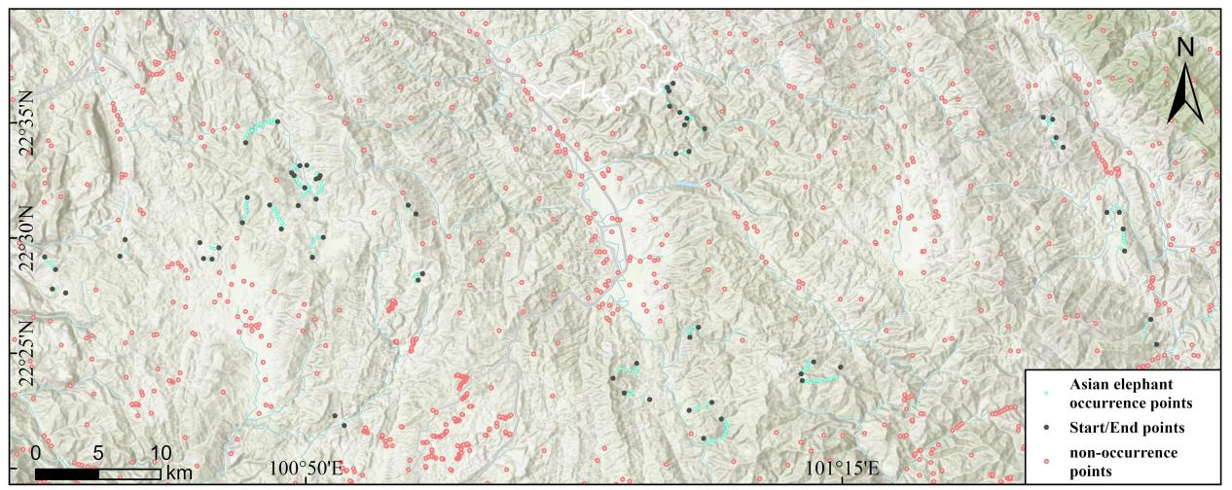
Figure A3-1. Distribution of Absence Points in the Study Area. After screening with a 1 km buffer zone, there are 1,128 missing points.

Appendix 4: Resource selection probability of honeycomb hexagonal grid nodes
The shapefile's attribute table contains 6,774,271 hexagonal grid nodes comprehensively covering the study area. Each node is uniquely identified by the mandatory Id field. Key functional attributes include:
line: Path membership indicator (value=0 denotes non-path-associated nodes)
SE: Start/end node designation (S=startpoint, E=endpoint). Non-terminal nodes were configured with SE='A' as a placeholder value to satisfy file format requirements.
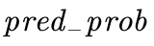: Probabilistic resource selection value derived from model outputs
The line attribute operates synergistically with SE to algorithmically reconstruct path geometries during model execution, where each unique line number corresponds to an individual movement path with explicitly defined start (SE='S') and end (SE='E') nodes.

Table 4-1 Resource selection probability of honeycomb hexagonal grid nodes
ID | line | SE
431082 | 1 | S | 0.68
473196 | 2 | S | 0.74
488419 | 1 | E | 0.36
542675 | 2 | E | 0.83
833007 | 3 | E | 0.97
863328 | 3 | S | 0.67
1265161 | 5 | S | 0.78
3041 | 0 | A | 0.23
3045 | 0 | A | 0.16
3053 | 0 | A | 0.13
3057 | 0 | A | 0.11
1773131 | 11 | S | 0.73
1794098 | 12 | E | 0.27
1803408 | 8 | E | 0.34
1827445 | 11 | E | 0.62
1839665 | 9 | S | 0.76
1869295 | 14 | S | 0.43
1890792 | 10 | S | 0.30
1890916 | 12 | S | 0.48
1906020 | 10 | E | 0.68
1912074 | 9 | E | 0.79
1926802 | 14 | E | 0.34
1989147 | 17 | S | 0.64
…… | …… | …… | ……

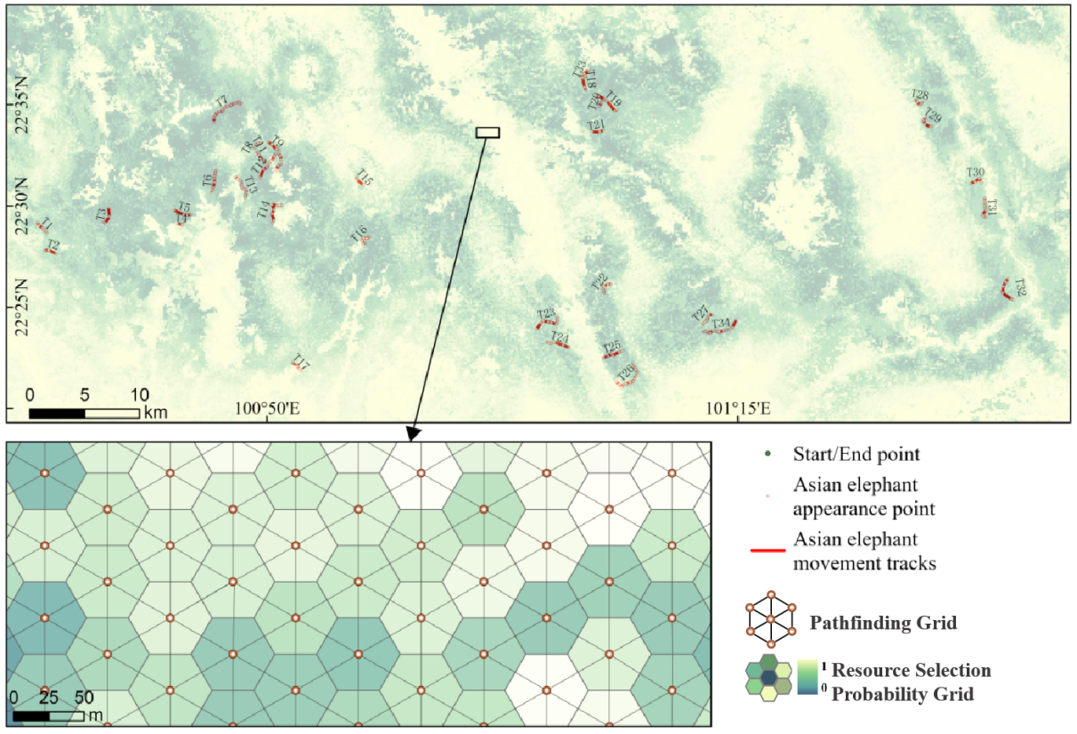
Figure A4-1. Resource Selection Probability Distribution of Hexagonal Grid Nodes: The visualization depicts a gridded representation of resource selection probabilities derived through spatial transformation of the pred_prob attribute values from the pathfinding hexagonal nodes. This probabilistic surface provides a spatially explicit representation of habitat preference likelihood across the study area, where each node's color gradient corresponds to its modeled resource selection probability value (0-1 scale).

Appendix 5: Simulation results of Asian elephant movement path
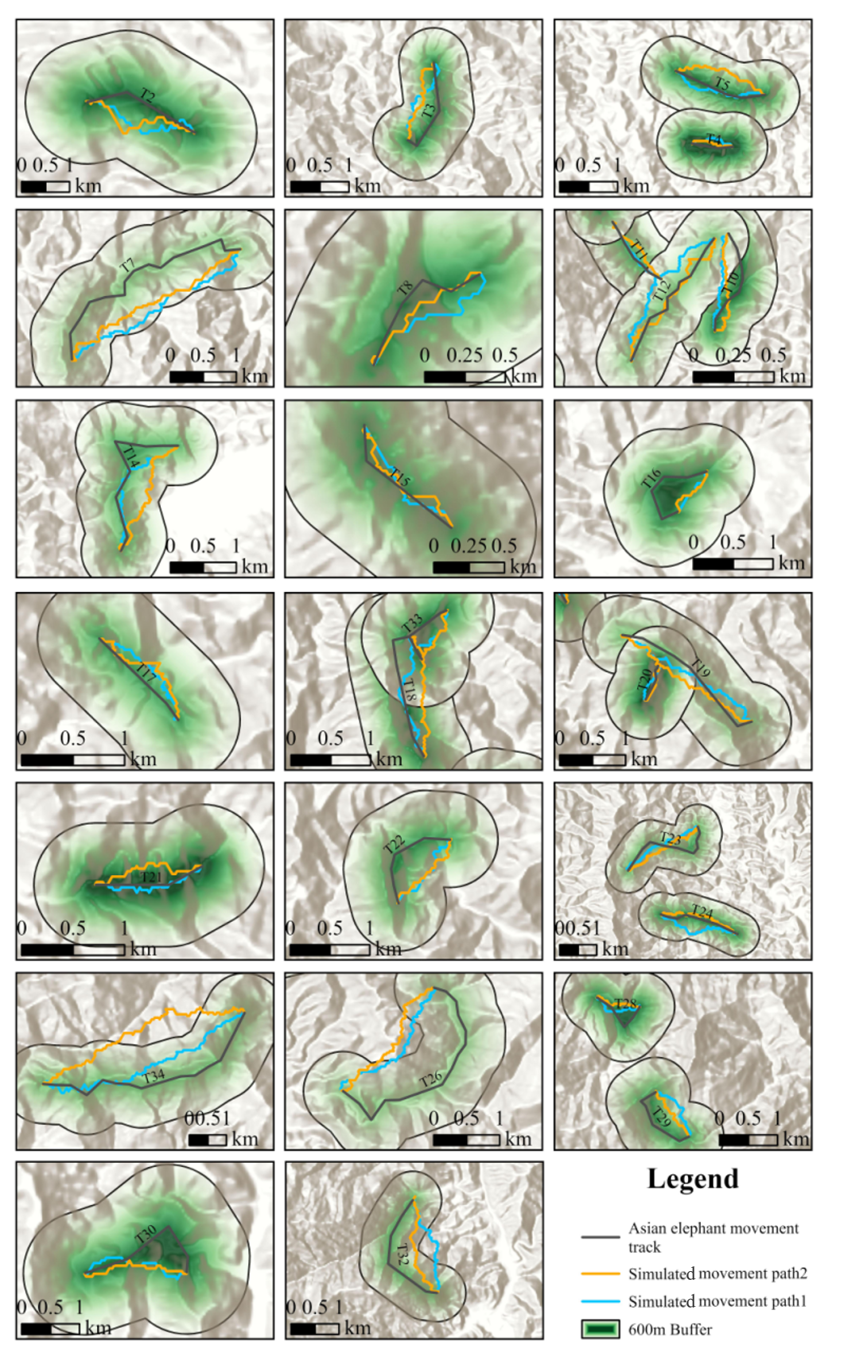
Figure 5-1. Simulation results of Asian elephant movement path: The positive direction is from left to right and the vertical direction is from top to bottom. Simulated movement Path 1 (light blue) represents the path in the forward direction, while simulated movement Path 2 (orange) represents the path in the reverse direction. The Asian Elephant movement track shows the actual movement path, and the 600m buffer highlights the overlap between the simulated paths and the actual path.

Appendix 6: Attempts at model optimization
1、Resource Selection Function Optimization Scheme
The resource selection function was initially modeled using logistic regression with preliminary optimization. Three distinct logistic regression approaches were implemented within a generalized linear model (GLM) framework to enhance model performance:
Step 1: Model Selection and Evaluation
L1 Regularization (Lasso Regression): Employed L1 regularization for feature selection, effectively eliminating non-significant predictors to improve model interpretability.
L2 Regularization (Ridge Regression): Applied L2 regularization to address overfitting, particularly for scenarios involving multicollinear features.
Non-regularized Logistic Regression: Implemented without regularization techniques, suitable for models with limited feature dimensions.
Step 2: Regularization Parameter Evaluation
Cross-validation was conducted to assess the three logistic regression variants, with ROC-AUC scores serving as the primary metric for model comparison and final selection.
Step 3: Variable Refinement
Multicollinearity was systematically addressed through variance inflation factor (VIF) analysis. Variables exhibiting VIF values exceeding critical thresholds were iteratively excluded to strengthen model robustness.
Despite these optimizations, the logistic regression framework demonstrated limited predictive accuracy ，ROC-AUC scores=80%. Consequently, an enhanced modeling strategy was adopted, ultimately selecting a random forest-based approach for resource selection function development.
2、Path Selection Function Optimization Scheme
The path selection optimization focuses on refining the scoring function that determines which candidate cell is selected at each step of the iterative search process.:
（1）Weight Dynamics
A dynamic weighting mechanism was implemented to enhance model sensitivity to neighborhood resource probabilities:
for neighbor, dist_to_end, distance in closer_neighbors:
weight = 1 - abs(neighbor['pred_prob'] - max_pred_prob)
distance_ratio = dist_to_end / current_dist_to_end
score = neighbor['pred_prob'] * (weight / ((distance_ratio ** 2) + 1e-6))
This formulation adaptively modulates the influence of resource selection probability () based on local probability variations.
- Additive–Subtractive Formulations and Scale Sensitivity
We experimented with additive and subtractive variants of the scoring function, such as:
for neighbor, dist_to_end, distance in closer_neighbors:
weight = 1 - abs(neighbor['pred_prob'] - max_pred_prob)
distance_ratio = dist_to_end / current_dist_to_end
score = pred_prob - distance_ratio / score = pred_prob + (1 - distance_ratio)
However, these formulations introduced unintended scale sensitivity. Specifically, as the path length increased, the absolute magnitude of the distance term would disproportionately influence the score, leading to instability in path shape and endpoint convergence. Such effects are difficult to normalize globally, especially when applied across heterogeneous landscapes with varying spatial extents.
- Nonlinear Mobility Scaling
To address the limitations of additive–subtractive formulations, we implemented a set of nonlinear, ratio-based mobility penalty functions. This class of functions progressively down weights the influence of distance while retaining endpoint attraction, allowing for smoother integration with habitat suitability scores. Three formulations were evaluated (Table 6-1):
Table 6-1 Distance function f(d) form
Function Type | Formula | Observations
Linear | 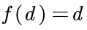 | Tended to generate overly direct paths, neglecting resource gradients
Exponential Decay | 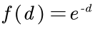 | Too sensitive to small distance changes; unstable in heterogeneous terrain
Generalized Power-Law | 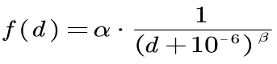 | Provided the best balance between endpoint attraction and resource-driven detours
These functions were implemented within the path scoring formula:
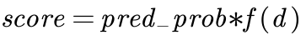
To quantitatively assess model performance, we calculated Hausdorff distances between simulated and empirical elephant movement paths. This analysis verified the realism of each functional form under actual movement constraints.
Table 6-2 Hausdorff Distance Comparison Across Scoring Functions
Function Type | Mean Hausdorff Distance (m) | Notes
Linear | 507 | Deviated significantly at decision points
Exponential Decay | 499 | Erratic behavior in heterogeneous terrain
Inverse Distance | 465 | Better performance, but unstable over long-range paths
Generalized Power-Law | 418 | performance optimal when α=1 and β=3
Based on both visual inspection and quantitative evaluation, the Generalized Power-Law with 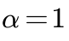 and 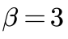 was selected as the final scoring function, as it consistently generated realistic and smooth paths closely matching observed elephant movements.
for neighbor, dist_to_end, distance in closer_neighbors:
distance_ratio = dist_to_end / current_dist_to_end
score = neighbor['pred_prob'] * (1 / ((distance_ratio ** 3) + 1e-6))

Appendix 7: Comparative Analyses of Movement Path Modeling Approaches
Table 7-1 Comparison of ERSF-VIPA and LCP Models
Comparison Dimensions | ERSF-VIPA | LCP
Core Goals | Reconstruct the movement paths of large, cryptic, or potentially dangerous wildlife based on limited data (occurrence points), supporting path prediction and human-wildlife conflict mitigation. | Calculates the "least cost" path from a starting point to an end point based on a landscape resistance surface. This is often used in corridor design and connectivity analysis.
Spatial Cognition Hypothesis | The initial resource selection probability calculation relies on global environmental data (just to reflect the species' own resource preferences), but the path search stage relies only on local information (neighborhood evaluation of the current node) without the assumption of global landscape cognition. | It is assumed that species have complete spatial cognition, are able to know the global landscape resistance distribution, and directly plan the optimal path from the starting point to the end point.
Path generation principle | 1. ERSF module: Estimates resource selection probabilities (non-linear relationships) on a hexagonal grid using a random forest algorithm.  2. VIPA module: Iterates the search within the hexagonal vector network, prioritizing neighbors with high suitability and short distances based on a combination of resource selection probabilities and a cubic distance coefficient score. | Based on a preset resistance surface (such as resistance values of land use, terrain, etc.), calculating the path with the least cumulative resistance is essentially a global optimization problem.
Data requirements | Basic occurrence records (without precise timestamps or location information), which can be expanded according to 4.3 to simulate multiple paths in unknown destination scenarios | High-resolution landscape resistance data (resistance values for each landscape type must be clearly defined); precise start and end point coordinates.
Spatial model structure | Adopting hexagonal vector grid | A grid structure is often used
Path optimization method | Local iterative optimization: Starting from the starting point, only the 6 neighboring nodes of the current node are evaluated each time, the optimal neighboring node is selected as the next stop, and the optimization gradually approached the end point without relying on global information.。 | Global one-time optimization: Based on the resistance distribution of the entire landscape, the complete path from the starting point to the end point is directly calculated. The path generation relies on the global resistance data.
Endpoint dependencies | The starting and ending points need to be preset, but the path generation process does not rely on global knowledge of the end point, but only gradually approximates it through neighborhood iteration (similar to "myopic" search). | Strictly relies on preset start and end points, and path generation is based on global knowledge of the end point location.
Ecological authenticity | 1. Integrate the nonlinear relationship of resource selection;  2. Simulate the "energy efficiency + resource preference" trade-off, closer to the decision-making logic of real animals. | 1. Assuming a linear relationship between resistance and path cost may simplify the nonlinear characteristics of ecological preferences;  2. Considering only "minimum cost" ignores the active selection behavior of animals for resources.
Similarities | 1. Both require starting and ending point information; 2. Both use environmental variables (such as topography and land use) as the basis for path generation; 3. Both can be used to predict species migration paths, serving fields such as ecological conservation.

Table 7-2 Comparison of ERSF-VIPA and Randomized Least-cost Path (RSP) (Panzacchi et al., 2016) Models
Comparison Dimensions | RSP | ERSF-VIPA
Data Dependency | Still requires dense GPS tracks (for SSF and θ calibration), relying on continuous positioning data | Only species occurrence points (such as feces, footprints) are required, which is suitable for historical data without time stamps and imprecise positioning
Spatial Cognition Hypothesis | Explicitly assumes "global landscape cognition" and path generation is based on optimizing the global friction surface (even if θ introduces randomness, global cost information is still required) | The initial resource selection probability calculation relies on global environmental data (just to reflect the species' own resource preferences), but the path search stage relies only on local information (neighborhood evaluation of the current node) without the assumption of global landscape cognition.
Nonlinear characterization capabilities | SSF relies on parameterized functions (such as the exponential form in eqn 2), which has limited ability to capture complex environmental interactions. | Capturing nonlinear resource selection with ERSF
Application Scenario | Focus on long-term migration corridor identification, suitable for species with intensive tracking data | Focuses on path reconstruction and conflict warning when data is limited (e.g., predicting elephants approaching villages)

Appendix 8: Results of multiple simulation path methods
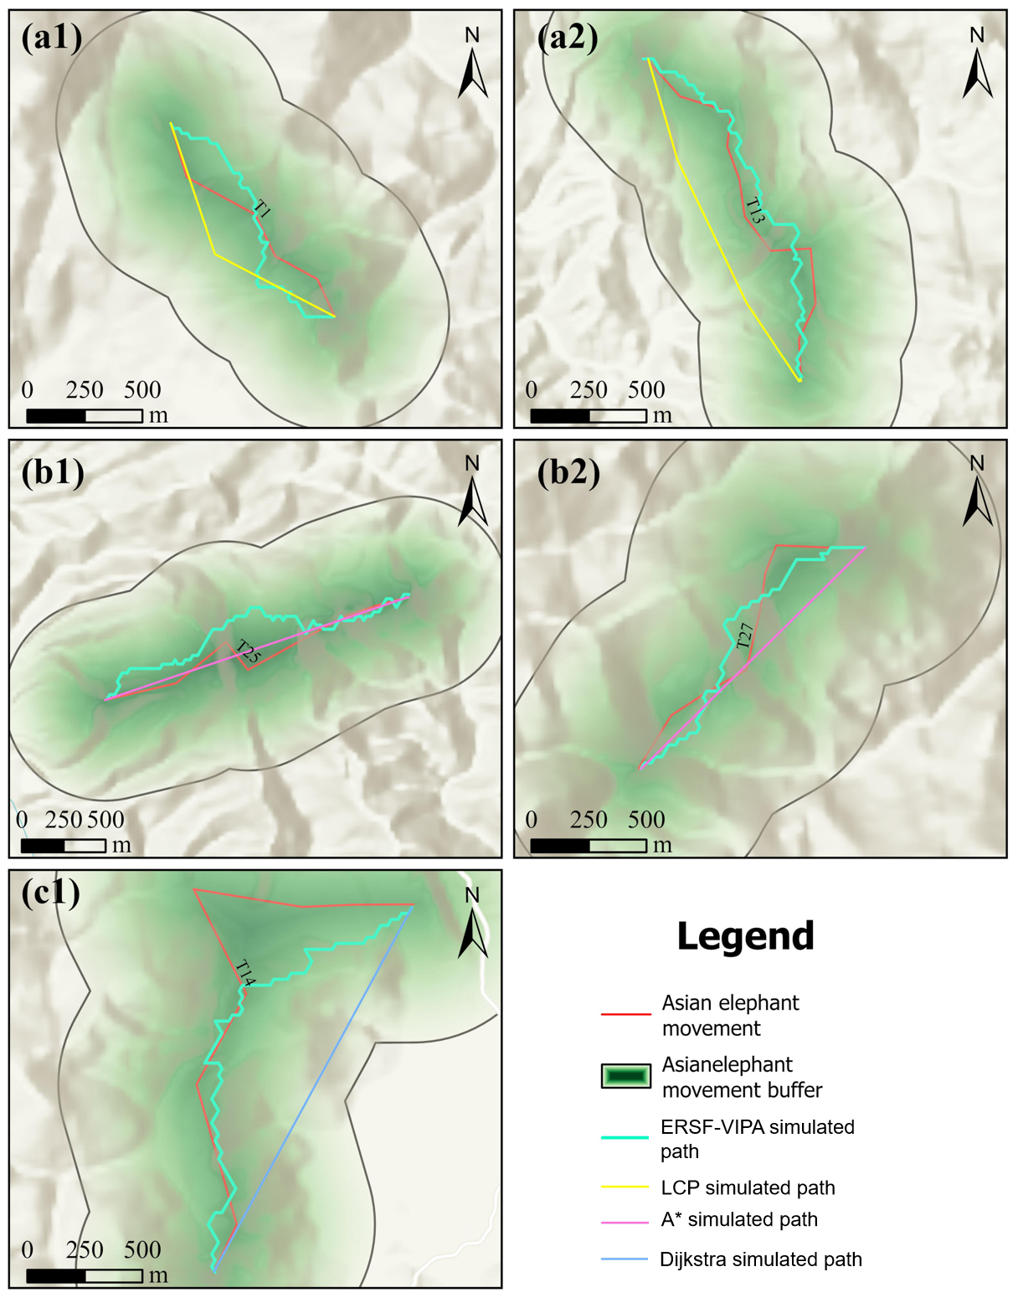
Figure A8-1. Results of multiple simulation path methods: The a-series of figures compare the Least-Cost Path (LCP) simulation with the ERSF-VIPA simulation. The b-series of figures compare the A* algorithm simulation with the ERSF-VIPA simulation. The c-series of figures compare the Dijkstra algorithm simulation with the ERSF-VIPA simulation.

Since the path-finding logic of circuit theory aligns with the principle of identifying the lowest-cost path, the LCP simulation results presented in the a-series of figures essentially reflect the path simulation outcomes based on circuit theory. As observed from the a-series in Figure A8-1, both circuit theory and LCP methods perform poorly at a local scale when simulating wildlife movement paths. This is because these approaches are primarily designed for broader spatial scales, making them more suitable for corridor planning rather than fine-scale movement simulations.
From the b-series in Figure A8-1, it is evident that the A* algorithm, which is designed to find the shortest path in an environment with completely impassable obstacles, does not align well with real-world wildlife movement. In natural landscapes, completely impassable barriers are rare at a local scale, and the A* algorithm fails to account for multiple environmental factors, resulting in poor ecological adaptability. Consequently, it is not suitable for direct application in wildlife movement simulations.
Similarly, the Dijkstra algorithm follows a logic comparable to A*, and as shown in the c-series of Figure A8-1, the paths generated by this method are also ecologically unrealistic.
In summary, the comparison of multiple path-finding methods further validates that the ERSF-VIPA framework developed in this study provides superior accuracy in simulating wildlife migration paths, demonstrating its effectiveness in ecological applications.

References
Boyce, M. S., Vernier, P. R., Nielsen, S. E., & Schmiegelow, F. K. (2002). Evaluating resource selection functions. Ecological modelling, 157(2-3), 281-300.https://doi.org/10.3390/ani12081018
Coverdale, T. C., Boucher, P. B., Singh, J., Palmer, T. M., Goheen, J. R., Pringle, R. M., & Davies, A. B. (2024). Herbivore regulation of savanna vegetation: Structural complexity, diversity, and the complexity–diversity relationship. Ecological Monographs, 94(4), e1624. https://doi.org/10.1002/ecm.1624
Darker, K. N. (2022). Enzootic geophagy by elephants (Loxodonta Africana) in relation to geochemical composition of mineral licks in Addo Elephant National Park, South Africa (Doctoral dissertation, University of the Free State).
Du, Y., Chen, J., & Xie, Y. (2023). The Impacts of the Asian Elephants Damage on Farmer’s Livelihood Strategies in Pu’er and Xishuangbanna in China. Sustainability, 15(6), 5033. https://doi.org/10.3390/su15065033
Huang C, Li X, Khanal L, Jiang X. 2019. Habitat suitability and connectivity inform a co-management policy of protected area network for Asian elephants in China. PeerJ 7:e6791 https://doi.org/10.7717/peerj.6791
Li, M. (2023). Hexagonal Discrete Global Grid Systems in Topographical and Hydrological Modeling. https://dx.doi.org/10.11575/PRISM/40787
Kumar, V., Raghevendra, S., Devagiri, G. M., & Rani, V. (2023). Assessing Asian elephant habitat preferences in the Central Western Ghats using GIS, remote sensing, and analytical hierarchy process (ahp). Int. J. Environ. Clim. Change, 13(10), 3355-3365. https://doi.org/10.9734/ijecc/2023/v13i103004
Panzacchi, M., Van Moorter, B., Strand, O., Saerens, M., Kivimäki, I., St. Clair, C. C., ... & Boitani, L. (2016). Predicting the continuum between corridors and barriers to animal movements using Step Selection Functions and Randomized Shortest Paths. Journal of Animal Ecology, 85(1), 32-42. https://doi.org/10.1111/1365-2656.12386
Selier, J., Slotow, R., & Di Minin, E. (2015). Large mammal distribution in a Transfrontier Landscape: trade‐offs between resource availability and human disturbance. Biotropica, 47(3), 389-397. https://doi.org/10.1111/btp.12217
Senay, S. D., Worner, S. P., & Ikeda, T. (2013). Novel three-step pseudo-absence selection technique for improved species distribution modelling. PloS one, 8(8), e71218. https://doi.org/10.1371/journal.pone.0071218
White, J. G., Sparrius, J., Robinson, T., Hale, S., Lupone, L., Healey, T., ... & Rendall, A. R. (2022). Can NDVI identify drought refugia for mammals and birds in mesic landscapes?. Science of the Total Environment, 851, 158318. https://doi.org/10.1016/j.scitotenv.2022.158318
Yang, W., Ma, Y., Jing, L., Wang, S., Sun, Z., Tang, Y., & Li, H. (2022). Differential impacts of climatic and land use changes on habitat suitability and protected area adequacy across the Asian elephant’s range. Sustainability, 14(9), 4933. https://doi.org/10.3390/su14094933
Zhang, J., Li, S., & Wang, L. (2022). Identifying ecological corridors for the Chinese ecological conservation redline in the Qinling-Daba Mountains. PLOS ONE, 17(7), e0271076. https://doi.org/10.1371/journal.pone.0271076

