Supplementary Information S1: Capture locations on the Osa Peninsula
We captured vultures in three different locations on the Osa Peninsula: A = 1 vulture, B = 39 vultures; C = 6 vultures.

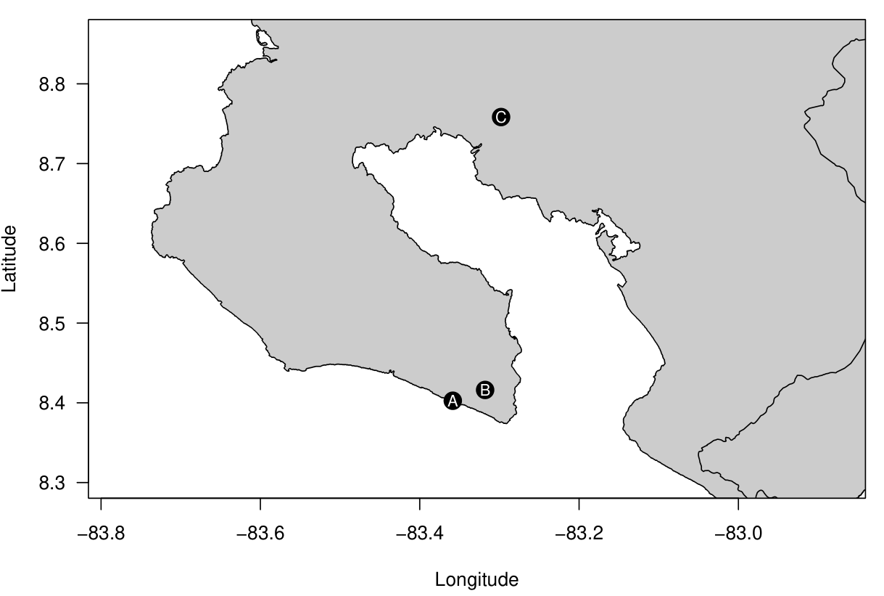

Supplementary Information S2: Tree height distribution in the study region
In order to discriminate forest qualities, we used the natural inflection (red dashed line) in tree height data to represent ‘disturbed’ (<25m) and ‘mature’ forests. The height data was from the ‘ETH Global Sentinel-2 10m Canopy Height’ model - Lang, Nico, Walter Jetz, Konrad Schindler, and Jan Dirk Wegner. "A high-resolution canopy height model of the Earth." arXiv preprint arXiv:2204.08322 (2022).

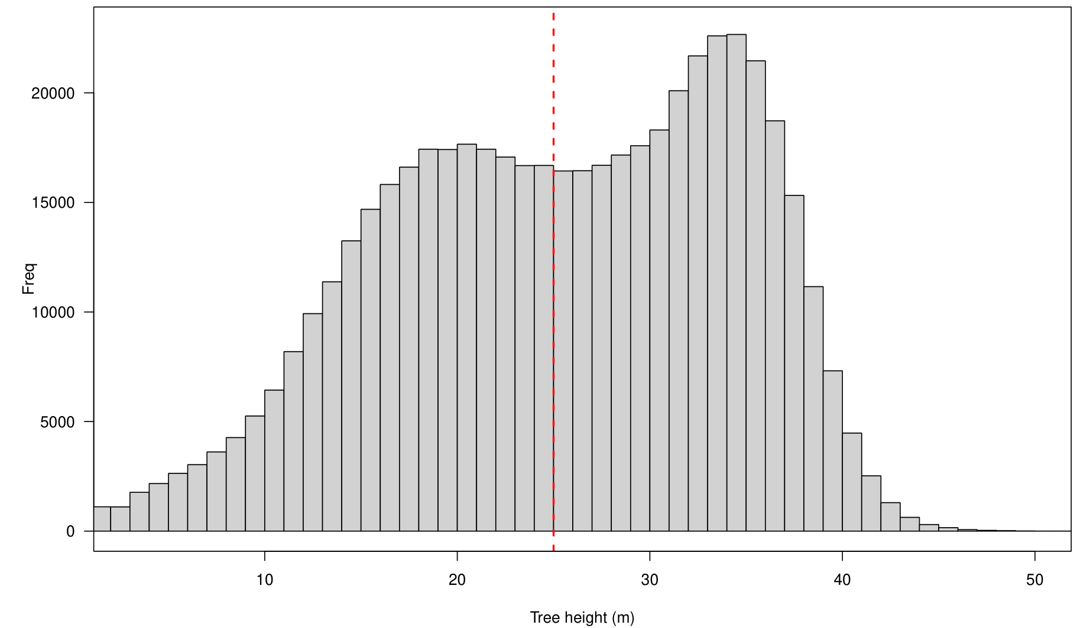

Supplementary Information S3: Cluster visit summaries

Of the King vulture feeding clusters identified using the methodology in the main text, we visited 67 of these within 72 hours of cluster initiation to identify what was occurring at these locations. Of the locations visited, 15 were not accessible due to terrain or private property boundaries, leaving 52 potential locations. Of these, 30 had identifiable animal remains still in situ, 25 of which represented domestic animals (cattle = 22; horse = 2; dog =1), and 5 represented wild animals (spider monkey = 2; Striped hog-nosed skunk = 1; UID snake = 1; UID parrot =1). One location had unidentifiable animal remains, and the last one appeared to be a palm nut feeding site.

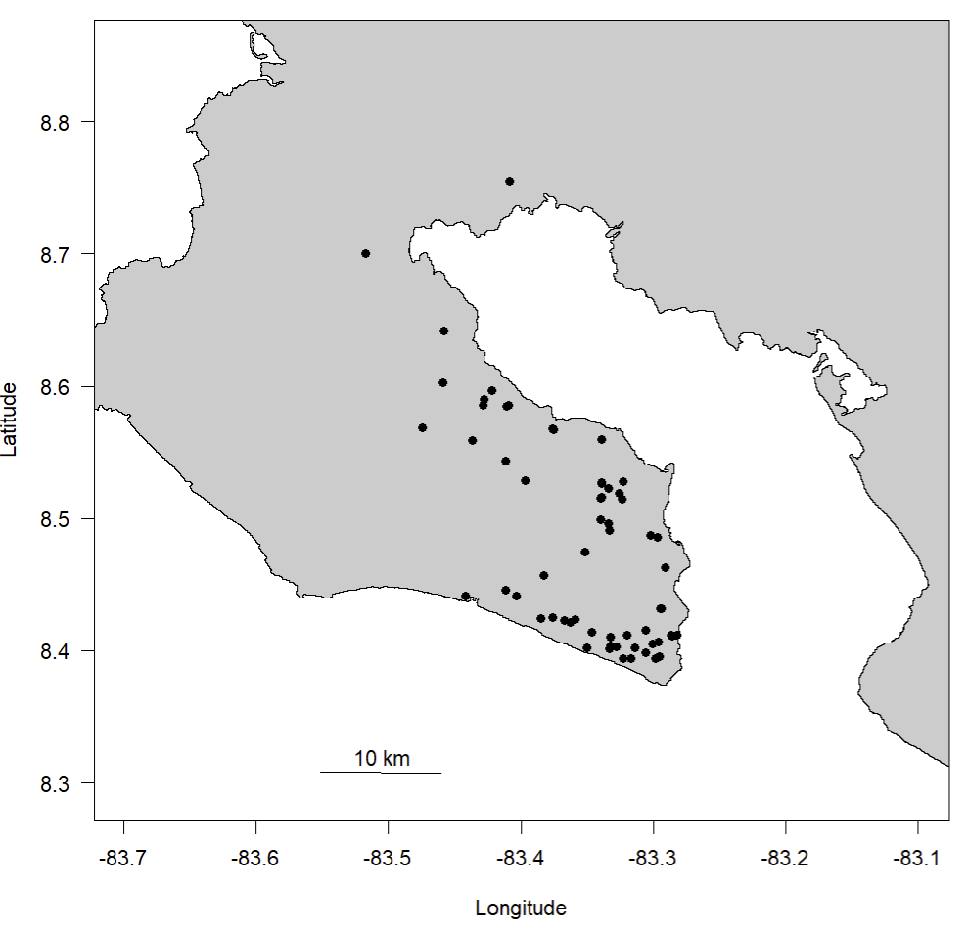
Appendix C Figure 1. The locations of the feeding cluster visits (black circles).

Supplementary Information S4: Removal of locations over the open water bodies

We removed all locations over the open water bodies from consideration in the analysis (n = 225; 0.2 % of flying locations). Where king vultures did fly over the ocean (Appendix D Figure 1 left panel), they were on average 221 m from the shore (min = 20 m; max = 2190 m; Appendix B Figure 1 right panel).
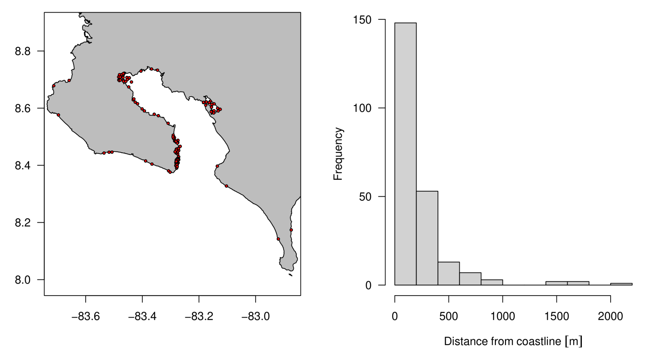
Appendix D Figure 1. King vulture locations over the open ocean. Where: A = the locations where ocean flights occurred (red dots, n = 229) and; B = a histogram of the distances at which the locations were detected from the coast.

Supplementary Information S5: Individual King vulture home range estimates
Home ranges estimated through brownian bridge models (see methods).
Movebank_ID | Start | End | Sampling period (months) | Home range (km²)
1933592747 | 23-02-2022 | 31-10-2023 | 20.1 | 68.68
1933592631 | 30-01-2023 | 31-10-2023 | 9.2 | 1296.94
1933592681 | 24-01-2023 | 31-10-2023 | 9.4 | 3293.27
1933592693 | 17-03-2022 | 09-09-2022 | 5.9 | 309.84
1933592708 | 30-01-2023 | 31-10-2023 | 9.2 | 4350.02
1933592734 | 17-05-2023 | 31-10-2023 | 5.6 | 725.84
1933592747 | 11-02-2023 | 31-10-2023 | 8.8 | 1370.28
2533349512 | 04-01-2023 | 31-10-2023 | 10.1 | 50.29
2533363557 | 03-10-2022 | 31-10-2023 | 19.7 | 210.91
2533363948 | 01-03-2022 | 31-10-2023 | 19.5 | 683.38
2533365648 | 04-01-2023 | 31-10-2023 | 10.1 | 79.29
2535340237 | 16-03-2022 | 31-10-2023 | 19.5 | 1177.44
2535885093 | 15-06-2023 | 31-10-2023 | 4.6 | 631.28
2535885106 | 18-05-2023 | 31-10-2023 | 5.6 | 755.78
2535885120 | 14-01-2023 | 31-10-2023 | 9.8 | 2450.40
2535885137 | 31-03-2023 | 31-10-2023 | 7.2 | 1481.23
2568025570 | 11-02-2023 | 31-10-2023 | 8.8 | 2115.61
2568025644 | 14-01-2023 | 31-10-2023 | 9.8 | 16.83
2586886507 | 30-01-2023 | 31-10-2023 | 9.2 | 2182.86
2586886544 | 15-06-2023 | 31-10-2023 | 4.6 | 1579.14
2586886583 | 30-04-2023 | 31-10-2023 | 6.2 | 625.42
2648857422 | 30-12-2022 | 31-10-2023 | 10.3 | 1793.34
2650416704 | 23-01-2023 | 31-10-2023 | 9.5 | 1656.36
2650449235 | 30-12-2022 | 31-10-2023 | 10.3 | 37.41
2650449248 | 17-05-2023 | 31-10-2023 | 5.6 | 19.70
2650449262 | 18-05-2023 | 31-10-2023 | 5.6 | 1229.23
2650449281 | 03-05-2023 | 31-10-2023 | 6.1 | 908.67
2653547669 | 30-05-2023 | 31-10-2023 | 5.2 | 470.83
2653547810 | 30-05-2023 | 31-10-2023 | 5.2 | 1249.26
2653547841 | 09-03-2022 | 31-10-2023 | 19.7 | 1375.66
2690987968 | 04-01-2023 | 31-10-2023 | 10.1 | 1870.65
2690988230 | 31-03-2022 | 31-10-2023 | 19.0 | 1216.88
2690988249 | 20-05-2023 | 31-10-2023 | 5.5 | 1870.65

Supplementary Information S6: Co-linearity of predictor variables for King vulture habitat use

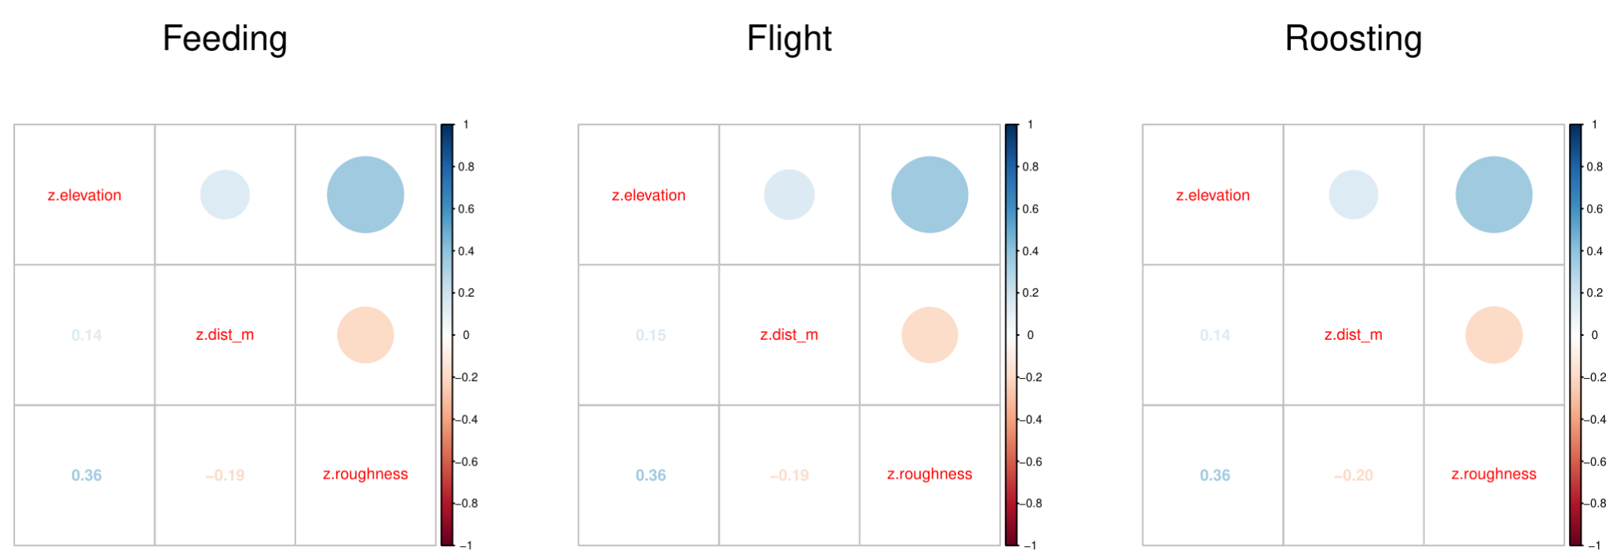
Appendix G Figure 1. Showing the lack of correlation between continuous predictors in the king vulture habitat selection models. Where the colours show the direction of correlation (blue = positive; red = negative) and the circle size (top right) and number (bottom left) show the magnitude of the correlation.
Supplementary Information S7 Information theoretic model selection for inter-individual variation in king vulture habitat selection

Flight
Fixed effects | Number of parameters | ID Random intercept | Habitat random slopes | ΔAICc | Model  weight
Disturbed forest + grassland margins + palm oil + other | 18 | ✓ | ✓ | 0 | 1
Disturbed forest + grassland margins + palm oil + other | 8 | ✓ |  | -4540 | 0

Roosting

Fixed effects | Number of parameters | ID Random intercept | Habitat random slopes | ΔAICc | Model  weight
Disturbed forest + grassland margins + palm oil + other | 14 | ✓ | ✓ | 0 | 1
Disturbed forest + grassland margins + palm oil + other | 8 | ✓ |  | -268 | 0

Feeding

Fixed effects | Number of parameters | ID Random intercept | Habitat random slopes | ΔAICc | Model  weight
Disturbed forest + grassland margins + palm oil + other | 18 | ✓ | ✓ | 0 | 1
Disturbed forest + grassland margins + palm oil + other | 8 | ✓ |  | -281 | 0

Supplementary Information S8: Global model coefficients for each flight behaviour and species

King vulture

Flight

Parameter | Estimate | Std. Error | z value | Pr(>|z|)
Intercept (Mature forest) | 0.000 | 880.300 | 0.00 | 1.000
Disturbed forest | -0.273 | 0.087 | -3.14 | 0.002
Grassland margins | -0.242 | 0.088 | -2.75 | 0.006
Palm oil | -1.219 | 0.115 | -10.57 | < 0.001
Other | -1.908 | 0.150 | -12.71 | < 0.001
Terrain roughness | 0.170 | 0.003 | 52.91 | < 0.001
Elevation | -0.440 | 0.005 | -87.74 | < 0.001
Distance to contiguous forest | -0.784 | 0.007 | -109.78 | < 0.001

Roosting

Parameter | Estimate | Std. Error | z value | Pr(>|z|)
Intercept (Mature forest) | -0.001 | 881.800 | 0.00 | 1.000
Disturbed forest | -0.834 | 0.076 | -11.02 | < 0.001
Grassland margins | -0.128 | 0.075 | -1.71 | 0.088
Palm oil | -3.570 | 0.381 | -9.37 | < 0.001
Other | -4.797 | 0.678 | -7.08 | < 0.001
Terrain roughness | 0.125 | 0.008 | 14.83 | < 0.001
Elevation | -0.457 | 0.013 | -35.63 | < 0.001
Distance to contiguous forest | -0.688 | 0.017 | -39.85 | < 0.001

Feeding

Parameter | Estimate | Std. Error | z value | Pr(>|z|)
Intercept (Mature forest) | 0.000 | 884.500 | 0.00 | 1.000
Disturbed forest | -1.433 | 0.084 | -17.10 | < 0.001
Grassland margins | -1.313 | 0.112 | -11.74 | < 0.001
Palm oil | -3.964 | 0.303 | -13.08 | < 0.001
Other | -4.795 | 0.448 | -10.70 | < 0.001
Terrain roughness | 0.243 | 0.011 | 22.29 | < 0.001
Elevation | -0.488 | 0.019 | -26.16 | < 0.001
Distance to contiguous forest | -0.325 | 0.022 | -14.70 | < 0.001

Supplementary Information S9: Farm surveys of king vulture perceptions

Farming of domestic cattle is one of the most common land use practises on the Osa Peninsula. In order to characterise the potential threats to king vultures from consuming domestic meat and local farmer perceptions of vultures, we approached 40 farmers, 28 of which agreed to participate in our surveys (70%; see Appendix J Figure 1). The farms visited all followed ‘National Route 245’ which runs from Corcovado National Park, through Puerto Jimenez), and up towards the neck of the peninsula. Structured interviews were conducted by EFT through asking a standardised set of 34 questions.

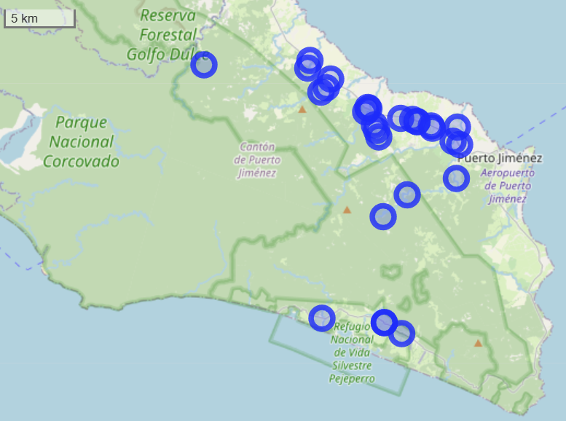
Appendix J Figure 1: Locations (blue circles) where farm surveys were conducted.

The questions asked focused on two main topics: i) animal health and veterinary practices; ii) perceptions and knowledge of vultures. The survey aimed to assess the animals' welfare, (water sources, food, how they treated diseased and dead animals) and how the owners of those farms perceived vultures and understood the ecological services these species provide. Below we present a subset of the relevant results to this manuscript.

Use of antibiotics to treat cattle: 21 of 28 farmers (75%) self reported using antibiotics to treat their cattle when they are unwell. Of those farmers, they reported using 7 types of antibiotics: Oxytetracycline (n = 14); DK (n = 4); Amoxicillin (n = 2); Penicillin (n = 1); Enrofloxacin (n = 1); Tylvalosin (n = 1); Ivermectin (n = 1).

Vulture presence:
- Black vultures: 82.1% of farmers reported seeing black vultures daily, 14.3% weekly, with only one individual (3.5%) having never seen one;
- King vultures: 42% reported seeing King vultures daily, 18% infrequently (weekly/monthly/yearly) and 40% never see them
- Turkey vultures: 3.5% reported seeing Turkey vultures daily, 71% infrequently (weekly/monthly/yearly) and 25% report never seeing them.

Advantages of vultures: 78.6% of respondents reported they ‘cleaned the environment’, 10.7% stated they ‘control diseases’, 10.7% report no benefits.

Disadvantages of vultures: 50% of respondents stated ‘none’, 43% stated they ‘kill animals’ (e.g. calves, dogs and pigs), 3.5% stated they ‘cause disease’, and one person did not respond.

Trend in vulture population sizes: 50% reported no change, 25% reported an increase in the population, 21.4% a decrease; one person said they did not know.
Supplementary Information S10 Lack of use of habitat in Panama

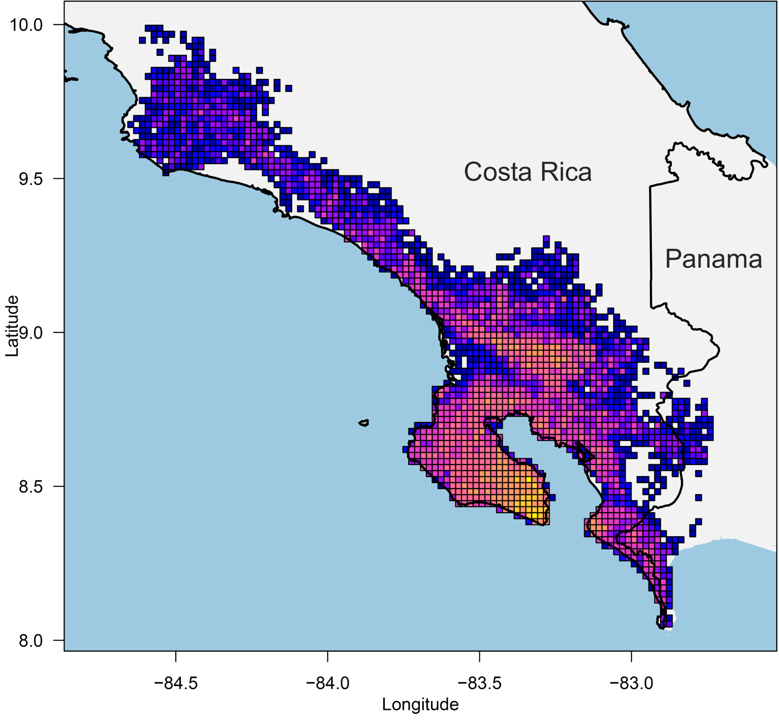
Appendix K Figure 1: Log point density from the King vultures involved in this analysis. Individuals rarely venture into Panama on the southern Pacific coast.

