Supplementary Materials: FishDiveR: Wavelet analyses and machine learning provide robust classification of animal behaviours from depth data.
Table S1. The suite of daily and diel statistics calculated on each 24-hour segment of the depth time-series. The depth statistics were combined with the principal component scores and standardised before being used in the k-means clustering.
No. | Statistic | Daily or diel
1 | Mean depth | Daily
2 | Standard deviation of depth | Daily
3 | Min depth | Daily
4 | Max depth | Daily
5 | Mean absolute vertical velocity | Daily
6 | Maximum descent vertical velocity | Daily
7 | Maximum ascent vertical velocity | Daily
8 | Depth skewness | Daily
9 | Depth kurtosis | Daily
10 | Proportion of time spent < 7.5 m | Daily
11 | Mean depth | Diel
12 | Standard deviation of depth | Diel
13 | Depth range | Diel
14 | Mean absolute vertical velocity | Diel
15 | Maximum descent vertical velocity | Diel
16 | Maximum ascent vertical velocity | Diel
17 | Proportion of time spent <7.5 | Diel
Note: The diel statistics were calculated by subtracting the daytime depth statistics from night-time depth statistics and then standardised by dividing by the maximum depth on that day. These 17 depth statistics formed the basis for subsequent k-means clustering.
Table S2. Simulated data – Parameters values for each of the four generated behaviours in the 180-day dataset.
 | Simulated Behaviour Type
Parameter | Diel vertical migration | Reverse diel vertical migration | Bounce diving | Surface foraging
shallow depth (metres) | 12.2 | 30 | 15 | 1.3
shallow depth S.D. (metres) | 4.2 | 15 | 3.5 | 1
min bottom depth (metres) | 185 | 60 | 135 | -
max bottom depth (metres) | 250 | 135 | 165 | -
bottom depth S.D. (metres) | 5.2 | 20 | 2.5 | -
dive duration mean (minutes) | 40 | - | 35 | -
dive duration S.D. (minutes) | 10 | - | 8 | -
surface interval mean (minutes) | 10 | - | 10 | -
surface interval S.D. (minutes) | 10 | - | 3 | -
Table S3. Pop-up satellite archival tag deployment information for the four case study species.
Tag Type | Species | Deployment Date | Release Date | Duration (days) | Depth Sampling Frequency
miniPAT | Oceanic manta ray Mobula birostris | 13/10/2013 | 12/01/2014 | 87 | 5-second
SPLASH | Whale Shark Rhincodon typus | 17/01/2008 | 14/04/2008 | 87 | 1-minute
PAT | Atlantic cod Gadus morhua | 03/04/2001 | 06/02/2002 | 308 | 10-minute
SPLASH | Largetooth sawfish Pristis pristis | 24/09/2022 | 25/11/2022 | 61 | 1-second

Animal ethics, tagging methods, and research organisations
Tags were deployed under the auspices of the following organisations, with ethics permits where required:
Oceanic manta ray Mobula birostris – Animal ethics approval was granted by Murdoch University animal ethics committee permit number RW3318/21 and protocol ID 836, and by the Indonesian ethics committee of the National Research and Innovation agency (BRIN) proposal number 07062022000004. For details of tag attachment see (Beale et al. 2019).
Atlantic cod Gadus morhua – All tagging was conducted under government licence and was in adherence with national regulations on the treatment of experimental animals (Righton et al. 2010). For full details see the ‘Horizontal and vertical movement data derived from a data storage tag deployed on a single Atlantic cod in the North Sea from 2001 to 2002 - Cefas (Centre for Environment, Fisheries and Aquaculture Science)’ https://www.cefas.co.uk/data-and-publications/dois/horizontal-and-vertical-movement-data-derived-from-a-data-storage-tag-deployed-on-a-single-atlantic-cod-in-the-english-channel-from-2005-to-2006/
Largetooth sawfish Pristis pristis – Tagging was undertaken by the Western Australia Department of Primary Industries and Regional Development under FRMA 1994 Exemption 251003922. Sampling occurred under a scientific use licence granting animal ethics approval. Tagging procedure as per (Papastamatiou et al. 2015).
Whale shark Rhincodon typus – Whale sharks were tagged using protocols described in (Arrowsmith et al. 2021). Permits to tag animals were provided by the Commonwealth Government of Australia and ethics approvals were granted by the University of Western Australia.
Table S1. Simulated data – Eigenvalues and the percentage of variance explained within the dataset by the principal component with eigenvalues ≥ 1.
Principal Component | Eigenvalue | Percentage of variance | Cumulative percentage of variance
1 | 138.426 | 46.61 | 46.61
2 | 108.132 | 36.41 | 83.02
3 | 23.683 | 7.97 | 90.99
4 | 7.425 | 2.50 | 93.49
5 | 3.730 | 1.26 | 94.75
6 | 1.995 | 0.67 | 95.42
7 | 1.846 | 0.62 | 96.04
8 | 1.565 | 0.53 | 96.57
9 | 1.390 | 0.47 | 97.03
10 | 1.236 | 0.42 | 97.45

Table S2. Simulated data – Output from k-means clustering. The number of days assigned to each behaviour cluster of both k = 4 and k = 5 for comparative purposes.
Cluster Assignment | Days per Cluster K = 4 | Days per Cluster k = 5
1 | 17 | 17
2 | 34 | 57
3 | 57 | 72
4 | 72 | 28
5 | - | 6
Note: Cluster number assignments are not directly comparable between k-means results for k = 4 and k = 5 as cluster number is assigned randomly by the k-means algorithm.
Table S3. Simulated data – Mean standardised values of the combined 17 daily depth statistics and the three wavelet components used in k-means clustering to assign behaviour clusters to each day of data.
 | Standardised Mean Value per Cluster
Daily Statistic | Cluster 1 | Cluster 2 | Cluster 3 | Cluster 4 | Cluster 5
Mean depth | -0.73 | 0.73 | 0.47 | -1.86 | -1.86
S.D. depth | -0.72 | -0.25 | 1.07 | -1.51 | -1.51
Minimum depth | -0.69 | 1.40 | -0.62 | -0.69 | -0.69
Maximum depth | -0.19 | 0.02 | 0.89 | -1.83 | -1.83
Mean absolute vertical velocity | 2.71 | 0.19 | -0.23 | -1.19 | -1.17
Mean descent vertical velocity | -0.44 | 0.41 | 0.69 | -1.94 | -1.95
Mean ascent vertical velocity | -0.71 | 0.36 | 0.68 | -2.12 | 0.24
Depth skewness | 0.81 | -1.44 | 0.51 | 0.94 | 0.96
Depth kurtosis | -0.21 | 1.26 | -1.04 | 0.16 | 0.33
Proportion of time spent in surface waters (≤ 7 meters) | -0.49 | -0.57 | -0.40 | 2.06 | 2.06
Diel difference in mean depth | 1.42 | 0.67 | -1.19 | 0.68 | 0.66
Diel difference in S.D. depth | 0.31 | -0.77 | 0.88 | -0.73 | -0.72
Diel difference in range | 0.38 | 0.04 | -0.40 | 0.44 | 1.32
Diel difference in mean absolute vertical velocity | 1.82 | -0.18 | -0.51 | -0.02 | 2.75
Diel difference in ascent vertical velocity | -0.54 | -0.84 | 1.18 | -0.80 | -0.83
Diel difference in descent vertical velocity | -0.13 | -0.15 | -0.26 | -0.05 | 5.13
Diel difference in proportion of time spent in surface waters (≤ 7 meters) | -1.47 | -0.65 | 1.16 | -0.64 | -0.65
Wavelet component 1 | -0.06 | 1.37 | -0.93 | -0.27 | -0.38
Wavelet component 2 | -1.11 | 0.41 | 0.67 | -1.64 | -1.23
Wavelet component 3 | 0.24 | -0.01 | -0.20 | 0.21 | 0.83
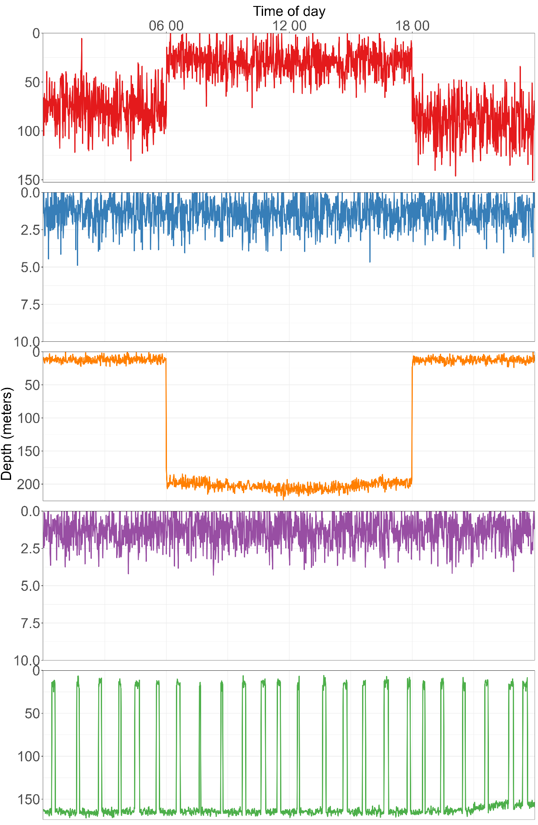
Figure S1. Simulated data – Depth time-series of the 24-hour segment closest to the centre (most representative) of each behaviour cluster identified, based on daily statistics (Supplementary Table 6). The shading indicates night-time periods, with fixed sunrise and sunset times at 6 am and 6 pm, respectively. Clusters are coloured consistently with the depth time-series shown in Supplementary Figure 2. The panels highlight distinct behavioural patterns among clusters 1 through 4, whereas clusters 4 and 5 appear visually very similar.
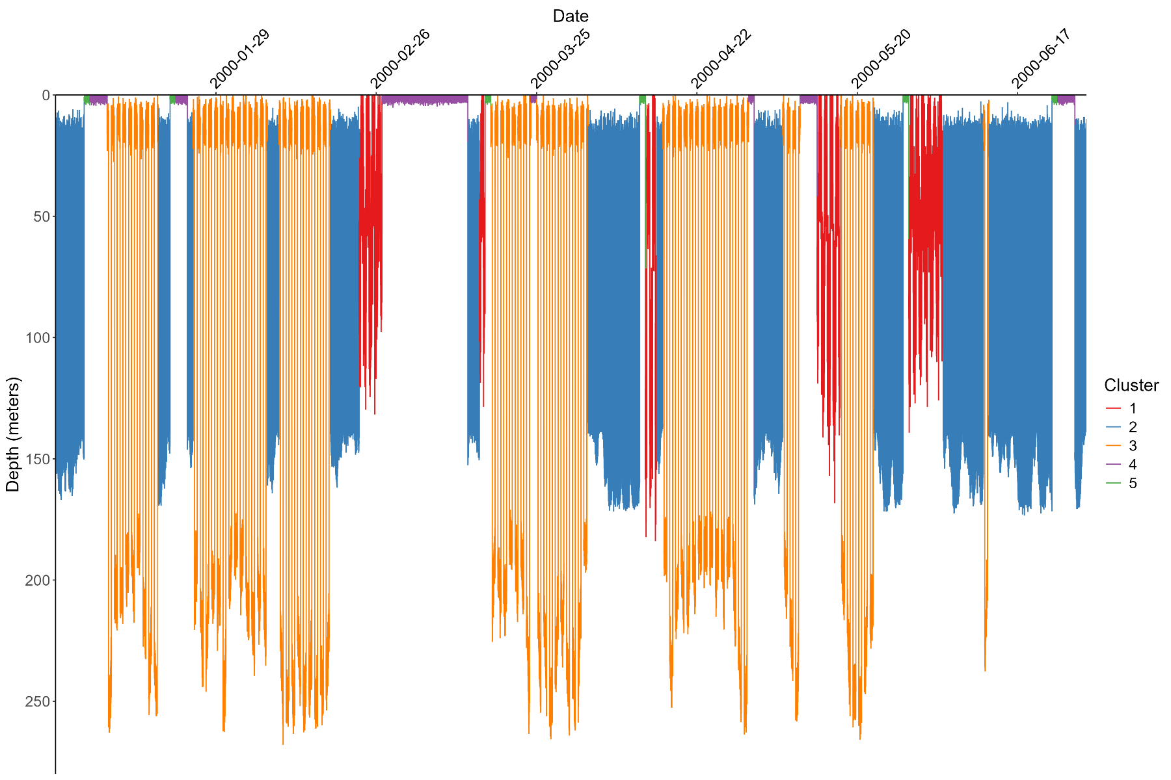
Figure S2. Simulated data – Depth time-series of 180-day dataset. Simulated data were generated to mimic existing data from oceanic manta rays, containing four commonly recorded vertical movement behaviours: diel vertical migration, reverse diel vertical migration, shallow movement, and bounce diving. Each 24-hour segment is coloured by its assigned cluster, highlighting the temporal distribution of clusters, and variability of vertical movement across the dataset.
Table S4. Principal component analysis eigenvalues and percentage variance of the four case study species.
 | Oceanic manta ray |  |  | Whale shark |  |  | Atlantic cod |  |  | Largetooth sawfish
Principal Component | Eigen-value | Percent of Variance | Cumulative Percent of Variance | Eigen-value | Percent of Variance | Cumulative Percent of Variance | Eigen-value | Percent of Variance | Cumulative Percent of Variance | Eigen-value | Percent of Variance | Cumulative Percent of Variance
1 | 106.45 | 35.84 | 35.84 | 103.21 | 34.75 | 34.75 | 143.85 | 55.12 | 55.12 | 94.71 | 36.29 | 36.29
2 | 52.78 | 17.77 | 53.61 | 74.55 | 25.10 | 59.85 | 31.61 | 12.11 | 67.23 | 39.36 | 15.08 | 51.37
3 | 22.45 | 7.56 | 61.17 | 31.12 | 10.48 | 70.33 | 13.40 | 5.13 | 72.36 | 28.13 | 10.78 | 62.15
4 | 18.84 | 6.34 | 67.51 | 18.89 | 6.36 | 76.69 | 12.14 | 4.65 | 77.01 | 16.59 | 6.36 | 68.50
5 | 14.95 | 5.03 | 72.55 | 11.91 | 4.01 | 80.70 | 10.61 | 4.07 | 81.08 | 14.35 | 5.50 | 74.00
6 | 12.18 | 4.10 | 76.65 | 9.64 | 3.25 | 83.95 | 7.98 | 3.06 | 84.13 | 11.07 | 4.24 | 78.25
7 | 9.82 | 3.31 | 79.96 | 6.92 | 2.33 | 86.28 | 6.49 | 2.49 | 86.62 | 8.63 | 3.31 | 81.55
8 | 7.75 | 2.61 | 82.57 | 5.68 | 1.91 | 88.19 | 5.46 | 2.09 | 88.71 | 7.03 | 2.69 | 84.25
9 | 7.69 | 2.59 | 85.16 | 5.07 | 1.71 | 89.89 | 4.91 | 1.88 | 90.59 | 5.94 | 2.27 | 86.52
10 | 5.82 | 1.96 | 87.12 | 3.63 | 1.22 | 91.12 | 3.24 | 1.24 | 91.83 | 5.46 | 2.09 | 88.61
11 | 4.77 | 1.61 | 88.72 | 3.24 | 1.09 | 92.20 | 2.68 | 1.03 | 92.86 | 4.34 | 1.66 | 90.27
12 | 4.34 | 1.46 | 90.18 | 2.80 | 0.94 | 93.15 | 2.62 | 1.00 | 93.86 | 3.57 | 1.37 | 91.64
13 | 3.11 | 1.05 | 91.23 | 2.52 | 0.85 | 93.99 | 1.82 | 0.70 | 94.56 | 2.45 | 0.94 | 92.58
14 | 2.78 | 0.94 | 92.16 | 2.25 | 0.76 | 94.75 | 1.60 | 0.61 | 95.17 | 2.36 | 0.91 | 93.48
15 | 2.37 | 0.80 | 92.96 | 2.11 | 0.71 | 95.46 | 1.35 | 0.52 | 95.69 | 2.28 | 0.87 | 94.36
16 | 2.19 | 0.74 | 93.70 | 1.76 | 0.59 | 96.06 | 1.24 | 0.47 | 96.16 | 1.76 | 0.67 | 95.03
17 | 2.17 | 0.73 | 94.43 | 1.39 | 0.47 | 96.52 | 1.23 | 0.47 | 96.63 | 1.39 | 0.53 | 95.56
18 | 1.83 | 0.61 | 95.04 | 1.19 | 0.40 | 96.93 | 1.03 | 0.40 | 97.03 | 1.25 | 0.48 | 96.04
19 | 1.75 | 0.59 | 95.63 | 1.01 | 0.34 | 97.27 | - | - | - | 1.16 | 0.45 | 96.49
20 | 1.52 | 0.51 | 96.14 | - | - | - | - | - | - | 1.03 | 0.40 | 96.88
21 | 1.29 | 0.43 | 96.58 | - | - | - | - | - | - | - | - | -
22 | 1.11 | 0.37 | 96.95 | - | - | - | - | - | - | - | - | -
Note: Orange text indicates the principal components for each species which contribute to ≥ 75% of the cumulative percent of variance within the dataset. The loadings of each principal component across the period range for each species highlight the different data represented by that component (Figures S3-6).
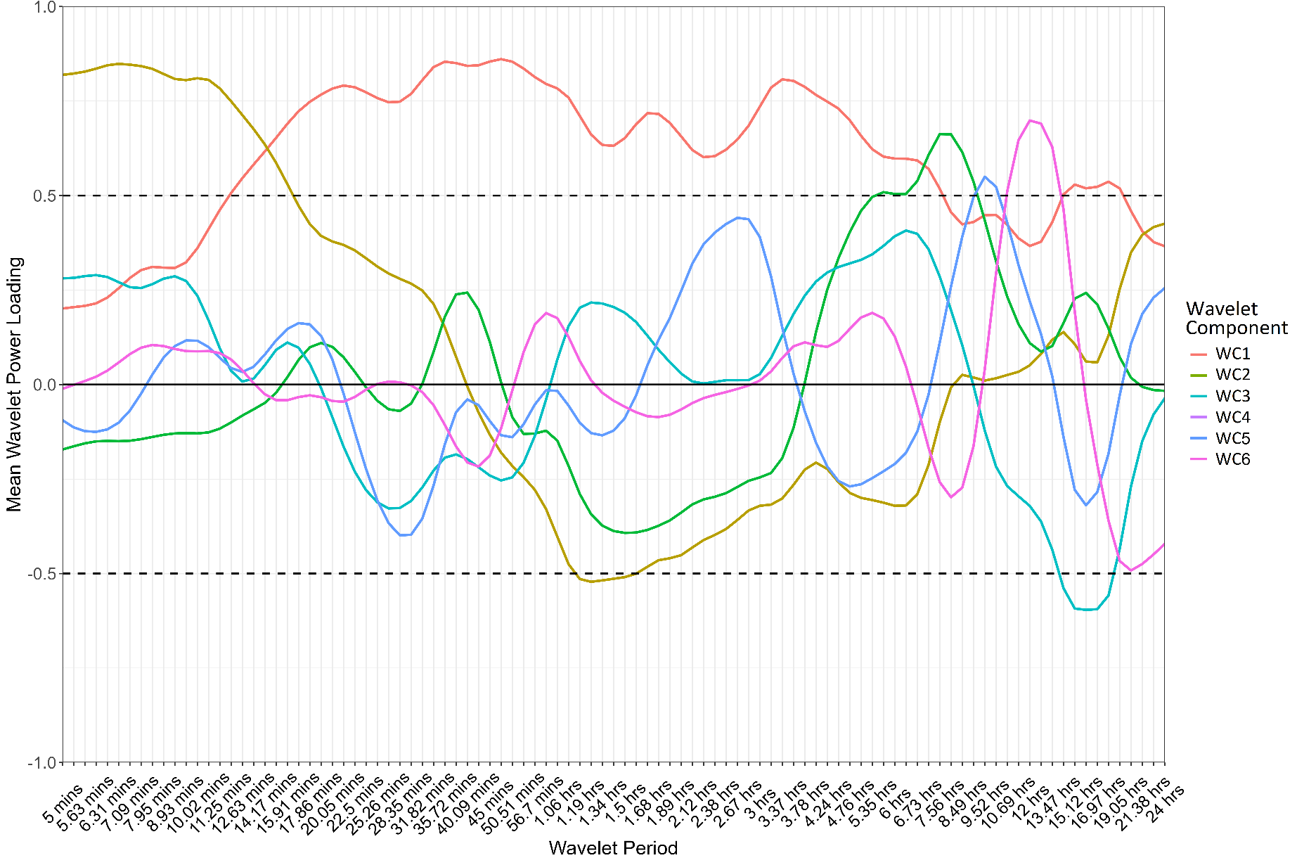
Figure S3. Oceanic manta ray mean wavelet power loadings of wavelet components (WCs) one through six across the wavelet period range (lower period of 5-minutes to upper period of 24-hours). Each WC reflects a specific aspect of the vertical movement patterns, dominating at different timescales and capturing the variance in behaviour across the period range.
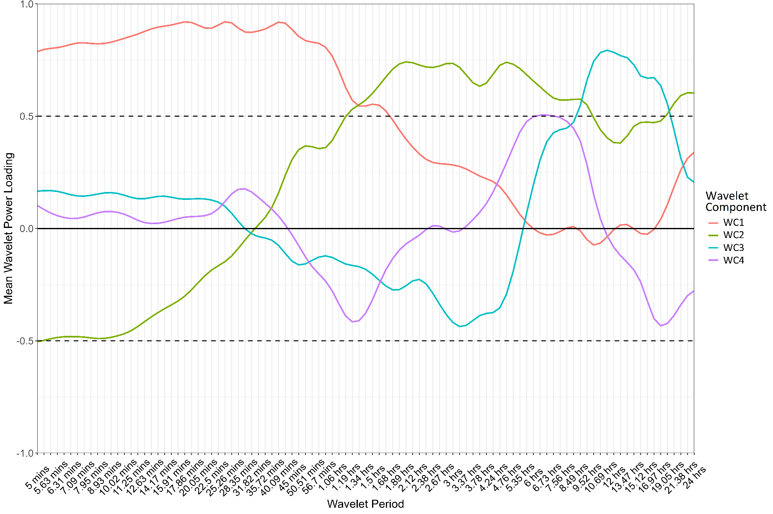
Figure S4. Whale shark mean wavelet power loadings of wavelet components (WCs) one through four across the wavelet period range (lower period of 5-minutes to upper period of 24-hours). Each WC reflects a specific aspect of the vertical movement patterns, dominating at different timescales and capturing the variance in behaviour across the period range.
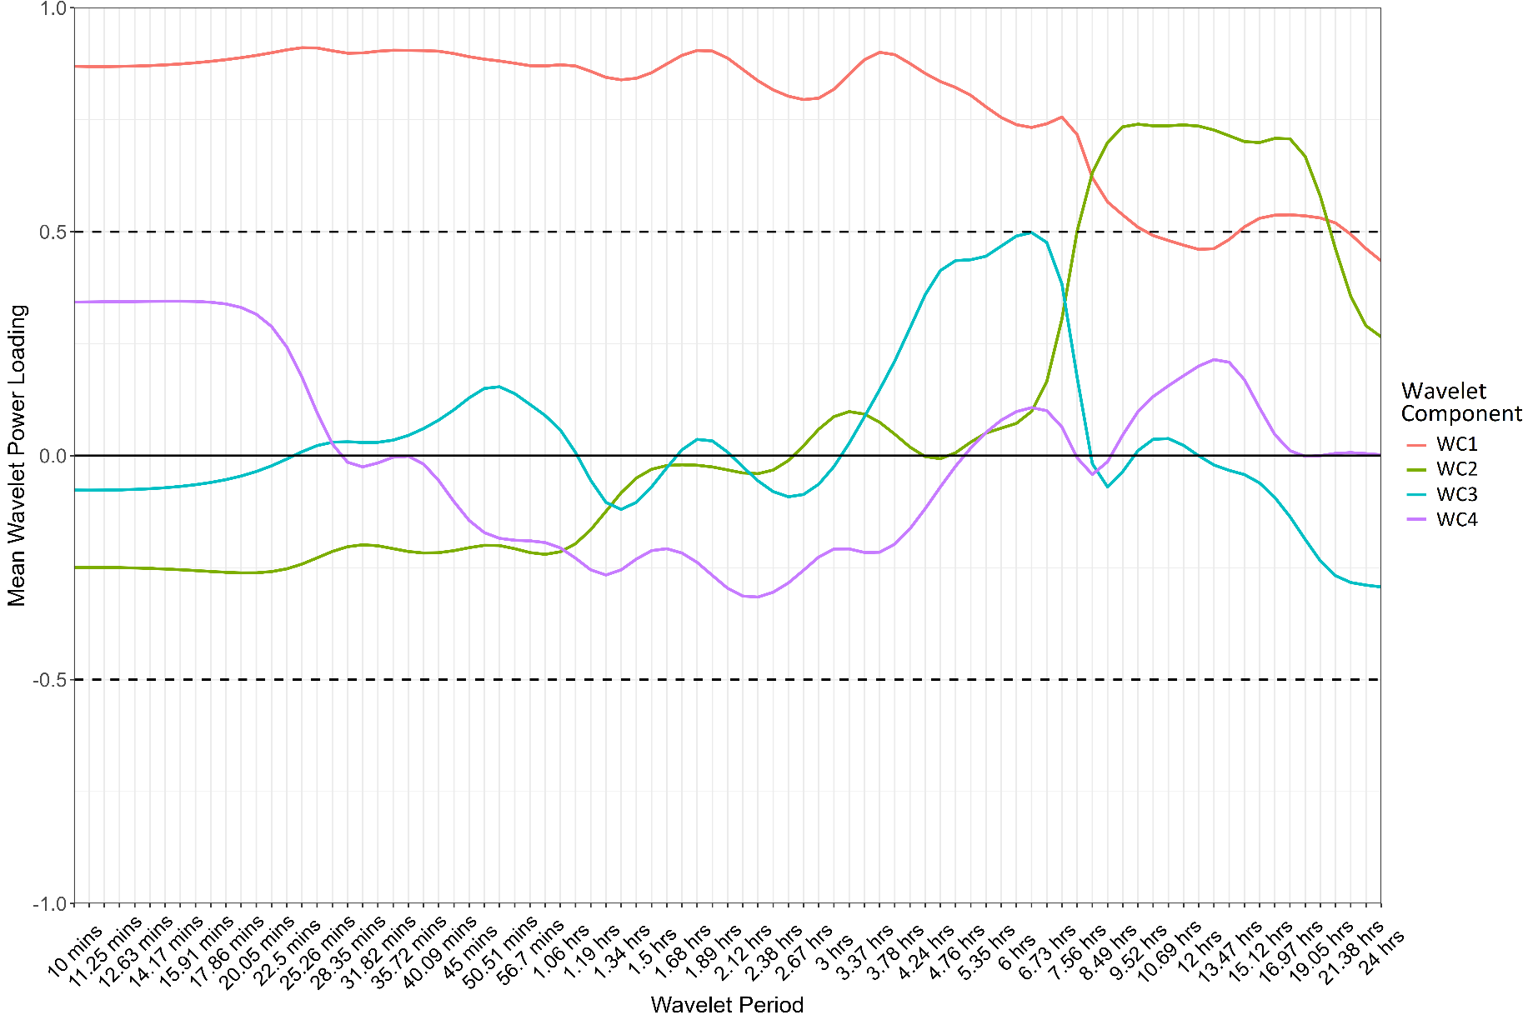
Figure S5. Atlantic cod mean wavelet power loadings of wavelet components (WCs) one through four across the wavelet period range (lower period of 10-minutes to upper period of 24-hours). Each WC reflects a specific aspect of the vertical movement patterns, dominating at different timescales and capturing the variance in behaviour across the period range.
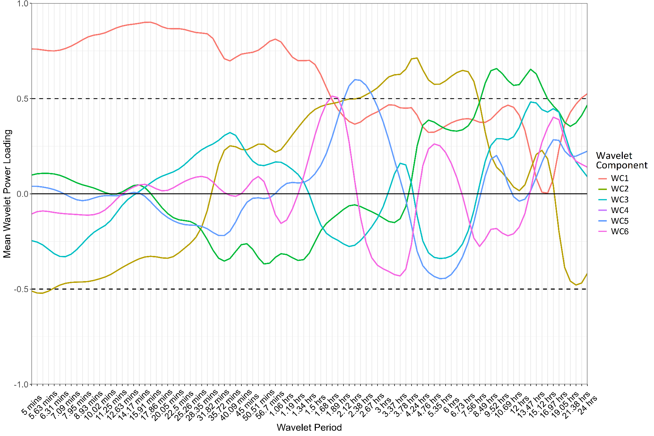
Figure S6. Largetooth sawfish mean wavelet power loadings of wavelet components (WCs) one through six across the wavelet period range (lower period of 5-minutes to upper period of 24-hours). Each WC reflects a specific aspect of the vertical movement patterns, dominating at different timescales and capturing the variance in behaviour across the period range.
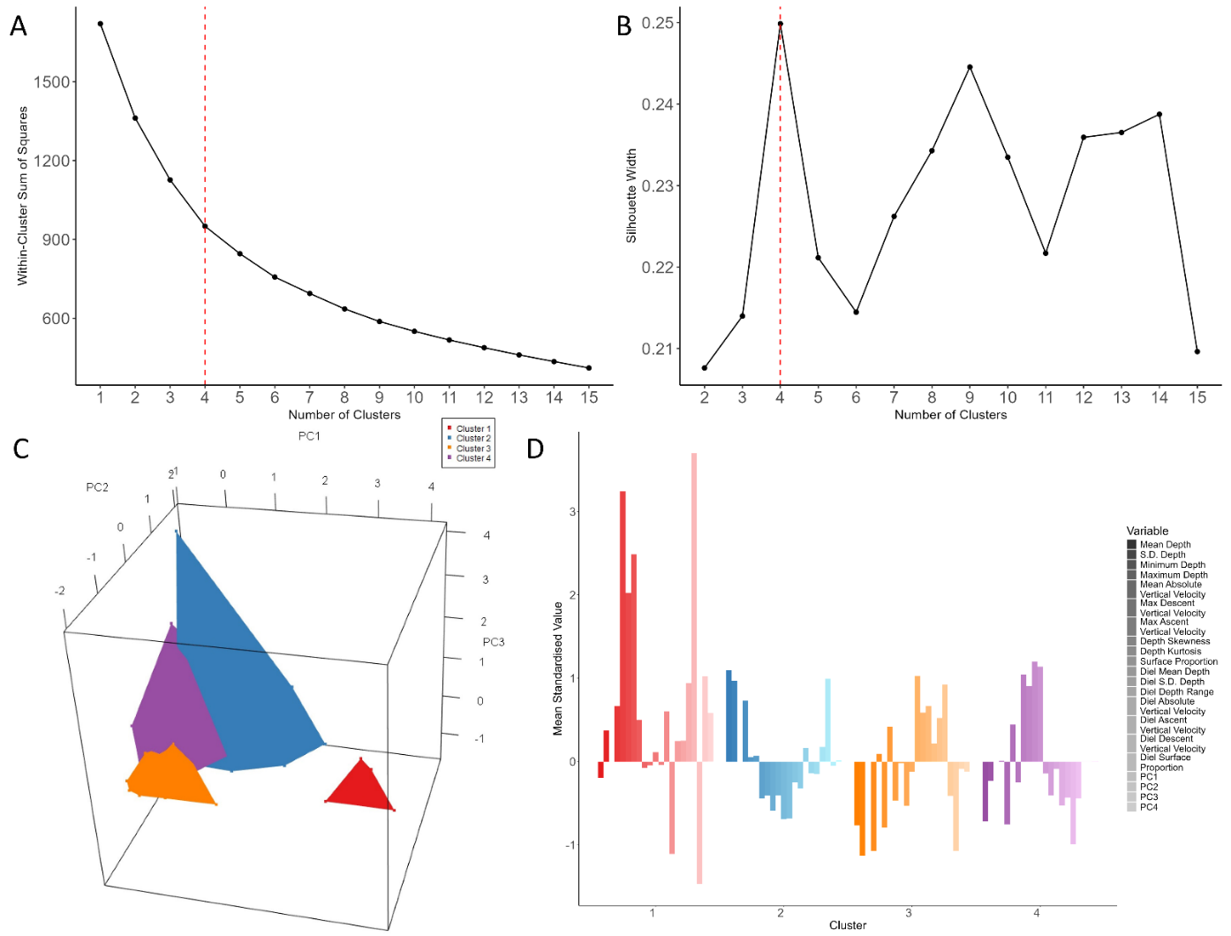
Figure S7. Determining the optimal number of clusters (k) to use in k-means analysis of whale shark, tagged at Christmas Island, Australia. Panel A) Elbow method plot showing the within-cluster sum of squares for different numbers of clusters. A noticeable bend or "elbow" indicates the point where adding more clusters provides diminishing returns in terms of explained variance. Panel B) Silhouette width analysis plot for different numbers of clusters. The average silhouette width measures how similar an object is to its own cluster compared to other clusters. The combined elbow and silhouette width suggest four as the optimal number of clusters for the data, above this there is a diminishing increase in silhouette width, but an increase in complexity of cluster identification. Panel C) Three-dimensional plot showing the separation of 24-hour segments amongst PCs one through three. Panel D) Bar plot of the mean standardised value of each k-means feature per cluster, calculated from each 24-hour segment assigned to a cluster. Each bar indicates the deviation of the cluster’s mean value from the overall dataset mean, highlighting the distinct separation of clusters based on the k-means features (depth statistics and WCs).
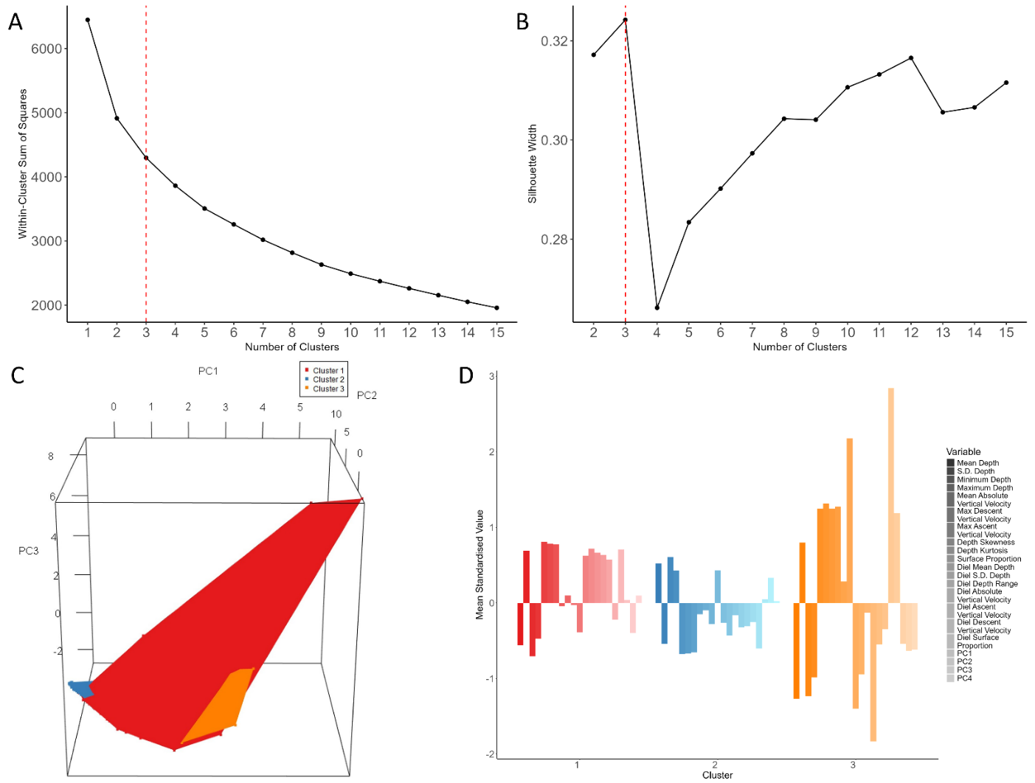
Figure S8. Determining the optimal number of clusters (k) to use in k-means analysis of Atlantic cod, tagged in the English Channel, UK. Panel A) Elbow method plot showing the within-cluster sum of squares for different numbers of clusters. A noticeable bend or "elbow" indicates the point where adding more clusters provides diminishing returns in terms of explained variance. Panel B) Silhouette width analysis plot for different numbers of clusters. The average silhouette width measures how similar an object is to its own cluster compared to other clusters. The combined elbow and silhouette width suggest three as the optimal number of clusters for the data, above this there is a diminishing increase in silhouette width, but an increase in complexity of cluster identification. Panel C) Three-dimensional plot showing the separation of 24-hour segments amongst PCs one through three. Panel D) Bar plot of the mean standardised value of each k-means feature per cluster, calculated from each 24-hour segment assigned to a cluster. Each bar indicates the deviation of the cluster’s mean value from the overall dataset mean, highlighting the distinct separation of clusters based on the k-means features (depth statistics and WCs).
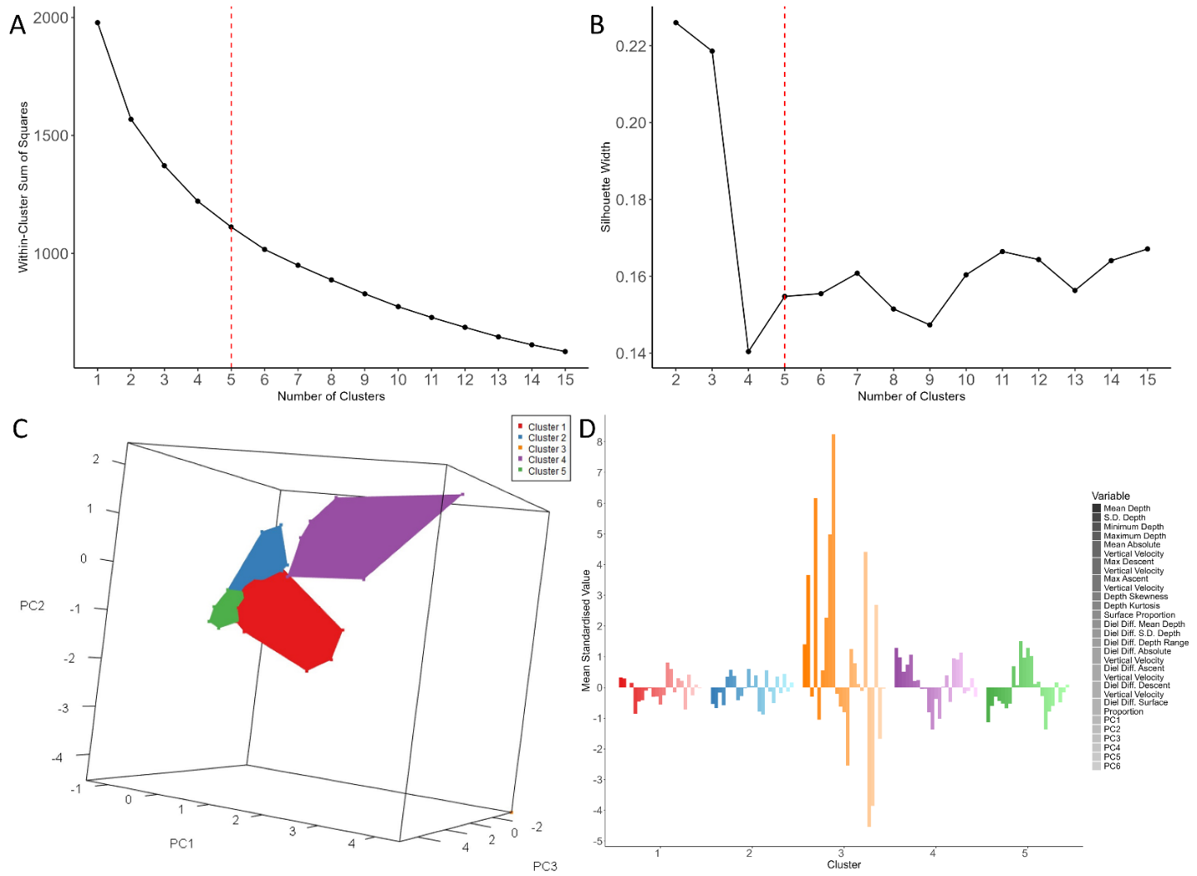
Figure S9. Determining the optimal number of clusters (k) to use in k-means analysis of oceanic manta ray, tagged in Indonesia. Panel A) Elbow method plot showing the within-cluster sum of squares for different numbers of clusters. A noticeable bend or "elbow" indicates the point where adding more clusters provides diminishing returns in terms of explained variance. Panel B) Silhouette width analysis plot for different numbers of clusters. The average silhouette width measures how similar an object is to its own cluster compared to other clusters. The combined elbow and silhouette width suggest five as the optimal number of clusters for the data, above this there is a diminishing increase in silhouette width, but an increase in complexity of cluster identification. Panel C) Three-dimensional plot showing the separation of 24-hour segments amongst PCs one through three. Panel D) Bar plot of the mean standardised value of each k-means feature per cluster, calculated from each 24-hour segment assigned to a cluster. Each bar indicates the deviation of the cluster’s mean value from the overall dataset mean, highlighting the distinct separation of clusters based on the k-means features (depth statistics and WCs). Note cluster 3 has a single point in panel C as this cluster was assigned only once.
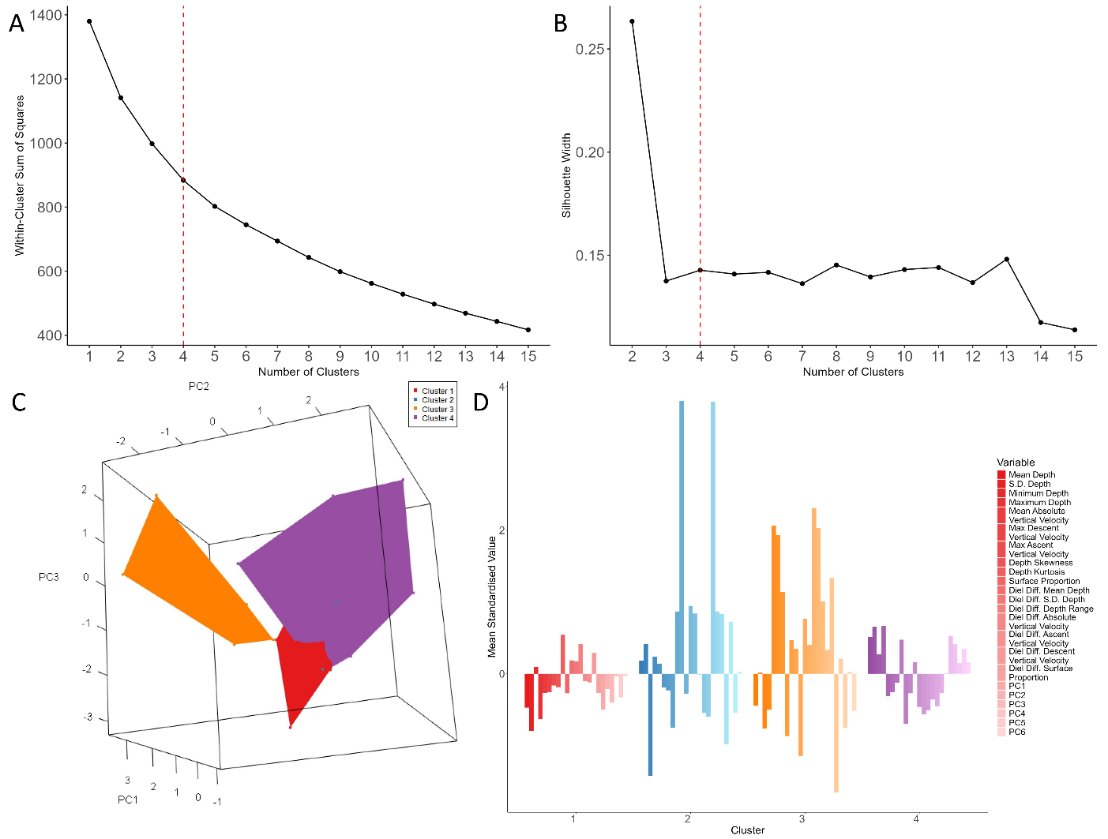
Figure S10. Determining the optimal number of clusters (k) to use in k-means analysis of largetooth sawfish, tagged in Australia. Panel A) Elbow method plot showing the within-cluster sum of squares for different numbers of clusters. A noticeable bend or "elbow" indicates the point where adding more clusters provides diminishing returns in terms of explained variance. Panel B) Silhouette width analysis plot for different numbers of clusters. The average silhouette width measures how similar an object is to its own cluster compared to other clusters. The combined elbow and silhouette width suggest four as the optimal number of clusters for the data, above this there is a diminishing increase in silhouette width, but an increase in complexity of cluster identification. Panel C) Three-dimensional plot showing the separation of 24-hour segments amongst PCs one through three. Panel D) Bar plot of the mean standardised value of each k-means feature per cluster, calculated from each 24-hour segment assigned to a cluster. Each bar indicates the deviation of the cluster’s mean value from the overall dataset mean, highlighting the distinct separation of clusters based on the k-means features (depth statistics and WCs).
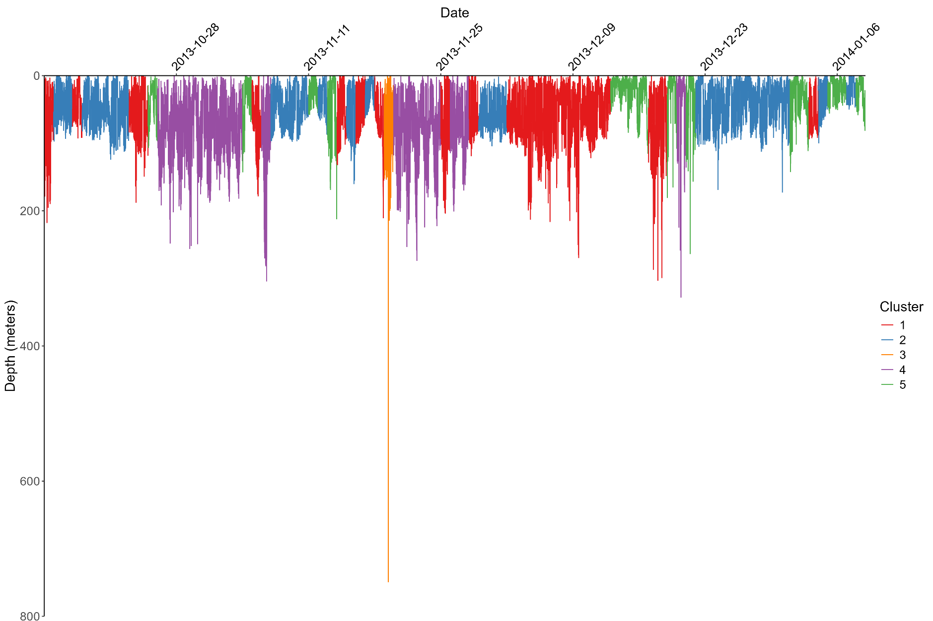
Figure S11. Depth time-series of oceanic manta ray tagged in West Papua, Indonesia. Data were recorded at a 5-second sampling frequency. Days are coloured by k-means cluster assignment, corresponding to behaviour clusters shown in Figure 6A and k-means features in Figure S9C & D.
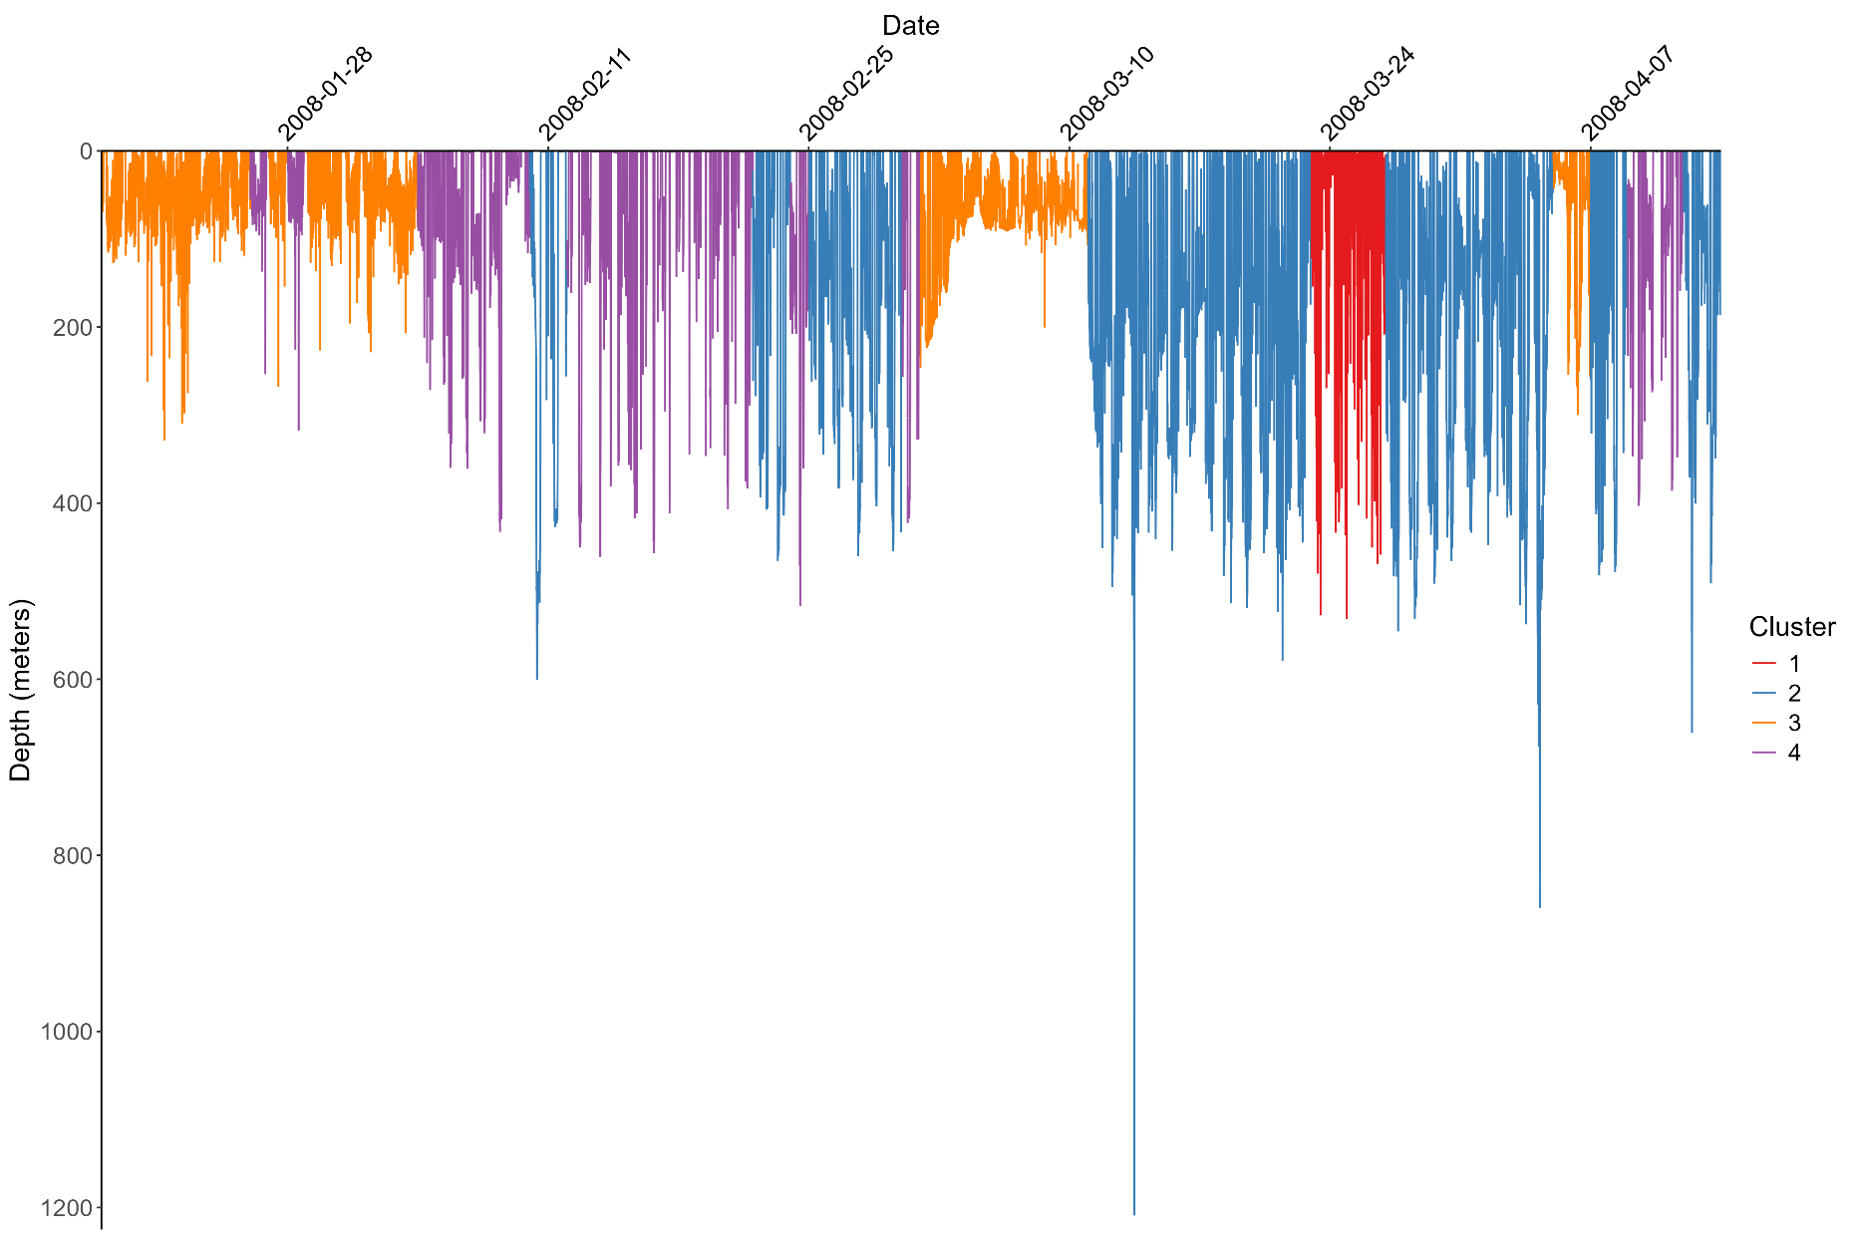
Figure S12. Depth time-series of whale shark tag, tagged in Christmas Island, Australia. Data were recorded at a 1-minute sampling frequency. Days are coloured by k-means cluster assignment, corresponding to behaviour clusters shown in Figure 6B and k-means features in Figure S7C & D.
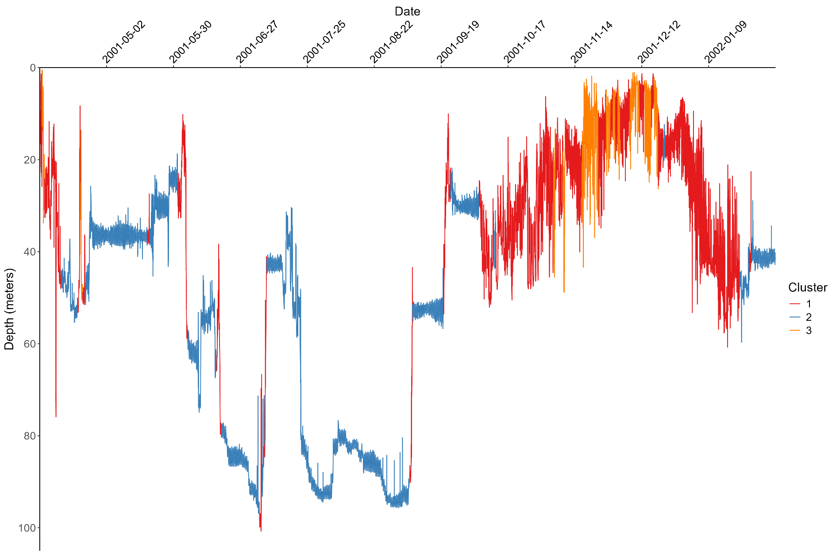
Figure S13. Depth time-series of Atlantic cod, tagged in the English Channel, UK. Data were recorded at a 10-minute sampling frequency. Days are coloured by k-means cluster assignment, corresponding to behaviour clusters shown in Figure 6C and k-means features in Figure S8C & D.
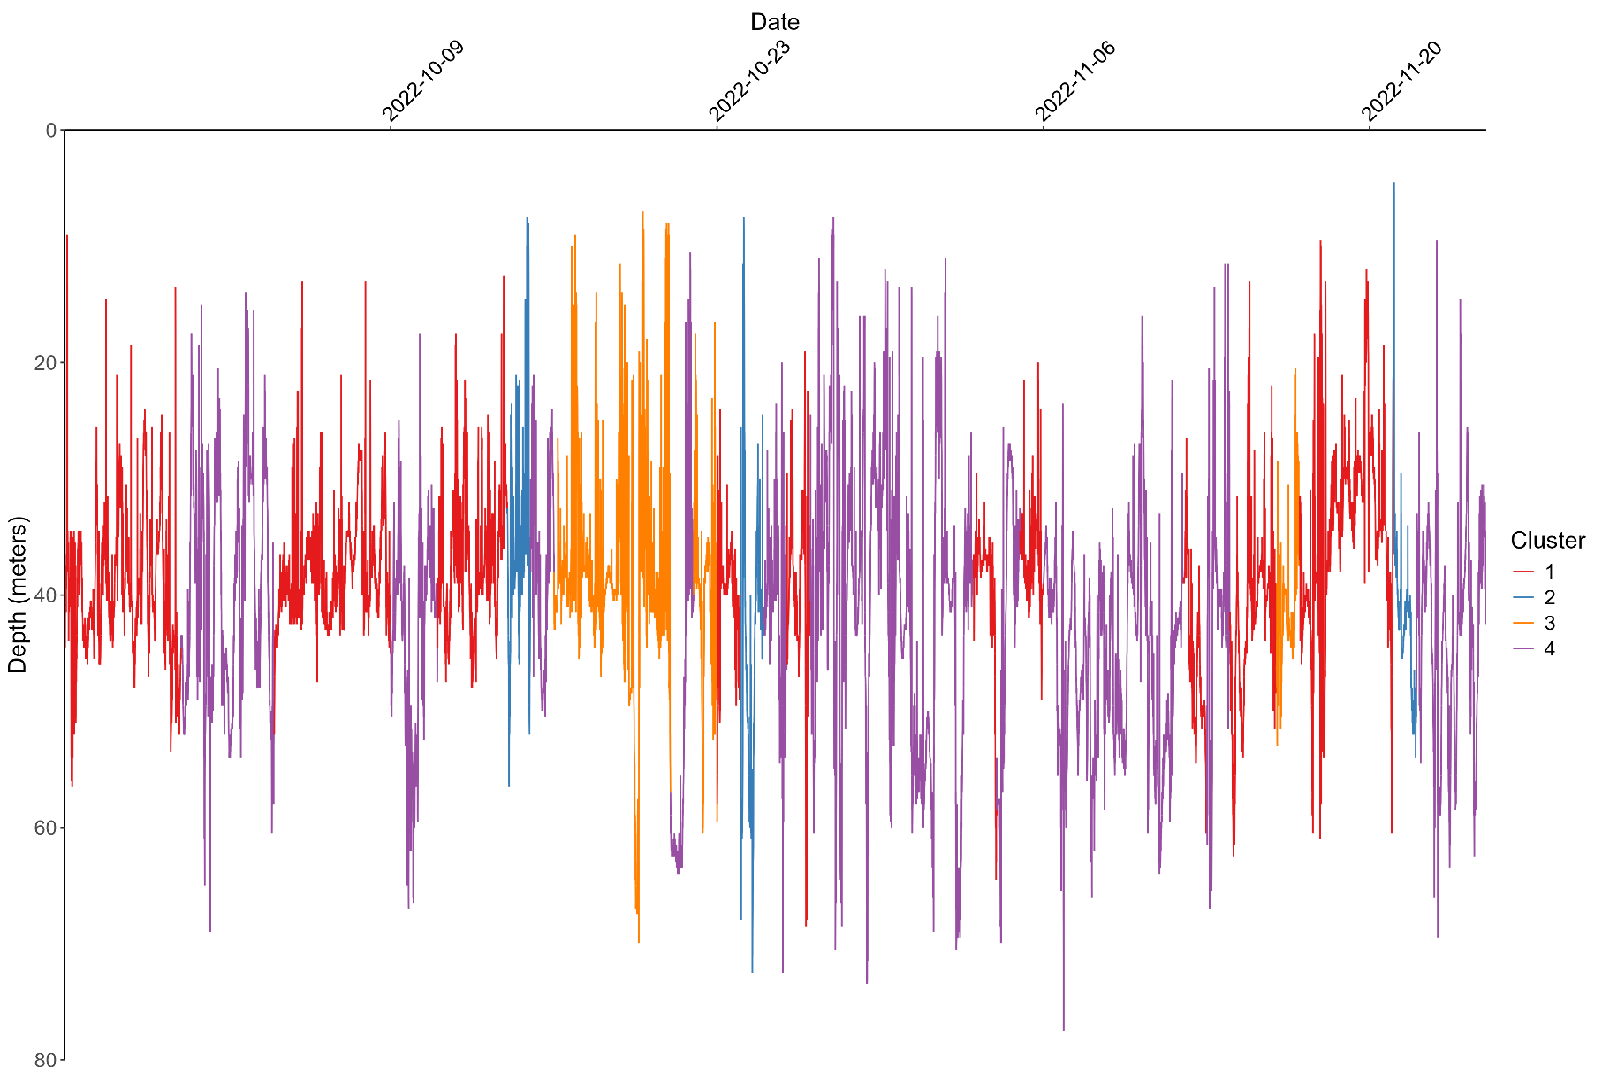
Figure S14. Depth time-series of largetooth sawfish, tagged in Australia. Data were recorded at a 1-second sampling frequency. Days are coloured by k-means cluster assignment, corresponding to behaviour clusters shown in Figure 6D and k-means features in Figure S10C & D.

This section demonstrates the difference between including and not including wavelet components (PC’s) in the workflow.
Additional supplementary materials. Comparison of standard workflow (including both depth statistics and wavelet statistics) with just depth statistics.
Here we show three examples, firstly the simulated data, followed by a whale shark tag, and a green sawfish tag.
Simulated data
There are minor differences in the selection of k, with the silhouette width remaining higher when using only depth statistics, for higher values of k. The optimal number for k remains five, and assignment of clusters is the same for both workflows.
This lack of difference is likely due to the nature of the simulated data being controlled by bounds of depth, depth change over time, and fixed maximum random walks.
The higher silhouette width at larger values of k is an indication that leaving out wavelet components may lead to a larger value of k being selected for.

Simulated data
Selecting k
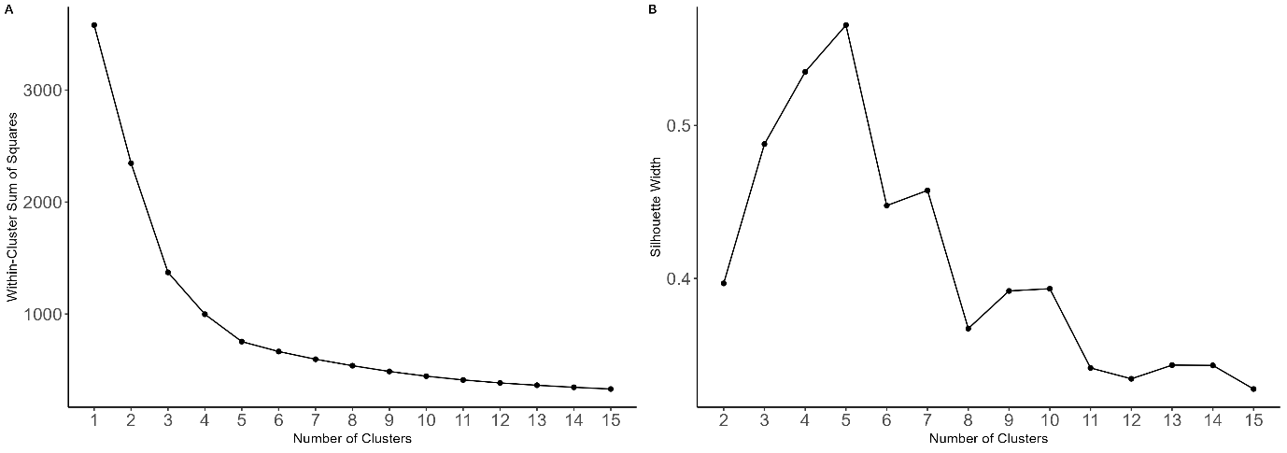
Figure S15. Standard workflow
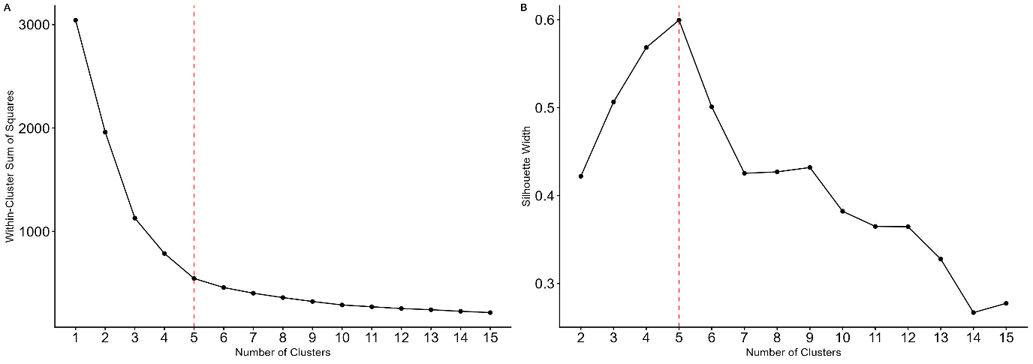
Figure S16. No wavelet components

Variables defining cluster separation
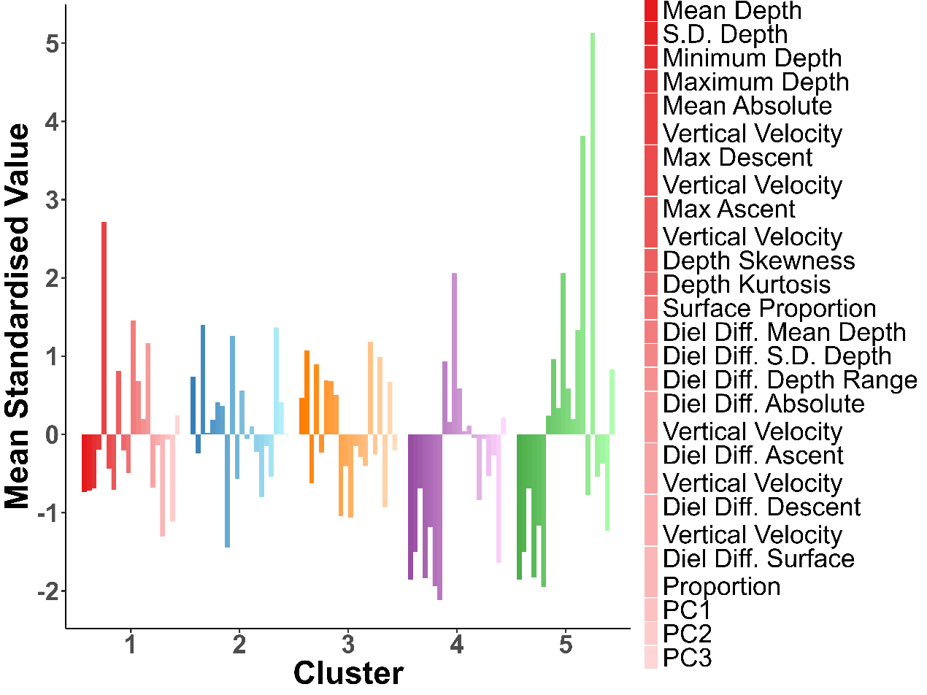
Figure S17. Standard workflow
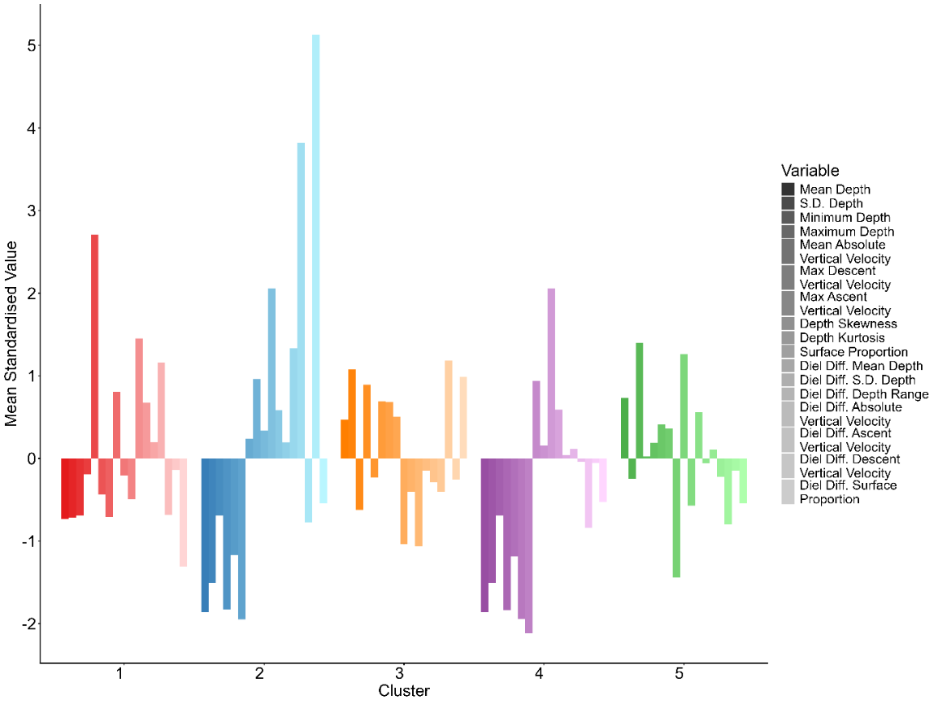
Figure S18. No wavelet components

Whale shark tag
There are large differences in silhouette width between the two workflows, with a lower value of k being selected for clearly on the standard workflow. The workflow without wavelet components potentially splits a single behaviour into two clusters.
Cluster assignment is also different between the two workflows. In our judgement the standard workflow assigns clusters to groups better than not including the periodic components included in the wavelet components, however, without ground-truthed data there is no way to know which assignment is ‘correct’ or closer a better representation of the behaviour of the animal.
Selecting k
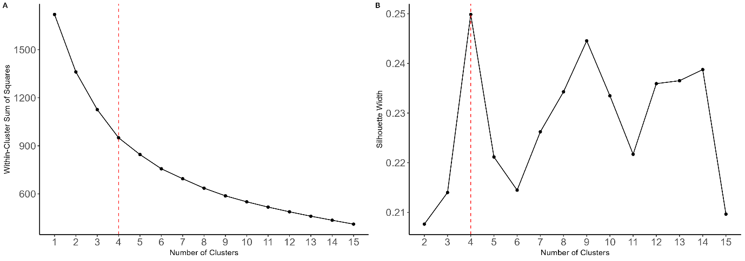
Figure S19. Standard workflow

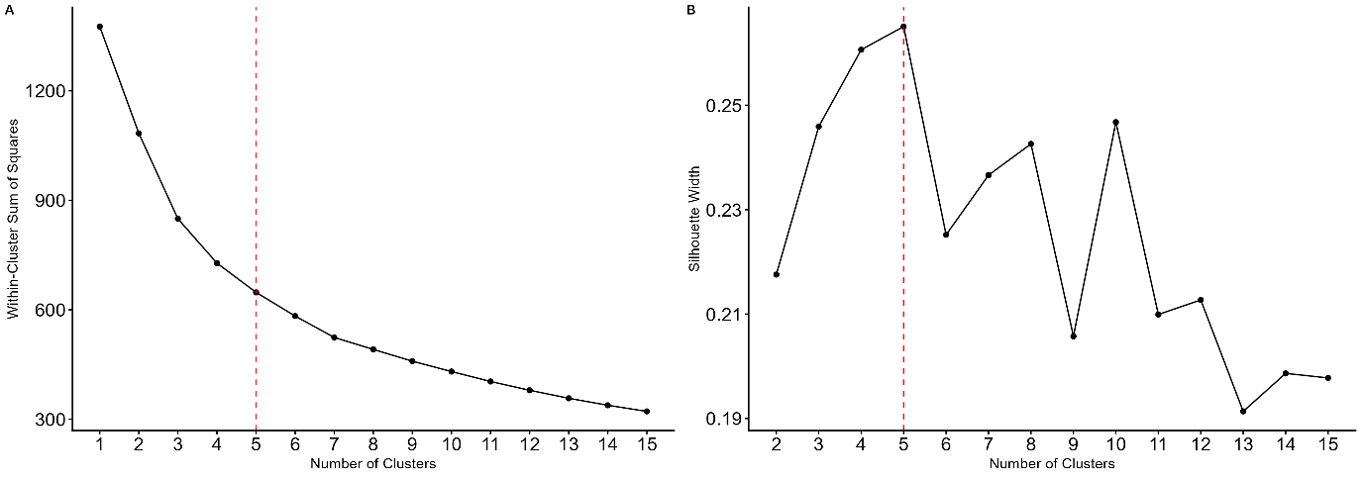
Figure S20. No wavelet components

Variables defining clusters
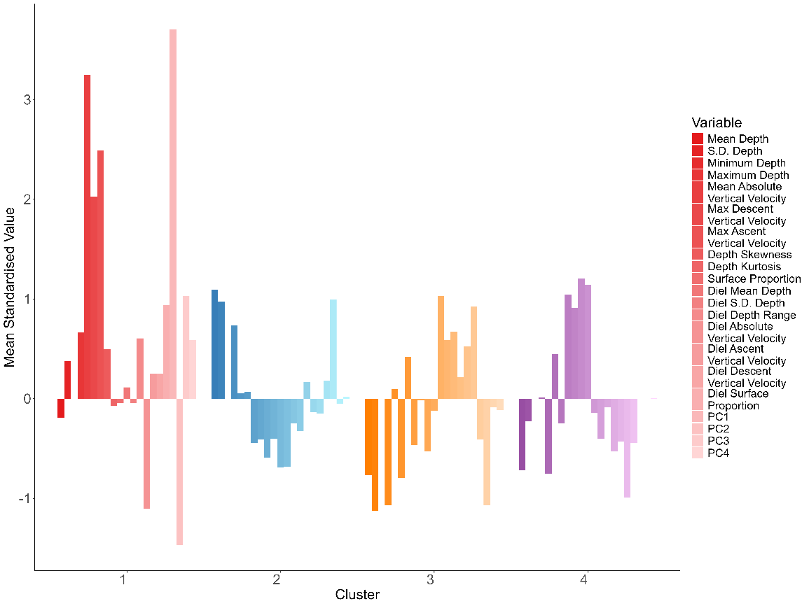
Figure S21. Standard workflow
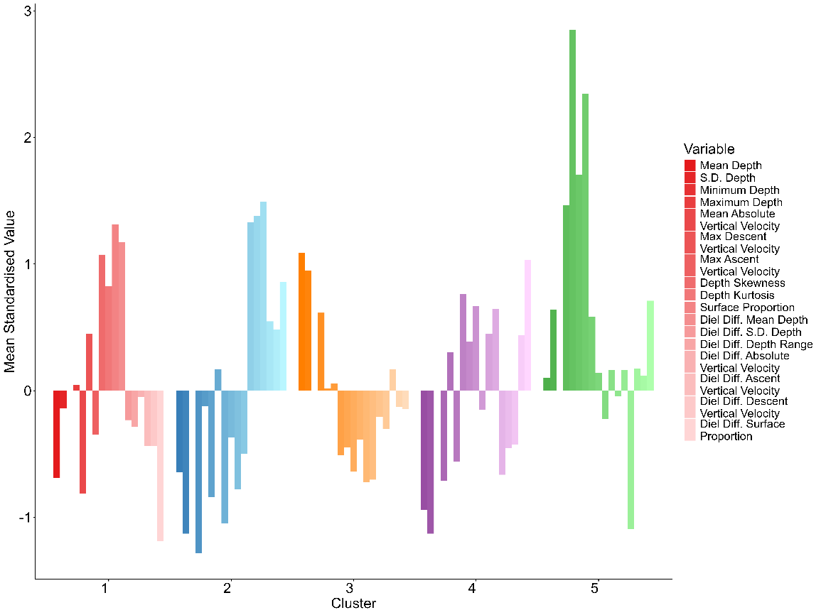
Figure S22. No wavelet components

Depth timeseries coloured by cluster assignment
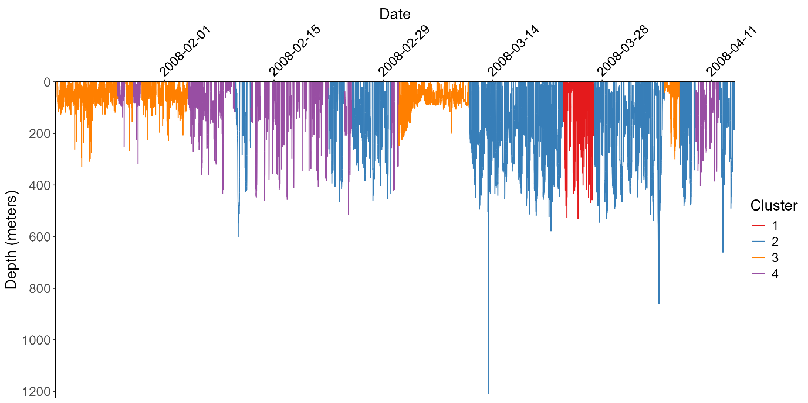
Figure S23. Standard workflow
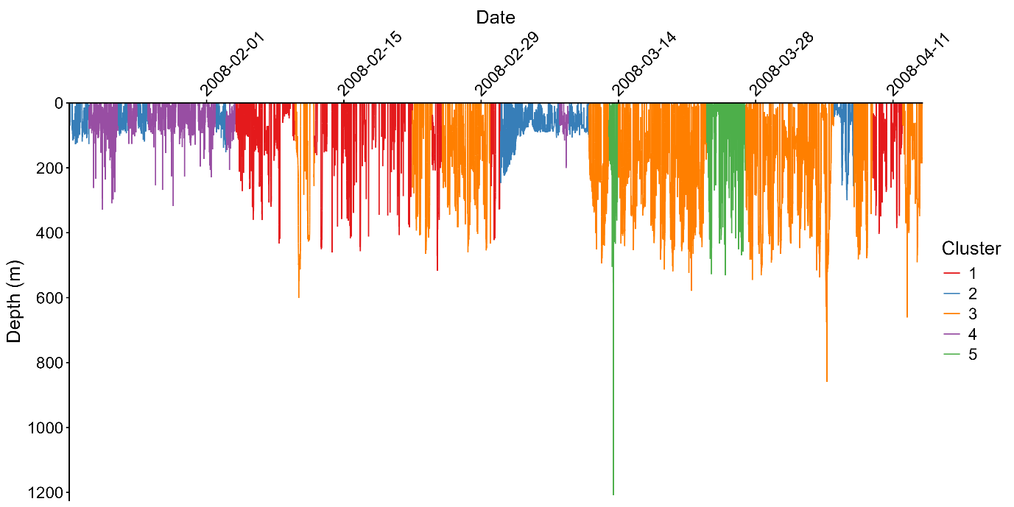
Figure S24. No wavelet components

Green sawfish tag
There are large differences in silhouette width between the two workflows, with a lower value of k being selected for on the non-standard workflow.
Cluster assignment is also different between the two workflows. In our judgement the standard workflow with the additional cluster assigns days better than not including the periodic components included in the wavelet components. However, without ground-truthed data there is no way to know which assignment is ‘correct’ or closer a better representation of the behaviour of the animal.

Selecting k
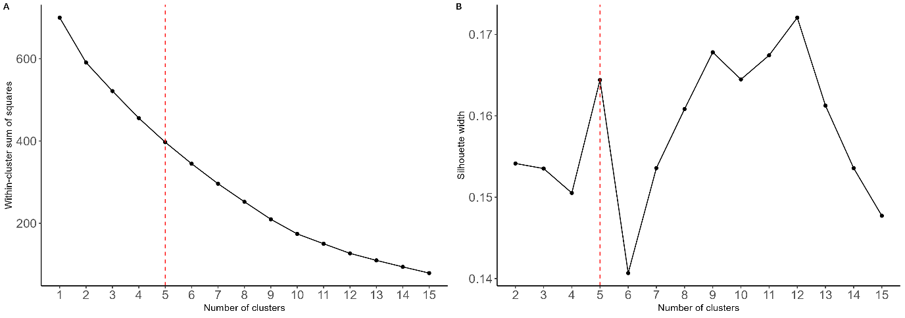
Figure S25. Standard workflow
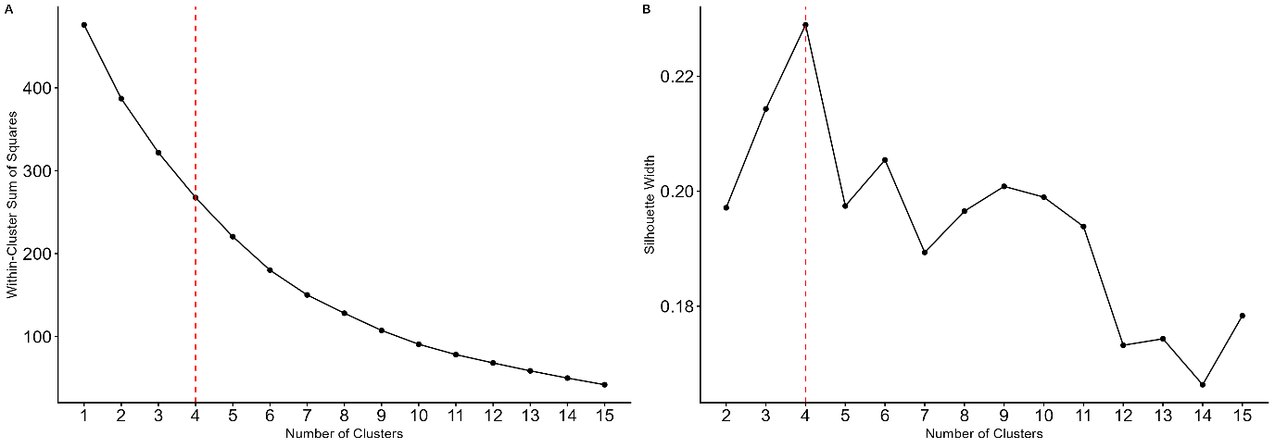
Figure S26. No wavelet components

Variables defining clusters
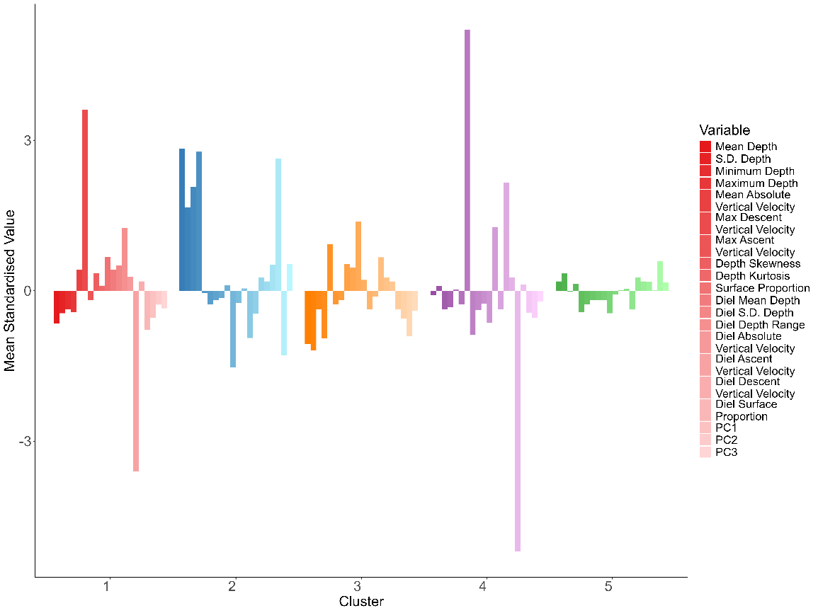
Figure S27. Standard workflow
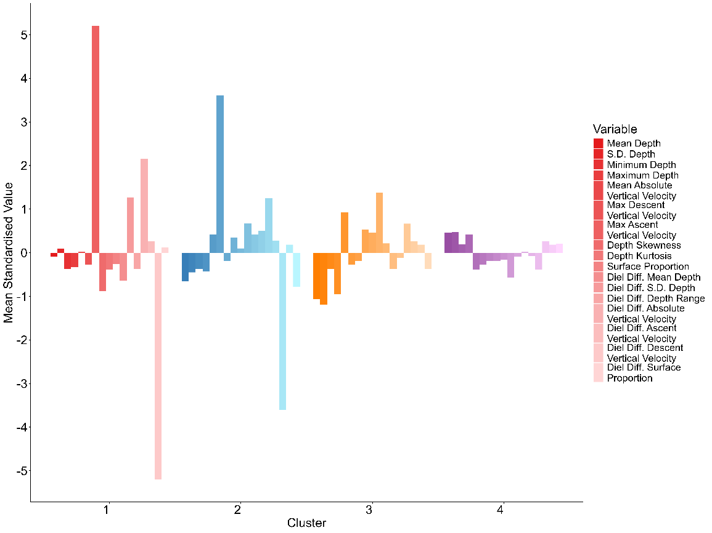
Figure S28. No wavelet components

Depth timeseries coloured by cluster assignment
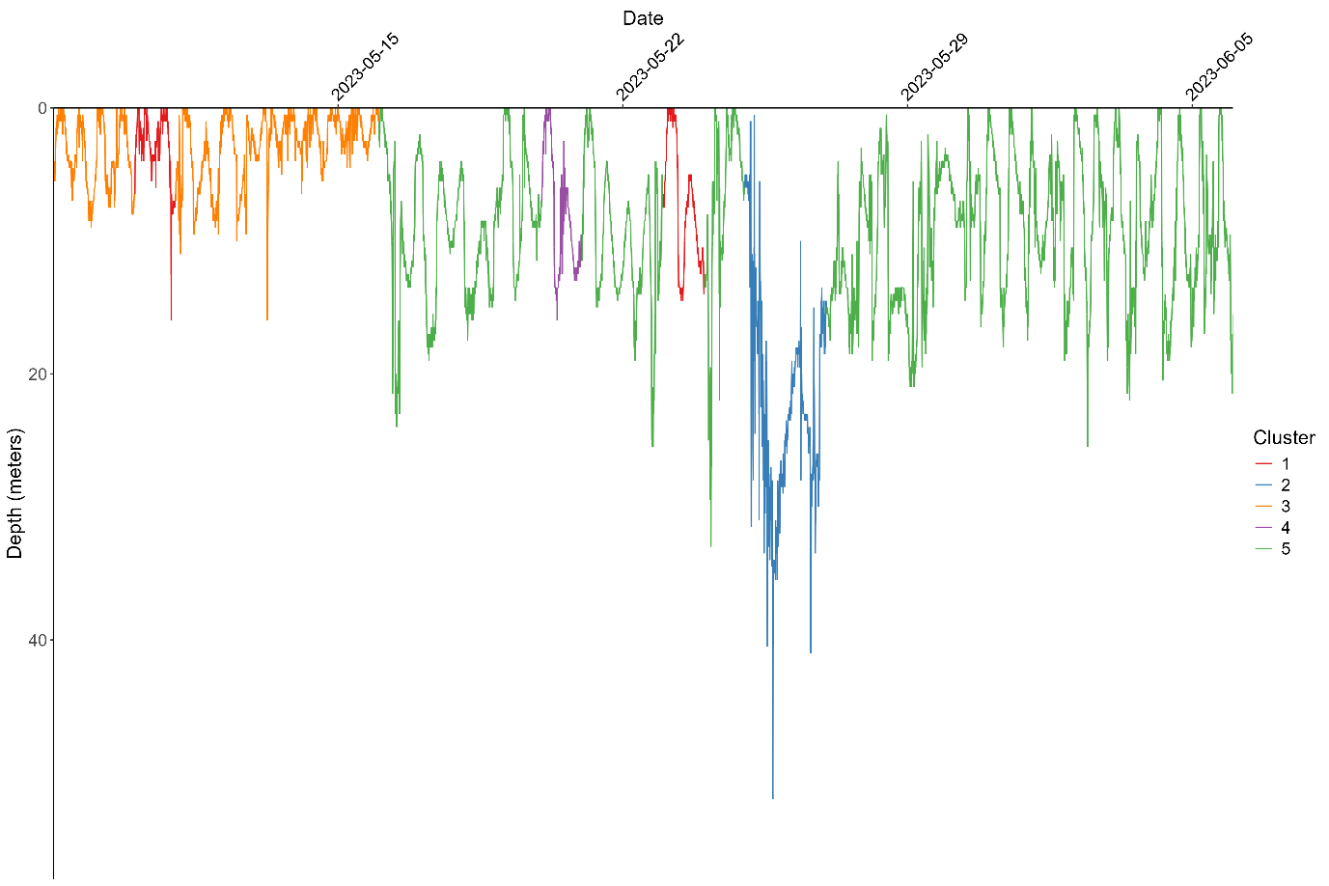
Figure S29. Standard workflow
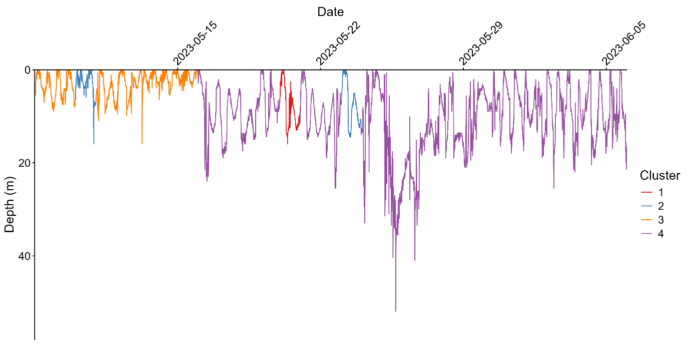
Figure S30. No wavelet components

Variables defining clusters
Figure S31. Standard workflow including principal components results in four clusters.
Figure S32. Modified workflow with no wavelet components included results in five clusters.

Depth timeseries coloured by cluster assignment
Figure S33. Standard workflow including principal components groups days into four behaviour clusters
Figure S34. Modified workflow with no wavelet components groups days into five behaviour clusters.

Supplementary materials references
Arrowsmith LM, Sequeira AMM, Pattiaratchi CB, Meekan MG (2021) Water temperature is a key driver of horizontal and vertical movements of an ocean giant, the whale shark Rhincodon typus. Mar Ecol Prog Ser 679:101–114
Beale CS, Stewart JD, Setyawan E, Sianipar AB, Erdmann M V. (2019) Population dynamics of oceanic manta rays (Mobula birostris) in the Raja Ampat Archipelago, West Papua, Indonesia, and the impacts of the El Niño–Southern Oscillation on their movement ecology. Divers Distrib 25:1472–1487
Papastamatiou YP, Dean Grubbs R, Imhoff JL, Gulak SJB, Carlson JK, Burgess GH (2015) A subtropical embayment serves as essential habitat for sub-adults and adults of the critically endangered smalltooth sawfish. Glob Ecol Conserv 3:764–775
Righton DA, Andersen KH, Neat F, Thorsteinsson V, Steingrund P, Svedäng H, Michalsen K, Hinrichsen HH, Bendall V, Neuenfeldt S, Wright P, Jonsson P, Huse G, Kooij J Van Der, Mosegaard H, Hüssy K, Metcalfe J (2010) Thermal niche of Atlantic cod Gadus morhua: Limits, tolerance and optima. Mar Ecol Prog Ser 420:1–13

