Please place table S.1 in the supplementary material
Table S.1. Distance (km) from the study sites where golden-cheeked warblers (Setophaga chrysoparia) were located during the breeding season to their locations estimated from the geolocator data, during confirmed study site periods. Our study sites included Dinosaur Valley State Park (DVSP), Fort Hood (FH), Balcones Canyonlands National Wildlife Refuge (BCNWR), Joint Base San Antonio-Camp Bullis (CB), and Kerr Wildlife Management Area (KWMA) in Texas.
Site | n | Unit | Mean (km) | SD (km)
All sites | 61 | Latitude | 26.0 | 33.9
 |  | Longitude | 23.6 | 31.4
DVSP | 7 | Latitude | 46.3 | 61.0
 |  | Longitude | 30.3 | 33.0
FH | 23 | Latitude | 30.4 | 42.1
 |  | Longitude | 40.2 | 40.2
BCNWR | 14 | Latitude | 26.4 | 6.1
 |  | Longitude | 11.6 | 17.7
CB | 1 | Latitude | 11.9 | -
 |  | Longitude | 1.3 | -
KWMA | 16 | Latitude | 11.4 | 3.9
 |  | Longitude | 8.6 | 4.4

Please place table S.2 in the supplementary material
 | Migration stopover | Winter stationary
Latitude | 444 km ± 215 km | 275 km ± 149 km
Longitude | 233 km ± 122 km | 172 km ± 93 km
Table S.2. Summary of the mean and standard deviation distances (km) for the upper and lower credible intervals (latitudes and longitudes) per stationary period (migration, winter) based on data from 61 light-level geolocators attached to male golden-cheeked warblers (Setophaga chrysoparia) (2017–2021). Data includes the periods of the fall and spring equinoxes.

Please place figure S.3 in the supplementary material
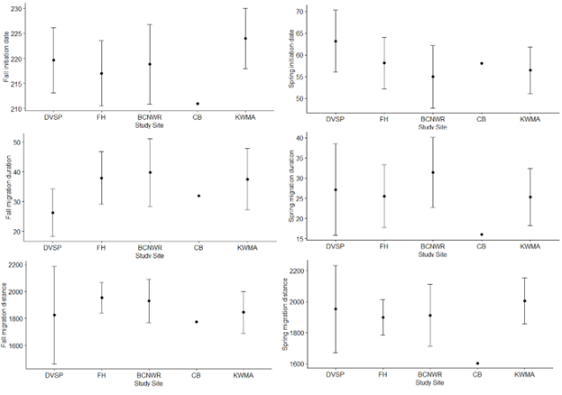Figure S.3. Comparisons of fall and spring migration initiation dates (Julian date), fall and spring migration durations (days), and fall and spring migration distances (km) across study sites for male golden-cheeked warblers (Setophaga chrysoparia) based on data from 61 light-level geolocators (2017–2021). Our study sites included Dinosaur Valley State Park (DVSP), Fort Hood (FH), Balcones Canyonlands National Wildlife Refuge (BCNWR), Joint Base San Antonio-Camp Bullis (CB), and Kerr Wildlife Management Area (KWMA) in Texas. Figure includes points for CB, but we excluded CB data from analyses due to low sample sizes.

Please place figure S.4 in the supplementary material
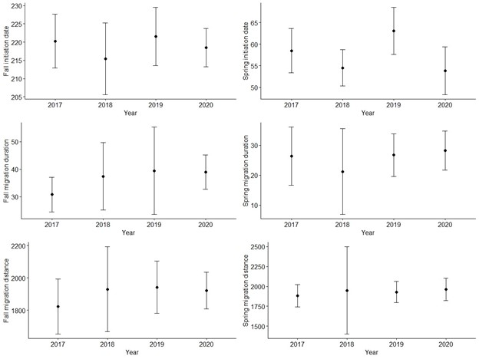Figure S.4. Comparisons of fall and spring migration initiation dates (Julian date), fall and spring migration durations (days), and fall and spring migration distances (km) across years for male golden-cheeked warblers (Setophaga chrysoparia) based on data from 61 light-level geolocators (2017–2021). Our study sites included Dinosaur Valley State Park, Fort Hood, Balcones Canyonlands National Wildlife Refuge, Joint Base San Antonio-Camp Bullis, and Kerr Wildlife Management Area in Texas.

Please place table S.5 in the supplementary material
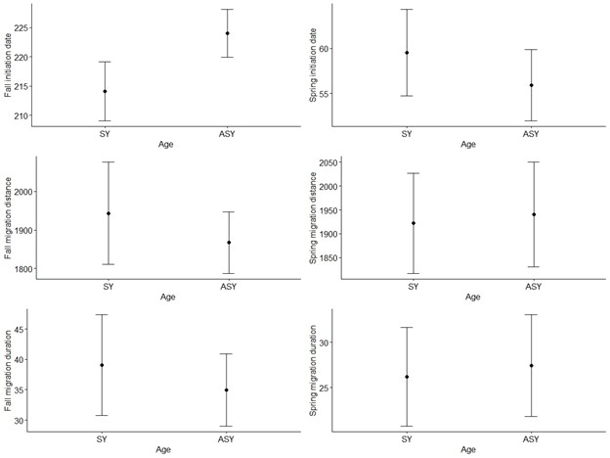Figure S.5. Comparisons of fall and spring migration initiation dates (Julian date), fall and spring migration durations (days), and fall and spring migration distances (km) between second year (SY) and after second year (ASY) male golden-cheeked warblers (Setophaga chrysoparia) based on data from 61 light-level geolocators (2017–2021). Our study sites included Dinosaur Valley State Park, Fort Hood, Balcones Canyonlands National Wildlife Refuge, Joint Base San Antonio-Camp Bullis, and Kerr Wildlife Management Area in Texas.

Please place figure S.6 in the supplementary material
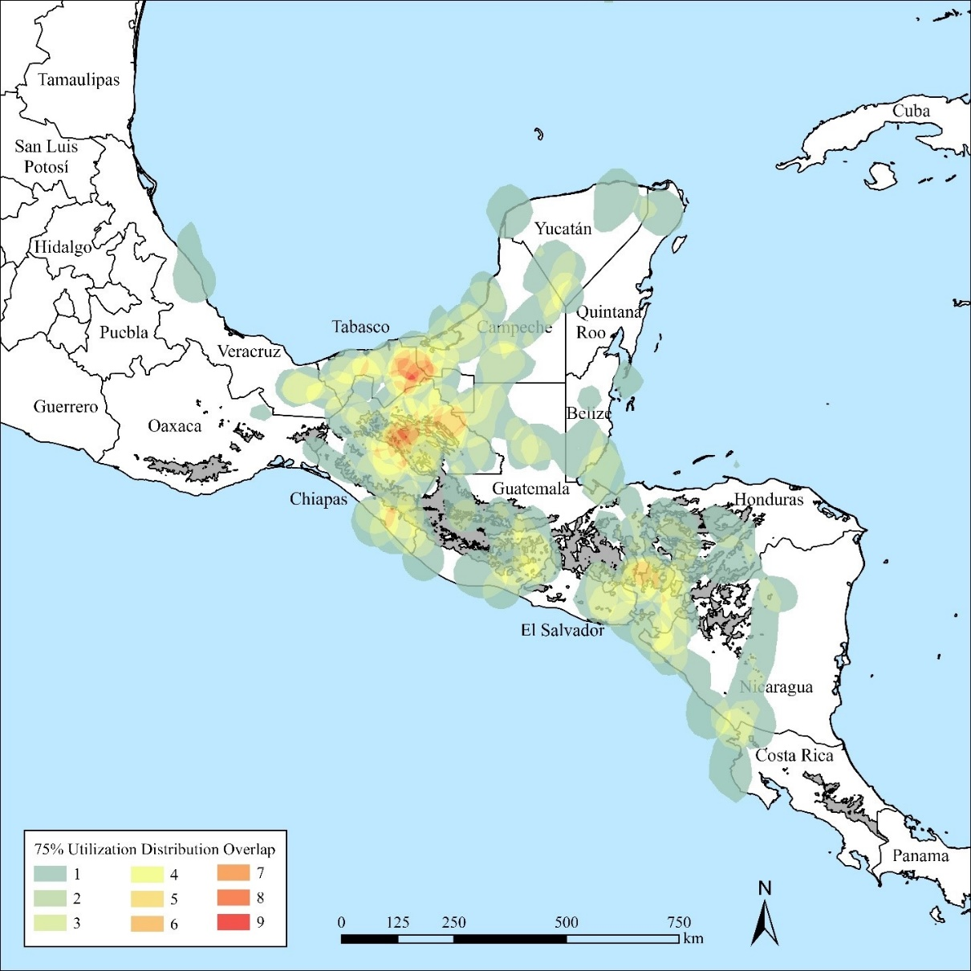
Figure S.6. Overlapping individual 75% utilization distributions (UDs) based on estimated overwintering locations for male golden-cheeked warblers (Setophaga chrysoparia) from 61 light-level geolocators (2017–2021). To calculate overlap, we converted individual 75% UDs to raster images in ArcGIS Pro 2.9.12, reclassified each 1 km cell as binary (0 for outside the 75% UD; 1 for inside the 75% UD), and summed the number of 75% UDs that overlapped per 1 km raster cell. We were unable to calculate the 75% UD for two birds due to an error (location points were too close), so we substituted the 50% UD for these two data sets.

Please place figure S.7 in the supplementary material
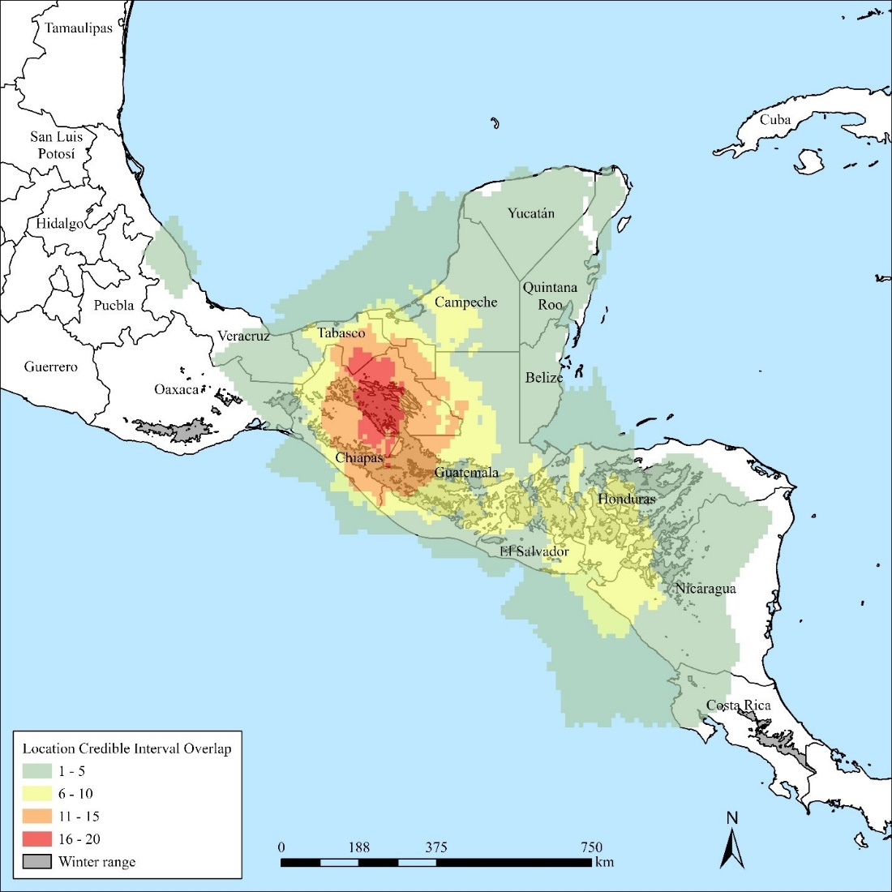
Figure S.7. Estimated number of male golden-cheeked warblers (Setophaga chrysoparia) that occurred in each map pixel based on data from 60 light-level geolocators (2017–2021). We first limited our dataset to only include credible interval widths (latitude or longitude) ≤500 km, then created convex hulls representing the estimated 95% credible interval around each geolocated point. We then combined convex hulls for each individual to represent the area that the bird may have used during the wintering period and converted this area to a binary raster image with 11 km resolution. Last, we overlapped all raster images to estimate the number of birds that may have occurred in each pixel. We excluded one bird that did not have geolocated points during the wintering period (here defined as November 1–January 15).

