Supplemental materials
Wet season results
We found little evidence of temperature-mediated changes in spatial overlap between cheetahs and lions and between African wild dogs and lions in the wet season. Specifically, the proportion of time species spent within competitor home ranges showed minimal changes in biologically relevant scales across temperatures in the wet season (Table S2) (Figure S2), and there were minimal temperature-mediated changes in habitat selection, with only wild dogs increasing their selection for floodplains under warmer temperatures (Tables S3-5) (Figure S3). Similar to the dry season, however, we found that cheetahs became increasingly nocturnal during warmer temperatures in the wet season, and this led to reduced temporal partitioning on warm days (Tables S6-7) (Figure S4).
Table S1. Summary of generalised additive mixed models for analyses investigating close encounters within cheetah-lion and African wild dog-lion dyads.
Term | Estimate | EDF | SE | Ref. df | t-value | F-value | P-value
CHEETAH-LION (DRY SEASON)
(Intercept) | -4.595 |  | 0.234 |  | -19.646 |  | < 0.001
s(lag0_temperature_max_scale) |  | 1.000 |  | 1.000 |  | 1.241 | 0.265
s(lag1_temperature_max_scale) |  | 2.049 |  | 2.049 |  | 4.211 | 0.014
s(day) |  | 3.375 |  | 3.375 |  | 8.471 | < 0.001
CHEETAH-LION (WET SEASON)
(Intercept) | -4.643 |  | 0.202 |  | -22.931 |  | < 0.001
s(lag0_temperature_max_scale) |  | 1.000 |  | 1.000 |  | 0.315 | 0.575
s(lag1_temperature_max_scale) |  | 1.000 |  | 1.000 |  | 0.396 | 0.529
s(day) |  | 1.000 |  | 1.000 |  | 0.992 | 0.319
WILD DOG-LION (DRY SEASON)
(Intercept) | -4.375 |  | 0.254 |  | -17.246 |  | < 0.001
s(lag0_temperature_max_scale) |  | 1.000 |  | 1.000 |  | 1.115 | 0.291
s(lag1_temperature_max_scale) |  | 1.000 |  | 1.000 |  | 0.391 | 0.532
s(day) |  | 1.000 |  | 1.000 |  | 0.037 | 0.848
WILD DOG-LION (WET SEASON)
(Intercept) | -4.493 |  | 0.203 |  | -22.186 |  | < 0 .001
s(lag0_temperature_max_scale) |  | 1.000 |  | 1.000 |  | 0.531 | 0.466
s(lag1_temperature_max_scale) |  | 1.000 |  | 1.000 |  | 0.605 | 0.437
s(day) |  | 1.000 |  | 1.000 |  | 0.014 | 0.906
EDF = estimated degrees of freedom, SE = standard error, Ref. df = reference degrees of freedom

Table S2. Summary of generalised additive mixed models for analyses investigating time spent within competitor home ranges for cheetah-lion and African wild dog-lion dyads.
Term | Estimate | EDF | SE | Ref. df | t-value | F-value | P-value
Cheetahs in lion ranges (dry season)
(Intercept) | -3.892 |  | 0.300 |  | -12.980 |  | < 0.001
s(lag0_temperature_max_scale) |  | 6.885 |  | 6.885 |  | 10.909 | < 0.001
s(lag1_temperature_max_scale) |  | 8.652 |  | 8.652 |  | 32.145 | < 0.001
s(day) |  | 8.864 |  | 8.864 |  | 70.133 | < 0.001
Cheetahs in lion ranges (wet season)
(Intercept) | -3.349 |  | 0.299 |  | -11.200 |  | < 0.001
s(lag0_temperature_max_scale) |  | 8.133 |  | 8.133 |  | 3.865 | < 0.001
s(lag1_temperature_max_scale) |  | 2.161 |  | 2.161 |  | 1.362 | 0.189
s(day) |  | 8.188 |  | 8.188 |  | 40.532 | < 0.001
Lions in cheetah ranges (dry season)
(Intercept) | -3.042 |  | 0.332 |  | -9.166 |  | < 0.001
s(lag0_temperature_max_scale) |  | 8.371 |  | 8.371 |  | 9.365 | < 0.001
s(lag1_temperature_max_scale) |  | 4.672 |  | 4.672 |  | 19.552 | < 0.001
s(day) |  | 8.385 |  | 8.385 |  | 33.722 | < 0.001
Lions in cheetah ranges (wet season)
(Intercept) | -3.411 |  | 0.588 |  | -5.798 |  | < 0.001
s(lag0_temperature_max_scale) |  | 2.788 |  | 2.788 |  | 12.620 | < 0.001
s(lag1_temperature_max_scale) |  | 7.927 |  | 7.927 |  | 12.419 | < 0.001
s(day) |  | 8.169 |  | 8.169 |  | 78.162 | < 0.001
Wild dogs in lion ranges (dry season)
(Intercept) | -3.692 |  | 0.477 |  | -7.733 |  | < 0.001
s(lag0_temperature_max_scale) |  | 7.090 |  | 7.090 |  | 5.279 | < 0.001
s(lag1_temperature_max_scale) |  | 1.000 |  | 1.000 |  | 0.445 | 0.505
s(day) |  | 8.664 |  | 8.664 |  | 23.065 | < 0.001
Wild dogs in lion ranges (wet season)
(Intercept) | -3.325 |  | 0.239 |  | -13.903 |  | < 0.001
s(lag0_temperature_max_scale) |  | 7.469 |  | 7.469 |  | 9.432 | < 0.001
s(lag1_temperature_max_scale) |  | 7.879 |  | 7.879 |  | 8.059 | < 0.001
s(day) |  | 8.082 |  | 8.082 |  | 23.826 | < 0.001
Lions in wild dog ranges (dry season)
(Intercept) | -3.236 |  | 0.360 |  | -8.986 |  | < 0.001
s(lag0_temperature_max_scale) |  | 6.725 |  | 6.725 |  | 5.558 | < 0.001
s(lag1_temperature_max_scale) |  | 4.909 |  | 4.909 |  | 5.166 | < 0.001
s(day) |  | 8.641 |  | 8.641 |  | 75.076 | < 0.001
Lions in wild dog ranges (wet season)
(Intercept) | -2.211 |  | 0.316 |  | -6.990 |  | < 0.001
s(lag0_temperature_max_scale) |  | 7.315 |  | 7.315 |  | 11.477 | < 0.001
s(lag1_temperature_max_scale) |  | 8.414 |  | 8.414 |  | 14.170 | < 0.001
s(day) |  | 8.780 |  | 8.780 |  | 78.403 | < 0.001
EDF = estimated degrees of freedom, SE = standard error, Ref. df = reference degrees of freedom
Table S3. Coefficient estimates of cheetah iSSA models.
Model term | Coefficient | Exp. coef. | SE | RSE | z-score | p-value | Lower 95% CI | Upper 95% CI
DRY SEASON
Grassland | 0.726 | 2.067 | 0.076 | 0.074 | 9.821 | < 0.001 | 1.788 | 2.389
Floodplain | 0.498 | 1.645 | 0.103 | 0.105 | 4.732 | < 0.001 | 1.338 | 2.022
Mixed woodland | -0.052 | 0.949 | 0.099 | 0.092 | -0.568 | 0.570 | 0.793 | 1.137
Day (spline 1) | 0.568 | 1.766 | 25.935 | 5.915 | 0.096 | 0.923 | 1.63E-05 | 1.91E + 05
Day (spline 2) | -6.473 | 0.002 | 15.259 | 2.813 | -2.301 | 0.021 | 6.23E-06 | 0.383
Day (spline 3) | 1.982 | 7.260 | 22.472 | 8.245 | 0.240 | 0.810 | 6.96E-07 | 7.58E + 07
Day (spline 4) | -3.199 | 0.041 | 9.120 | 1.483 | -2.157 | 0.031 | 0.002 | 0.747
Step length | -1.14E-04 | 1.000 | 4.16E-05 | 3.29E-05 | -3.481 | 0.001 | 0.9998 | 0.99995
log (step length) | 0.331 | 1.392 | 0.039 | 0.041 | 7.972 | < 0.001 | 1.283 | 1.509
cos (turning angle) | 0.045 | 1.046 | 0.044 | 0.012 | 3.832 | < 0.001 | 1.022 | 1.071
Grassland * temperature (lag 0) | -0.067 | 0.935 | 0.090 | 0.029 | -2.305 | 0.021 | 0.883 | 0.990
Floodplain * temperature (lag 0) | 0.308 | 1.360 | 0.178 | 0.187 | 1.650 | 0.099 | 0.944 | 1.961
Mixed woodland * temperature (lag 0) | -0.209 | 0.811 | 0.147 | 0.097 | -2.147 | 0.032 | 0.671 | 0.982
Grassland * temperature (lag 1) | 0.039 | 1.040 | 0.079 | 0.036 | 1.100 | 0.271 | 0.970 | 1.116
Floodplain * temperature (lag 1) | -0.223 | 0.800 | 0.162 | 0.187 | -1.195 | 0.232 | 0.555 | 1.154
Mixed woodland * temperature (lag 1) | 0.118 | 1.126 | 0.135 | 0.051 | 2.306 | 0.021 | 1.018 | 1.245
WET SEASON
Grassland | 0.658 | 1.932 | 0.087 | 0.065 | 10.113 | < 0.001 | 1.700 | 2.195
Floodplain | 0.690 | 1.994 | 0.162 | 0.097 | 7.126 | < 0.001 | 1.649 | 2.411
Mixed woodland | 1.20E-04 | 1.000 | 0.113 | 0.025 | 0.005 | 0.996 | 0.952 | 1.051
Day (spline 1) | 43.170 | 5.61E + 18 | 72.551 | 11.269 | 3.831 | < 0.001 | 1.43E + 09 | 2.19E + 28
Day (spline 2) | -118.534 | 3.32E-52 | 127.634 | 9.181 | -12.911 | < 0.001 | 5.09E-60 | 2.17E-44
Day (spline 3) | -3.050 | 0.047 | 41.970 | 7.695 | -0.396 | 0.692 | 1.34E-08 | 1.68E + 05
Day (spline 4) | 3.483 | 32.547 | 7.399 | 1.542 | 2.258 | 0.024 | 1.584 | 668.669
Step length | -2.18E-05 | 1.000 | 3.12E-05 | 1.39E-05 | -1.564 | 0.118 | 1.000 | 1.000
log (step length) | 0.257 | 1.293 | 0.035 | 0.025 | 10.311 | < 0.001 | 1.232 | 1.358
cos (turning angle) | 0.029 | 1.030 | 0.044 | 0.005 | 5.749 | < 0.001 | 1.020 | 1.040
Grassland * temperature (lag 0) | 0.082 | 1.085 | 0.094 | 0.044 | 1.853 | 0.064 | 0.995 | 1.183
Floodplain * temperature (lag 0) | 0.294 | 1.341 | 0.190 | 0.155 | 1.898 | 0.058 | 0.990 | 1.817
Mixed woodland * temperature (lag 0) | 0.099 | 1.104 | 0.146 | 0.120 | 0.824 | 0.410 | 0.872 | 1.398
Grassland * temperature (lag 1) | 0.061 | 1.063 | 0.094 | 0.059 | 1.033 | 0.302 | 0.947 | 1.192
Floodplain * temperature (lag 1) | -0.117 | 0.889 | 0.190 | 0.126 | -0.926 | 0.354 | 0.694 | 1.140
Mixed woodland * temperature (lag 1) | -0.032 | 0.969 | 0.145 | 0.044 | -0.726 | 0.468 | 0.889 | 1.055
Exp. Coef = exponentiated coefficient; SE = standard error; RSE = robust standard error; CI = confidence interval

Table S4. Coefficient estimates of African wild dog iSSA models.
Model term | Coefficient | Exp. coef. | SE | RSE | z-score | p-value | Lower 95% CI | Upper 95% CI
DRY SEASON
Grassland | 0.227 | 1.255 | 0.043 | 0.067 | 3.387 | 0.001 | 1.100 | 1.431
Floodplain | -0.226 | 0.798 | 0.085 | 0.211 | -1.069 | 0.285 | 0.527 | 1.207
Mixed woodland | 0.048 | 1.049 | 0.057 | 0.061 | 0.780 | 0.435 | 0.930 | 1.183
Day (spline 1) | 6.189 | 487.118 | 14.164 | 2.671 | 2.317 | 0.021 | 2.594 | 91478.960
Day (spline 2) | 4.111 | 61.000 | 10.828 | 3.650 | 1.126 | 0.260 | 0.048 | 77993.100
Day (spline 3) | -0.281 | 0.755 | 10.643 | 3.964 | -0.071 | 0.944 | 0.000 | 1789.443
Day (spline 4) | 0.102 | 1.107 | 4.797 | 1.131 | 0.090 | 0.928 | 0.121 | 10.170
Step length | 0.000 | 1.000 | 0.000 | 0.000 | -5.945 | 0.000 | 1.000 | 1.000
log (step length) | 0.197 | 1.218 | 0.021 | 0.033 | 5.948 | 0.000 | 1.141 | 1.299
cos (turning angle) | 0.105 | 1.111 | 0.026 | 0.043 | 2.431 | 0.015 | 1.021 | 1.210
Grassland * temperature (lag 0) | 0.040 | 1.040 | 0.072 | 0.059 | 0.671 | 0.502 | 0.927 | 1.168
Floodplain * temperature (lag 0) | 0.167 | 1.181 | 0.200 | 0.104 | 1.597 | 0.110 | 0.963 | 1.450
Mixed woodland * temperature (lag 0) | 0.017 | 1.017 | 0.114 | 0.097 | 0.172 | 0.863 | 0.841 | 1.230
Grassland * temperature (lag 1) | 0.020 | 1.021 | 0.071 | 0.045 | 0.451 | 0.652 | 0.934 | 1.115
Floodplain * temperature (lag 1) | -0.097 | 0.908 | 0.199 | 0.119 | -0.815 | 0.415 | 0.719 | 1.146
Mixed woodland * temperature (lag 1) | -0.062 | 0.940 | 0.112 | 0.074 | -0.833 | 0.405 | 0.813 | 1.087
WET SEASON
Grassland | 0.042 | 1.042 | 0.029 | 0.044 | 0.939 | 0.348 | 0.956 | 1.137
Floodplain | -0.822 | 0.440 | 0.079 | 0.227 | -3.623 | 0.000 | 0.282 | 0.686
Mixed woodland | 0.020 | 1.020 | 0.035 | 0.040 | 0.500 | 0.617 | 0.943 | 1.104
Day (spline 1) | 2.313 | 10.106 | 10.067 | 3.043 | 0.760 | 0.447 | 0.026 | 3934.064
Day (spline 2) | 6.658 | 778.889 | 12.675 | 3.296 | 2.020 | 0.043 | 1.219 | 497789.400
Day (spline 3) | -8.457 | 0.000 | 11.533 | 3.585 | -2.359 | 0.018 | 0.000 | 0.239
Day (spline 4) | 1.720 | 5.584 | 4.191 | 0.909 | 1.892 | 0.058 | 0.940 | 33.170
Step length | 0.000 | 1.000 | 0.000 | 0.000 | -2.619 | 0.009 | 1.000 | 1.000
log (step length) | 0.118 | 1.125 | 0.014 | 0.019 | 6.081 | 0.000 | 1.083 | 1.168
cos (turning angle) | -0.011 | 0.989 | 0.017 | 0.007 | -1.545 | 0.122 | 0.974 | 1.003
Grassland * temperature (lag 0) | 0.021 | 1.021 | 0.038 | 0.024 | 0.899 | 0.369 | 0.975 | 1.070
Floodplain * temperature (lag 0) | 0.303 | 1.354 | 0.138 | 0.109 | 2.766 | 0.006 | 1.092 | 1.677
Mixed woodland * temperature (lag 0) | -0.004 | 0.996 | 0.047 | 0.053 | -0.072 | 0.943 | 0.898 | 1.105
Grassland * temperature (lag 1) | 0.022 | 1.022 | 0.038 | 0.036 | 0.593 | 0.553 | 0.951 | 1.097
Floodplain * temperature (lag 1) | 0.013 | 1.013 | 0.140 | 0.155 | 0.086 | 0.931 | 0.748 | 1.373
Mixed woodland * temperature (lag 1) | 0.078 | 1.081 | 0.049 | 0.048 | 1.605 | 0.109 | 0.983 | 1.188
Exp. Coef = exponentiated coefficient; SE = standard error; RSE = robust standard error; CI = confidence interval

Table S5. Coefficient estimates of lion iSSA models.
Model term | Coefficient | Exp. coef. | SE | RSE | z-score | p-value | Lower 95% CI | Upper 95% CI
DRY SEASON
Grassland | 0.197 | 1.218 | 0.038 | 0.058 | 3.412 | 0.001 | 1.087 | 1.363
Floodplain | 0.203 | 1.225 | 0.044 | 0.069 | 2.942 | 0.003 | 1.070 | 1.402
Mixed woodland | 0.090 | 1.094 | 0.040 | 0.061 | 1.468 | 0.142 | 0.970 | 1.235
Day (spline 1) | -3.153 | 0.043 | 8.473 | 2.169 | -1.453 | 0.146 | 0.001 | 3.001
Day (spline 2) | -2.462 | 0.085 | 5.829 | 1.927 | -1.278 | 0.201 | 0.002 | 3.725
Day (spline 3) | -3.946 | 0.019 | 7.345 | 1.520 | -2.597 | 0.009 | 0.001 | 0.380
Day (spline 4) | -2.230 | 0.108 | 2.866 | 0.737 | -3.026 | 0.002 | 0.025 | 0.456
Step length | -3.28E-05 | 1.000 | 1.86E-05 | 1.76E-05 | -1.859 | 0.063 | 1.000 | 1.000
log (step length) | 0.110 | 1.117 | 0.012 | 0.013 | 8.192 | < 0.001 | 1.088 | 1.147
cos (turning angle) | 0.007 | 1.007 | 0.015 | 0.006 | 1.045 | 0.296 | 0.994 | 1.019
Grassland * temperature (lag 0) | -0.025 | 0.976 | 0.028 | 0.014 | -1.807 | 0.071 | 0.950 | 1.002
Floodplain * temperature (lag 0) | 0.050 | 1.051 | 0.049 | 0.047 | 1.064 | 0.287 | 0.959 | 1.153
Mixed woodland * temperature (lag 0) | 0.052 | 1.053 | 0.040 | 0.039 | 1.346 | 0.178 | 0.977 | 1.136
Grassland * temperature (lag 1) | 0.029 | 1.030 | 0.028 | 0.016 | 1.792 | 0.073 | 0.997 | 1.063
Floodplain * temperature (lag 1) | -0.005 | 0.995 | 0.049 | 0.028 | -0.172 | 0.864 | 0.942 | 1.051
Mixed woodland * temperature (lag 1) | -0.051 | 0.950 | 0.040 | 0.032 | -1.585 | 0.113 | 0.891 | 1.012
WET SEASON
Grassland | 0.272 | 1.313 | 0.035 | 0.065 | 4.175 | < 0.001 | 1.155 | 1.492
Floodplain | 0.236 | 1.267 | 0.050 | 0.081 | 2.913 | 0.004 | 1.080 | 1.485
Mixed woodland | 0.025 | 1.025 | 0.038 | 0.050 | 0.493 | 0.622 | 0.929 | 1.132
Day (spline 1) | 6.809 | 906.234 | 8.806 | 3.321 | 2.051 | 0.040 | 1.351 | 6.08E + 05
Day (spline 2) | -6.596 | 0.001 | 10.654 | 2.761 | -2.389 | 0.017 | 0.000 | 0.306
Day (spline 3) | -1.817 | 0.163 | 9.094 | 1.760 | -1.032 | 0.302 | 0.005 | 5.116
Day (spline 4) | 1.286 | 3.617 | 3.159 | 0.531 | 2.422 | 0.015 | 1.278 | 10.234
Step length | -2.29E-05 | 1.000 | 1.78E-05 | 1.08E-05 | -2.134 | 0.033 | 1.000 | 1.000
log (step length) | 0.126 | 1.134 | 0.012 | 0.011 | 11.869 | < 0.001 | 1.111 | 1.158
cos (turning angle) | 0.002 | 1.002 | 0.016 | 0.006 | 0.309 | 0.757 | 0.991 | 1.013
Grassland * temperature (lag 0) | -0.011 | 0.989 | 0.027 | 0.017 | -0.671 | 0.502 | 0.957 | 1.022
Floodplain * temperature (lag 0) | 0.011 | 1.011 | 0.052 | 0.025 | 0.428 | 0.669 | 0.962 | 1.063
Mixed woodland * temperature (lag 0) | 0.010 | 1.010 | 0.039 | 0.022 | 0.464 | 0.643 | 0.968 | 1.054
Grassland * temperature (lag 1) | 0.003 | 1.003 | 0.028 | 0.021 | 0.153 | 0.879 | 0.963 | 1.045
Floodplain * temperature (lag 1) | 0.018 | 1.018 | 0.054 | 0.032 | 0.547 | 0.585 | 0.955 | 1.085
Mixed woodland * temperature (lag 1) | -0.057 | 0.945 | 0.039 | 0.038 | -1.493 | 0.135 | 0.876 | 1.018
Exp. Coef = exponentiated coefficient; SE = standard error; RSE = robust standard error; CI = confidence interval

Table S6. Summary of generalised additive mixed model results for analyses investigating changes in activity timings for lion, cheetah, and African wild dogs.
Term | Estimate | EDF | SE | Ref. df | t-value | F-value | P-value
CHEETAH (DRY SEASON)
(Intercept) | 0.050 |  | 0.178 |  | 0.279 |  | 0.780
te(sunTime,lag0_temperature_max_scale) |  | 12.926 |  | 12.926 |  | 54.278 | < 0.001
te(sunTime,lag1_temperature_max_scale) |  | 2.135 |  | 16.000 |  | 0.477 | 0.004
s(day) |  | 1.000 |  | 1.000 |  | 0.737 | 0.391
CHEETAH (WET SEASON)
(Intercept) | -0.011 |  | 0.123 |  | -0.091 |  | 0.927
te(sunTime,lag0_temperature_max_scale) |  | 7.848 |  | 7.848 |  | 85.803 | < 0.001
te(sunTime,lag1_temperature_max_scale) |  | 0.000 |  | 16.000 |  | 0.000 | 0.412
s(day) |  | 1.000 |  | 1.000 |  | 38.848 | 0.000
AFRICAN WILD DOG (DRY SEASON)
(Intercept) | 0.741 |  | 0.055 |  | 13.401 |  | < 0.001
te(sunTime,lag0_temperature_max_scale) |  | 11.790 |  | 11.790 |  | 58.200 | < 0.001
te(sunTime,lag1_temperature_max_scale) |  | 3.526 |  | 16.000 |  | 0.394 | 0.027
s(day) |  | 4.561 |  | 4.561 |  | 6.214 | 0.000
AFRICAN WILD DOG (WET SEASON)
(Intercept) | 0.952 |  | 0.058 |  | 16.300 |  | < 0.001
te(sunTime,lag0_temperature_max_scale) |  | 14.577 |  | 14.577 |  | 85.521 | < 0.001
te(sunTime,lag1_temperature_max_scale) |  | 0.952 |  | 16.000 |  | 0.113 | 0.123
s(day) |  | 4.587 |  | 4.587 |  | 12.605 | 0.000
LION (DRY SEASON)
(Intercept) | 1.594 |  | 0.158 |  | 10.115 |  | < 0.001
te(sunTime,lag0_temperature_max_scale) |  | 14.716 |  | 14.716 |  | 20.524 | < 0.001
te(sunTime,lag1_temperature_max_scale) |  | 3.653 |  | 16.000 |  | 0.380 | 0.055
s(day) |  | 5.267 |  | 5.267 |  | 5.432 | < 0.001
LION (WET SEASON)
(Intercept) | 1.455 |  | 0.211 |  | 6.891 |  | < 0.001
te(sunTime,lag0_temperature_max_scale) |  | 10.065 |  | 10.065 |  | 5.217 | < 0.001
te(sunTime,lag1_temperature_max_scale) |  | 7.682 |  | 16.000 |  | 1.246 | 0.001
s(day) |  | 5.568 |  | 5.568 |  | 5.496 | < 0.001
EDF = estimated degrees of freedom, SE = standard error, Ref. df = reference degrees of freedom

Table S7. Summary of changes in activity overlap between species pairs across low (20th percentile) and warm (80th percentile) temperatures across the study period. Mean and confidence interval values represent bootstrapped coefficients of overlap. Underlined rows indicate differences in coefficients of overlap with no overlapping confidence intervals.
Coefficient of overlap (mean) | Upper CI | Lower CI | Species dyad | Temperature lag | Temperature category | Season
0.748 | 0.723 | 0.773 | cheetah–lion | 0 | low | dry
0.804 | 0.774 | 0.833 | cheetah–lion | 0 | high | dry
0.771 | 0.743 | 0.798 | cheetah–lion | 1 | low | dry
0.780 | 0.750 | 0.810 | cheetah–lion | 1 | high | dry
0.717 | 0.686 | 0.747 | cheetah–lion | 0 | low | wet
0.807 | 0.777 | 0.837 | cheetah–lion | 0 | high | wet
0.786 | 0.757 | 0.814 | cheetah–lion | 1 | low | wet
0.789 | 0.758 | 0.820 | cheetah–lion | 1 | high | wet
0.831 | 0.806 | 0.856 | dog–lion | 0 | low | dry
0.841 | 0.817 | 0.865 | dog–lion | 0 | high | dry
0.831 | 0.804 | 0.858 | dog–lion | 1 | low | dry
0.856 | 0.827 | 0.886 | dog–lion | 1 | high | dry
0.840 | 0.812 | 0.868 | dog–lion | 0 | low | wet
0.822 | 0.794 | 0.850 | dog–lion | 0 | high | wet
0.832 | 0.806 | 0.858 | dog–lion | 1 | low | wet
0.822 | 0.792 | 0.851 | dog–lion | 1 | high | wet
CI = confidence interval

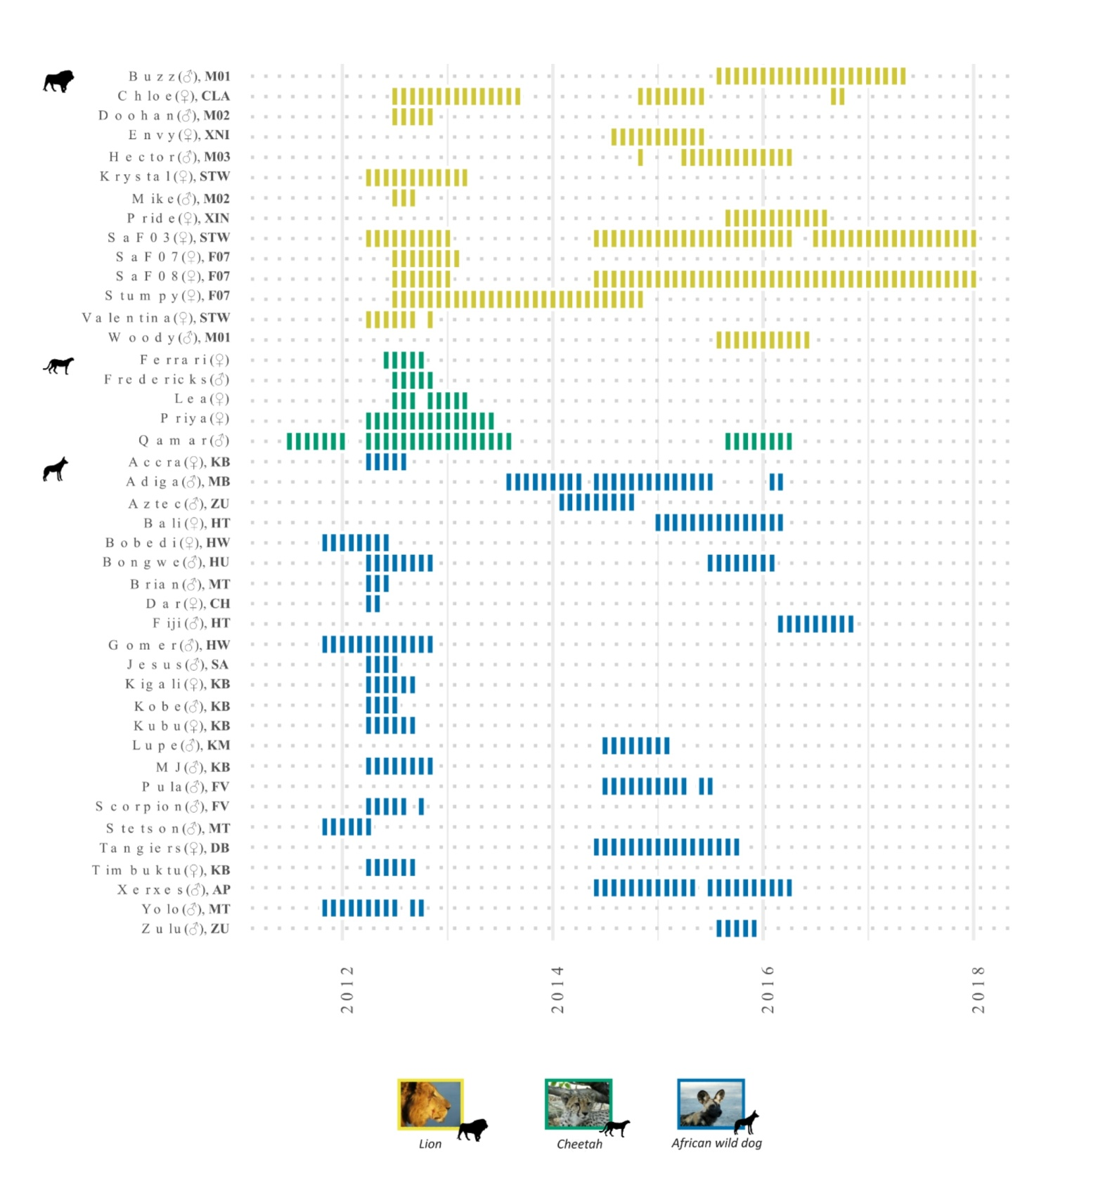
Figure S1. Summary of collar deployment durations across species. The GANT chart denotes months with collar data across all collared individuals. Individual sexes are included within brackets immediately after each individual's name, followed by the social groups in bold immediately after. No social groups are included for cheetahs, as all collared individuals were solitary or part of different coalitions.
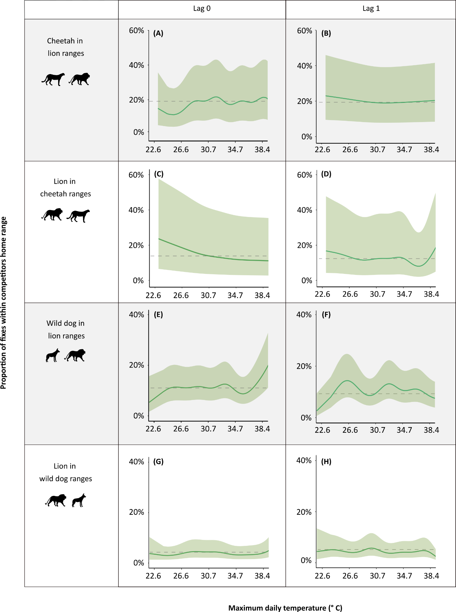
Figure S2. Wet season proportion of GPS locations within competitor home ranges in relation to maximum daily temperatures on the day of (lag₀) and the day prior (lag₁). Horizontal dashed lines indicate the proportion of locations within competitor home ranges at median temperature values. Maximum daily temperature tick marks correspond approximately to -2, -1, 0, + 1, and + 2 standard deviations from the mean. Shaded ribbons represent 95% confidence intervals.
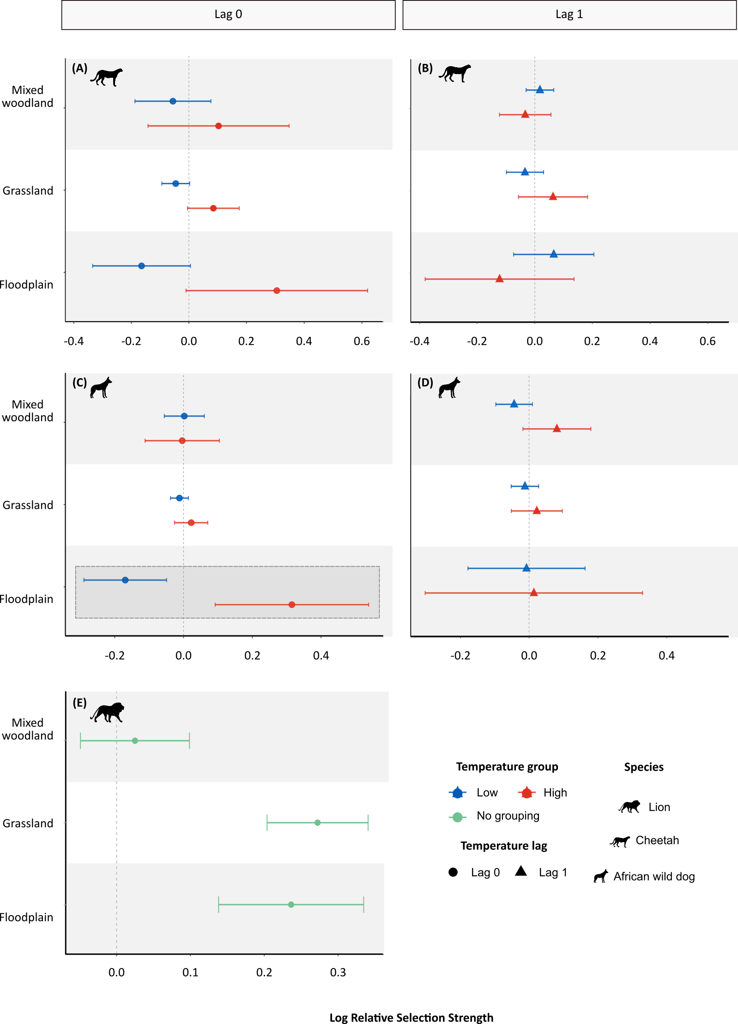
Figure S3. Wet season relative selection strength estimates for mixed woodlands, grasslands, and floodplains, relative to mopane woodlands, across cool (20th percentile) and warm (80th percentile) maximum daily temperatures and across time lags for each predator species. Dashed vertical lines represent no change in selection. Positive values indicate selection for that habitat and negative values represent avoidance. Bars represent 95% confidence intervals. Dashed boxes indicate habitats for which there was a statistically significant change in selection as a function of temperature.
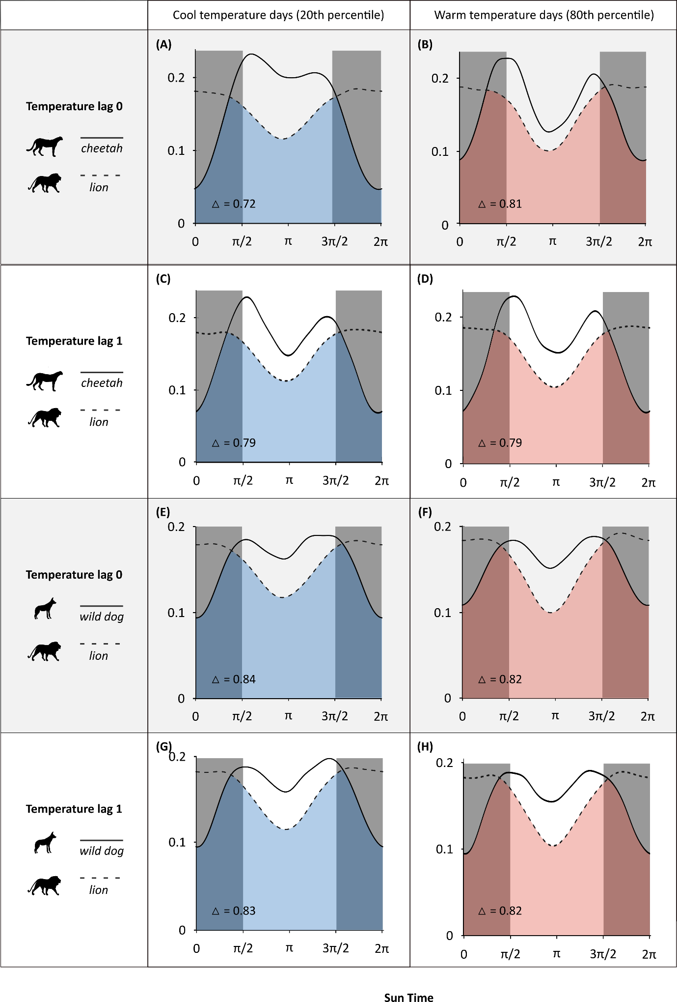
Figure S4. Wet season changes in temporal partitioning between cheetahs and lions and between African wild dogs and lions across maximum daily temperatures and temperature lags. Curves denote species kernel densities for activity. Shaded and unshaded panels on each plot delineate night and day, respectively. The x-axis denotes sun time, a transformation of clock time that anchors sunrise and sunset to π/2 and 3π/2, respectively, to control for seasonal differences in sunrise and sunset times. △ denotes the coefficient of activity overlap (where 0 indicates no overlap and 1 indicates full overlap).

