Supporting Information for: Heart rate biologgers reveal individual-specific energy landscapes for mule deer. Movement Ecology.
Supplementary Material S1: Additional details on study sites and populations.
In the Cache study region, winters are cold and severe with warm but relatively short summer periods. Outside of the town of Logan, human pressure is generally low although the area has a sizeable area devoted to agriculture. The Nebo study area consists of mountainous terrain with numerous towns and increasing human development in the lower elevations to the west. The southern site, Pine Valley, is associated with finer-scale topographic features, with elevation varying between ~650 m – ~3100 m. The area does experience a large increase in human visitation in the spring and summer from nearby Zion National Park. The region is semi-desert/desert with extremely arid conditions with very warm temperatures during the summer and mild winters with ephemeral snow in lower elevations. Details on temperature, precipitation, and elevation are presented in Table S1.
Individuals migrated short distances (~25 km) in the spring and autumn [1]. We used migration dates to delineate seasons for mule deer (Table S2).
Supplementary Material S2: Additional details on calculating instantaneous rate of green-up.
To calculate IRG, we first downloaded and extracted normalized difference vegetation index (NDVI) data from surface reflectance bands 1 and 2 of MODIS product MOD09Q1 for our study areas. This product has a spatial resolution of 250 × 250 m and an 8-day temporal resolution. We set all pixels that were contaminated by cloud or that contained negative values to NA. We then used the snow cover band of MODIS MOD09A1 (500 m² resolution) to set all pixels that were below the 0.025 quartile of snow-free values to the 0.025 quartile to eliminate the influence of melting snow when fitting green-up curves. We then smoothed each time series (e.g., all pixel values at a location through time for a given year) of NDVI data using a 3-observation moving window median analysis and scaled each time series to from 0 and 1. Finally, we fit a double-logistic regression curve to each time series/location and took the first derivative as our measure of IRG.

Supplementary Material S3: Additional Methods related to data manipulation, defining seasons, and Hidden Markov movement models.
To prepare the data, we first took the GPS locations and extracted the coordinates of the next location and the time between the two locations. This allowed us to then quantify each row in the database as a “step” (the straight line between two successive locations). We visually screened the data to remove any unreasonably large steps or extreme spatial outliers. Most of the collars used in this study were programmed to take a location every two hours, however two collars recorded locations every 30 minutes. For these collars, we rarefied the data to only include the first location recorded every two hours to match the temporal resolution of the rest of our data. Due to some imprecision in the exact timing of the recording of locations and gaps in the data, we only retained steps in which the time difference was between 1.8 and 2.2 hours. This ensured that the time intervals of all steps were comparable.
To prepare the heart rate data, we removed all capture days and two days following capture until deer behavior was presumably no longer affected by the stress of the capture event. The biologgers occasionally erroneously provided 0 or very low heart rate values. Following [2] who deployed similar biologgers in moose (Alces alces), we excluded any heart rate value less than 38 (12.4%), which was found to be the minimum winter heart rate of moose in their study. Further validation by [2] found no bias in biologger observations across movement phases in moose (e.g., when moose were active or resting). We related all heart rate observations to the appropriate step by subsetting the heart rate data for a given collar to between the start and end times of each step and taking the mean of all observations over that period. For most steps our estimate of mean heart rate was based on 60 observations (two hours/2 min interval heart rate data), however due to missing/censored values indicated above some steps had less observations. We therefore removed any steps in which we had less than 10 heart rate measurements (~6.8% of steps).
We divided our analysis into both summer and winter seasons, based on seasonal migration, given that we predicted that relationships between heart rate and the environment would vary by season. Seasonal migration was defined using Migration Mapper (version 3.0; [3]) which provides a plot of net squared displacement to allow the user to manually assign dates to migration start and end points. The migration period itself was excluded from our analyses. The majority of the individuals in our dataset were migratory, however we also had four resident individuals that did not migrate. For residents, we defined the start and end of summer and winter as the mean start and end dates of those seasons (in each year) of the migratory subset of our sample. We also had two individuals that we classified as mixed migrants who used three distinct ranges throughout the year. For these individuals, we included locations for both seasonal/summer locations but removed the points that occurred during what could be considered a “mid-season migration”. We also included data from individuals with limited data sets (from a capture event in December until the following capture event in March, e.g., their winter season), whose migratory status was unknown. All locations of these individuals were assigned to the corresponding winter and in no cases were there any major displacements of these individuals that would correspond to a migratory event.
Our goal was to define the physiological cost of movement across the landscape and how it compared to when animals were either not moving or moving very short distances. As such, we wanted to differentiate between movement states of deer (e.g., resting or foraging versus moving). To do so, we fit Hidden Markov movement models to the data using R package moveHMM [4]. We fit a two-state model (resting/encamped versus moving). Initial parameters for step length were set at 30 m and 200 m respectively for the two states, with initial turn angles set at -2.7 radians and 0 radians, respectively. Each model was fit with ID-season (winter or summer) as the unique ID, with mule deer ID and season fit as covariates on state transition rates in the model. We used the viterbi function to extract the most probable state for each step to the data. 38.4% of deer steps were classified as being in a moving state in the winter, and 33.2% were classified as moving in the summer. Overall, deer were active roughly equally at night (after 6 PM and before 6 AM, 36.4% of steps) as during the day (35.6% of steps). Step length and turning angle distributions for the two states are presented in Figure S1.
Finally, we extracted the environmental/landscape data described above to each step. Many of these were calculated as the mean of values along the line of the step (e.g., a line drawn between the start and end points of a given step, sampling each pixel along the line). These included elevation, slope, terrain aspect (trasp), forest cover, and snow depth. We also calculated a measure of cumulative elevation gain along a step. This calculated the difference in elevation of each pixel from the previous pixel intersected by the step and summed all positive values. Due to the lower resolution of temperature data we simply extracted the value of minimum and maximum PRISM temperatures at the starting point of the step.
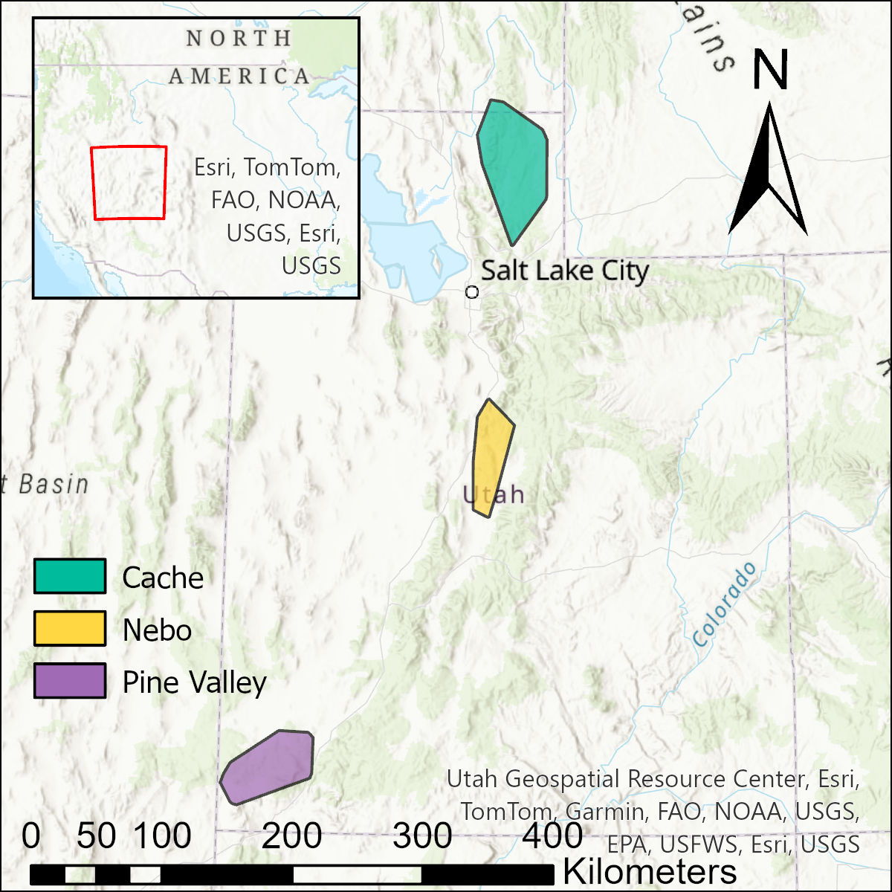

Figure S1: Study area showing the extent (99% minimum convex polygon of mule deer (Odocoileus hemionus) locations) for the three study areas in Utah, USA.
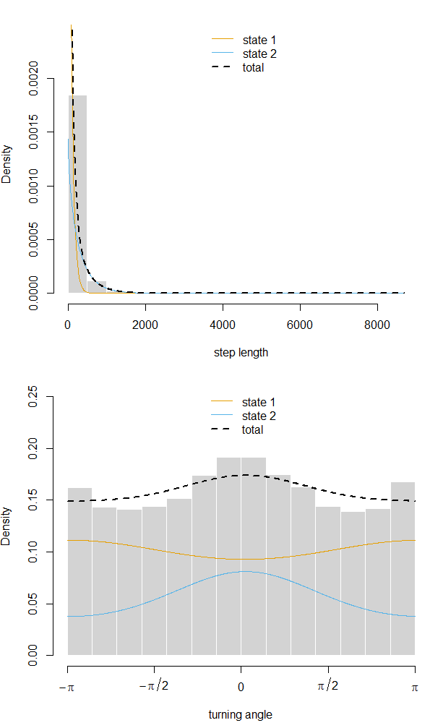
Figure S2: Distributions of step lengths and turning angles from Hidden Markov Movement Models for mule deer (Odocoileus hemionus, n = 37) in Utah, 2022–2024.
Table S1: Sample size of mule deer (Odocoileus hemionus) across study sites, along with climatic and elevation data for mule deer. Included are summer and winter average temperature, precipitation, and snowfall for the three study sites (nearest weather station in parentheses), plus average elevation of mule deer locations at each study site in both summer and winter.
 | Cache (Logan, UT) | Nebo (Nephi, UT) | Pine Valley (Saint George, UT)
Sample size | 11 | 11 | 15
July average temperature (°C) | 23.4 | 24.1 | 30.4
January average temperature (°C) | -3.9 | -2.0 | 5.1
Average total snowfall (cm) | 146.0 | 128.8 | Trace
Average total precipitation (cm) | 48.2 | 34.9 | 23.6
Average summer elevation of deer locations (m) | 2246 | 2266 | 2040
Average winter elevation of deer locations (m) | 1902 | 1758 | 1529

Table S2: Average start and end of seasons for mule deer (Odocoileus hemionus, n = 37) populations in Utah based on spring and autumn migration dates.
Population | Winter 2022 | Summer 2022 | Winter 2023 | Summer 2023 | Winter 2024
Cache | 2021-09-27 to 2022-04-26 | 2022-05-05 to 2022-10-31 | 2022-12-07 to 2023-05-11 | 2023-05-21 to 2023-10-23 | 2023-10-22 to end of data  collection
Pine Valley | 2021-12-13 to 2022-03-21 | 2022-04-08 to 2022-10-12 | 2022-11-03 to 2023-04-21 | 2023-05-03 to 2023-10-14 | 2023-10-20 to end of data  collection
Nebo |  |  | 2023-03-06 to 2023-05-15 | 2023-05-25 to 2023-12-02 | 2024-01-19 to end of data  collection

Table S3: Mean coefficient values and 95% bootstrapped confidence intervals for mule deer (Odocoileus hemionus; n = 37) energy landscapes in Utah, 2022–2024.

Parameter | Cache Winter | Nebo Winter | Pine Valley Winter | Cache Summer | Nebo Summer | Pine Valley Summer
Step length (100 m) | -11.2 (-13.73, -8.74) | -13.75 (-16.95, -10.62) | -11.82 (-13.85, -9.65) | -4.58 (-6.03, -3.07) | -7.86 (-13.57, -2.14) | -10.25 (-12.36, -8.17)
State | 7.01 (4.97, 9.02) | 8.59 (6.13, 10.8) | 6 (4.73, 7.41) | 2.64 (1.25, 3.97) | 6.86 (1.12, 12.36) | 8.55 (7.53, 9.46)
Elevation gain (100 m) | 5.38 (3.83, 7.07) | 4.85 (2.75, 6.93) | 2.83 (1.64, 3.9) | 6.35 (3.77, 8.75) | 1.89 (-0.79, 4.51) | 4.49 (0.84, 8.29)
Aspect (trasp) | 1.58 (-0.32, 3.64) | 0.95 (-1.48, 3.07) | 0.1 (-1.57, 2.26) | -0.32 (-3.23, 2.21) | 1.74 (-5.19, 8.68) | -2.22 (-4.53, 0.24)
Elevation | -0.14 (-1.14, 0.97) | 0 (-2.08, 2.62) | -0.65 (-1.62, 0.33) | -0.07 (-3.29, 3.39) | 3.73 (0.64, 6.47) | 2.2 (0.1, 3.81)
Forest Cover | -0.21 (-4.19, 3.81) | -1.9 (-4.82, 0.91) | -1.13 (-4.68, 2.69) | 0.84 (-0.7, 2.36) | -5.12 (-9.47, 1.27) | -1.74 (-3.31, 0.1)
Temperature (min/max) | 1.58 (0.74, 2.46) | 0.24 (-0.8, 1.2) | 0.42 (-0.5, 1.39) | -0.07 (-1.5, 1.11) | 3.5 (-0.01, 7.85) | -0.64 (-1.84, 0.39)
Snow depth (cm) | -0.67 (-1.19, -0.19) | -1.18 (-2.78, 0.7) | 3.03 (-0.12, 6.24) | NA | NA | NA
Step length × State | 11.9 (8.83, 14.62) | 15.8 (12.13, 19.59) | 13.21 (10.64, 15.37) | 3.8 (1.38, 6.18) | 9.3 (3.6, 15) | 11.08 (8.83, 13.34)

Table S4: Coefficient estimates and 95% confidence intervals from mixed effects models for mule deer (Odocoileus hemionus; n = 37) energy landscapes for each season/population in Utah, 2022–2024.
Parameter | Cache Winter | Nebo Winter | Pine Valley Winter | Cache Summer | Nebo Summer | Pine Valley Summer
Intercept | 61.66, (57.21, 66.11) | 65.32, (59.3, 71.34) | 67.89, (59.54, 76.24) | 81.06, (76.45, 85.67) | 87.52, (77.52, 97.52) | 82.52, (74.74, 90.3)
Step length (100 m) | 10.07, (9.5, 10.64) | 15.59, (14.61, 16.57) | 11.63, (11, 12.26) | 4.08, (3.61, 4.55) | 1.52, (0.97, 2.07) | 10.91, (10.34, 11.48)
State | 7.83, (7.32, 8.34) | 9.45, (8.72, 10.18) | 5.71, (5.28, 6.14) | 3.35, (2.94, 3.76) | 5.55, (4.77, 6.33) | 8.64, (8.07, 9.21)
Elevation gain (100 m) | 4.86, (4.00, 5.72) | 1.42, (0.22, 2.62) | 3.2, (2.47, 3.93) | 2.11, (1.33, 2.89) | -1.05, (-2.13, 0.03) | 1.17, (0.29, 2.05)
Aspect (trasp) | 3.11, (2.46, 3.76) | -0.42, (-1.56, 0.72) | 0.18, (-0.33, 0.69) | -1.03, (-1.56, -0.5) | 1, (-0.22, 2.22) | -1.32, (-1.91, -0.73)
Elevation | -0.62, (-0.84, -0.40) | 3.11, (2.8, 3.42) | -1.1, (-1.34, -0.86) | -0.12, (-0.26, 0.02) | 0.34, (0.03, 0.65) | 1.18, (0.93, 1.43)
Forest Cover | 2.53, (1.71, 3.35) | -7.24, (-8.14, -6.34) | -1.53, (-2.1, -0.96) | 1.91, (1.46, 2.36) | -6.54, (-7.4, -5.68) | -2.51, (-3.06, -1.96)
Temperature (min/max) | 2.88, (2.7, 3.06) | 1.7, (1.43, 1.97) | 0.25, (0.07, 0.43) | -0.41, (-0.55, -0.27) | 4.18, (3.83, 4.53) | -0.34, (-0.5, -0.18)
Snow depth (cm) | 0.02, (-0.04, 0.08) | -0.05, (-0.23, 0.13) | 1.18, (0.65, 1.71) | NA | NA | NA | 0.02, (-0.04, 0.08)
Step length × State | -9.21, (-9.76, -8.66) | -13.05, (-14.03, -12.07) | -10.31, (-10.92, -9.7) | -4.04, (-4.51, -3.57) | -0.16, (-0.67, 0.35) | -9.86, (-10.43, -9.29)

References
1. van de Kerk M, Larsen RT, Olson DD, Hersey KR, McMillan BR. Variation in movement patterns of mule deer: have we oversimplified migration? Mov Ecol. 2021;9:44.
2. Græsli AR, Thiel A, Fuchs B, Singh NJ, Stenbacka F, Ericsson G, et al. Seasonal Hypometabolism in Female Moose. Front Ecol Evol. 2020;8:107.
3. Merkle JA, Gage J, Sawyer H, Lowrey B, Kauffman MJ. Migration Mapper: Identifying movement corridors and seasonal ranges for large mammal conservation. Methods Ecol Evol. 2022;13:2397–403.
4. Michelot T, Langrock R, Patterson TA. moveHMM: An R package for the statistical modelling of animal movement data using hidden Markov models. Methods in Ecology and Evolution. 2016;7:1308–15.

