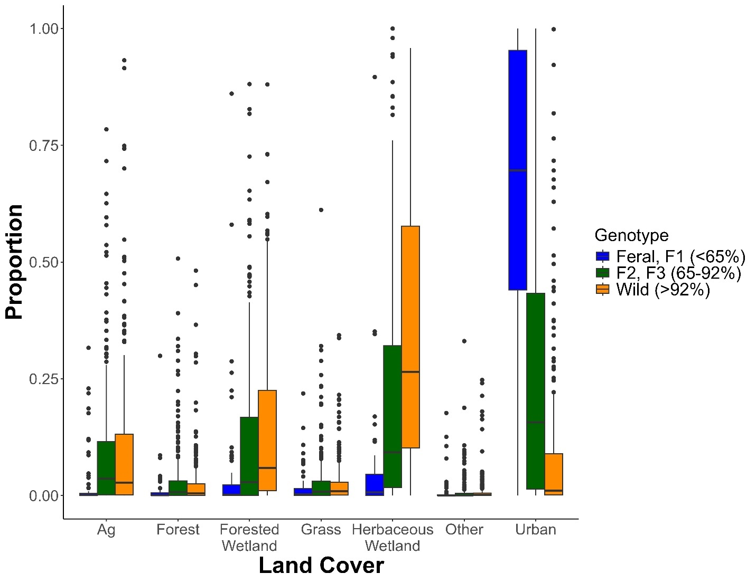
Supplemental File 4. Boxplots of the proportion of GPS locations in each land cover type collected from 16 August – 29 February, 2021–2024 from female mallards marked with GPS-GSM transmitters in Michigan, Wisconsin, Illinois, Indiana, and Ohio, 2021–2023. Land cover types include the following categories from the 2021 National Land Cover Database and the Land Cover of Canada database: emergent herbaceous wetlands, forested wetlands, open water, developed (low, medium, and high intensity developed and developed open space), grassland (grassland and pasture), forest (deciduous, evergreen, needleleaf, and mixed forest), agriculture, and other (barren, scrub shrub, and shrubland). Medians are shown by the bold horizonal line, boxes denote the 25th and 75th percentiles, whiskers are 1.5 times the interquartile range, and points denote individual values more extreme than the whiskers. Genotype categories correspond to the percentage wild ancestry.

