Supplemental Material

Assessing consequences of anthropogenic hybridization: Great Lakes mallard movement and resource selection

Benjamin Z. Luukkonen^{a, *}, Scott R. Winterstein^{b}, Daniel B. Hayes^{b}, Drew N. Fowler^{c}, Gregory J. Soulliere^{d}, John M. Coluccy^{e}, Brendan Shirkey^{f}, John Simpson^{f}, Amy A. Shipley^{g}, Jason M. Winiarski^{h}, Benjamin J. O’Neal^{i}, Joshua M. Osborn^{j}, Barbara A. Avers^{k}, Vergie M. Musni^{l}, Philip Lavretsky^{l}

ª Michigan Department of Natural Resources, Wildlife Division, 621 10th St Plainwell, MI 49080, USA

^{b} Department of Fisheries and Wildlife, Michigan State University, 480 Wilson Rd, East Lansing, MI 48824, USA

^{c} U.S. Geological Survey, Louisiana Cooperative Fish and Wildlife Research Unit, 224 Renewable Natural Resources Building, Baton Rouge, LA 70803, USA

^{d} U.S. Fish and Wildlife Service, Upper Mississippi/Great Lakes Joint Venture, 2651 Coolidge Rd, Suite 101, East Lansing, MI 48823, USA (retired)

^{e} Ducks Unlimited Inc., 7322 Newman Blvd Building 2, Dexter, MI 48130, USA

^{f} Winous Point Marsh Conservancy, 3500 South Lattimore Road, Port Clinton, OH 43452, USA

^{g} Wisconsin Department of Natural Resources, Office of Applied Science, 2801 Progress Rd, Madison, WI 53716, USA

^{h} Department of Forest and Wildlife Ecology, University of Wisconsin – Madison, 1630 Linden Dr, Madison, WI 53706, USA

^{i} Department of Biology, Franklin College, 101 Branigin Blvd, Franklin, IN 46131, USA

^{j} Forbes Biological Station–Bellrose Waterfowl Research Center, Illinois Natural History Survey, Prairie Research Institute, University of Illinois at Urbana-Champaign, Havana, IL 62644, USA

^{k} Michigan Department of Natural Resources, Wildlife Division, 4166 Legacy Pkwy, Lansing, MI 48910, USA

^{l} Department of Biological Sciences, University of Texas El Paso, 500 W University, El Paso, TX 79902, USA

*Correspondence:
Benjamin Z. Luukkonen
luukkonenb1@michigan.gov

Supplementary Material S1: Mallard daily movement distance model evaluation results.
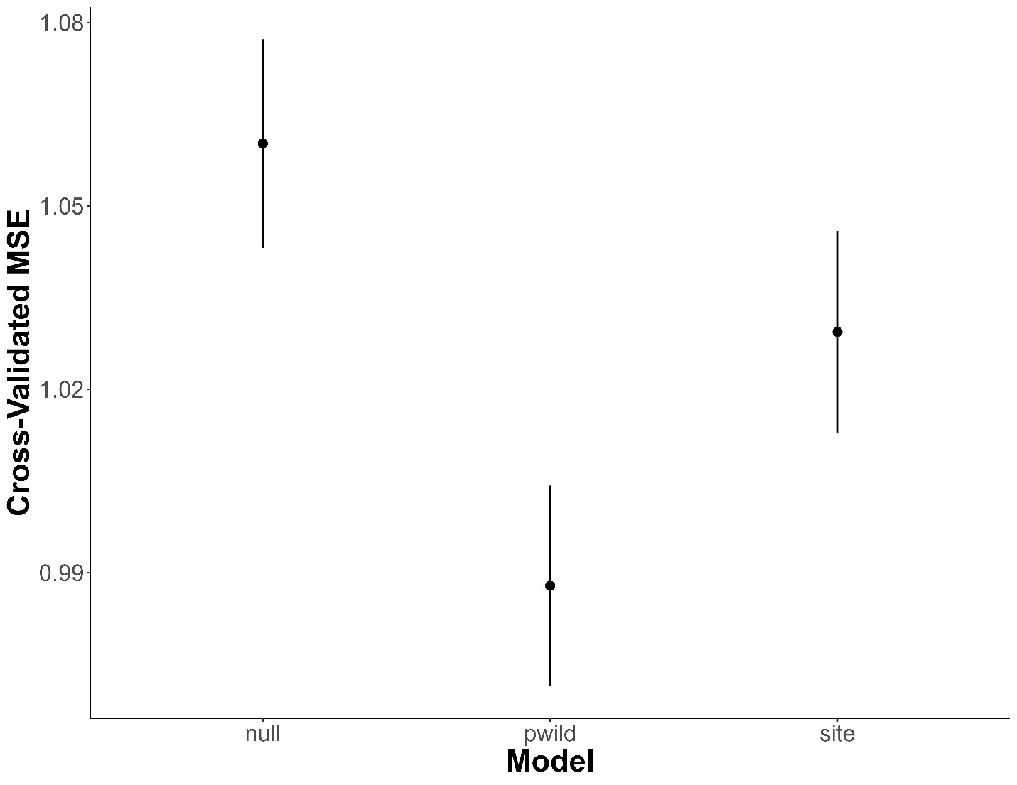
Figure S1.1. Bias-adjusted mean squared prediction errors (MSE) estimated via 10-fold cross validation for candidate models predicting average daily mallard movement distance in relation to proportion wild ancestry (pwild) and capture site type (site; urban or rural) for female mallards marked with GPS-GSM transmitters in Michigan, Wisconsin, Illinois, Indiana, and Ohio, 2021–2023. Error bars denote 1 standard error.
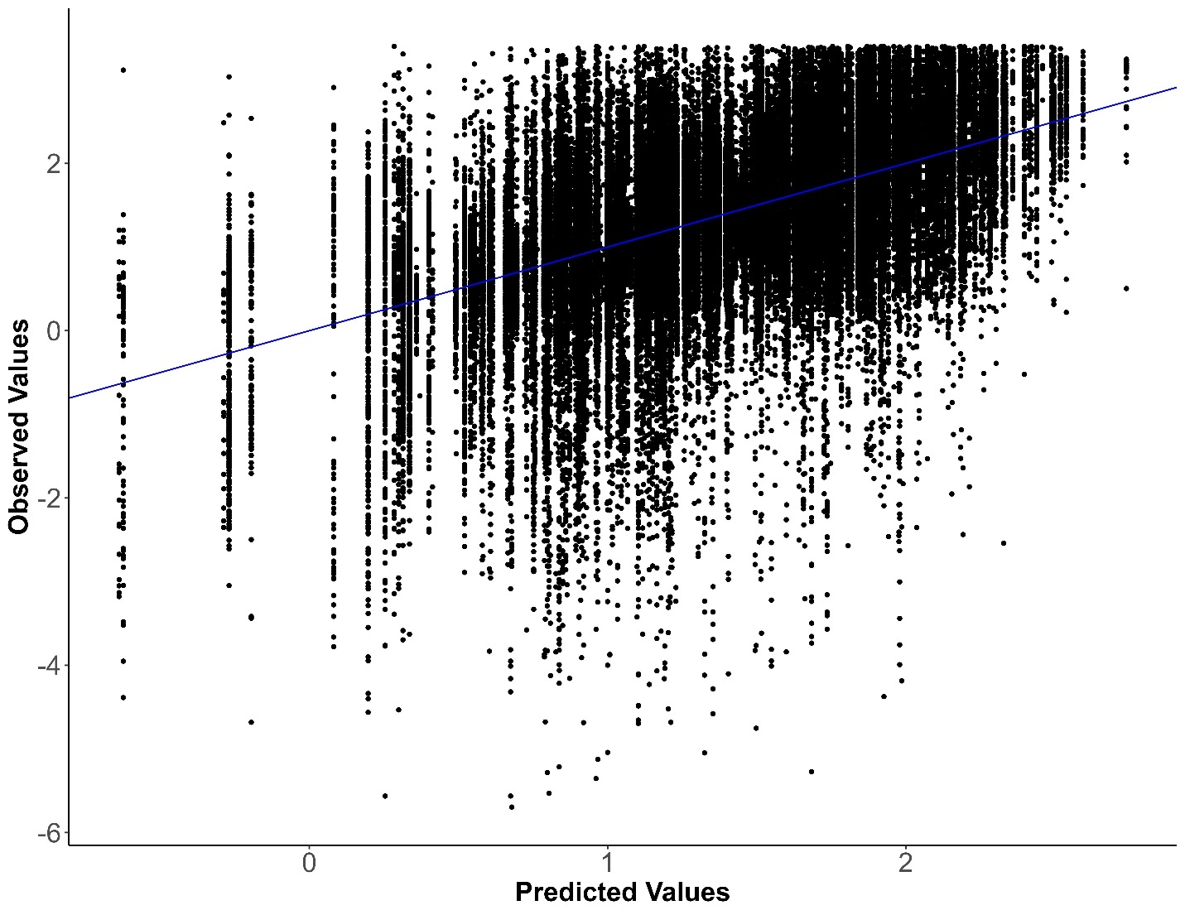
Figure S1.2. Observed vs predicted values from a linear mixed model predicting average daily mallard movement distance as a function of proportion wild ancestry for female mallards marked with GPS-GSM transmitters in Michigan, Wisconsin, Illinois, Indiana, and Ohio, 2021–2023. The blue line has y-intercept of 0 and slope of 1 to denote a 1:1 relationship.

Supplementary Material S2: Mallard migration probability model evaluation results.
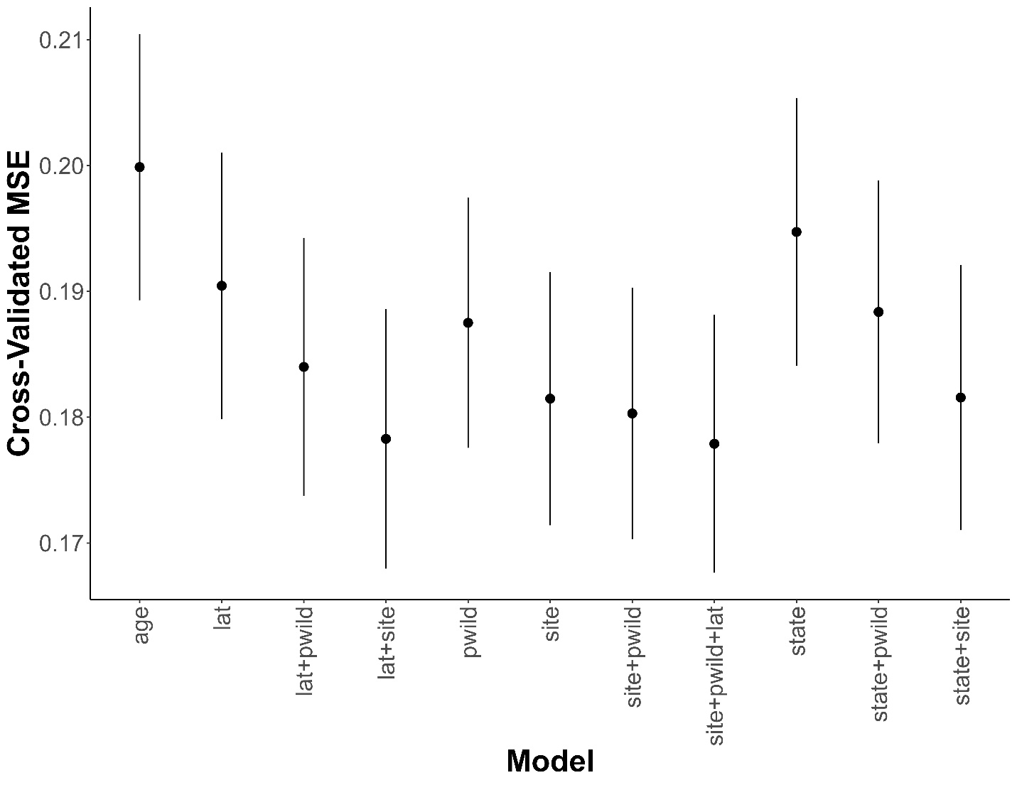
Figure S2.1. Bias-adjusted mean squared prediction errors (MSE) estimated via 10-fold cross validation for candidate models predicting probability of mallard autumn migration in relation to proportion wild ancestry (pwild), capture site type (site; urban or rural), capture latitude (lat), and capture state for female mallards marked with GPS-GSM transmitters in Michigan, Wisconsin, Illinois, Indiana, and Ohio, 2021–2023. Error bars denote 1 standard error.
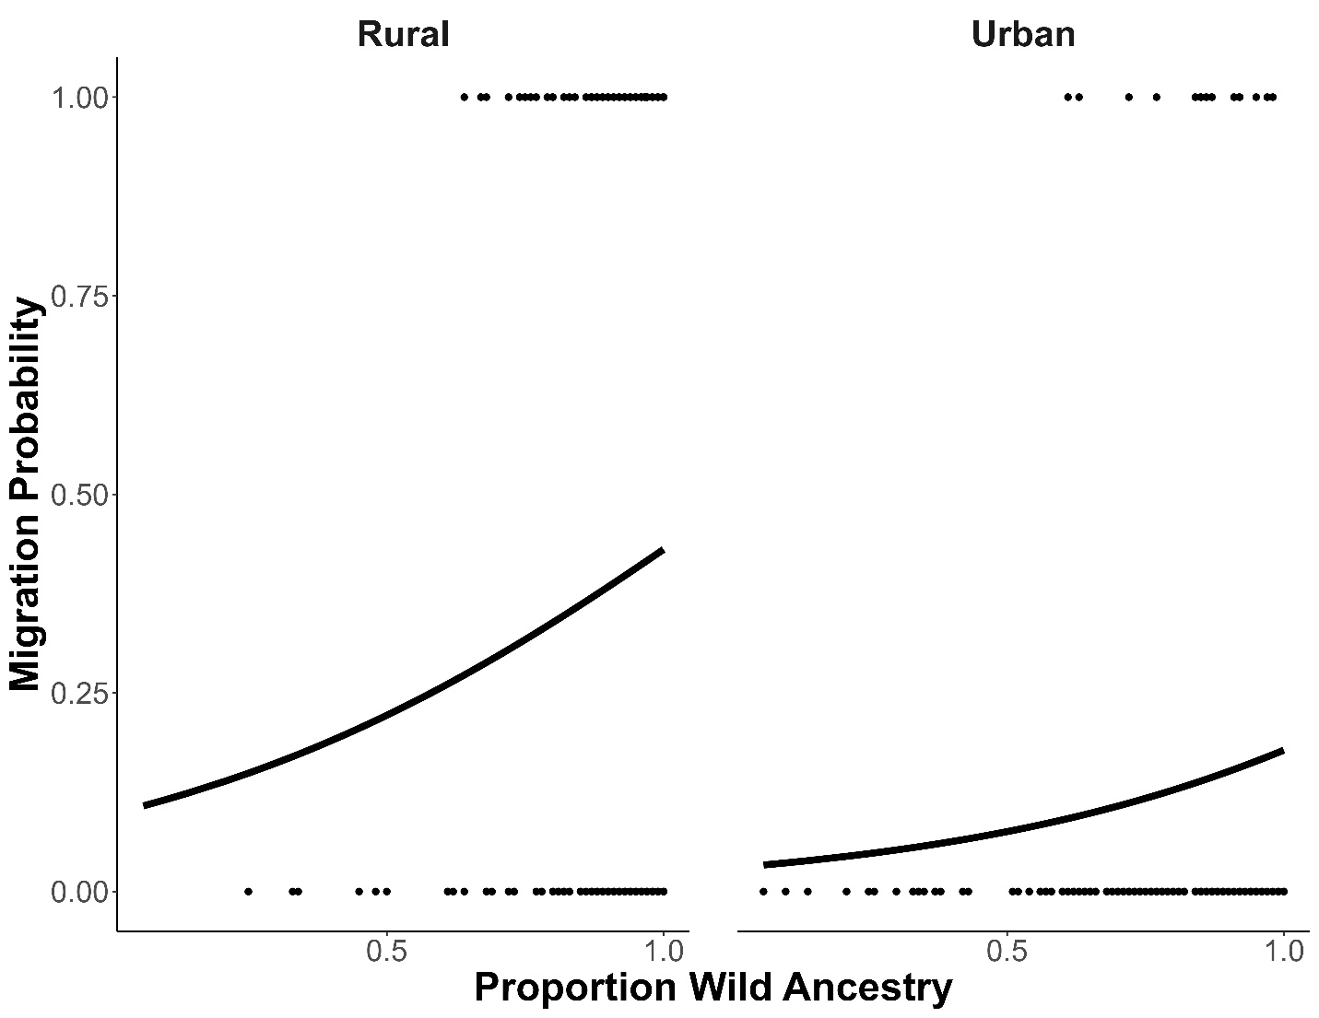
Figure S2.2. Overall observed (points; 0 indicates no migration and 1 indicates migration) vs predicted (lines) mallard autumn migration probability in relation to proportion wild ancestry and capture site type (urban or rural) at a capture latitude of 43 degrees north for female mallards marked with GPS-GSM transmitters in Michigan, Wisconsin, Illinois, Indiana, and Ohio, 2021–2023.

