SUPPLEMENTARY MATERIALS
Biotic and abiotic factors drive circadian migration patterns in northern pintails across the Eurasian flyway
Devon Cevenini, Daniele Baroni, Jacopo G. Cecere, Lucio Panzarin, Marco Basso, Alessandro Franzoi, Fernando Spina, Simone Pirrello, Federico De Pascalis, Simona Imperio, Andrea Pilastro, Lorenzo Serra

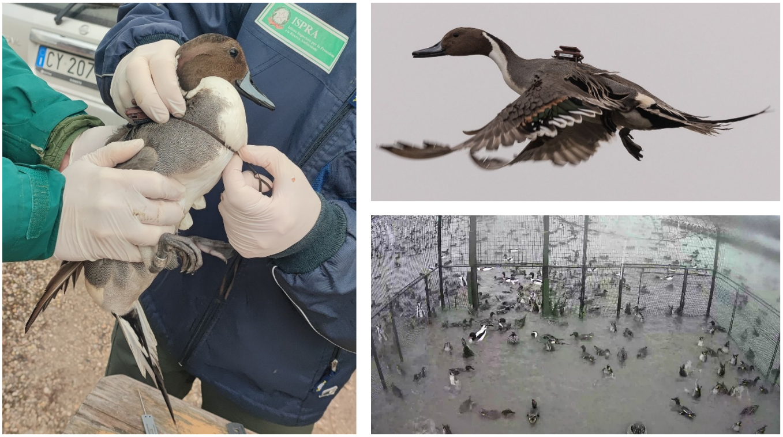
Figure S1 Details of the device deployment: fitting the harness on the wishbone and sternum (left), tagged male pintail just released (top, photo credits: Marco Basso), swim-in-trap and surroundings as visible from the remote-controlled photo trap (bottom).

Table S1 Summary information of GPS-tracked pintails (n=22, for 25 complete pre-breeding migration events). Pintail identity, year of deployment, sex (M=male, F=female), age (A=adult, J=juvenile, J/A=juvenile at catching, adult in the second year of tracking), bodymass (gr), GPS device model, setting of the GPS device, and total device weight (TDW, sum of tag and harness) are provided for each individual. Pintail id comprises the metal ring number followed by an at symbol and the device identification code. The ids in bold are individuals tracked for successive years.
Pintail id | Year | Sex | Age | Bodymass | GPS device model | Setting | TDW
N34234@1BF1A215 | 2022 | M | A | 1057 | Technosmart Europe Gipsy 14 | 1 fix/2 hr | 22.80
N34246@096AFE12 | 2022 | M | A | 938 | Technosmart Europe Gipsy 14 | 1 fix/2 hr | 21.00
N34556@85367112 | 2023 | F | J | 802 | Technosmart Europe Gipsy 14 | 1 fix/2 hr | 22.40
N34557@066AFE12 | 2023 | F | J | 604 | Technosmart Europe Gipsy 14 | 1 fix/1 hr | 20.60
N34654@240764 | 2025 | F | A | 1105 | Ornitrack OT E25 | 1 fix/1 hr | 14.20
N34673@240769 | 2025 | F | A | 944 | Ornitrack OT E25 | 1 fix/1 hr | 14.20
N5808@76035010 | 2020 | F | A | 1000 | Technosmart Europe Gipsy 17 | 1 fix/2 hr | 21.30
N5866@BIAV04 | 2019 | M | A | 1120 | Ecotone Saker 20 | 1 fix/2 hr | 21.40
N5871@BIAV07 | 2019 | F | A | 940 | Ecotone Saker 20 | 1 fix/2 hr | 20.40
N5879@989002 | 2019 | M | A | 1110 | Milsar 14 | 1 fix/2 hr | 13.70
N5880@989003 | 2019 | M | A | 960 | Milsar 14 | 1 fix/2 hr | 16.90
N5892@989012 | 2019 | F | J | 960 | Milsar 14 | 1 fix/2 hr | 14.90
N5897@D2025010 | 2020 | M | A | 1120 | Technosmart Europe Gipsy 17 | 1 fix/2 hr | 21.00
N5898@A1E70211 | 2020 | M | A | 1000 | Technosmart Europe Gipsy 17 | 1 fix/2 hr | 20.90
N5900@FA035010 | 2020 | M | A | 1080 | Technosmart Europe Gipsy 17 | 1 fix/2 hr | 21.40
N5922@5BE10211 | 2021 | M | J | 1020 | Technosmart Europe Gipsy 17 | 1 fix/2 hr | 23.80
N5928@182915 | 2021 | M | J/A | 1100 | Ornitrack OT E20B | 15 x (1 fix/1 min)/1 hr | 31.00
N5932@A1E70211 | 2021 | F | A | 950 | Technosmart Europe Gipsy 17 | 1 fix/2 hr | 23.70
N5933@191290 | 2021 | M | A | 1250 | Ornitrack OT E25 | 15 x (1 fix/1 min)/1 hr | 32.30
N5936@191293 | 2021 | F | A | 1000 | Ornitrack OT E25 | 15 x (1 fix/1 min)/1 hr | 30.00
N5959@182908 | 2021 | F | A | 900 | Ornitrack OT E25 | 15 x (1 fix/1 min)/1 hr | 32.20
N5960@180084 | 2021 | M | A | 1191 | Ornitrack OT E25 | 15 x (1 fix/1 min)/1 hr | 31.50

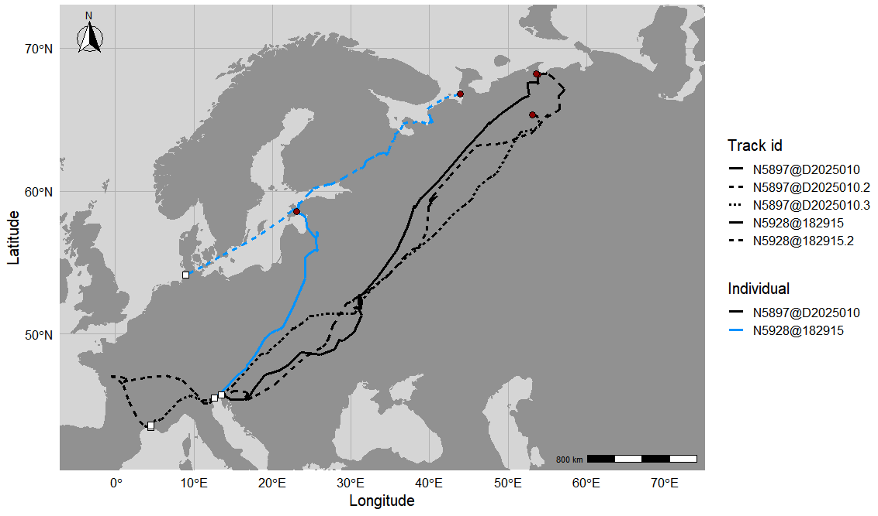
Figure S2 Pre-breeding migrations of two male pintails (N5897@D2025010 captured as an adult, in black, and N5928@182915 captured as a juvenile, in light blue) in three and two successive years, respectively. White squares indicate onset locations and dark red circles indicate breeding sites.

Sensitivity analysis for the upper threshold of the γt value
To assess whether the classification of active migration based on the move persistence parameter γt was robust to the choice of the threshold, we conducted a sensitivity analysis by varying the upper threshold used to define active-migration locations (i.e., γt > upper threshold). Based on the approximately bimodal distribution of γt (Figure S3), thirty threshold values were randomly sampled from a uniform distribution between 0.75 and 0.88 (inclusive). The upper bound of 0.88 was chosen because values of γt above 0.88 yielded insufficient active-migration observations, leading to model convergence failures. For each threshold value, active migration was redefined accordingly, and the three binomial GLMMs (A, B, C, see below) estimating the probability of active migration (0/1; 1 indicates γt > upper threshold) were refitted. We then assessed the stability of the results by examining whether the sign of each estimate and its significance (Bonferroni-corrected: weakly significant at p < 0.017, strongly significant at p < 0.0003) remained consistent across the 30 iterations.
Based on these results (Table S2), we conservatively set the threshold at γt > 0.75 (similarly to (1)), as this value falls below the first change in significance of model estimates (γt = 0.777 for model B: the interaction between sun altitude and the temperate forest biome shifted from weakly to strongly significant). This choice was further confirmed by checking the time series plots of move persistence estimates obtained per track (plot function, aniMotum package, (2–4)) showing increasingly unclear movement behaviours for γt below ~ 0.75, in most tracks. Results became increasingly unstable from γt ~ 0.83 onward, with further changes in the significance of the estimates across models occurring at γt = 0.829, γt = 0.846, γt = 0.855, and γt = 0.868.
Models used (fixed effects only):
A = active migration ~ sun altitude * Δ sun altitude
B = active migration ~ sun altitude * biome class
C = active migration ~ ground temperature + distance from breeding site
Table S2 Results of the sensitivity analysis on the upper threshold for active migration classification (γt > threshold). For each model term, the table reports the percentage of converged iterations (n=30) in which the estimate was positive or negative, and the distribution across significance categories (Bonferroni corrected: strongly significant for p < 0.0003, weakly significant for p < 0.017, non-significant otherwise). The model specification for the three GLMMs A, B, and C is described above.
Model | Term | Positive estimates (%) | Negative estimates (%) | Strongly sign. (%) | Weakly sign. (%) | NS (%)
A | (Intercept) | 0 | 100 | 100 | 0 | 0
A | Sun altitude | 0 | 100 | 100 | 0 | 0
A | Δ Sun altitude | 0 | 100 | 100 | 0 | 0
A | Sun altitude :  Δ Sun altitude | 0 | 100 | 0 | 26.70 | 73.30
B | (Intercept) | 0 | 100 | 100 | 0 | 0
B | Sun altitude | 0 | 100 | 100 | 0 | 0
B | Coniferous forest | 16.70 | 83.30 | 0 | 0 | 100
B | Temperate forest | 100 | 0 | 0 | 10.00 | 90.00
B | Tundra | 0 | 100 | 0 | 0 | 100
B | Sun altitude : Coniferous forest | 0 | 100 | 63.30 | 36.70 | 0
B | Sun altitude : Temperate forest | 0 | 100 | 6.70 | 53.30 | 40.00
B | Sun altitude : Tundra | 0 | 100 | 0 | 0 | 100
C | (Intercept) | 0 | 100 | 100 | 0 | 0
C | Ground temperature | 100 | 0 | 100 | 0 | 0
C | Distance from breeding site | 76.70 | 23.30 | 30.00 | 13.30 | 56.70

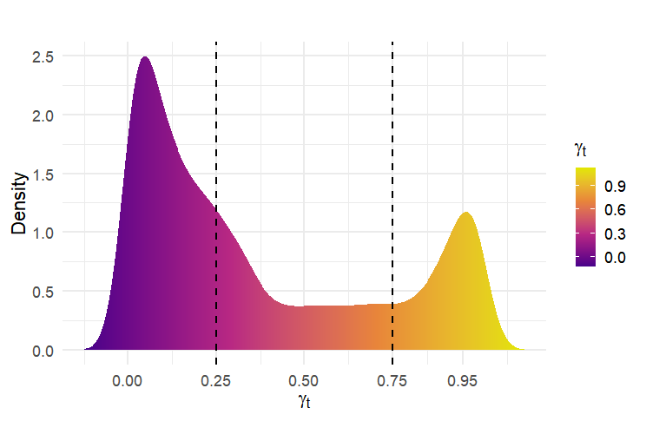
Figure S3 Distribution of γ_{t} for all locations based on the fitted move persistence model for n=22 pintails with n=25 complete pre-breeding migrations. Locations with predicted high move persistence (γ_{t} > 0.75) and low move persistence (γt < 0.25), representing the two behavioural modes considered in the study (i.e., active migration and residency), are assigned contrasting colours (yellow and purple). Cutoffs are represented with dashed lines for easier interpretation.

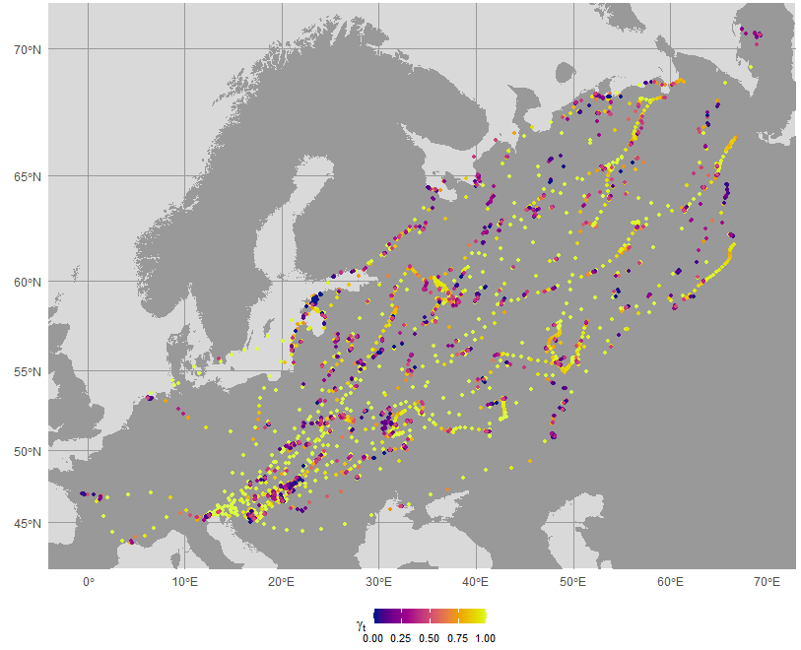
Figure S4 Spatial predictions of γ_{t} based on the fitted move persistence model for n=22 pintails with n=25 complete pre-breeding migrations. Locations with predicted high move persistence (γ_{t} > 0.75) and low move persistence (γt < 0.25), representing the two behavioural modes considered in the study (i.e., active migration and residency), are assigned contrasting colours (yellow and purple).

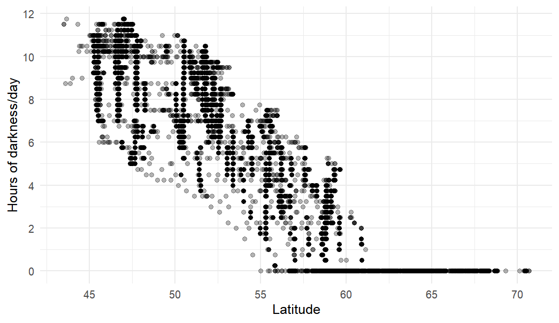
Figure S5 Visualisation of the photoperiod gradient encountered by GPS-tracked pintails during pre-breeding migration. The plot shows the number of hours after nautical sunset (sun altitude < - 0.21) across latitudes, for the 22180 observations used in this study. To obtain the number of hours of darkness a day, each location was duplicated 96 times (at 15-minute intervals) to cover the entire 24-hour cycle, and the sun altitude value was extracted for each time point.

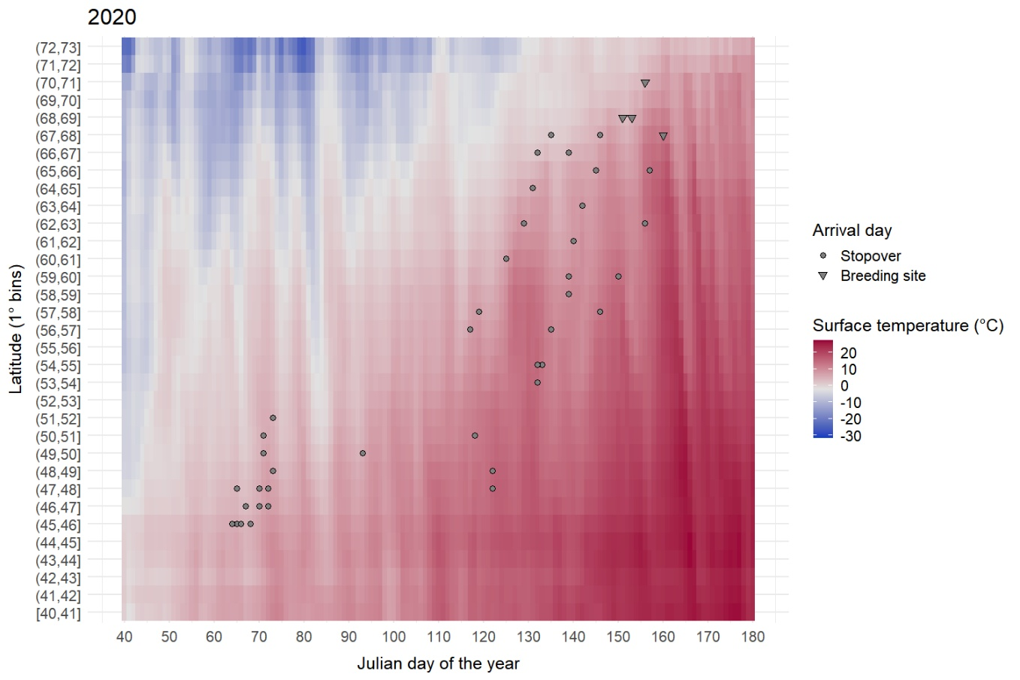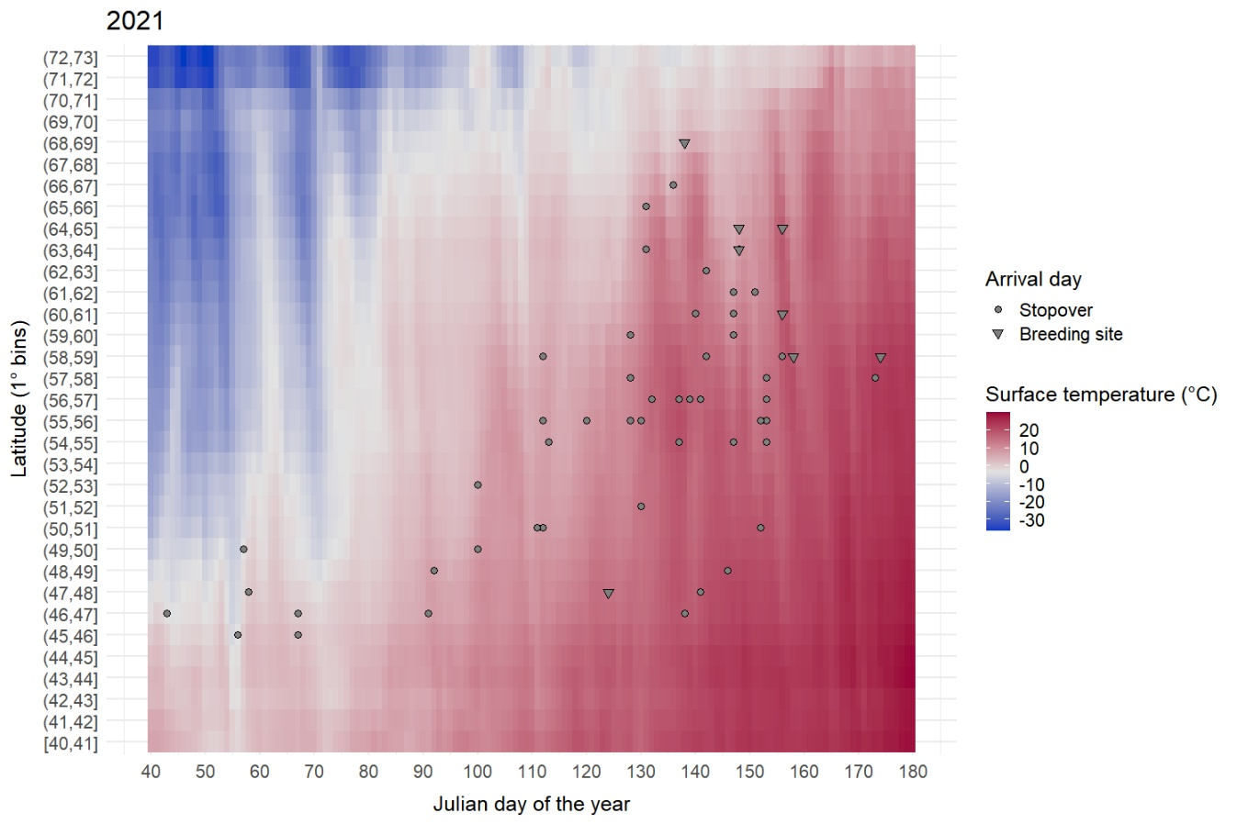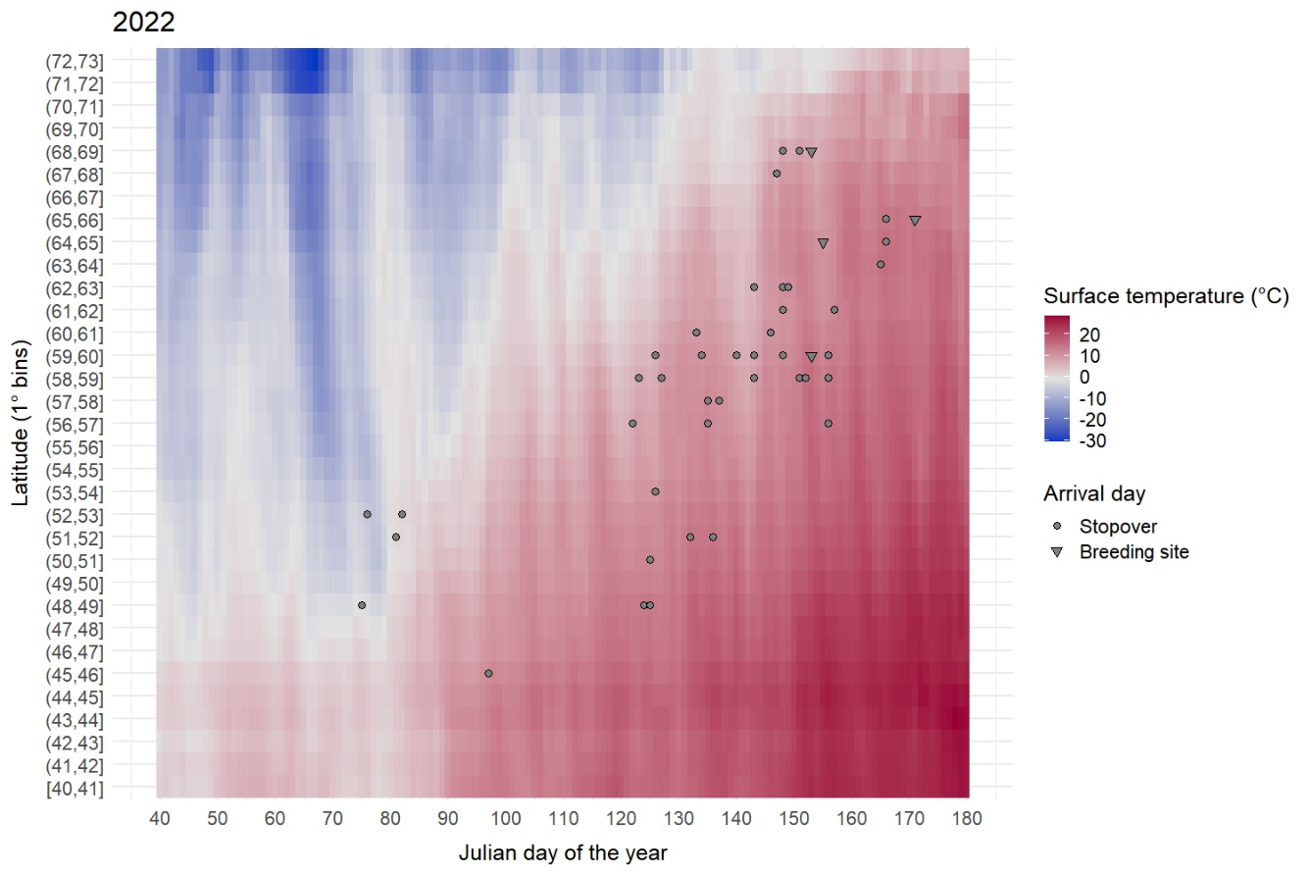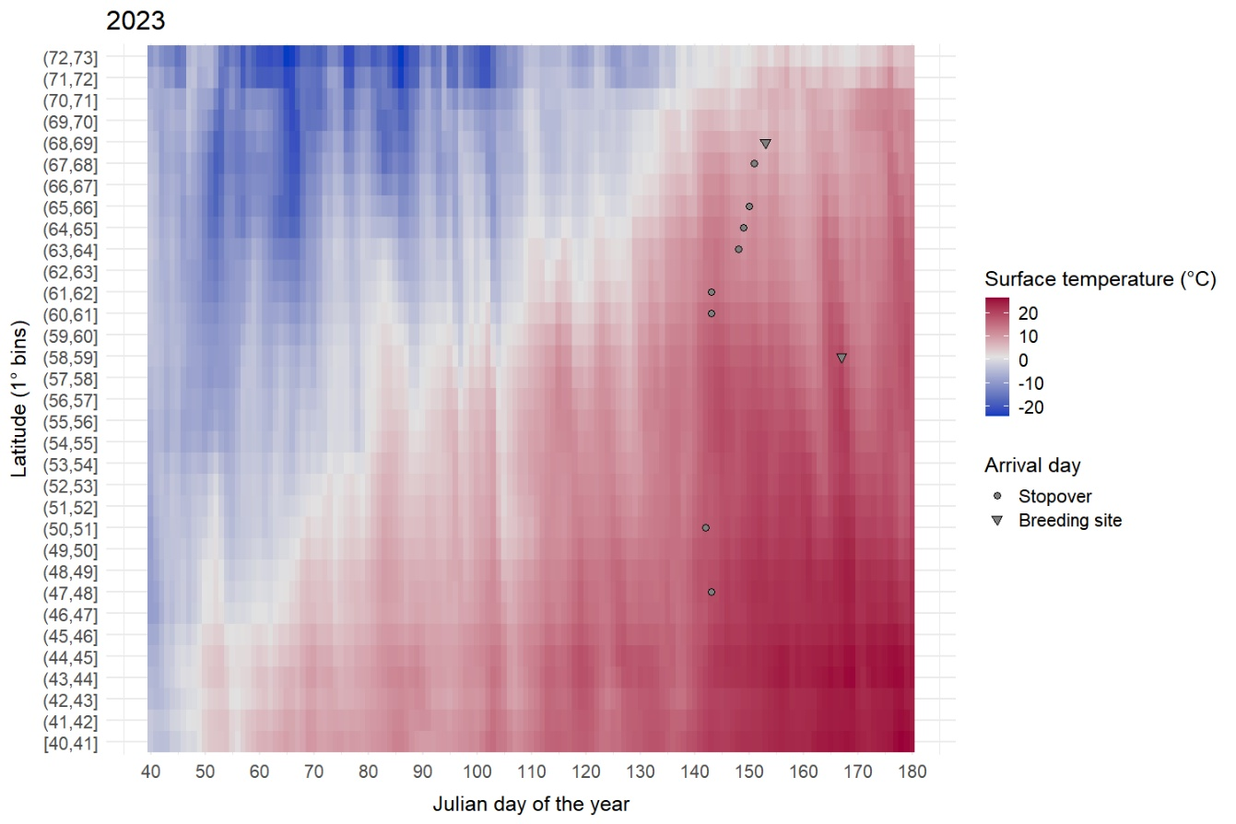
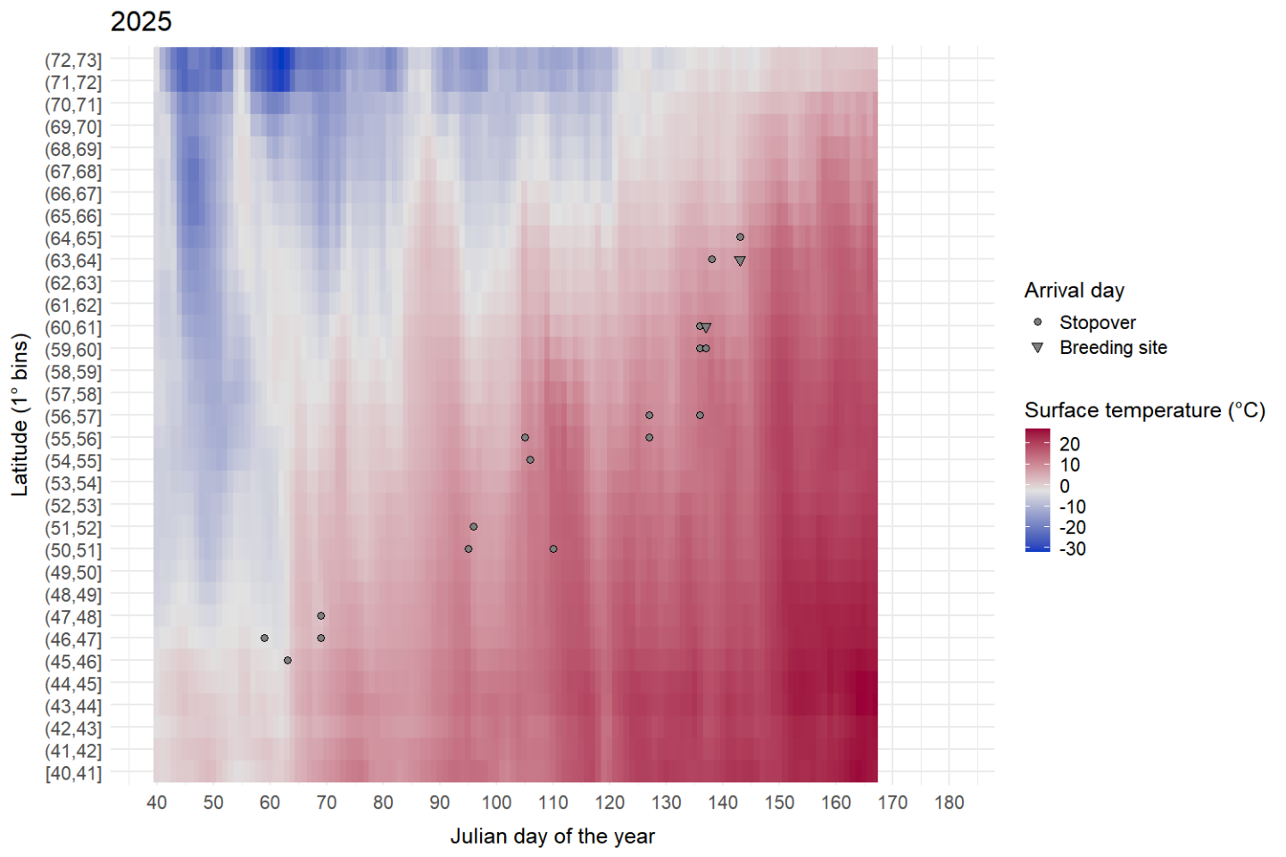
Figure S6 Spatio-temporal matrices of ground temperatures for each stopover and breeding site of pintails GPS-tracked in 2020 (n=4), 2021 (n=8), 2022 (n=4), 2023 (n=2), and 2025 (n=2); see Figure 2 for individuals tracked in 2019. For each stopover (centroid of all stopover locations), the daily mean ground temperature was extracted. The x-axis represents ‘time’ (beginning of February to end of June) as the day of the year from 1 January (some reference dates for ease of interpretation: 40 = 9 February, 60 = 1 March, 100 = 10 April, 130 = 10 May, 160 = 9 June), while the y-axis represents ‘space’ as the latitude (1° bins) of the stopover/breeding site. The daily means of ground temperatures for each latitude bin are stratified one on top of the other. The colour gradient represents the ground temperatures recorded across space and time. The grey dots and triangles indicate the day of the year when the pintail reached the stopover and the breeding area, respectively.

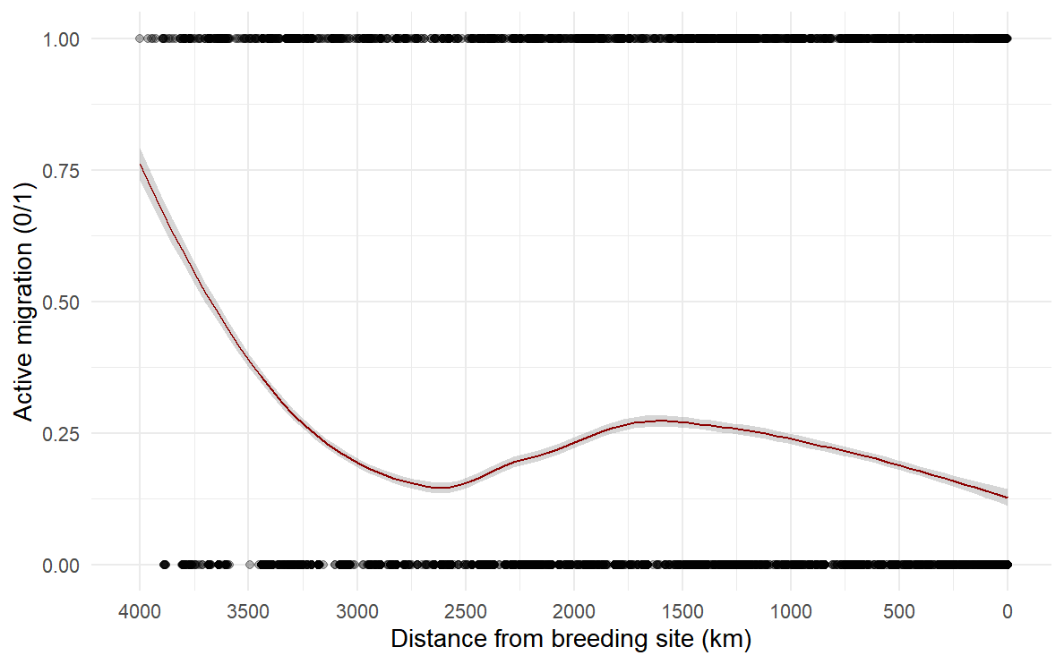
Figure S7 Raw data showing the relationship between the migratory status (0/1, where 1 indicates active migration, γt > 0.75) and the orthodromic distance from the breeding site across all GPS-tracked pintails. Points are the individual observations, and a loess smoother is shown in dark red to illustrate the trend in the data. The location of the migration onset is on the left-hand side of the plot, while the location of the breeding site is on the opposite side of the plot.

References
1. Jonsen ID, Myers RA, James MC. Identifying leatherback turtle foraging behaviour from satellite telemetry using a switching state-space model. Mar Ecol Prog Ser. 2007 May 14;337:255–64. doi:10.3354/meps337255
2. Jonsen ID, Patterson TA, Costa DP, Doherty PD, Godley BJ, Grecian WJ, et al. A continuous-time state-space model for rapid quality control of argos locations from animal-borne tags. Movement Ecology. 2020;8(31).
3. Jonsen ID, Patterson TA, Grecian WJ. aniMotum: fit latent variable movement models to animal tracking data for location quality control and behavioural inference [Internet]. Zenodo; 2022. Available from: https://zenodo.org/record/7425388 doi:10.5281/ZENODO.7425388
4. Jonsen ID, Grecian WJ, Phillips L, Carroll G, McMahon C, Harcourt RG, et al. aniMotum, an R package for animal movement data: Rapid quality control, behavioural estimation and simulation. Methods Ecol Evol. 2023 Mar;14(3):806–16. doi:10.1111/2041-210X.14060

