Autoencoder Derivations
Formally, let $x ϵ R^{n}$​​denote an input vector. An autoencoder consists of: An encoder function $f_{Ɵ}: R^{n}→ R^{p}$ parameterized by $Ɵ$, that maps to input $x$ to a latent representation $z ϵ R^{p}$ (with $p<n$):
$$z= f_{Ɵ}(x)$$
The decoder function $g_{ɸ}: R^{p}→ R^{n}$, parameterized by $ɸ$ , that reconstructs the input from the latent code:
$$\hat{x}= g_{ɸ}\left(z\right)= g_{ɸ}(f_{Ɵ}\left(x\right))$$
The model parameters $Ɵ$ and $ɸ$ are optimized to minimize the expected reconstruction loss over the dataset $X=\{x_{1},…x_{n}\}$:
$$\min{Ɵ,ɸ}:E_{x\sim X}[Δ(x, g_{ɸ}(f_{Ɵ}\left(x\right)))]$$
Where Δ is the dissimilarity measure, commonly the squared Euclidean norm [1,2]:
$$Δ(x,\hat{x)}={\left\|x_{i}- g_{ɸ}\left(f_{Ɵ}\left(x_{i}\right)\right)\right\|}_{2}^{2}$$
In practice, for a dataset of $n$ samples, this becomes:
$$\min{Ɵ,ɸ}=\frac{1}{n}\sum_{i=1}^{n}{{\left\|x_{i}- g_{ɸ}\left(f_{Ɵ}\left(x_{i}\right)\right)\right\|}_{2}^{2}}$$
Given the high dimensionality, complex, and nonlinear relationships in animal movement data, we implement our autoencoder architecture as a multilayer perceptron (MLP) composed of fully connected layers with nonlinear activations. This design enables the network to learn intricate mappings and extract informative latent representations from behavioral trajectories, beyond what is possible with purely linear or shallow models [4,5]. The following approach is particularly suited for scenarios in which only healthy animal movement data are available for training, enabling researchers to identify anomalous or potentially CWD+ individuals in held-out test datasets. Our autoencoder model receives an input vector $x ϵ R^{d}$, representing the set of movement features for a given window. The encoder maps $x$ to a latent representation $x ϵ R^{4}$through a sequence of fully connected dense layers, which allows for backpropagation with each nonlinear activations:
$$h_{1}=ReLU\left(W_{1}x+ b_{1}\right), W_{1} ϵ R^{32}, b_{1} ϵ R^{32}$$
$$h_{2}= ReLU\left(W_{2}h_{1}+ b_{1}\right), W_{2} ϵ R^{16x32}, b_{2} ϵ R^{16}$$
$$z= ReLU\left(W_{3}h_{2}+ b_{3}\right), W_{3} ϵ R^{4x16}, b_{3} ϵ R^{4}$$
In this context, $h_{1}$ and $h_{2}$ are the outputs of the first and second hidden layer (with dimensions 32 and 16 respectively), and $z$is the 4-dimensional bottlenet embedding that summarizes the input.
Each layer consists of a linear transformation (matrix multiplication plus bias addition), followed by a $ReLU$ activation which is defined as $ReLU\left(a\right)=\max{(0},a)$[3] for our MinMax-scaled inputs, this function primarily passes positive values through unchanged, and ensures that any negative values (which might occur through model computation) are set to zero. Using $ReLU$ activations allow the network to model non-linear relationships efficiently while maintaining non-negative outputs continuously through the autoencoder [4]. Once the latent embedding $z$ is obtained, the decoder networks perform the inverse operation, progressively expanding the information contained in $z$ back into the original high-dimensional feature space. The decoder reverses the encoder process, mapping from the latent representation z back to the original feature space:
$$h_{3}=ReLU\left(V_{1}z+ c_{1}\right), V_{1} ϵ R^{16x4}, c_{1} ϵ R^{16}$$
$$h_{4}= ReLU\left(V_{2}h_{3}+ c_{2}\right), V_{2} ϵ R^{32x16}, c_{2} ϵ R^{32}$$
$$\hat{x}= V_{3}h_{4}+ c_{3}, V_{3} ϵ R^{dx32}, c_{3} ϵ R^{d}$$
In the decoder, $h_{3}$ is the first decoder hidden layer with dimension 16, $h_{4}$is the second decoder hidden layer with dimension 32, and $\hat{x}$ is the reconstructed output of dimension $d$, produced by a linear (non-activated) output layer. The full autoencoder mapping can be written as
$\hat{x}= g_{ɸ}(f_{Ɵ}\left(x\right))$, where: $f_{Ɵ}\left(.\right)$ is the encoder network, parameterized by weights and biases, and $Ɵ= {\{W}_{1}, W_{2},W_{3},b_{1},b_{2},b_{3})$. The decoder represented as $g_{ɸ}\left(.\right)$ is parameterized by weights and biases $ɸ= {\{V}_{1}, V_{2},V_{3},c_{1},c_{2},c_{3})$. To train the autoencoder, we minimize a custom loss over the model parameters, jointly optimizing the encoder and decoder weights to ensure the reconstructed output $x$ closely approximates the original input $x$ across the dataset. So, for a dataset of $n$ samples ${\{x_{i}\}}_{i=1}^{n}$, the training objective is:
$$\min{Ɵ,ɸ}=\frac{1}{n}\sum_{i=1}^{n}{Loss(x_{i},{\hat{x}}_{i})}$$
Where the reconstruction for each input is:
$$\hat{x}= g_{ɸ}(f_{Ɵ}\left(x_{i}\right))$$
Custom loss function
The custom loss function aims to accurately capture the range of natural variation present in the behavioral repertoires of healthy individuals over the typical mean square error (MSE). The custom loss function is defined as:
$$Loss=MSE+ λ∙Penalty$$
$$=L\left(y,\hat{y}\right)=\frac{1}{d} \sum_{i=1}^{d}{{(y_{i}-{\hat{y}}_{i})}^{2}}+λ \sum_{i=1}^{d}{{(y_{i}-{\hat{y}}_{i})}^{2}}$$
Where $y_{i}$ is the true value of the $i^{th}$ feature, ${\hat{y}}_{i}$ is the model’s reconstruction, $d$ is the number of features, $λ$ is a hyperparameter (tuned separately for each model), The first term ($MSE$) which measures average per-feature reconstruction fidelity. The second (penalty) term increases sensitivity to large deviations, improving detection of anomalous events, consistent with deep learning based anomaly detection used in fraud detection [5]. The second term uses the sum of squared errors (SSE) to scale the reconstruction objective by the total deviation across all features. Since $\sum_{i=1}^{d}{{(y_{i}-{\hat{y}}_{i})}^{2}}=d × MSE$, which is the equivalent to a constant rescaling of MSE: $L\left(1+λd\right) × MSE$. In practice, this rescaling changes the magnitude of the optimization gradients as well as the numerical scale of reconstruction errors used for thresholding, while preserving the same reconstruction objective. The consistent use of the same loss definition for training and computing reconstruction error thresholds ensures comparability across models and supports anomaly flagging in disease surveillance settings.
- Baldi P. Autoencoders, Unsupervised Learning, and Deep Architectures. Proceedings of ICML Workshop on Unsupervised and Transfer Learning. 2012;27:27-39. https://proceedings.mlr.press/v27/baldi12a/baldi12a.pdf
- Goodfellow I, Bengio Y, Courville A. Deep Learning. Dietterich T, editor. Cambridge, MA: The MIT Press; 2016. https://mitpress.mit.edu/9780262035613/deep-learning/
- Sun L, Wu C, Ching WK, Akutsu T. On the compressive power of autoencoders with linear and ReLU activation functions. Neural Computation. 2025;37:235-259. https://doi.org/10.1162/neco_a_01729
- Hajim WI, Zainudin S, Mohd Daud K, Alheeti K. Optimized models and deep learning methods for drug response prediction in cancer treatments: a review. PeerJ Comput Sci. 2024; 10:e1903. doi:10.7717/peerj-cs.1903
- Sulaiman SS, Ibrahheem IB, Hameed SM. Credit Card Fraud Detection Using Improved Deep Learning Models. Computers, Materials &amp; Continua. 2024; 78(1):1049-69. doi:10.32604/cmc.2023.046051

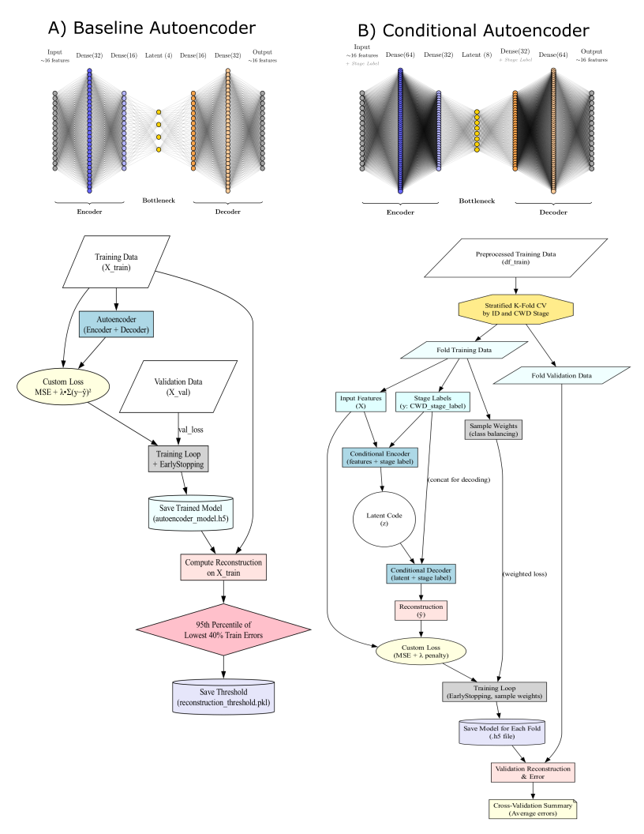
- Unsupervised AutoEncoder B) Conditional AutoEncoder

Figure 1. Workflow for training and obtaining a threshold for behavioral anomaly classification for the a) unsupervised and b) supervised (i.e. conditional) autoencoder.
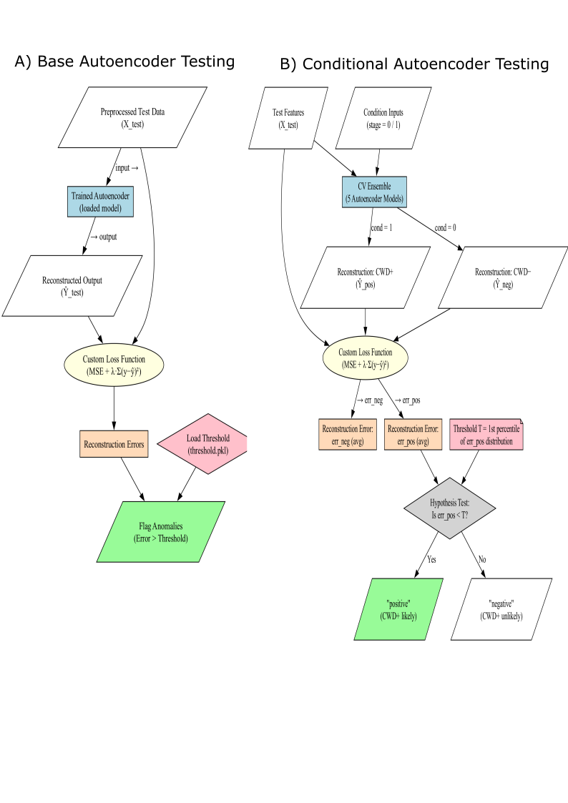
- Unsupervised AutoEncoder B) Conditional AutoEncoder

Figure 2. Workflow for testing the a) unsupervised and b) supervised (i.e. conditional) autoencoder.

Table 1: Summary of location data obtained from mule deer in Wyoming, USA, with the animal ID, sex of the individual, number of relocations, the start and end dates of data, the total number of days included in analyses, the last known CWD status of the animal coded as CWD negative (FALSE) and CWD⁺ positive (TRUE) and the first date where CWD infection was detected.
Deer ID | Sex | # locations | Start date | End date | # days | Last CWD Status | First CWD+ Date
1 | Female | 3855 | 3/1/10 | 11/14/13 | 1354 | TRUE | 2/8/13
2 | Female | 1855 | 3/1/10 | 12/21/11 | 660 | TRUE | 2/18/11
3 | Female | 1000 | 3/1/10 | 2/18/11 | 354 | FALSE | NA
4 | Female | 4035 | 3/1/10 | 2/8/14 | 1440 | FALSE | NA
5 | Female | 381 | 3/1/10 | 8/1/10 | 153 | FALSE | NA
6 | Female | 1494 | 3/1/10 | 8/13/11 | 530 | TRUE | 3/1/10
7 | Female | 3506 | 3/1/10 | 2/8/14 | 1440 | FALSE | NA
8 | Female | 2384 | 3/1/10 | 3/10/12 | 740 | TRUE | 2/10/12
9 | Female | 101 | 3/1/10 | 4/13/10 | 43 | FALSE | NA
11 | Female | 704 | 3/1/10 | 12/1/10 | 275 | TRUE | 3/1/10
12 | Female | 2114 | 3/1/10 | 11/21/11 | 630 | TRUE | 2/19/11
13 | Female | 2283 | 3/1/10 | 4/30/12 | 791 | FALSE | NA
14 | Female | 191 | 3/1/10 | 6/1/10 | 92 | FALSE | NA
15 | Female | 1639 | 3/1/10 | 12/4/11 | 643 | TRUE | 2/19/11
16 | Female | 1471 | 3/1/10 | 12/14/11 | 653 | TRUE | 2/19/11
17 | Female | 3534 | 3/1/10 | 2/8/14 | 1440 | TRUE | 2/8/14
18 | Female | 3699 | 3/1/10 | 2/9/14 | 1441 | TRUE | 2/9/13
19 | Female | 1548 | 3/1/10 | 9/12/11 | 560 | TRUE | 3/1/10
20 | Female | 90 | 3/1/10 | 4/10/10 | 40 | TRUE | 3/1/10
21 | Female | 1924 | 3/1/10 | 4/4/12 | 765 | TRUE | 2/18/11
22 | Female | 441 | 3/1/10 | 9/1/10 | 184 | FALSE | NA
23 | Female | 2799 | 3/1/10 | 2/9/13 | 1076 | TRUE | 2/9/13
24 | Female | 860 | 3/1/10 | 2/19/11 | 355 | TRUE | 2/19/11
25 | Female | 871 | 3/2/10 | 2/26/11 | 361 | TRUE | 3/1/10
26 | Female | 378 | 3/2/10 | 8/1/10 | 152 | FALSE | NA
27 | Female | 793 | 3/2/10 | 2/6/14 | 1437 | FALSE | NA
29 | Female | 509 | 3/2/10 | 9/1/10 | 183 | FALSE | NA
30 | Female | 3483 | 3/2/10 | 2/9/14 | 1440 | TRUE | 2/9/13
31 | Female | 1030 | 3/2/10 | 3/6/11 | 369 | TRUE | 3/6/11
32 | Female | 233 | 3/2/10 | 6/1/10 | 91 | TRUE | 3/2/10
33 | Female | 953 | 3/2/10 | 3/21/11 | 384 | FALSE | NA
34 | Female | 2641 | 3/2/10 | 9/8/12 | 921 | FALSE | NA
35 | Female | 1953 | 3/2/10 | 2/29/12 | 729 | TRUE | 2/19/11
36 | Female | 2861 | 3/2/10 | 1/23/13 | 1058 | TRUE | 2/10/12
37 | Female | 3209 | 3/2/10 | 8/24/12 | 906 | TRUE | 2/11/12
38 | Female | 1167 | 3/2/10 | 4/29/11 | 423 | FALSE | NA
40 | Female | 1032 | 3/2/10 | 2/11/11 | 346 | TRUE | 3/2/10
41 | Male | 1803 | 2/18/11 | 5/16/13 | 818 | FALSE | NA
42 | Female | 2154 | 2/18/11 | 2/8/14 | 1086 | FALSE | NA
43 | Female | 887 | 2/18/11 | 2/11/12 | 358 | FALSE | NA
44 | Female | 111 | 2/18/11 | 4/11/11 | 52 | FALSE | NA
45 | Female | 2911 | 2/18/11 | 2/8/14 | 1086 | FALSE | NA
46 | Male | 186 | 2/18/11 | 5/1/11 | 72 | FALSE | NA
47 | Male | 745 | 2/18/11 | 11/9/11 | 264 | TRUE | 2/18/11
48 | Female | 90 | 2/18/11 | 3/27/11 | 37 | TRUE | 2/18/11
50 | Female | 3034 | 2/18/11 | 2/9/14 | 1087 | FALSE | NA
51 | Female | 1840 | 2/18/11 | 2/8/14 | 1086 | FALSE | NA
53 | Male | 673 | 2/18/11 | 11/15/11 | 270 | TRUE | 2/18/11
55 | Male | 63 | 2/18/11 | 3/18/11 | 28 | FALSE | NA
56 | Female | 2028 | 2/18/11 | 2/9/13 | 722 | FALSE | NA
57 | Female | 1044 | 2/18/11 | 5/14/13 | 816 | TRUE | 2/11/12
58 | Male | 666 | 2/18/11 | 10/19/11 | 243 | TRUE | 10/19/11
60 | Female | 1607 | 2/18/11 | 10/27/12 | 617 | FALSE | NA
61 | Female | 1525 | 2/18/11 | 11/14/12 | 635 | TRUE | 2/10/12
62 | Female | 788 | 2/18/11 | 12/4/11 | 289 | TRUE | 2/18/11
64 | Female | 1407 | 2/18/11 | 12/11/12 | 662 | TRUE | 2/11/12
65 | Female | 1262 | 2/18/11 | 4/3/13 | 775 | TRUE | 2/11/12
66 | Female | 832 | 2/19/11 | 12/24/11 | 308 | FALSE | NA
67 | Female | 1965 | 2/19/11 | 3/7/13 | 747 | TRUE | 2/10/12
68 | Female | 1999 | 2/19/11 | 2/9/13 | 721 | TRUE | 2/10/12
69 | Female | 2206 | 2/19/11 | 6/11/13 | 843 | TRUE | 2/11/12
70 | Male | 2756 | 2/19/11 | 2/8/14 | 1085 | TRUE | 2/8/14
71 | Female | 2074 | 2/19/11 | 3/3/13 | 743 | TRUE | 2/10/12
72 | Female | 2904 | 2/19/11 | 2/9/14 | 1086 | TRUE | 2/9/14
73 | Male | 643 | 2/19/11 | 10/22/11 | 245 | TRUE | 2/19/11
74 | Female | 703 | 2/19/11 | 10/28/11 | 251 | TRUE | 2/19/11
76 | Female | 1502 | 2/11/12 | 2/8/14 | 728 | FALSE | NA
77 | Female | 2026 | 2/11/12 | 2/8/14 | 728 | FALSE | NA
78 | Female | 1817 | 2/11/12 | 2/8/14 | 728 | FALSE | NA
79 | Female | 1771 | 2/10/12 | 2/8/14 | 729 | TRUE | 2/8/13
80 | Male | 134 | 2/10/12 | 4/4/12 | 54 | TRUE | 2/10/12
81 | Male | 826 | 2/10/12 | 12/11/12 | 305 | FALSE | NA
82 | Female | 2103 | 2/10/12 | 2/8/14 | 729 | FALSE | NA
83 | Female | 2424 | 2/11/12 | 12/9/13 | 667 | TRUE | 2/8/13
84 | Female | 1033 | 2/11/12 | 2/10/13 | 365 | FALSE | NA
88 | Male | 1411 | 2/10/12 | 2/8/14 | 729 | FALSE | NA
89 | Female | 2042 | 2/10/12 | 2/9/14 | 730 | FALSE | NA
90 | Male | 1943 | 2/10/12 | 2/8/14 | 729 | TRUE | 2/8/13
91 | Female | 2170 | 2/11/12 | 2/5/14 | 725 | TRUE | 2/9/13
92 | Male | 926 | 2/10/12 | 1/4/13 | 329 | TRUE | 2/10/12
93 | Male | 1986 | 2/11/12 | 2/9/14 | 729 | TRUE | 2/9/13
94 | Male | 709 | 2/11/12 | 10/18/12 | 250 | TRUE | 10/18/12
95 | Female | 534 | 2/10/12 | 8/4/12 | 176 | FALSE | NA
96 | Female | 1887 | 2/11/12 | 1/23/14 | 712 | TRUE | 2/9/13
99 | Female | 1138 | 2/11/12 | 2/8/14 | 728 | FALSE | NA
100 | Female | 1866 | 2/11/12 | 2/8/14 | 728 | FALSE | NA
102 | Female | 2072 | 2/10/12 | 2/9/14 | 730 | TRUE | 2/9/13
104 | Female | 1237 | 3/25/12 | 5/6/13 | 407 | FALSE | NA
105 | Female | 590 | 3/25/12 | 10/27/12 | 216 | TRUE | 3/25/12
107 | Male | 532 | 3/25/12 | 11/23/12 | 243 | TRUE | 3/25/12
108 | Female | 736 | 3/25/12 | 12/31/12 | 281 | FALSE | NA
109 | Female | 1020 | 2/8/13 | 2/8/14 | 365 | FALSE | NA
111 | Female | 712 | 2/8/13 | 2/8/14 | 365 | FALSE | NA
113 | Female | 1041 | 2/8/13 | 2/8/14 | 365 | TRUE | 2/8/14
114 | Female | 957 | 2/8/13 | 2/8/14 | 365 | TRUE | 2/8/14
115 | Female | 997 | 2/8/13 | 2/8/14 | 365 | FALSE | NA
116 | Male | 797 | 2/8/13 | 2/9/14 | 366 | TRUE | 2/8/13
118 | Female | 110 | 2/8/13 | 3/25/13 | 45 | FALSE | NA
119 | Female | 825 | 2/8/13 | 2/8/14 | 365 | FALSE | NA
120 | Male | 73 | 2/8/13 | 3/12/13 | 32 | FALSE | NA
121 | Female | 898 | 2/8/13 | 2/8/14 | 365 | TRUE | 2/8/14
122 | Female | 144 | 2/8/13 | 4/7/13 | 58 | TRUE | 2/8/13
124 | Female | 901 | 2/8/13 | 2/8/14 | 365 | FALSE | NA
125 | Female | 90 | 2/8/13 | 3/10/13 | 30 | TRUE | 2/8/13
129 | Female | 322 | 2/9/13 | 6/5/13 | 116 | FALSE | NA
130 | Female | 1004 | 2/9/13 | 2/8/14 | 364 | TRUE | 2/8/14
141 | Male | 628 | 2/25/13 | 10/15/13 | 232 | TRUE | 10/15/13

Table 2: Logistic regression model results including model coefficients, standard errors, z-values and p-values, for movement metrics between CWD- and CWD+ mule deer, Wyoming, USA.
Movement Metric | Coefficient | Standard Error | z-value | p-value
Velocity | 5.19 | 4.65 | 1.12 | 0.26
Absolute Relative Angle | -1.94 | 1.78 | -1.09 | 0.28
Sinuosity | -1.01 | 0.72 | -1.40 | 0.16
Rolling Absolute Relative Angle Mean | 2.66 | 2.06 | 1.29 | 0.20
Rolling Absolute Relative Angle Standard Deviation | 0.31 | 0.45 | 0.70 | 0.48
Rolling Absolute Relative Angle Skew | 1.42 | 1.52 | 0.93 | 0.35
Rolling Absolute Relative Angle Kurtosis | 0.90 | 0.64 | 1.40 | 0.16
Rolling Velocity Mean | -3.71 | 5.51 | -0.67 | 0.50
Rolling Velocity Standard Deviation | -1.19 | 1.97 | -0.60 | 0.55
Rolling Velocity Skew | -3.50 | 1.94 | -1.81 | 0.07
Rolling Velocity Kurtosis | 3.08 | 1.92 | 1.61 | 0.11
AKDE low 95% | 0.22 | 6.76 | 0.03 | 0.97
AKDE median | -2.75 | 12.43 | -0.22 | 0.82
AKDE high 95% | 2.56 | 6.41 | 0.40 | 0.70
Summer season | 0.14 | 0.37 | 0.36 | 0.72

