Multi-scale analysis of spatial drivers in wild boar space use at a biweekly scale across landscape patterns and step selection - Supplementary information

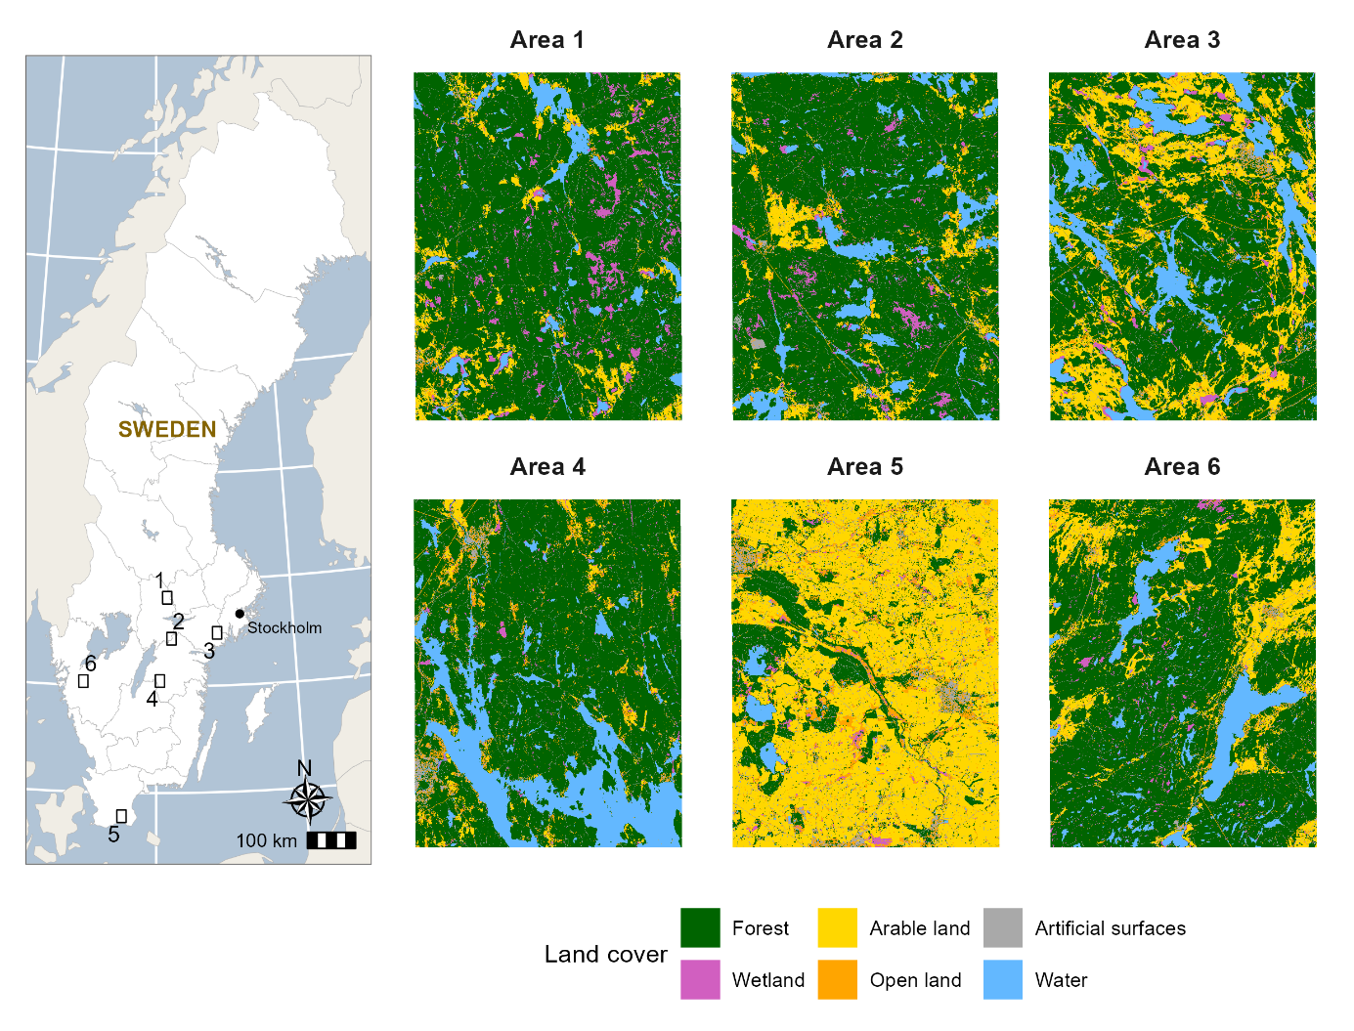
Figure S1. Map of the study area in southern and central Sweden, showing the spatial distribution of the six selected study sites (Areas 1–6). The right panels illustrate the detailed landscape composition and land cover classes (Forest, Arable land, Artificial surfaces, Wetland, Open land, and Water) within each corresponding site.

Construction of spatial-weight matrices and model selection procedures
A. Spatial-weight matrix construction
To characterize spatial relationships among AKDE-derived space-use polygons, we constructed a series of spatial-weight matrices (W) based on Euclidean distances between representative points located within each polygon. Representative points were generated using a point-on-surface algorithm to ensure they fell within polygon boundaries and avoided biases associated with geometric centroids. This approach ensured a consistent spatial reference for distance calculations across irregular polygon geometries.
For distance thresholds ranging from 1–20 km, pairs of polygons with inter-point distances ≤ threshold were defined as neighbours. Observations from the same individual or from different weeks were excluded to maintain biological realism, and self-links were removed. To retain isolated polygons and avoid numerical issues, units without neighbours were assigned a spatial lag value of zero. Network connectivity (proportion of polygons with ≥ 1 neighbour) was calculated for each threshold to characterize spatial structure.
B. OLS models and LM diagnostics
For each W matrix, we fitted an ordinary least squares (OLS) model and applied Lagrange Multiplier (LM) and robust LM tests to diagnose the presence and type of spatial dependence [1]. These diagnostics distinguished between omitted spatial processes (error dependence) and endogenous spatial lag dependence in the response variable. The results consistently indicated the presence of both forms of spatial dependence, motivating the use of a model capable of capturing both endogenous and exogenous indirect spatial effects.
C. Spatial Durbin model specification
Based on diagnostic outcomes, we selected the spatial Durbin model, which accommodates spatial dependence in both the dependent variable and the covariates [2]. The specific form was:
$$y=ρWy+Xβ+WXθ +ε, ε \sim N(0, σ^{2}I)$$
where y is the vector of AKDE-derived space-use areas, X is the matrix of explanatory variables, and W is the spatial-weight matrix. The term Wy represents endogenous spatial lag (indirect effect in the response) while WX represents spatially lagged covariates (exogenous indirect effect). The parameter ρ measures strength and direction of endogenous dependence, and θ captures influence of neighbouring covariates.
This formulation allows decomposition of covariate effects into direct (within-area) and indirect (neighbourhood) components.
D. Model comparison and final selection
For each W matrix, the Durbin models were estimated and evaluated using Akaike information Criterion (AIC) values, Moran’s I of residuals [3]. We also examined key spatial parameters, including the spatial lag coefficient ρ, to assess the magnitude and direction of indirect spatial effects. The optimal distance threshold and final model specification were selected based on a multi-criteria approach, prioritising models with the lowest AIC and non-significant Moran’s I of residuals, while also ensuring stability and ecological interpretability of estimated indirect spatial effects
E. Effect estimation
For the selected Durbin model, we conducted Monte Carlo simulations with 1,000 replications to quantify uncertainty in the decomposition of direct, indirect, and total effects. In each replication, effect estimates were recalculated based on simulated parameter draws from the estimated variance–covariance matrix of the Durbin model [4]. We assessed statistical significance at the 5% level (p < 0.05).

References
1.Anselin L, Florax R, Rey SJ. Advances in spatial econometrics: methodology, tools and applications. Springer Science & Business Media; 2013.
2. Elhorst JP, others. Spatial econometrics: from cross-sectional data to spatial panels. Springer; 2014.
3. Moran PAP. Notes on continuous stochastic phenomena. Biometrika. JSTOR; 1950;37:17–23.
4. LeSage J, Pace RK. Introduction to spatial econometrics. Chapman and Hall/CRC; 2009.

