Why sharks gather: seasonal residency and thermal responses at coastal infrastructure in the eastern Mediterranean Sea

Supplementary information: Acoustic design

This study used acoustic telemetry to monitor shark presence across a network of monitoring sites along the Israeli coastline. We used four transmitter models (V16-6H, Innovasea Canada; T-HP16, D-HP16, and ID-HP16, Thelma Biotel, Norway) incorporating temperature and depth sensors, each with different detection limits (Table 1, main text), and three receiver models (VR2W, Innovasea, Canada; TBR-700, and TBR-800, Thelma Biotel, Norway).
- Study design
Monitored sites ranged from hard and soft substrate environments representing natural habitats to coastal and offshore infrastructure known to host seasonal aggregations of sharks, including multiple power stations and fish farms (Table S1; Fig. 1, main text). Notably, the shallow depth, strong turbulence, and high density of underwater structures around the core fieldwork area, the Orot-Rabin power and desalination station in Hadera, have previously been shown to represent highly reverberant conditions, posing significant challenges for acoustic telemetry. We conducted a series of field experiments aimed at mitigating the proportion of failed detections due to transmission loss or ID code disruption (i.e., false negatives) and tested multiple data filtering scenarios to identify and reject records of non-existent or non-present tags (i.e., false positives).
Table S1: Overview of acoustic receiver deployment locations along the Israeli Mediterranean coastline, categorised by habitat type.
Habitat type | Category | Site | Depth (metres) | Lat (°N) | Lon (°E)
Natural | Hard substrate (rocky reef) | Akhziv | 45 | 33.088533 | 35.07717
Natural | Hard substrate (rocky reef) | Akhziv | 25 | 33.034 | 35.071
Natural | Hard substrate (rocky reef) | Jisr al-Zarka | 45 | 32.530611 | 34.85369
Natural | Soft substrate (sediment) | Gaash | 30 | 32.2371 | 34.7889
Natural | Soft substrate (sediment) | Hertseliya | 27 | 32.177693 | 34.77799
Human-altered | Fish farm | Ashdod | 16 (bottom: 80) | 31.89714 | 34.53434
Human-altered | Fish farm | Mikhmoret | 35 | 32.41375 | 34.83756
Human-altered | Power station | Ashdod | 12 | 31.85794 | 34.65491
Human-altered | Power station | Ashqelon | 8 | 31.635599 | 34.51267
Human-altered | Power station | Hadera | 11 | 32.466197 | 34.87518
Human-altered | Power station | Hadera | 9 | 32.462625 | 34.87563
Human-altered | Power station | Hadera | 7 | 32.464978 | 34.87814
Human-altered | Power station | Hadera | 6 | 32.460806 | 34.8775
Human-altered | Power station | Hadera | 8 | 32.463528 | 34.87233
Human-altered | Power station | Sdot-Yam | 5 | 32.5306 | 34.8537

  - Effective detection range and site delineation:
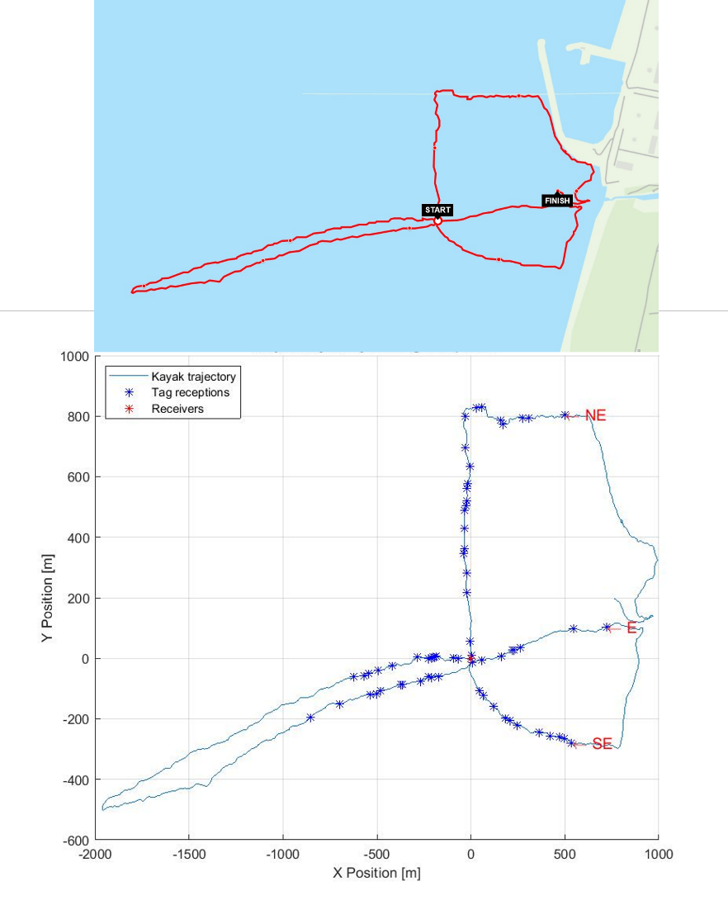
To optimise the design of our array, we performed two types of acoustic experiments. First, we moored a vertical line with three acoustic receivers (VR2W, Vemco, Canada, n = 1; TBR-700, Thelma Biotel, Norway, n = 2) at a bottom depth of 12 m and towed four transmitters alongshore and perpendicular to the isobaths by kayak. In the next step, we recovered the receivers, offloaded the data, and projected all positions from which tag transmissions were received along the kayak’s route (Fig. S1). For records logged on the TBR-700 receiver, we plotted the relationship between the signal-to-noise ratio (SNR) and the kayak’s distance from the mooring to infer the optimal spacing between receivers.
Figure S1: Experimental setup for acoustic range testing on December 25, 2018. Top: Kayak trajectory during tow tests with four acoustic tags alongshore and across the thermal plume. Bottom: Projected tag reception positions (blue asterisks) relative to kayak path (blue line) and receiver locations (red asterisks) on a vertical mooring deployed at 12 m depth, equipped with one VR2W and two TBR-700 receivers.

We observed successful detections up to 500 m and 950 m by the VR2W and TBR-700 receivers, respectively (Fig. S2). However, the latter presented a non-monotonic relationship between range and SNR at distances greater than 450 m. Therefore, we used this range as the maximum distance for the spacing of adjacent receivers in the following steps. Additionally, we found that sharks were not detected close to the warm effluents or in very shallow water (SNR < 9 dB; depth < 4 m). Therefore, the second experiment focused on the delineation of an area around the plume with a sufficiently high detection probability (> 0.5) to ensure that the sharks would be recorded upon arrival to or departure from the aggregation site.
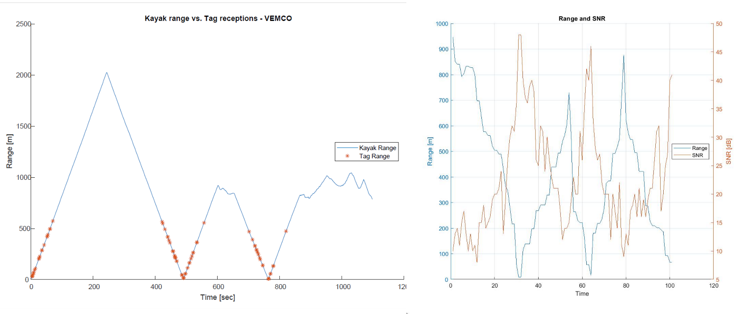
Figure S2: Acoustic range testing results used to inform receiver spacing and array design. Left: Tag detection distances (red asterisks) from the VR2W receiver plotted against kayak distance over time. Right: Relationship between signal-to-noise ratio (SNR, orange) and distance (blue) for detections on a TBR-700 receiver.

Here, we deployed transmitters at known locations and depths for 60-minute durations and calculated the proportion of transmissions each receiver detected. We then mapped these proportions to visualise fine-scale differences in receiver performance across the array (Fig. S3). We selected a design that ensured a detection probability exceeding 50% along the entire periphery of the aggregation area within the thermal outfall, while maximising seaward coverage. This experiment informed the long-term positioning of our acoustic receiver array.

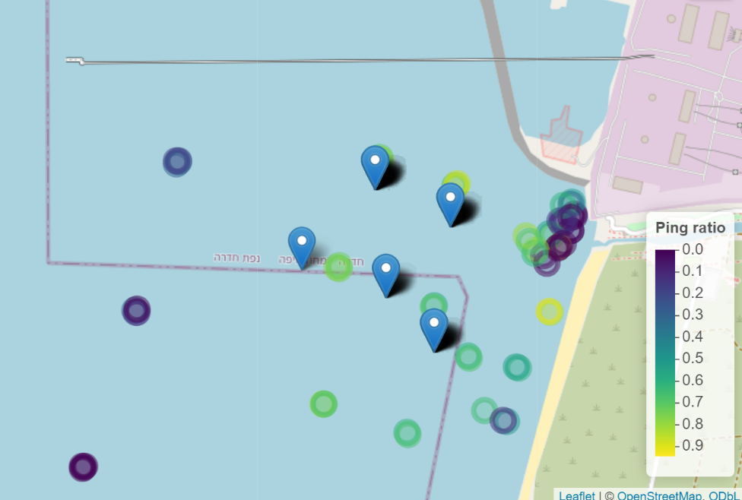
  - Post-processing:
Figure S3: Results of the fixed-location transmission experiments conducted around the Hadera thermal outfall on January 4-5 and 7-8, 2021. Blue pins represent receiver locations. Coloured circles indicate the detection ratio at each transmitter deployment point, calculated as the proportion of transmitted signals successfully detected by nearby receivers. Lower ratios are shown in darker purple and higher ratios in yellow.

We considered daily shark detections as the primary observation units for our acoustic analysis, necessitating a robust filtering process to distinguish true biological presence from false positives at a 24-hour resolution. To define an appropriate minimum threshold for valid detections per day, we examined the distribution of daily detection counts under increasingly stringent criteria – requiring one, two, or three detections per 24-hour period. To mitigate the risk of discarding biologically meaningful but sparse detections – such as those arising when sharks entered areas of limited receiver coverage or low signal-to-noise ratio (SNR) after moving too swiftly through higher-coverage zones – we implemented a secondary temporal filter. This criterion allowed days falling below the daily threshold to be retained if they occurred within a defined window (buffer) of surrounding valid detection days. We tested buffer durations ranging from ±1 to ±10 days, assessing multiple combinations of detection thresholds and temporal windows.
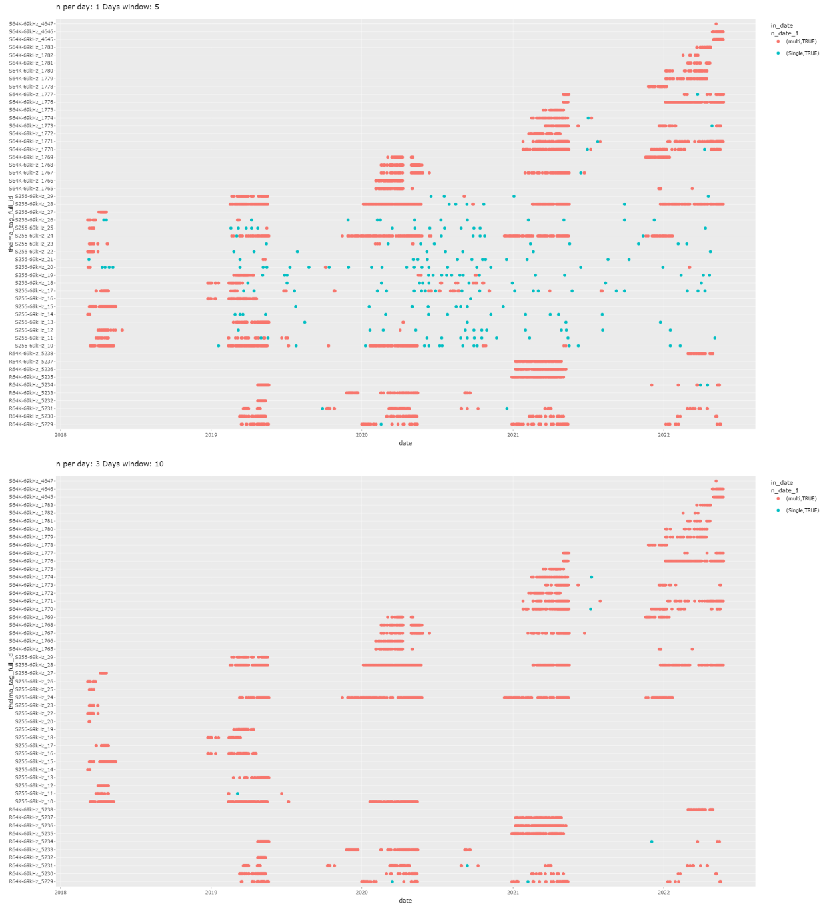
To evaluate performance, we plotted and visually assessed the spatio-temporal distribution of retained detections under each scenario, distinguishing “multi-day” detections embedded in broader periods of presence from “isolated” detections likely reflecting noise (Fig. S4). These plots were interpreted in the context of known seasonal aggregation patterns, allowing us to balance exclusion of artefacts with retention of ecologically plausible records. Based on this analysis, we selected a final filtering scheme requiring ≥ 3 detections per day, with a ±10-day buffer. This combination most effectively removed scattered single-day outliers between seasonal peaks while retaining likely true-positive events at the start or end of aggregations – periods where detection rates tend to be low. The resulting data set offered a biologically defensible basis for presence–absence inference in subsequent analyses.
Figure S4: Comparison of daily shark detections retained under different filtering thresholds. Each row represents an individual acoustic tag, with days classified as either multi-day detections (red bars) or isolated detections (blue dots) based on surrounding context. Top panel: Threshold of ≥1 detection per day with a ±5-day buffer. Bottom panel: Threshold of ≥ 3 detections per day with a ±10-day buffer (final selected filtering scenario). The stricter criteria in the bottom panel effectively reduce isolated detections occurring between seasonal presence periods while preserving the integrity of extended aggregation events.

- Telemetry data analysis:
This section outlines two methodological issues encountered during data processing and the approaches used to mitigate their potential impacts. The first relates to the variable availability of acoustic receivers and differences in transmitter–receiver compatibility, which introduced individual-level heterogeneity in detection effort. The second addresses the technical limitations of temperature sensors embedded in acoustic tags, which imposed upper bounds on recorded body temperatures. We describe how each issue was handled in the analysis and provide justification for the chosen corrections.

  - Protocol compatibility and monitoring effort:
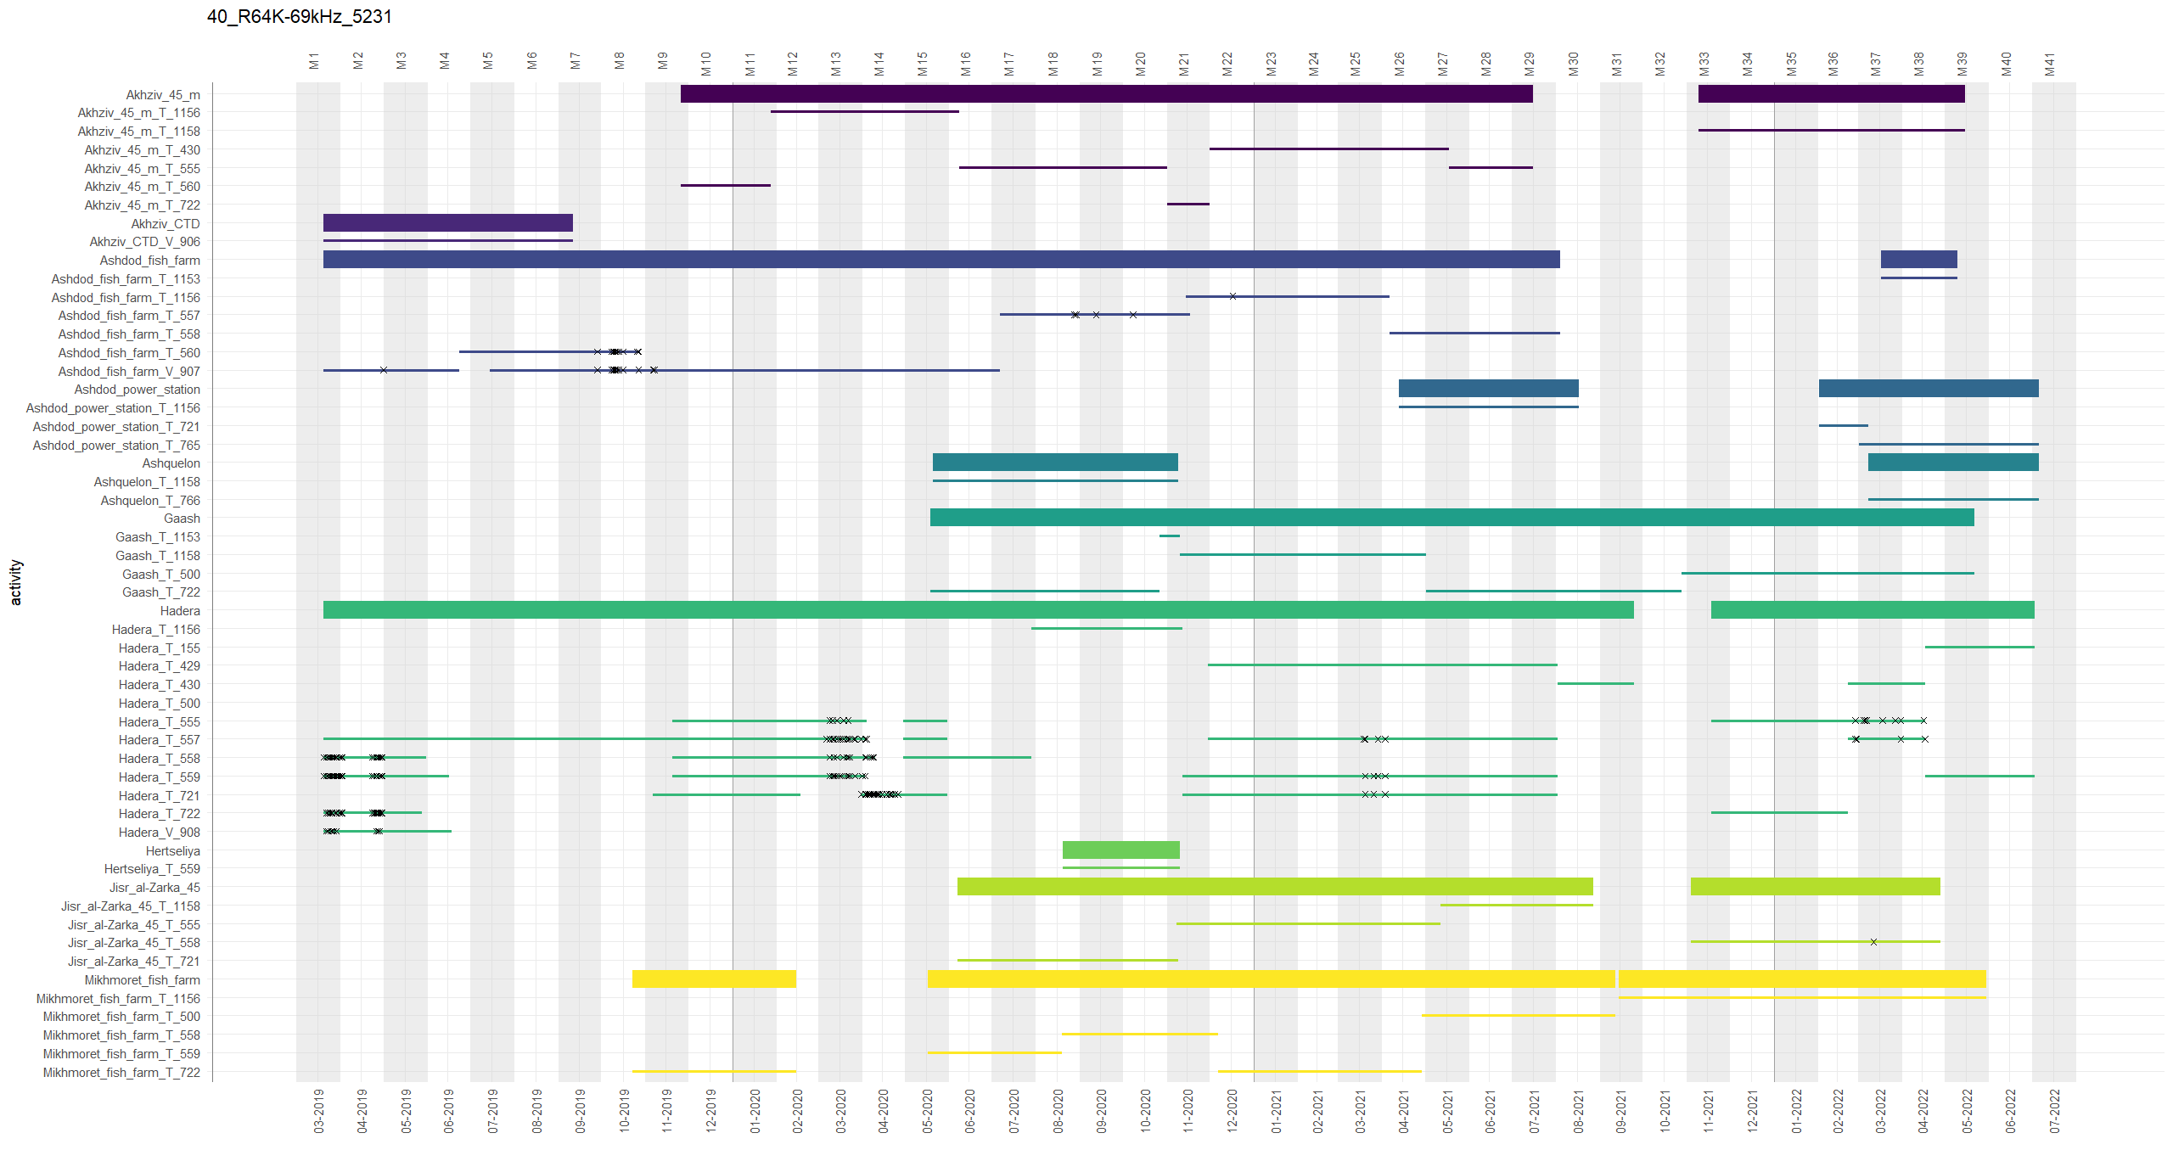
For TBR receivers, the ability to detect a shark’s transmitter depended on the compatibility of their factory-set communication protocols. As a result, monitoring effort varied across time, sites, and individuals. To account for this, we determined receiver availability and shark presence on a per-individual basis, covering the period from tagging until either transmitter battery expiration or mortality (Fig. S5).
Figure S5: Monitoring effort for one example shark (Carcharhinus obscurus, male), illustrating individual-level variation in acoustic coverage across space and time. Thick horizontal bars represent cumulative monitoring effort at each site (aggregated across all receivers), while thinner bars of the same colour indicate the deployment periods of individual receivers. Black Xs along the bars mark days on which the shark was detected. Vertical grey bands denote monthly intervals. This plot is also referenced in the main text as an example of interannual site fidelity to the core fieldwork area and of movement between sites across the broader study region.
Sensor limitations and correction strategy:
The acoustic transmitters incorporating a temperature sensor had a measurement limitation of 25.5°C or 35°C (n = 8 and n = 19, respectively; Table 1). Therefore, when a shark’s core body temperature exceeded its transmitter’s limitation, the latter value was logged. In the plot depicting the sharks’ monthly mean core body temperature relative to the monthly mean ambient seawater temperature (Fig. 5, main text), observations recorded as 25.5°C were flagged as likely erroneous. Where these records were less than the 95th percentile of ambient temperatures (calculated from stationary receiver data for the corresponding month), they were replaced by the 95th percentile value. This conservative approach ensures biologically plausible maximum temperature exposure is reflected while avoiding overestimation.
To address this issue in the models predicting the effect of variables on the sharks’ core body temperature during separate visits to the site (main text, Table 2), we conducted a sensitivity analysis by refitting the linear mixed-effects models after removing capped temperature measurements (i.e., values recorded at 25.5°C or 35°C). The results remained consistent with the full dataset, with only minor differences in parameter estimates. Ambient seawater temperature remained the strongest predictor of core body temperature (followed by time from visit onset), and species differences persisted (Figure S6). The stability of the findings suggests that the presence of capped values did not significantly bias the analysis. Supporting this statement, the transmitters limited to 35°C measured a maximum value of 27.3°C, and the highest seawater temperature we recorded upon gear deployment in the plume, using the YSI Pro30 Conductivity Meter, was 26.7°C. These observations suggest that sharks residing at the core fieldwork area did not experience significantly higher temperatures than the maximum values recorded.
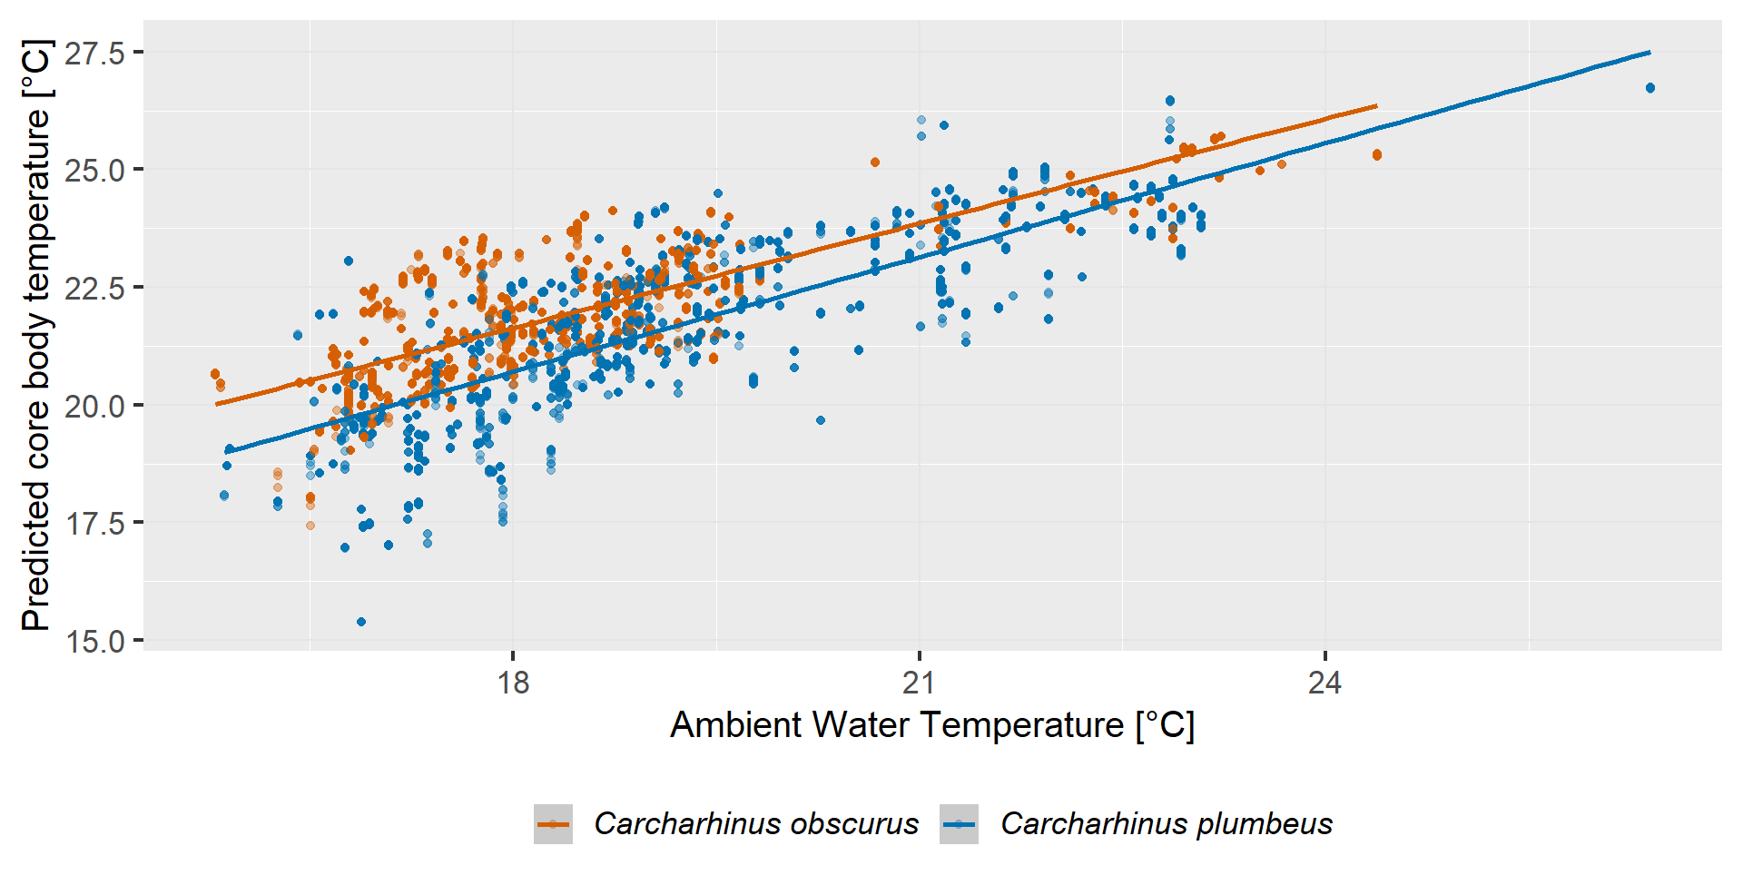
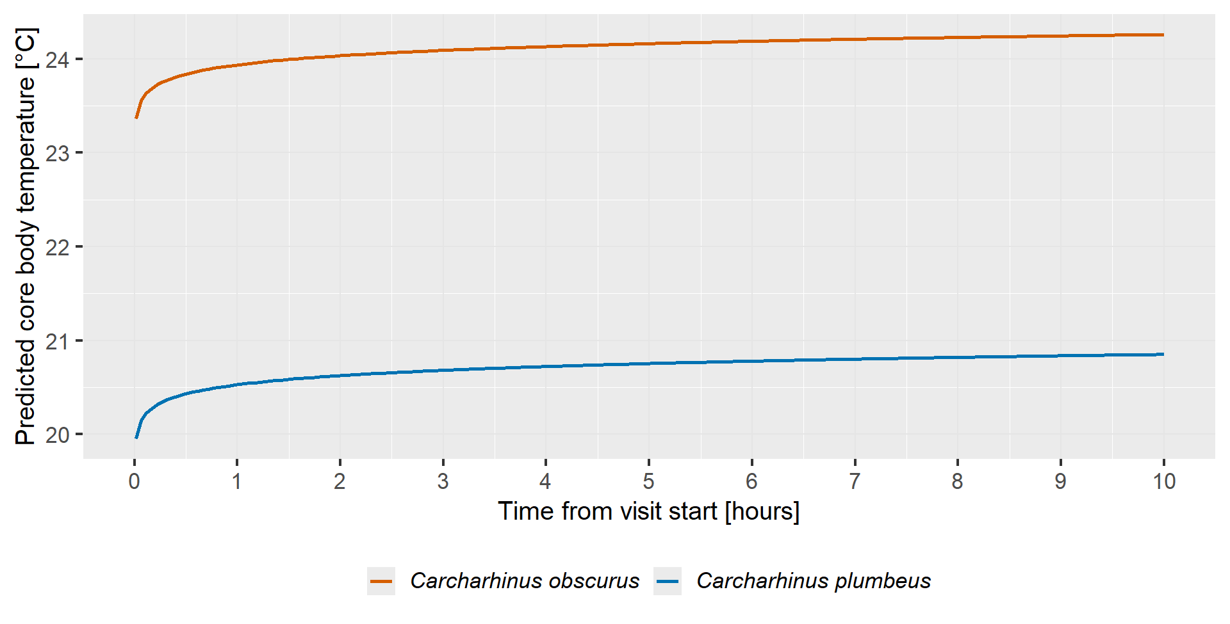
Figure S6: Fixed-effect predictions of core body temperature in relation to ambient seawater temperature and time since visit onset in two shark species. Top panel: Relationship between ambient water temperature and predicted core body temperature for Carcharhinus obscurus and C. plumbeus. Points represent individual observations, and the regression line with confidence intervals (shaded) illustrates the overall trend. Core body temperature increases with ambient temperature, but individual variation is evident. Bottom panel: Predicted effect of time since visit onset on core body temperature, with ambient temperature and body size fixed at their mean values. Lines show species-specific predictions from the mixed-effects model.

