Supplementary Materials

Title: Multiscale feeding ground fidelity in a migratory marine predator revealed by integrating satellite telemetry and stable isotopes

Authors:
Leena Riekkola^{1,*,} ‡, Geraldine Busquets-Vass^{2,3}, Virginia Andrews-Goff⁴, Rosalind Cole⁵, Rochelle Constantine^{1,6}, Solène Derville^{7,8}, David Lundquist⁵, Catherine E. Meyer¹, Mike Ogle⁵, Christopher J. Somes⁹, Alexandre N. Zerbini^{10,11,12,13}, Seth D. Newsome^{3,†}, Emma L. Carroll^{1,*, †}

Affiliations:
- School of Biological Sciences, University of Auckland – Waipapa Taumata Rau, Auckland, Aotearoa, New Zealand
- Laboratorio de Macroecología Marina, Centro de Investigación Científica y Educación Superior de Ensenada, Unidad Académica La Paz, La Paz BCS, México
- Biology Department, University of New Mexico, Albuquerque, NM, USA
- Australian Antarctic Division, Department of Climate Change, Energy, the Environment and Water, Kingston, Australia
- New Zealand Department of Conservation, Te Papa Atawhai, Wellington, New Zealand
- Institute of Marine Science, University of Auckland – Waipapa Taumata Rau, Auckland, Aotearoa, New Zealand
- UMR ENTROPIE (IRD-Université de La Réunion-CNRS-Ifremer-Université de Nouvelle-Calédonie), Noumea, New Caledonia
- Association Opération Cétacés, Noumea, New Caledonia
- GEOMAR Helmholtz Centre for Ocean Research, Kiel, Germany
- Marine Mammal Laboratory, Alaska Fisheries Science Center, National Marine Fisheries Service, National Oceanic and Atmospheric Administration, Seattle, WA 98115, USA
- Cooperative Institute for Climate, Ocean and Ecosystem Studies, University of Washington, Seattle, WA, USA
- Marine Ecology and Telemetry Research, Seabeck, WA, USA
- Mammal Research Institute, University of Pretoria, South Africa

* corresponding authors: LR: lrie003@aucklanduni.ac.nz; ELC: e.carroll@auckland.ac.nz
‡ current address: Departament de Biologia Evolutiva, Ecologia i Ciències Ambientals, Universitat de Barcelona, 08028 Barcelona, Spain
† SDN and ELC should both be considered as senior authors

Supplementary Table S1. Satellite tracking metadata for 12 southern right whales that had tracks of sufficient duration to identify feeding-ground movements, as well as biopsy samples with successful isotope measurements. All whales were tagged at Auckland Islands, New Zealand.
Date of tag deployment and last location = format as dd/mm/yyyy.
Track duration = from deployment to last location, calculations took into account the different time zones of deployment and last location.
No. of SSM locations = state=space model (SSM) locations remaining after various filtering steps, including exclusion of locations with Z quality class and a speed filter of 5 m/s.
No. of gaps >36h = gap duration rounded to the nearest hour. Tracks were segmented if a data gap was >36h to avoid interpolating over large distances.
No. of segments removed = track segments of <50 locations were removed. The number(s) in brackets indicate the number of locations in the segments that were removed.
% of ARS (area restricted search) vs transit locations = Note for interpretation: these values include locations that occurred at the Auckland Islands winter breeding grounds where ARS is unlikely to represent foraging. Due to data gaps, some individuals may have had very few locations in a given year, and if these were of a particular behavioural class that may have caused high % values for that year. We recommend these values be interpreted together with Figure 2 (main text) and Supplementary Figure S1.

PTT  (tag id) | Date of tag deployment  (local time) | Date of last location  (UTC) | Track duration  (days) | No. of raw Argos locations  (by year) | No. of SSM locations  (by year) | No. of gaps >36h  (gap duration, h) | No. of segments removed  (locations removed) | % of ARS vs transit locations
203574 | 17/08/2020 | 2/09/2021 | 382 | 1982 (2020)  6377 (2021) | 1444 (2020)  4427 (2021) | none | none | 27% ARS, 73% transit (2020)  20% ARS, 80% transit (2021)
215259 | 16/07/2021 | 2/11/2021 | 109 | 1046 (2021) | 746 (2021) | 3 (49, 40, 207) | 1 (17) | 8% ARS, 92% transit (2021)
215262 | 17/07/2021 | 15/12/2022 | 516 | 502 (2021)  1089 (2022) | 316 (2021)  717 (2022) | 18 (1055, 208, 3952, 51, 49, 141, 255, 72, 99, 47, 206, 56, 59, 46, 73, 127, 48, 48) | 16 (37, 30, 8, 6, 29, 1, 19, 7, 20, 8, 12, 11, 4, 17, 4, 5) | 0% ARS, 100% transit (2021)  23% ARS, 77% transit (2022)
215258 | 17/07/2021 | 15/03/2023 | 607 | 2012 (2021)  532 (2022)  585 (2023) | 1416 (2021)  357 (2022)  343 (2023) | 15 (59, 55, 70, 1176, 36, 3539, 119, 874, 544, 60, 1274, 529, 95, 428, 66) | 11 (14, 2, 1, 47, 34, 8, 9, 5, 3, 9, 34) | 68% ARS, 32% transit (2021)  71% ARS, 29% transit (2022)  61% ARS, 39% transit (2023)
215263 | 21/07/2021 | 7/01/2022 | 171 | 2188 (2021)  79 (2022) | 1494 (2021)  64 (2022) | none | none | 45% ARS, 55% transit (2021)  36% ARS, 64% transit (2022)
46950 | 21/07/2021 | 18/04/2022 | 272 | 2444 (2021)  1622 (2022) | 1730 (2021)  1176 (2022) | none | none | 41% ARS, 59% transit (2021)  25% ARS, 75% transit (2022)
235400 | 7/07/2022 | 13/09/2022 | 68 | 384 (2022) | 283 (2022) | 3 (186, 46, 36) | 3 (7, 3, 1) | 20% ARS, 80% transit (2022)
235402 | 8/07/2022 | 2/11/2022 | 118 | 993 (2022) | 767 (2022) | 1 (49) | none | 28% ARS, 72% transit (2022)
235401 | 10/07/2022 | 22/04/2023 | 287 | 2272 (2022)  1399 (2023) | 1666 (2022)  985 (2023) | 2 (36, 45) | 2 (4, 2) | 20% ARS, 80% transit (2022)  49% ARS, 51% transit (2023)
197853 | 11/07/2022 | 26/09/2023 | 442 | 2678 (2022)  4772 (2023) | 1898 (2022)  3490 (2023) | 2 (105, 46) | 1 (4) | 23% ARS, 77% transit (2022)  48% ARS, 52% transit (2023)
235399 | 11/07/2022 | 8/07/2023 | 362 | 1767 (2022)  1916 (2023) | 1240 (2022)  1254 (2023) | 7 (36, 58, 371, 155, 184, 532, 360) | 6 (3, 3, 4, 20, 13, 19) | 32% ARS, 68% transit (2022)  92% ARS, 8% transit (2023)
208742 | 12/07/2022 | 18/10/2022 | 98 | 819 (2022) | 563 (2022) | 2 (108, 40) | 2 (6, 30) | 51% ARS, 49% transit (2022)

Supplementary Table S2. Summary of isotope results for 12 southern right whales that had tracks of sufficient duration to identify feeding-ground movements, as well as biopsy samples with successful isotope measurements. All whales were tagged at Auckland Islands, New Zealand. PTT = unique tag number. Sample date is dd/mm/yyyy (local time).
PTT | Sampling date | Sample ID | δ13C (‰) | δ15N (‰) | %C (wt.) | %N (wt.) | C:N
203574 | 17/08/2020 | Eau20AI196 | -20.1 | 6.4 | 46.1 | 14.4 | 3.2
215259 | 16/07/2021 | Eau21AI135 | -18.0 | 9.6 | 46.0 | 14.1 | 3.3
215262 | 17/07/2021 | Eau21AI143 | -19.9 | 5.9 | 44.9 | 14.5 | 3.1
215258 | 17/07/2021 | Eau21AI144 | -18.0 | 9.5 | 44.8 | 14.7 | 3.1
215263 | 21/07/2021 | Eau21AI251 | -18.9 | 8.7 | 46.8 | 14.9 | 3.1
46950 | 21/07/2021 | Eau21AI252 | -18.6 | 7.9 | 46.2 | 14.5 | 3.2
235400 | 7/07/2022 | Eau22AI020 | -18.1 | 8.6 | 47.2 | 15.1 | 3.1
235402 | 8/07/2022 | Eau22AI022 | -19.0 | 9.4 | 45.2 | 14.0 | 3.2
235401 | 10/07/2022 | Eau22AI054 | -19.4 | 9.0 | 46.7 | 13.2 | 3.5
197853 | 11/07/2022 | Eau22AI061 | -19.4 | 8.3 | 46.6 | 13.8 | 3.4
235399 | 11/07/2022 | Eau22AI062 | -19.3 | 8.3 | 46.8 | 13.8 | 3.4
208742 | 12/07/2022 | Eau22AI085 | -19.3 | 7.8 | 47.8 | 15.2 | 3.1

Supplementary Figure S1. Feeding ground assignment and satellite tracks for tagged and biopsy sampled southern right whales not shown in Figure 1 (main text). Individual maps are provided for each whale (unique tag/PTT number). Blue colours show the 50th, 75th and 90th percentile probability of feeding ground origin based on isotope assignment. Light beige and dark brown tracks indicate the first and second year of tracking data, respectively, for an individual whale where available. Beige and brown dots indicate area restricted search (ARS; feeding) behaviour identified by state-space modelling. Track lines are speed filtered data due to data gaps in state-space modelled data. Dotted track lines indicate gaps in satellite tracking data.
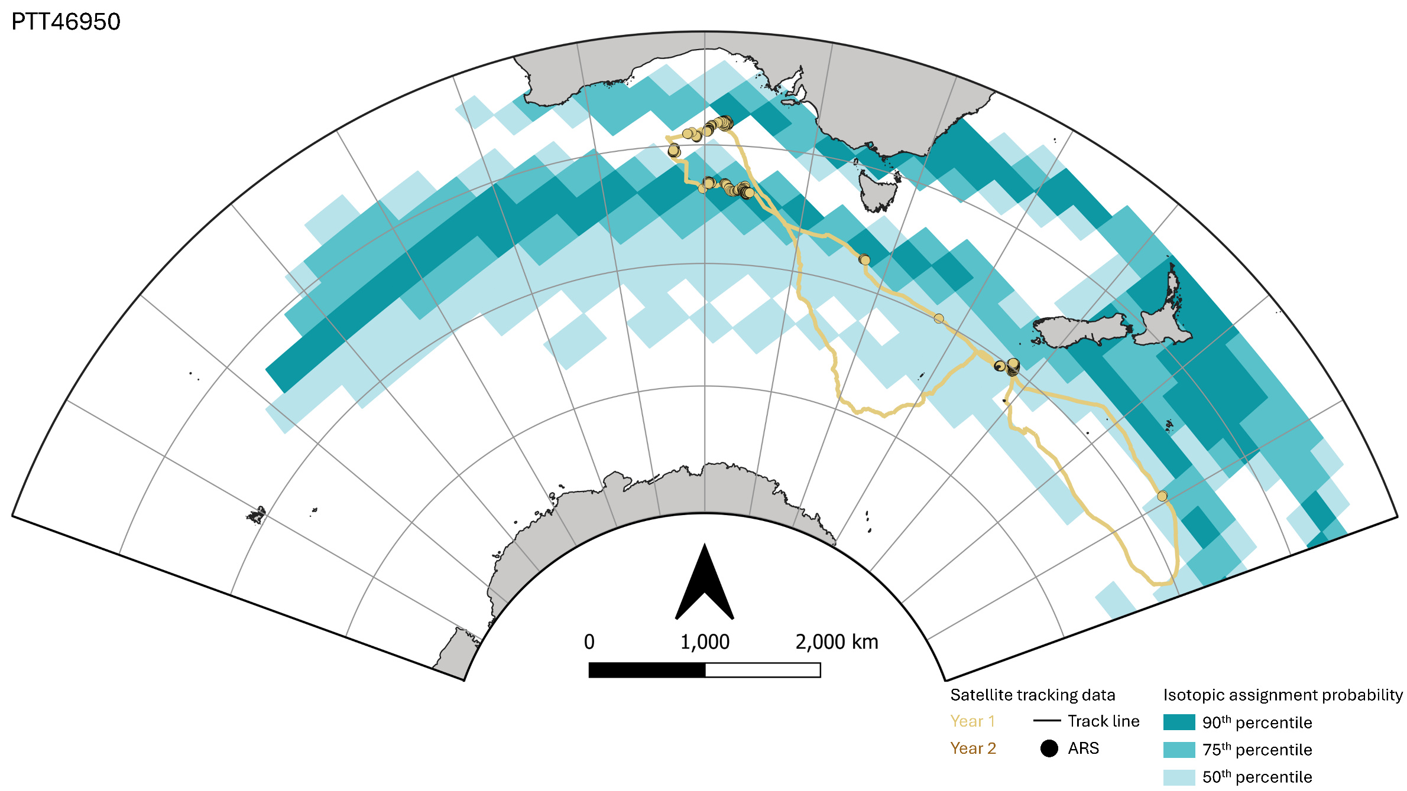

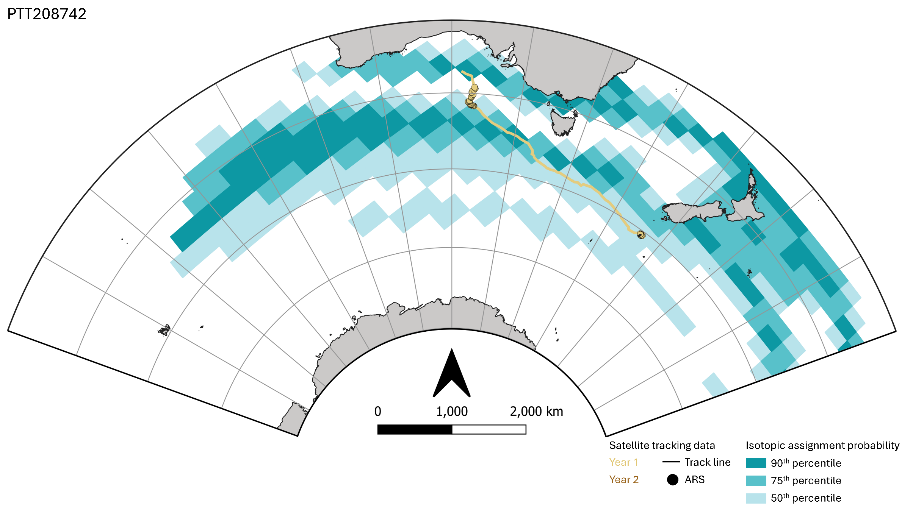

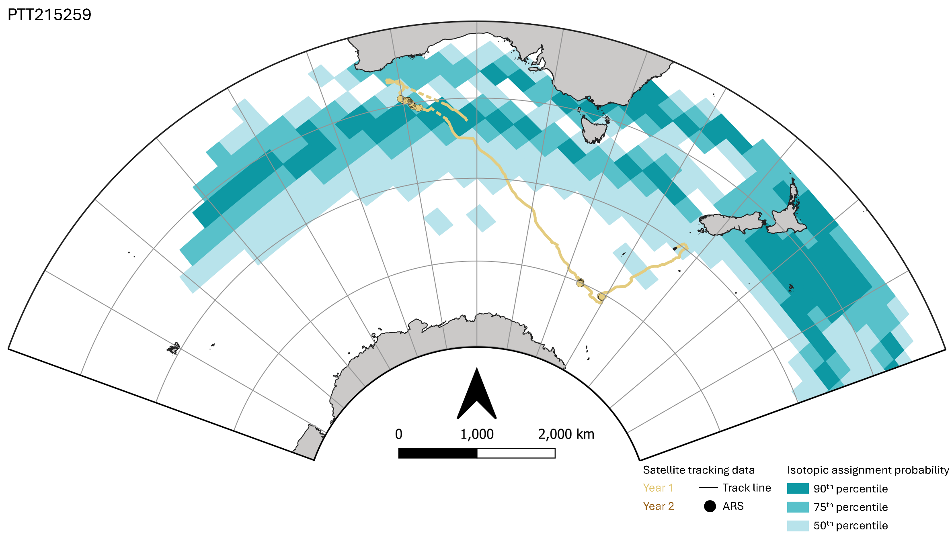

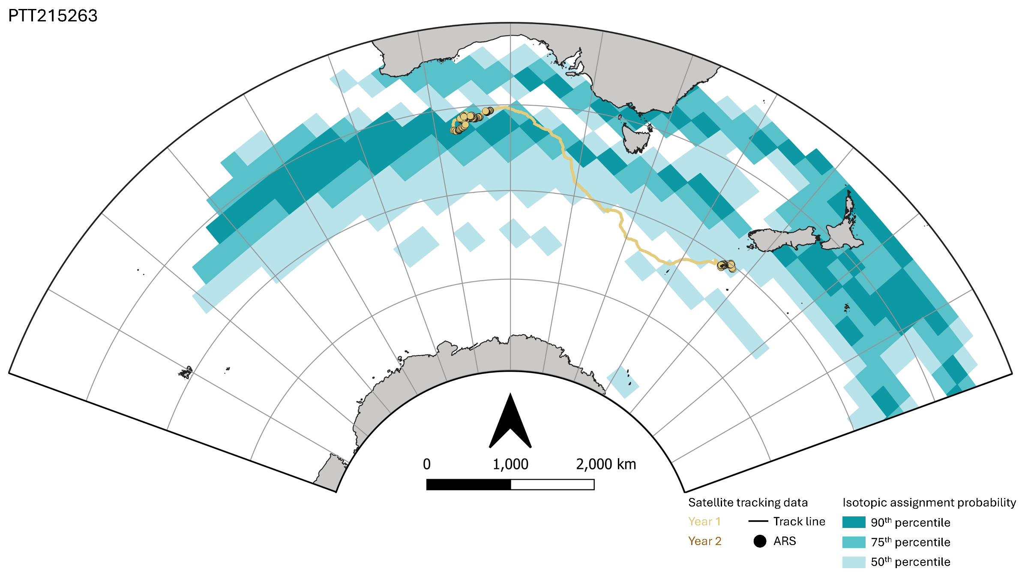

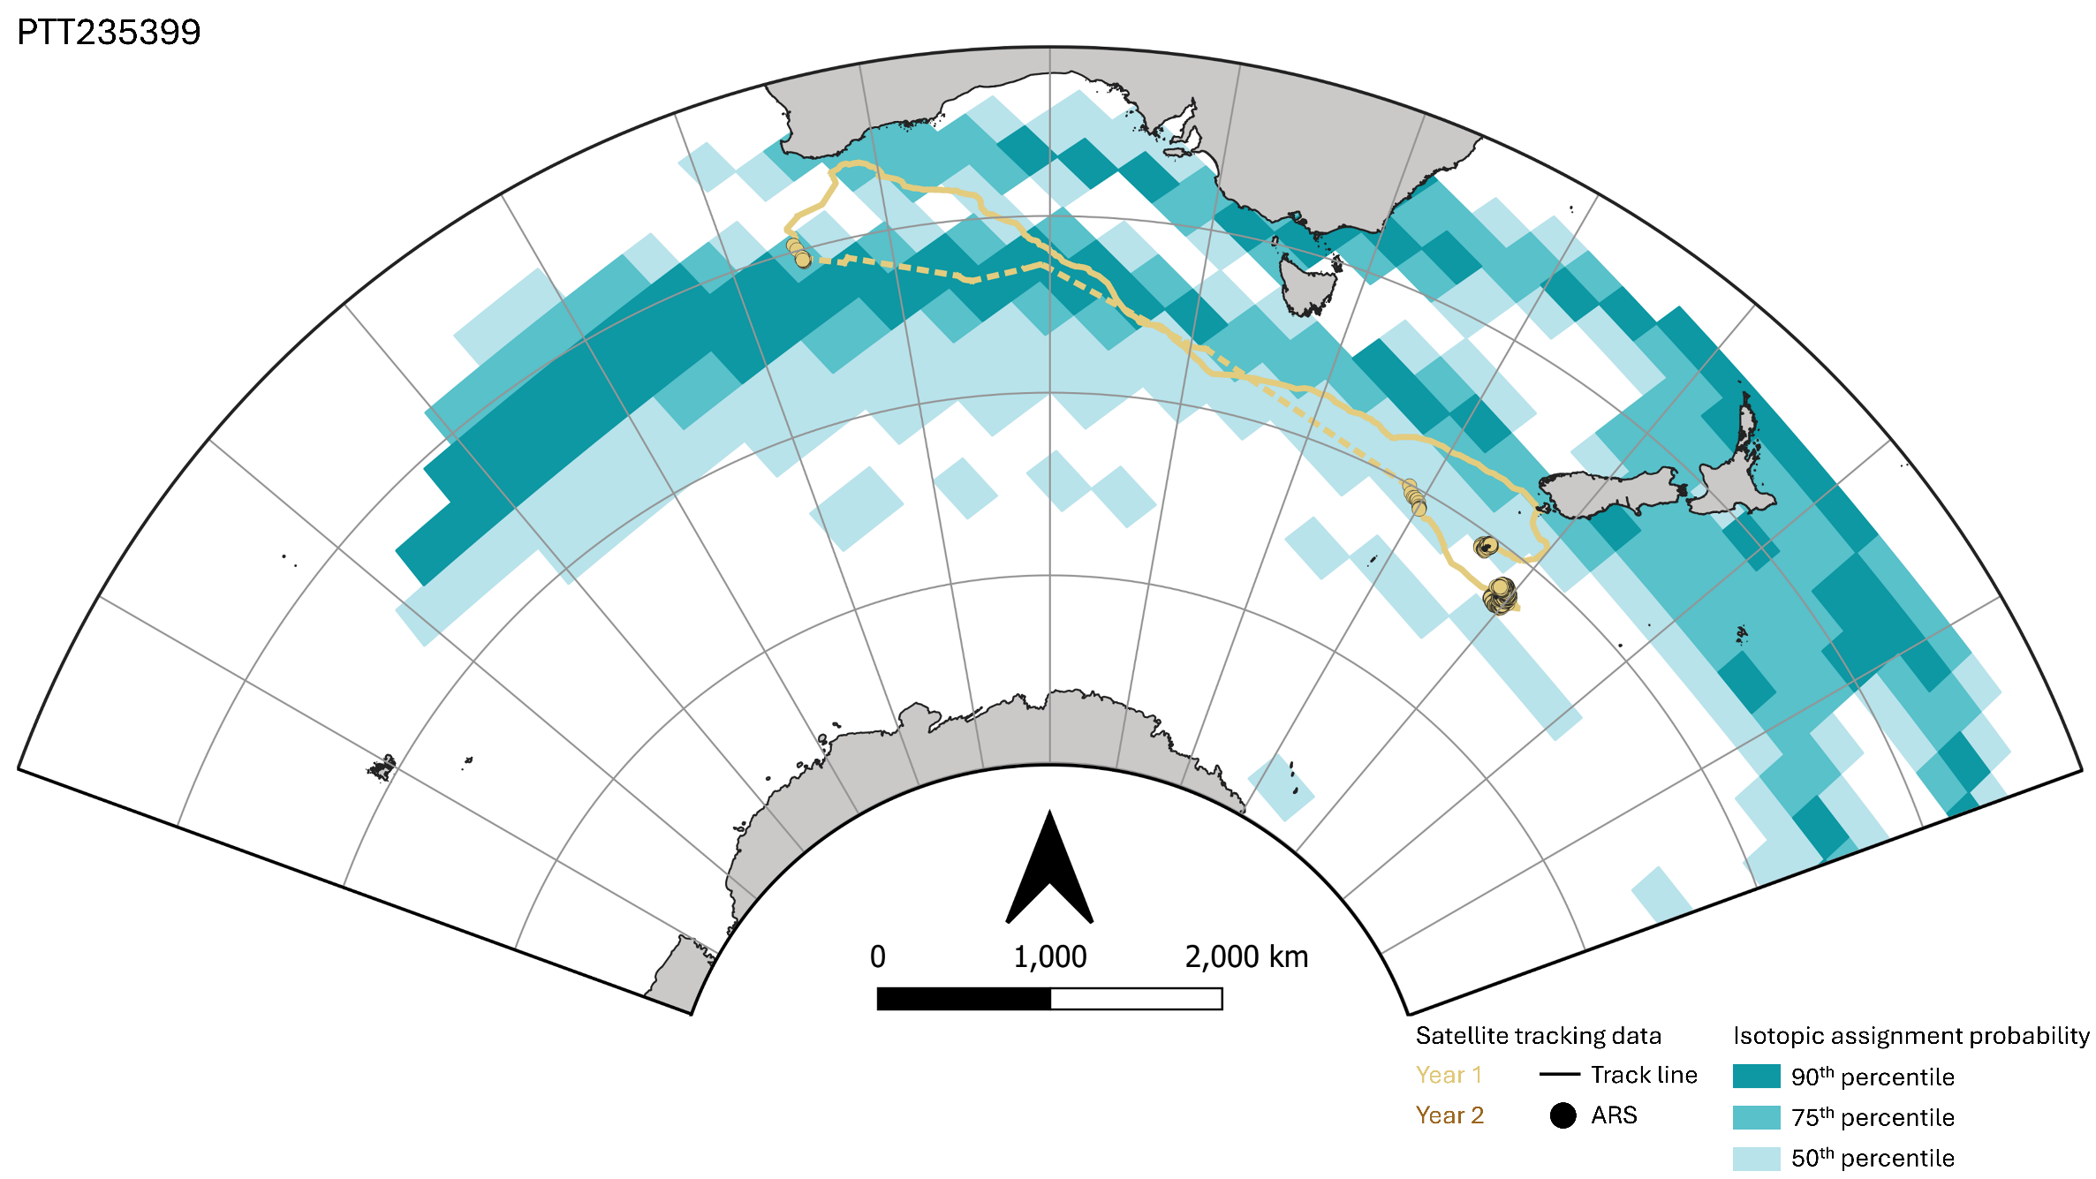
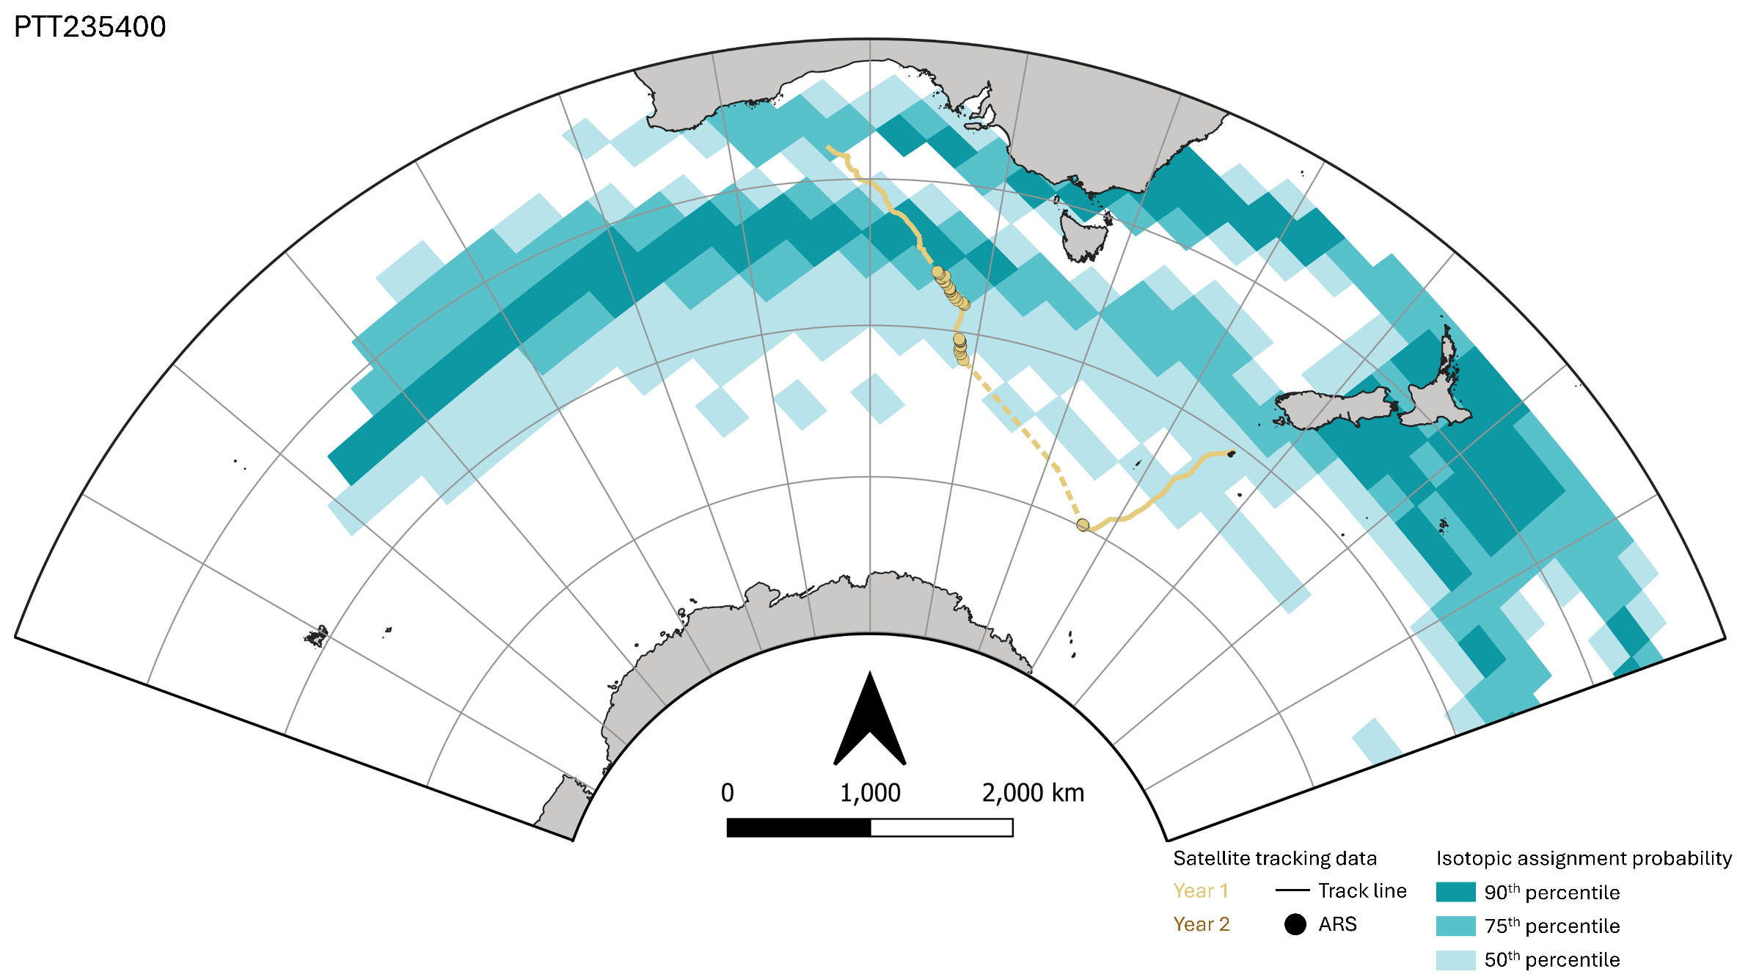

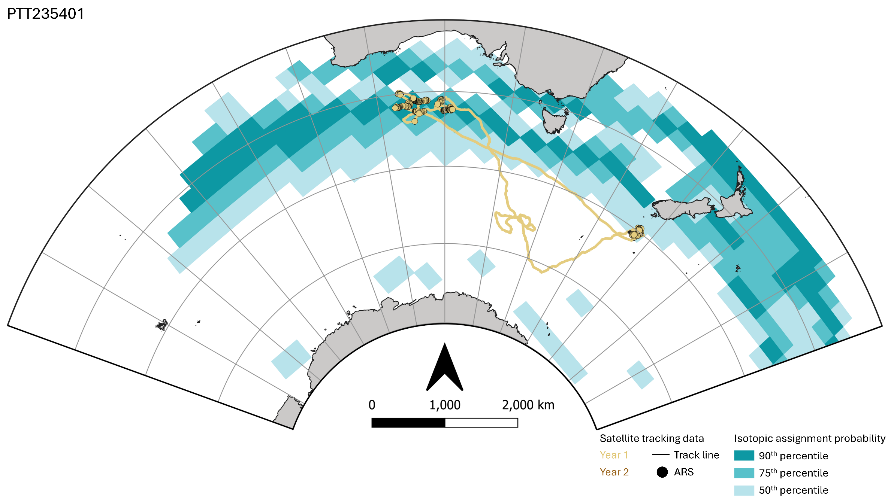

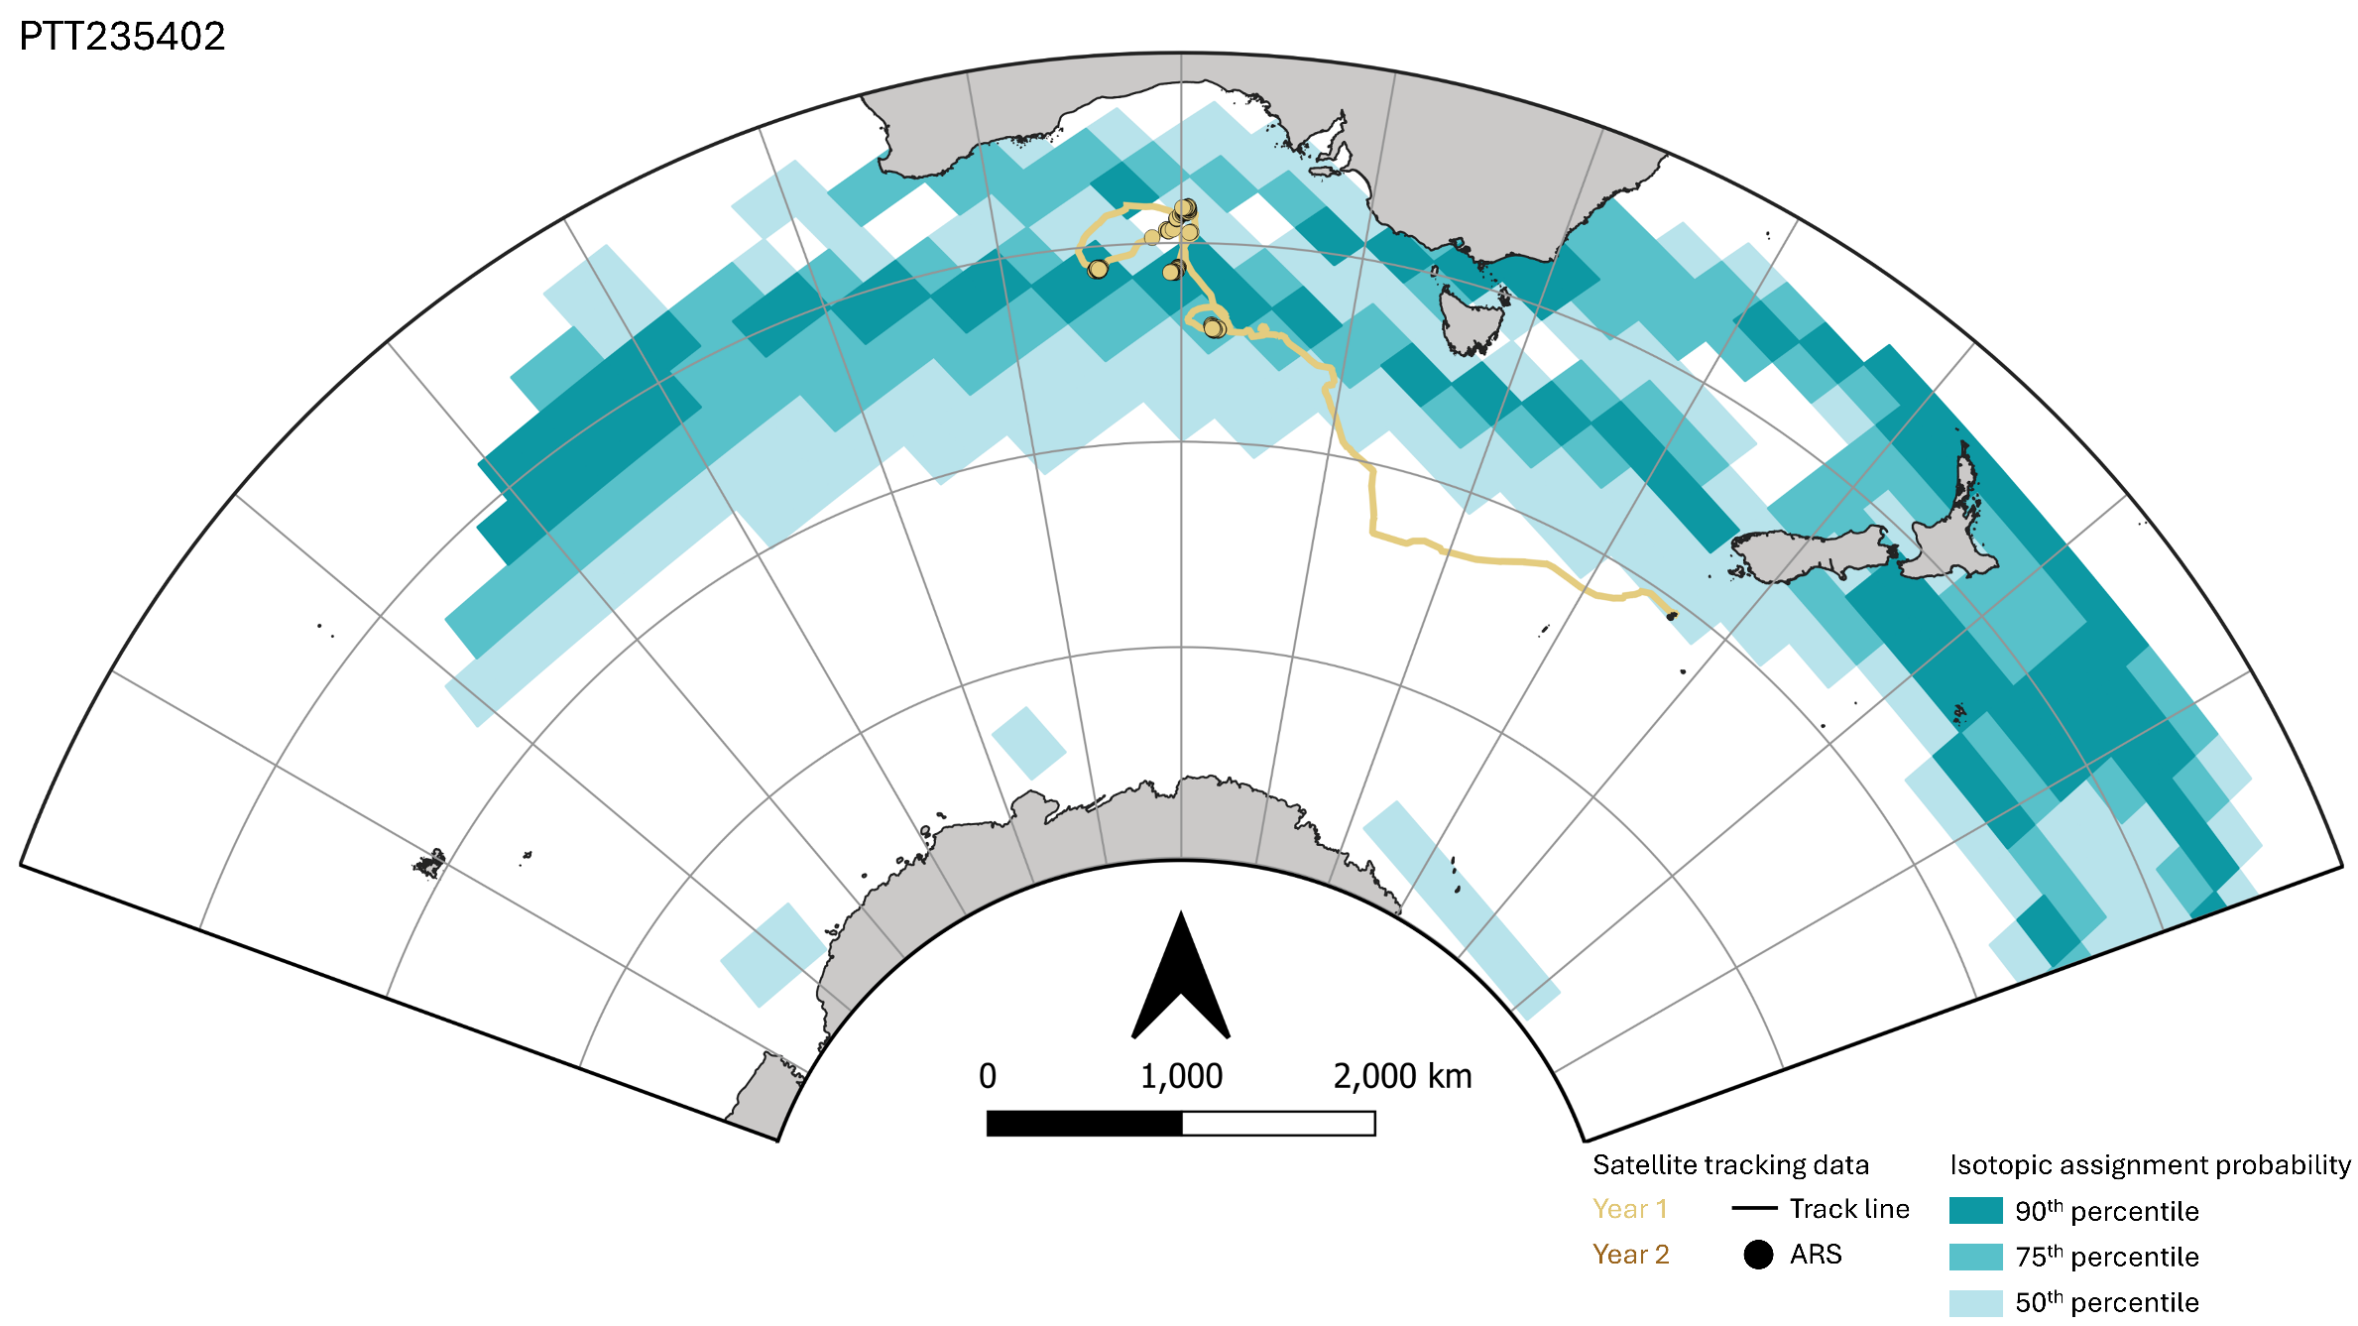
Supplementary Figure S2. Results of the overlap analysis and permutation tests assessing the relationship between behavioural state and isotope-assignment probability for a) all whales combined, and b) individual whales (i.e. tag ID or PTT). Because the raw isotope assignment values were not directly comparable between individuals, they were standardised within each individual's raster using empirical percentile ranks (x-axis). It may be helpful to interpret the below figures together with Figure 2 (main text) and Supplementary Figure S1.

a)
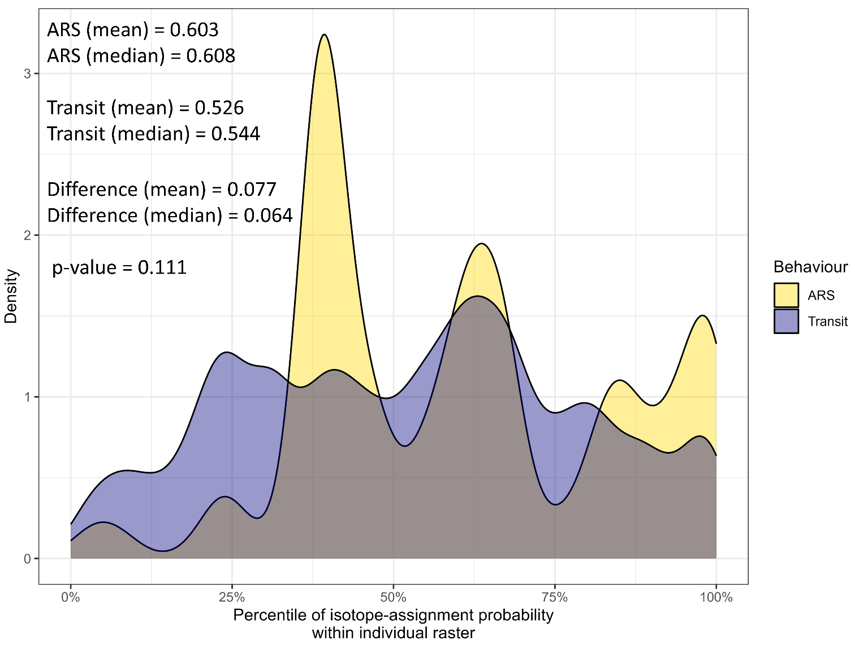

b)
