Additional file

Script V.02: October 23rd, 2012

THE MAJOR RISKS OF THYROIDECTOMY

- Damage to the recurrent and superior laryngeal nerves

- Damage to the parathyroid glands

DAMAGE TO THE RLN AND SLN

- Damage to the nerves occurs in <1% of thyroidectomy patients

- And can result in voice box paralysis (the inability to speak or control the pitch and volume of your voice) and difficulty swallowing and breathing

DAMAGE TO THE PARATHYROID

- The parathyroid glands are located on the back of thyroid and are responsible for regulating calcium levels in the blood

- Therefore, damage to the parathyroid glands can result in calcium deficiency called hypocalcemia

- 20% of patients will develop temporary hypocalcemia and 1% of patients will develop permanent hypocalcemia

THE SIGNS AND SYMPTOMS OF HYPOCALCEMIA

The most common indications of hypocalcemia include:

- Paresthesia
  - Tingling, pricking, and numbness in the hands, feet, and around the mouth

- Tetany
  - Twitching, stiffening, and cramping of the muscle. (This can occur anywhere in the body including the heart and throat)

- Hypocalcaemia also has been reported to cause seizures, anxieties, fatigue, and memory impairment

POST-OPERATIVE CARE INSTRUCTIONS

- Hypocalcemia is treated with calcium supplements and Vitamin D₃

- Calcium can be taken in form of calcium carbonate (common antacid) but must be taken with food or directly after eating

- Talk to your pharmacist about which supplement is best for you and to make sure that the supplement will not affect any medication you are taking

- The risks of encountering complications following surgery can be alleviated by taking your thyroid medication regularly

The script read for risk listing (See Additional file 1: A.1)

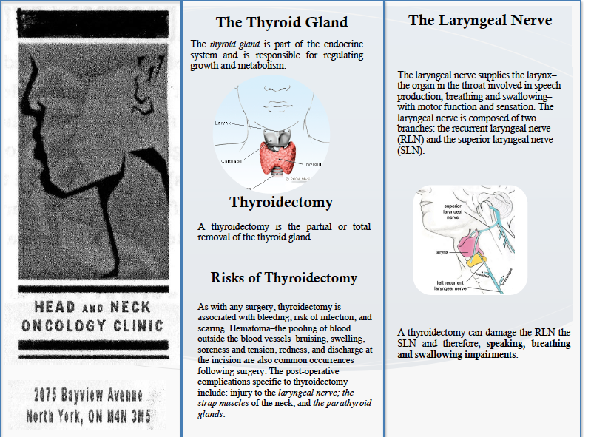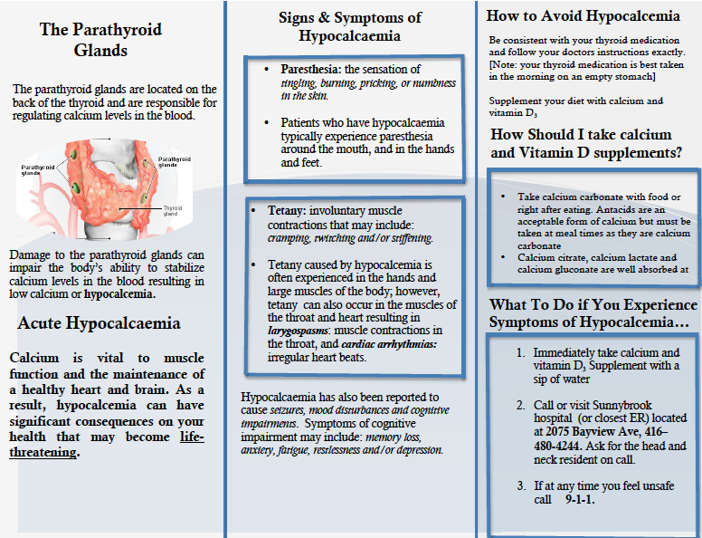
The Pamphlet (See Additional file 1: A.2)
Risk recall questionnaire test (See Additional file 1: A.3)

