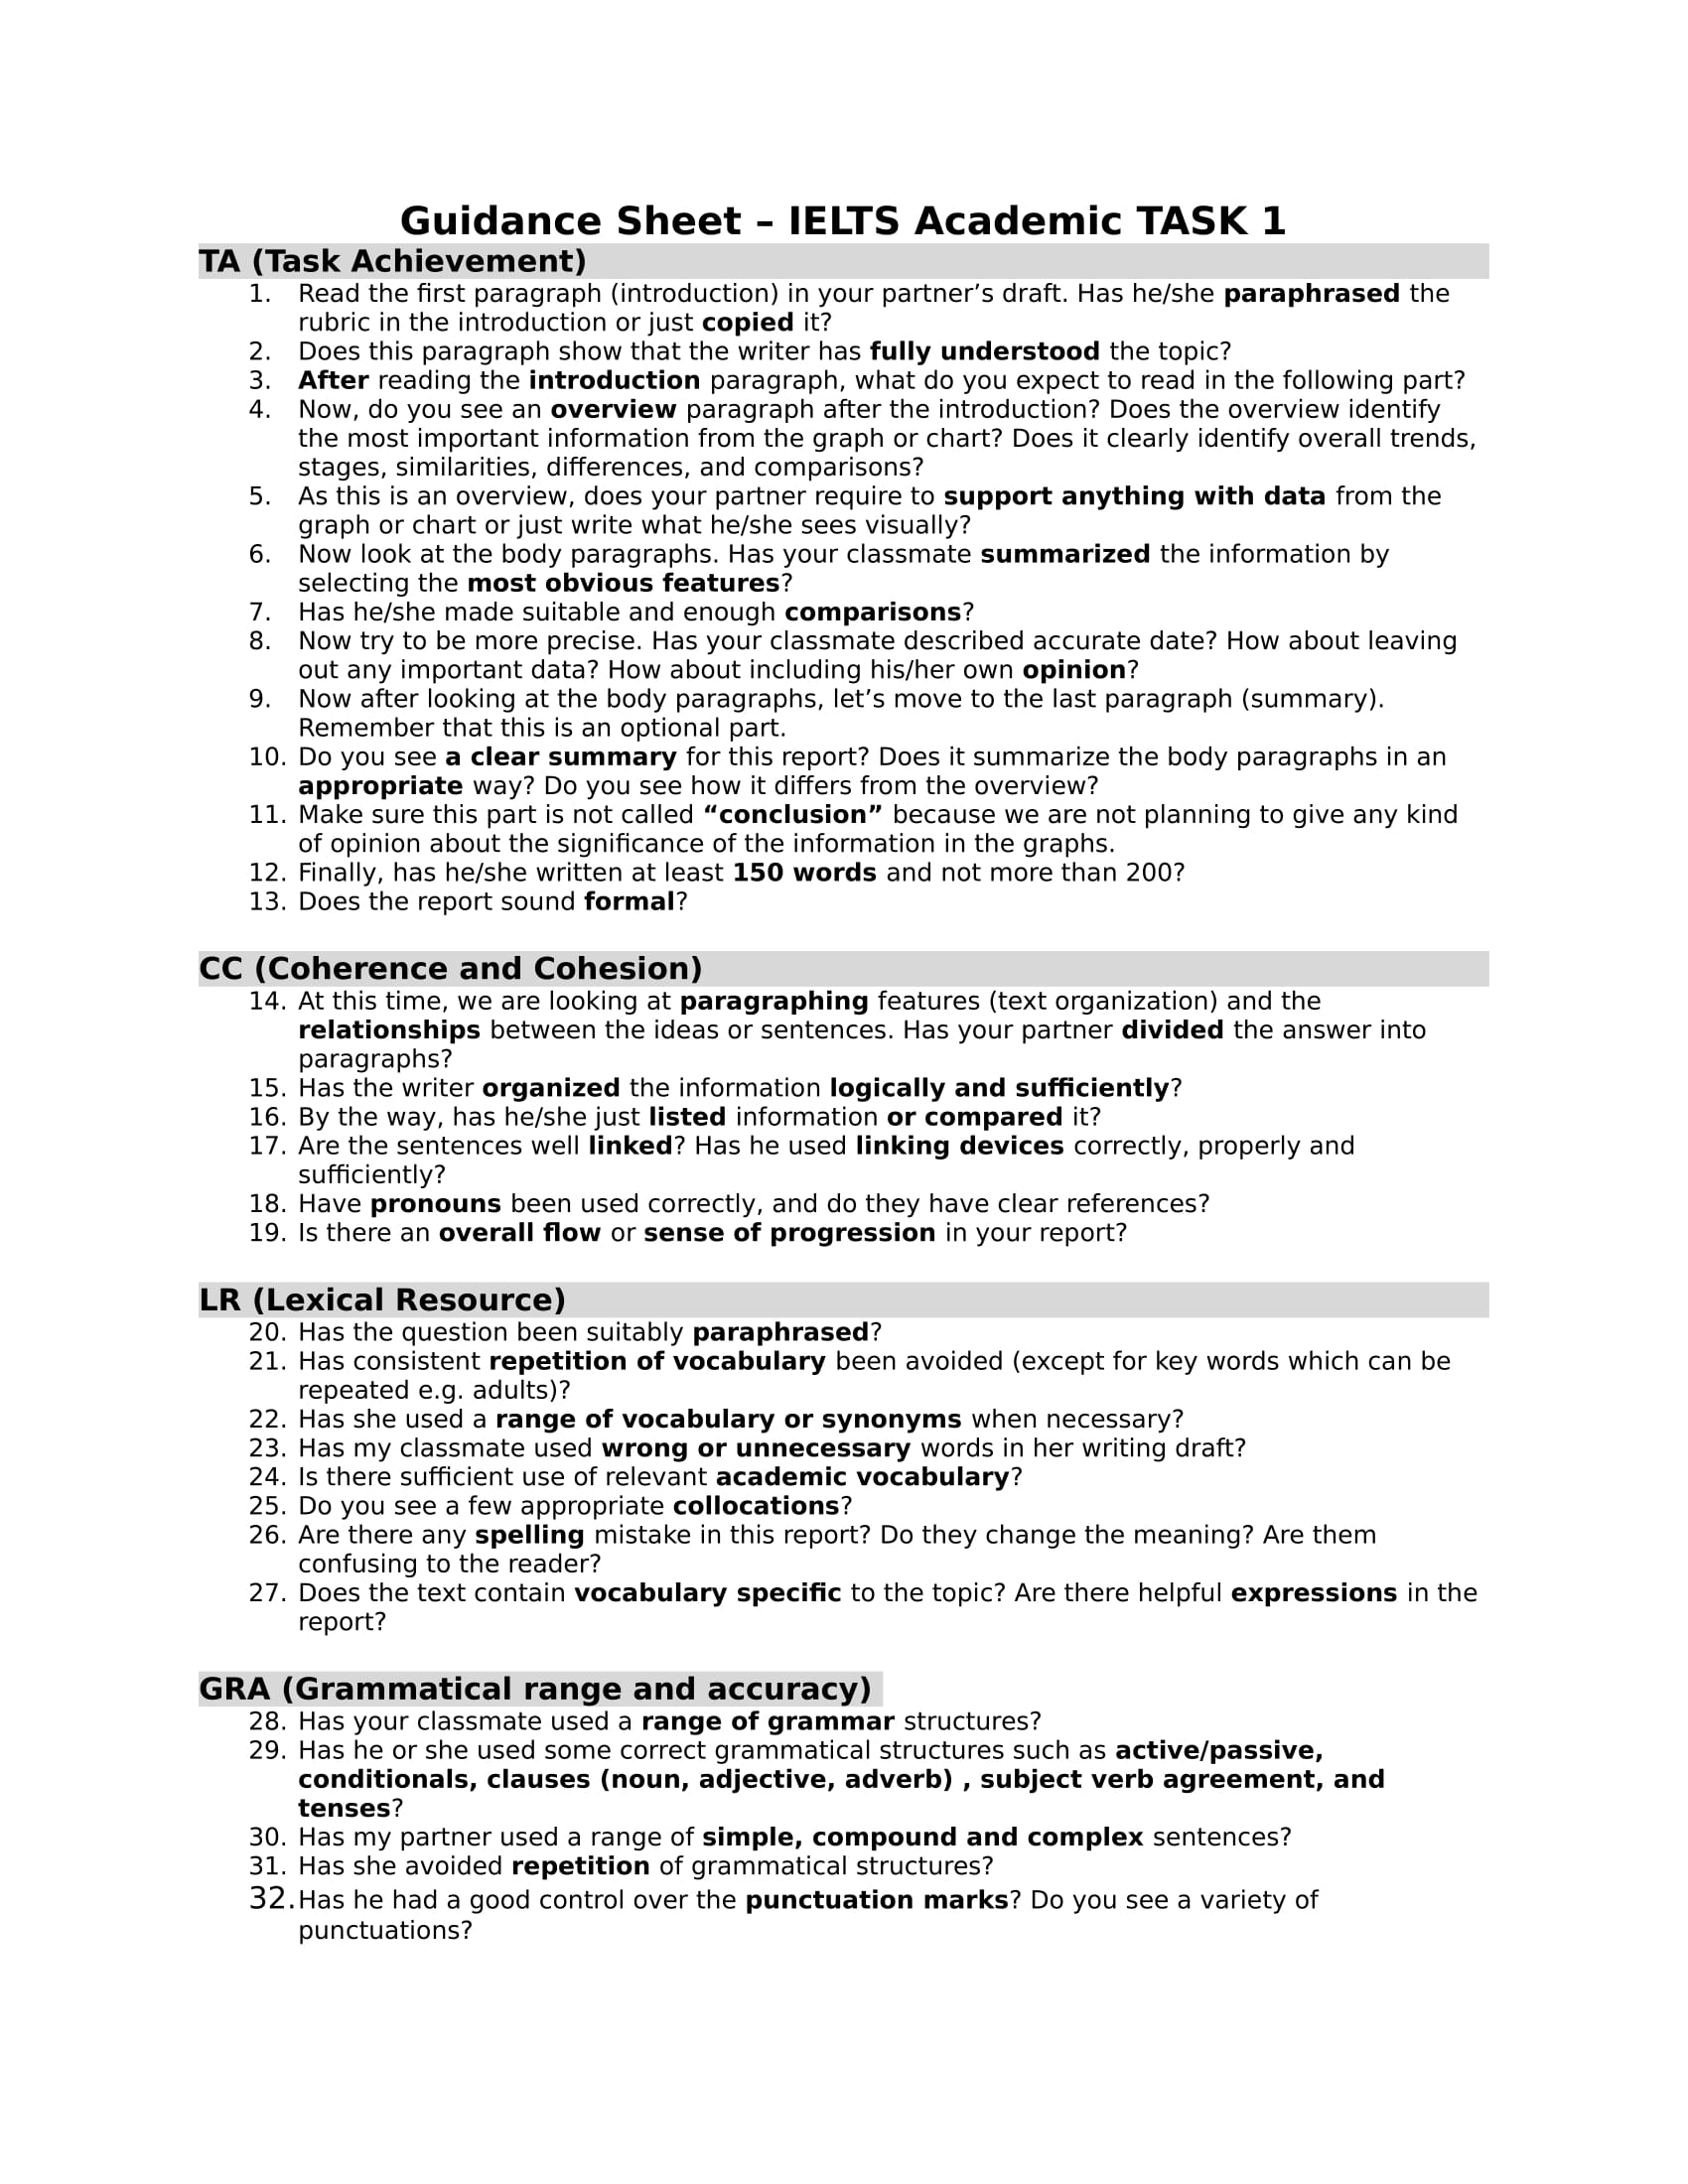
Additional file 1
The guidance sheet for IELTS Academic Writing Task 1

