Appendix A
West Virginia Department of Education Descriptive Writing Rubric
 | Organization | Development | Sentence Structure | Word Choice/  Grammar Usage | Mechanics
Score  6 | Exemplary Organization  - Clearly stated topic  - Clear and logical order  - Strong introductory paragraph, supporting paragraphs and concluding paragraph  - Sophisticated transition within and between sentences, ideas and paragraphs | Exemplary Development  - Sophisticated development of the topic for narrative and descriptive writing  - Sophisticated thesis statement and development of informative and persuasive writing  - Well executed progression of ideas  - Strong use of examples, evidence or relevant details  - Strong use of analogies, illustrations or anecdotes | Exemplary Sentence Structure  - Sophisticated and well controlled sentences  - Sentence variation (simple, compound, complex, compound-complex)  - Variation of phrases and clauses (gerund, participial, infinitive; subordinate clauses) | Exemplary Word Choice/  Grammar Usage  - Vivid, precise/concise, relevant  - Consistent grammar usage  - Subject/verb agreement  - Singular/plural nouns  - Verb (tense and usage)  - Pronoun usage  - Adjective/Adverb | Exemplary Mechanics  - May have minor errors  - Punctuation  - Capitalization  - Spelling  - Needs little or no editing
Score  5 | Effective Organization  - Clearly stated topic  - Clear and logical order  - Introductory paragraph, supporting paragraphs and concluding paragraph  - Purposeful transition within and between sentences, ideas and paragraphs | Effective Development  - Appropriate development of the topic for narrative and descriptive writing  - Appropriate thesis statement and development of informative and persuasive writing  - Clear progression of ideas  - Clear use of examples, evidence or relevant details  - Clear use of analogies, illustrations or anecdotes | Effective Sentence Structure  - Complete and correct sentences  - Sentence variation (simple, compound, complex, compound-complex)  - Variation of phrases and clauses (gerund, participial, infinitive; subordinate clauses) | Effective Word Choice/ Grammar Usage  - Appropriate, precise/concise, clear meaning  - Mostly consistent grammar usage  - Subject/verb agreement  - Singular/plural nouns  - Verb (tense and usage)  - Pronoun usage  - Adjective/Adverb | Effective Mechanics  - Few errors  - Punctuation  - Capitalization  - Spelling  - Needs some editing
Score  4 | Adequate Organization  - Clearly stated topic  - Some evidence of a logical order  - Introductory paragraph, supporting paragraphs and concluding paragraph  - Appropriate transition within and between sentences, ideas and paragraphs | Adequate Development  - Sufficient development of the topic for narrative and descriptive writing  - Sufficient thesis statement and development of informative and persuasive writing  - Progression of ideas  - Sufficient use of examples, evidence or relevant details  - Use of analogies, illustrations or anecdotes | Adequate Sentence Structure  - Complete and correct sentences  - Some sentence variation (simple, compound, complex, compound-complex) (errors in more complex sentences do not  detract)  - Variation of phrases and clauses (gerund, participial, infinitive; subordinate clauses) | Adequate Word Choice/  Grammar Usage  - Appropriate, specific  - Somewhat consistent grammar usage  - Subject/verb agreement  - Singular/plural nouns  - Verb (tense and usage)  - Pronoun usage  - Adjective/Adverb | Adequate Mechanics  - Some errors  - Punctuation  - Capitalization  - Spelling  - Needs editing but doesn’t  impede readability
Score  3 | Limited Organization  - Poorly stated topic  - Limited evidence of a logical order  - Introductory paragraph and concluding paragraph with limited supporting paragraphs  - Repetitive use of transition | Limited Development  - Limited development of the topic for narrative and descriptive writing  - Limited thesis statement development of informative and persuasive writing  - Limited progression of ideas  - Limited use of examples, evidence or relevant details  - Limited use of analogies, illustrations or anecdotes | Limited Sentence Structure  - Minor errors in sentence structure  - Limited sentence variation (simple, compound, complex, compound-complex)  (errors in more complex  sentence structure  begin to detract)  - Limited use of phrases and clauses (gerund, participial, infinitive; subordinate clauses) | Limited Word Choice/ Grammar Usage  - Vague, redundant, simplistic  - Several inconsistencies in grammar usage  - Subject/verb agreement  - Singular/plural nouns  - Verb (tense and usage)  - Pronoun usage  - Adjective/Adverb | Limited Mechanics  - Frequent errors  - Punctuation  - Capitalization  - Spelling  - Begins to impede readability
Score  2 | Minimal Organization/ Minimal Response  - Lack of acceptable topic  - Lacks evidence of a logical order  - Lacks introductory paragraph, supporting paragraphs and/or concluding paragraph  - Ineffective or overused transition | Minimal Development/  Minimal Response  - Minimal development of the topic for narrative and descriptive writing  - Minimal thesis statement and development of informative and persuasive writing  - Lacks a logical progression of ideas  - Minimal use of examples, evidence or relevant details  - Minimal use of analogies, illustrations or anecdotes | Minimal Sentence Structure/  Minimal Response  - Contains fragments and/or run-ons  - Minimal sentence variation (simple, compound, complex, compound-complex)  (errors in sentence structure detract)  - Minimal use of phrases and clauses (gerund, participial, infinitive; subordinate clauses) | Minimal Word Choice/ Grammar Usage/  Minimal Response  - Inadequate, imprecise, repetitive  - Frequent inconsistencies grammar usage  - Subject/verb agreement  - Singular/plural nouns  - Verb (tense and usage)  - Pronoun usage  - Adjective/Adverb | Minimal Mechanics/  Minimal Response  - Consistent errors  - Punctuation  - Capitalization  - Spelling  - Impedes readability
Score  1 | Inadequate Organization  - Lacks stated topic  - No logical pattern; difficult to follow  - Inadequate paragraphing  - Little or no transition | Inadequate Development  - Little or no development of the topic for narrative and descriptive writing  - Unclear thesis statement and development for informative and persuasive writing  - Unclear or no focus  - Few or no examples, evidence or relevant details  - Little use of analogies, illustrations or anecdotes | Inadequate Sentence Structure  - Contains numerous fragments and/or run-ons  - Little or no sentence variation (simple, compound, complex, compound-complex)  (errors in sentence structure detract)  - Little or no use of phrases and clauses (gerund, participial, infinitive; subordinate clauses) | Inadequate Word Choice/ Grammar Usage  - Rambling, inappropriate, incorrect, unclear  - Distracting inconsistencies grammar usage  - Subject/verb agreement  - Singular/plural nouns  - Verb (tense and usage)  - Pronoun usage  - Adjective/Adverb | Inadequate Mechanics  - Serious and consistent  errors  - Punctuation  - Capitalization  - Spelling  - Impedes understanding/communication

Appendix B
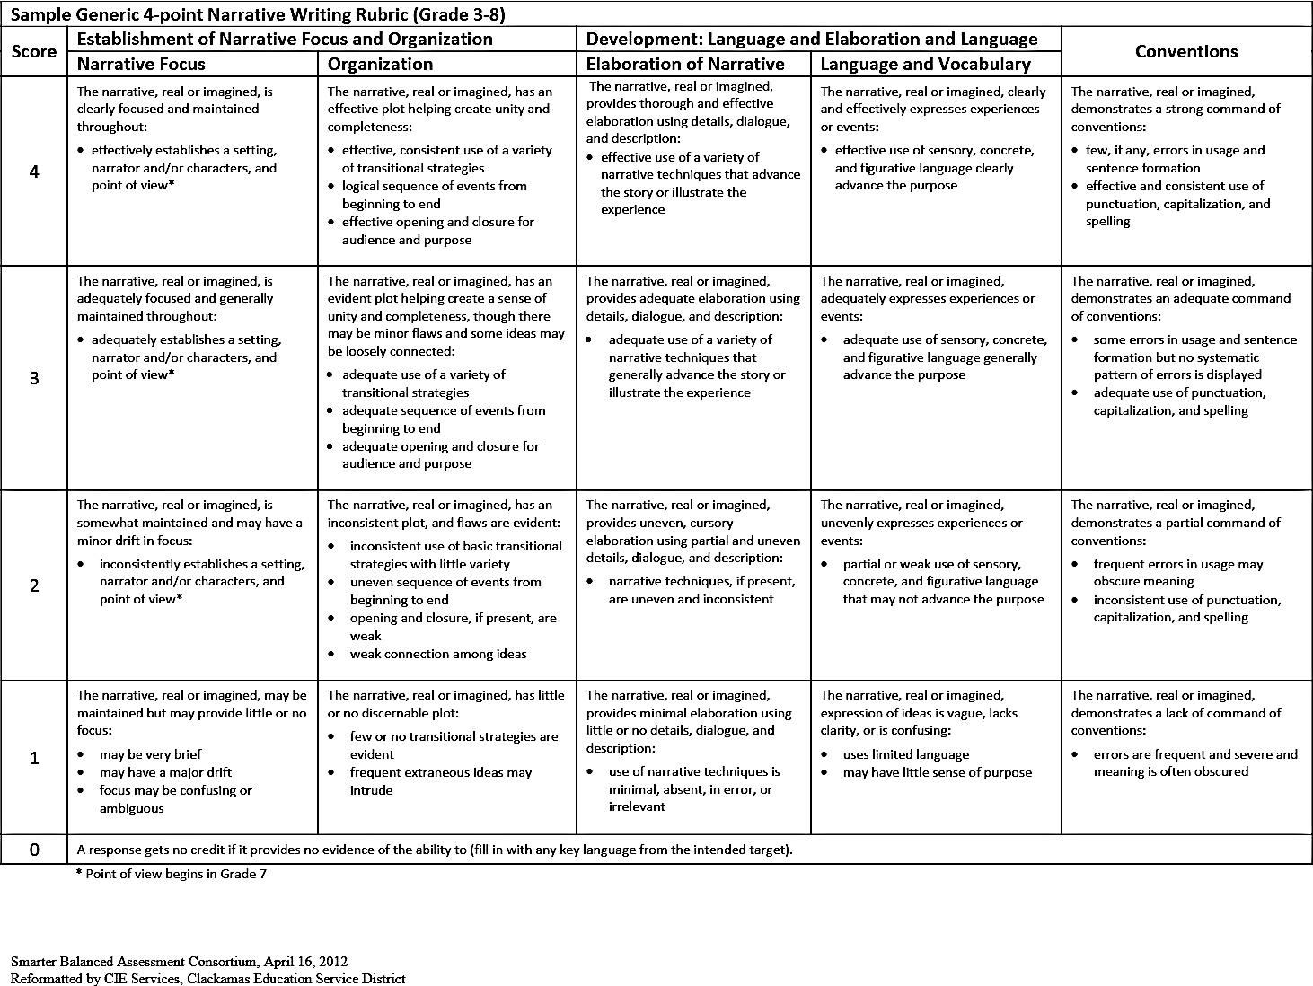
Smarter Balanced Narrative Writing Rubric
Appendix C
Samples of TA and PA on Descriptive Writing Tasks
Sample of Descriptive Task  Topic: What are your reading habits? | Teacher Feedback |  | Peer Feedback
 | Comment Category |  | Comment Category
The only book that I read is my school books. when I have exam I start to read from the first to the end. I never skip any part because I like to get the best score in the class. Sometimes my friends lagh me because I read the footnotes and glossary. when I want to read I need a very quiet place because I should understand what I am reading carefully. I usually lie in my bed to read my books. When I start to read I become drown into my book so that I can hardly hear my mother calling me for dinner. | - Check your grammar book for complex sentences.  - Check spelling.  …… AT me  - The sentence starts  with?  - Lie or lay?  - The paragraph needs some transitional words, such as the first strategy, the second … | Sentence Structure  Mechanics;  Word choice and grammar  Mechanics  Mechanics  Organization | - “that I have read”  - laugh  - Incorrect  - This is a good paragraph. | Word choice and grammar  Mechanics  Mechanics  Organization

Appendix D
Samples of TA and PA on Narrative Writing Tasks
Sample of Narrative Task  Topic: What do you remember about the worst day of your life? | Teacher Feedback |  | Peer Feedback
 | Comment Category |  | Comment Category
Last year I remember I had a lot of guests in my home. They were happily watching our wedding ceremony movie and I was extremely stressful. I didn’t know why because everything was okay. Then my cell phone rang loudly. My brother was on the phone. He was really sad and I could feel it on the phone. We talk for some minutes and then he said that his wife want to get divorced. He said that our mother got sick after hearing this issue and asked me to go to her home. I was really shocked. I couldn’t cry at that time because I had guests and I didn’t show any reaction. I really got broken at my heart like a vase. I hope no one has the worst day on his or her life. | - Check punctuation.  - talked or talk?  - All the verbs should be in past tense when you tell a story. | Convention  Language and vocabulary  Language and vocabulary | - We talked …  - his wife wanted … | Language and vocabulary  Language and vocabulary

