Appendix A. The adapted matrix, which serves as the coding scheme.
Applying Webb’s Depth-of-Knowledge Levels to Bloom’s Cognitive Process Dimensions
(Note: Descriptors in bold are reflected in the test items across the years. The data-driven codes are marked with an asterisk.)

 | Level 1  Recall and Reproduction of information; retrieval of explicitly stated information | Level 2  Basic reasoning; making straightforward inferences; answers can be located in the text | Level 3  Complex reasoning; interpret and integrate information; little scaffolding in the item | Level 4  Extended reasoning; evaluate and critique content and textual elements  (Not applicable to standardized tests such as HKDSE. Level 4 items require complex reasoning, planning, developing, and thinking, usually over an extended period of time. They are most common in performance tests.)
Remember: Retrieve knowledge from long-term memory, recognize, recall, locate, identify | (Not applicable. HKDSE does not provide any set of reading list beforehand. It does not involve recall of facts.) | (Not applicable. “Remember” does not require reasoning skills.)
Understand: Construct meaning, clarify, paraphrase, represent, translate, illustrate, give examples, classify, categorize, summarize, generalize, infer a logical conclusion), predict, compare/contrast, match like ideas, explain, construct models | - Identify or describe literary elements (characters, setting, dialogue, etc.)  - Describe or explain who, what, where, when, or how without referring to context  - Define or describe facts, details, terms, or principles | - Identify meaning of words or phrases in context  - * Identify appropriate words or phrases by referring to context  - * Make basic inferences about writer's intention  - Make basic inferences about text content  - * Identify specific information using pronoun referencing  - * Identify specific factual information in text  - Identify main ideas which can be located in text  - * Make logical predictions using structural devices  - Give examples of explicitly stated information  - Explain causal relationships  - * Determine the sequence of events | - * Interpret main idea which is implicit in text  - * Summarize implicit themes of texts  - Explain the purpose of a text using supporting evidence  - * Describe the effect of language features, such as metaphors or tone | - Explain how concepts or ideas specifically relate to other content domains (e.g., social, political, historical) or concepts or other texts, using evidence from multiple sources
Apply: Carry out or use a procedure in a given situation; carry out (apply to a familiar task), or use (apply) to an unfamiliar task | - Determine meaning of words or phrases using language structure or word relationship  - Apply rules to edit spelling, grammar, word use, punctuation, or conventions | - * Select appropriate words or phrases to use in context  - * Determine alternatives to text features (e.g., titles, sub-headings)  - Apply simple organizational structures (paragraph, sentence types) in writing | - Apply a concept in a new context  - Apply word choice, point of view, or style to impact readers’ interpretation of the text | - Illustrate how multiple themes across texts (historical, geographic, social, artistic, literary) may be interrelated, using evidence from multiple sources
Analyze: Break into constituent parts, determine how parts relate, differentiate between relevant-irrelevant, distinguish, focus, select, organize, outline, find coherence, deconstruct (e.g., for bias or point of view) | - Identify specific information contained in graphic representations or text features  - Decide which text type or text structure is appropriate to audience and purpose | - * Identify use of figurative language  - Compare literary elements  - Analyze format, organization, and internal text structures (e.g., signal words, transitions, semantic cues)  - Identify characteristic text features  - Distinguish between texts or genres | - Interpret use of figurative language  - Analyze interrelationships among concepts, issues, problems within the text | - Analyze multiple sources of evidence, or multiple works by the same author, or across genres, time periods, themes  - Analyze contrasting themes, perspectives, policies  - Gather, analyze, and organize multiple information sources  - Analyze discourse styles across texts
Evaluate: Make judgments based on criteria, check, detect inconsistencies or fallacies, judge, critique | - (Not applicable. Any evaluation would be put with reference to the reading text, which requires at least basic reasoning.) | - * Distinguish claims from alternate or opposing claims  - Locate inaccurate information in claims | - Cite evidence to develop logical argument  - Compare or contrast solutions to a problem  - Critique writer’s logic or conclusions | - Evaluate relevancy, accuracy, and completeness of information from multiple sources  - Evaluate how likely the writer’s argument would change what people think and do
Create: Reorganize elements into new patterns/structures, generate, hypothesize, design, produce | - Brainstorm ideas, concepts, problems, or perspectives related to the topic | - Generate claims for opinion-argument based on observations, prior knowledge, or experience | - Synthesize information within the text  - Develop alternative solutions to a problem | - Synthesize information across multiple sources or texts  - Articulate alternate theme, a new voice, new knowledge or nuanced perspective
Sources:
Depth-of-Knowledge Level Descriptors for Reading (Hess, 2004)
Hess Cognitive Rigor Matrix & Curricular Examples: Applying Webb’s Depth-of-Knowledge Levels to Bloom’s Cognitive Process Dimensions (sent by Dr. Hess)
PIRLS 2016 Reading Framework (IEA, n.d.)
English language curriculum and assessment guide (Secondary 4-6) (Curriculum Development Council & Hong Kong Examinations and Assessment Authority, 2007)

Appendix B. The codes and their corresponding examples.

Level 1
Recall and Reproduction of information; retrieval of explicitly stated information
(Apply) Determine meaning of words or phrases using language structure or word relationship | 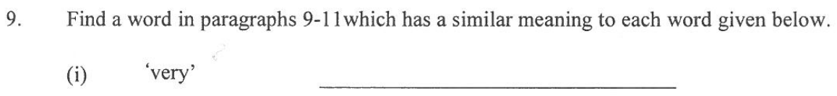 | 2019 A Q9
Level 2
Basic reasoning; making straightforward inferences; answers can be located in the text
(Understand) Identify meaning of words or phrases in context | 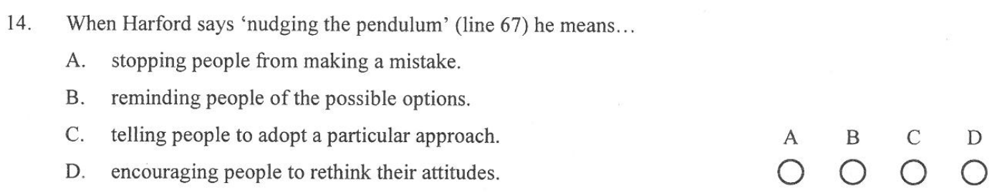 | 2019 A Q14
(Understand) Identify appropriate words or phrases by referring to context | 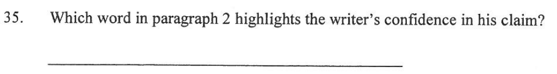 | 2019 B1 Q35
(Understand) Make basic inferences about writer's intention | 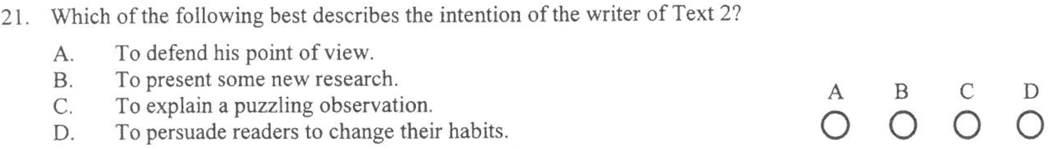 | 2018 A Q21
(Understand) Make basic inferences about text content |  | 2019 A Q12
(Understand) Identify specific information using pronoun referencing |  | 2019 A Q13
(Understand) Identify specific factual information in text | 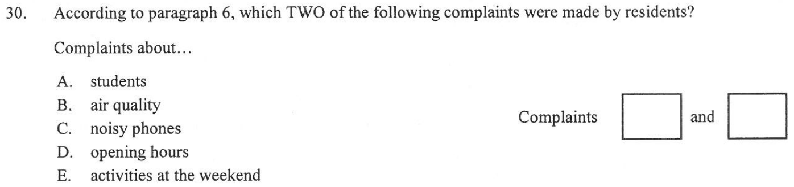 | 2019 B1 Q30
(Understand) Identify main ideas which can be located in text | 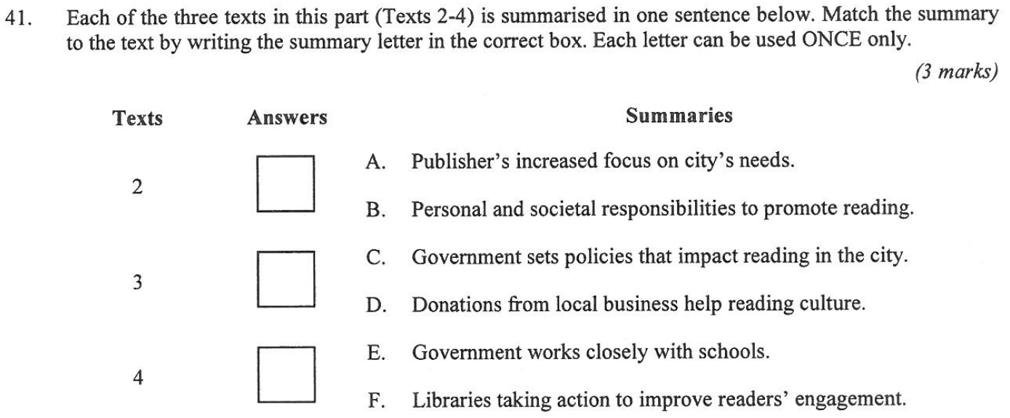 | 2019 B1 Q41
(Understand) Make logical predictions using structural devices | 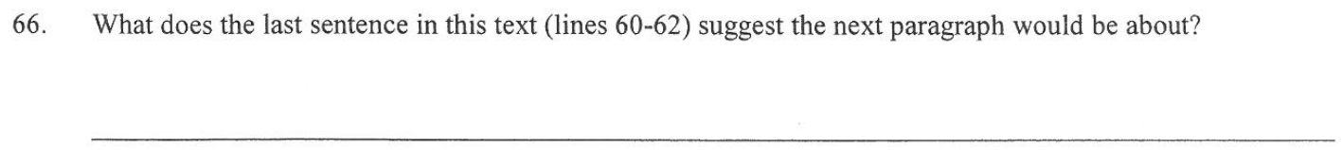 | 2019 B2 Q66
(Understand) Give examples of explicitly stated information |  | 2018 A Q11
(Understand) Determine the sequence of events | 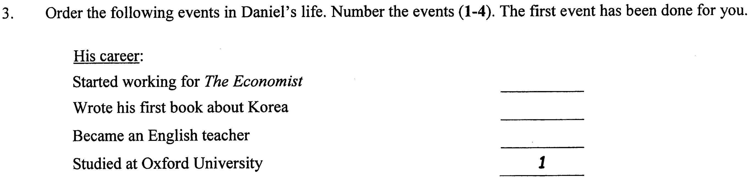 | 2015 A Q3
(Apply) Select appropriate words or phrases to use in context | 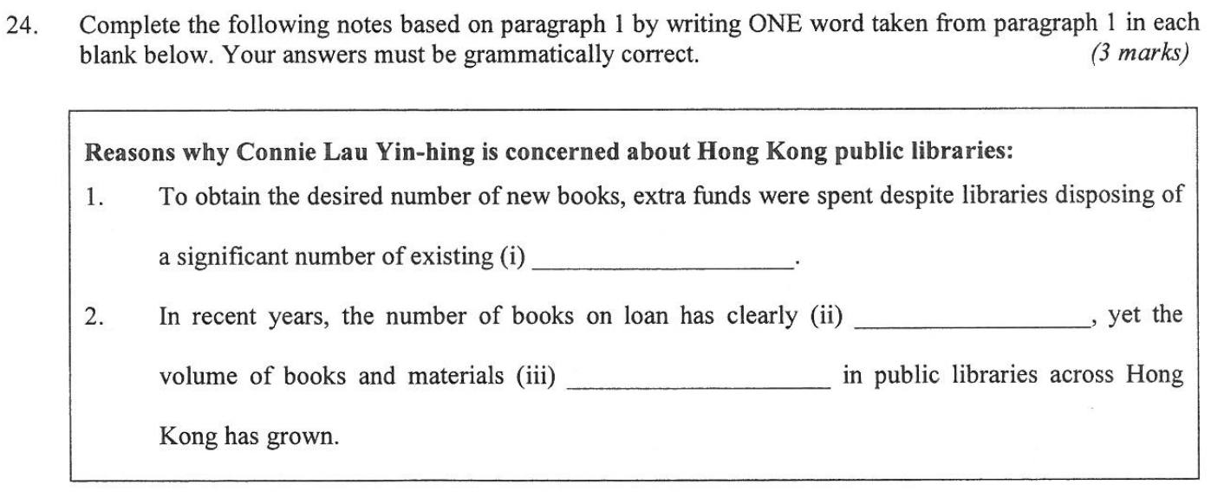 | 2019 B1 Q24
(Apply) Determine alternatives to text features (e.g., titles, sub-headings) | 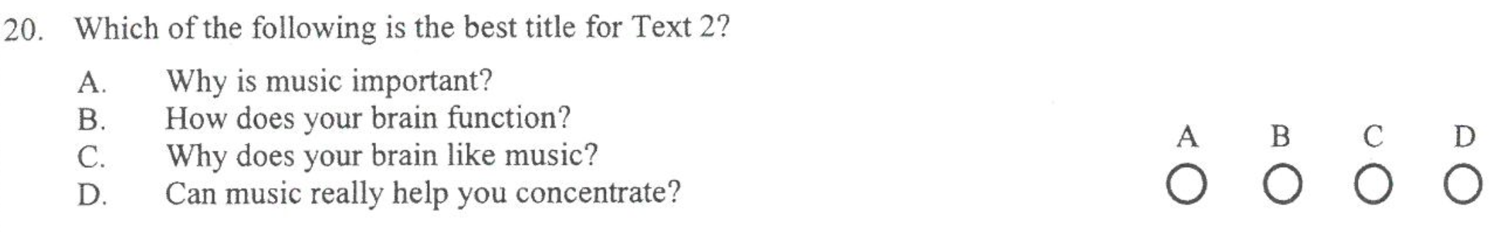 | 2018 A Q20
(Analyze) Identify use of figurative language | 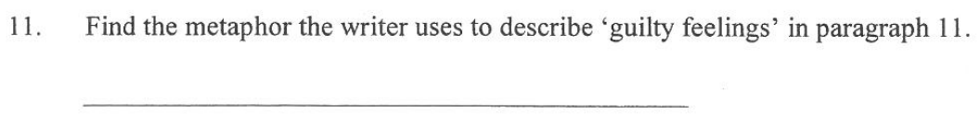 | 2019 A Q11
(Analyze) Analyze format, organization, and internal text structures (e.g., signal words, transitions, semantic cues) |  | 2016 B2 Q54
(Analyze) Identify characteristic text features | 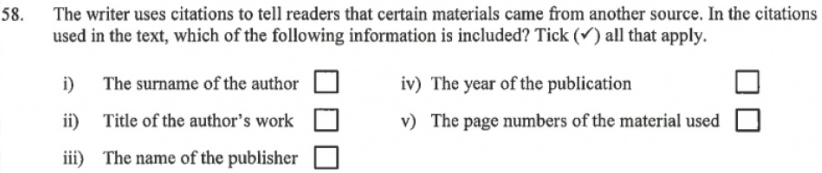 | 2017 B2 Q58
(Evaluate) Distinguish claims from alternate or opposing claims | 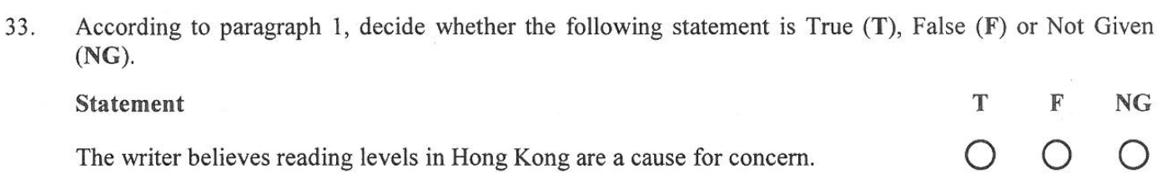 | 2019 B1 Q33
(Evaluate) Locate inaccurate information in claims | 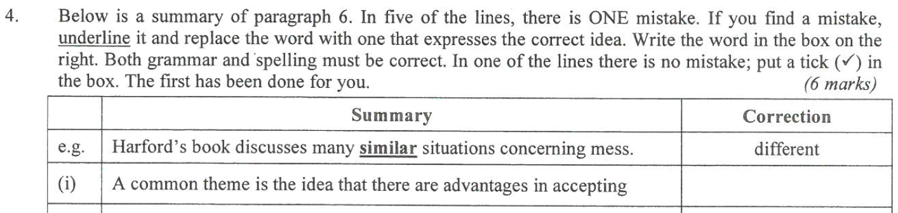 | 2019 A Q4
Level 3
Complex reasoning; interpret and integrate information; little scaffolding in the item
(Understand) Interpret main idea which is implicit in text | 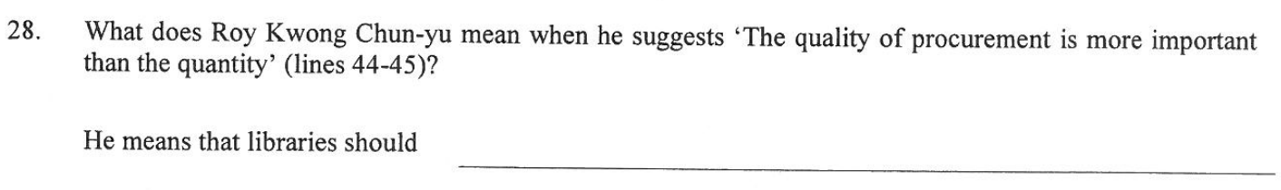 | 2019 B1 Q28
(Understand) Summarize implicit themes of texts | 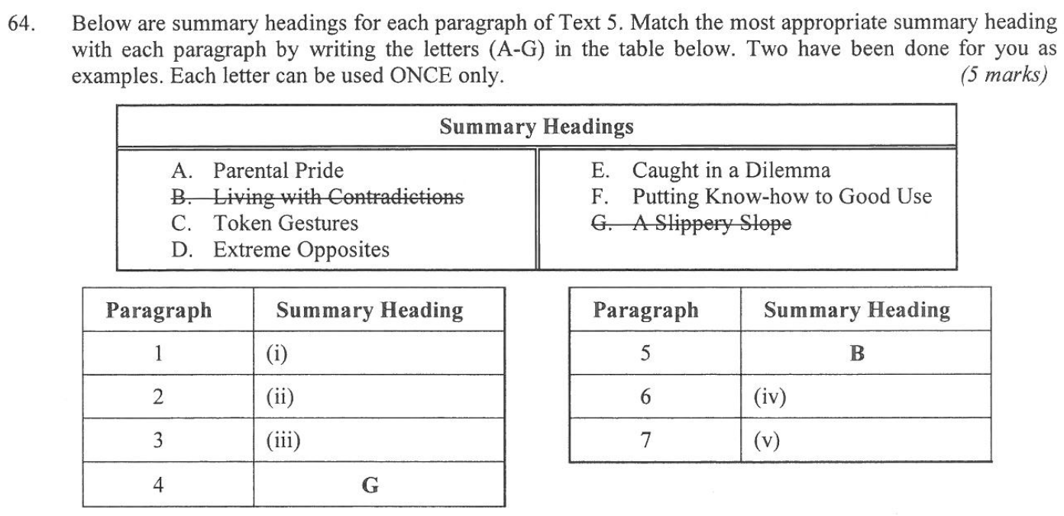 | 2019 B2 Q64
(Understand) Describe the effect of language features, such as metaphors or tone | 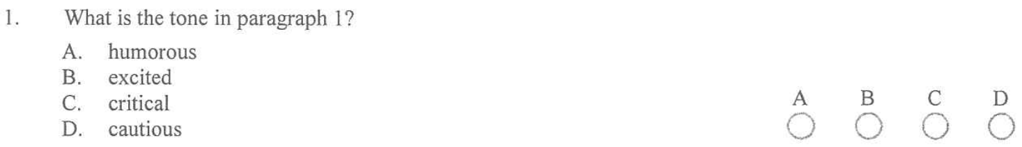 | 2013 A Q1
(Analyze) Interpret use of figurative language | 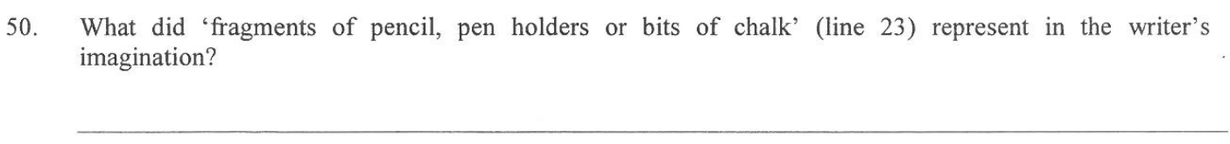 | 2019 B2 Q50
(Evaluate) Cite evidence to develop logical argument | 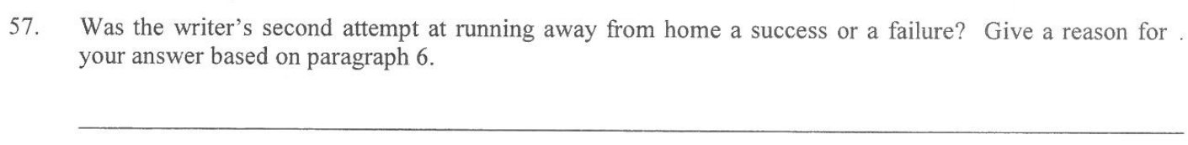 | 2019 B2 Q57
Level 4
Extended reasoning; evaluate and critique content and textual elements
(Not applicable to standardized tests such as HKDSE.
Level 4 items require complex reasoning, planning, developing, and thinking, usually over an extended period of time. They are most common in performance tests.)

Appendix C. Distribution of reading literacy processes in all the test administrations by year.

Year |  | 2012 |  | 2013 |  | 2014 |  | 2015 |  | 2016 |  | 2017 |  | 2018 |  | 2019
Cognitive Level | Descriptors | n | % | n | % | n | % | n | % | n | % | n | % | n | % | n | %
1 | Determine meaning of words or phrases using language structure or word relationship | 7 | 5.07 | 3 | 2.46 | 5 | 3.88 | 3 | 2.50 | 3 | 2.36 | 2 | 1.57 | 8 | 6.35 | 10 | 7.94
2 | Identify meaning of words or phrases in context | 2 | 1.45 | 3 | 2.46 | 5 | 3.88 | 5 | 4.17 | 4 | 3.15 | 5 | 3.94 | 4 | 3.17 | 3 | 2.38
2 | Identify appropriate words or phrases by referring to context | 2 | 1.45 | 0 | 0 | 0 | 0 | 1 | .83 | 1 | .79 | 1 | .79 | 4 | 3.17 | 4 | 3.17
2 | Make basic inferences about writer’s intention | 2 | 1.45 | 1 | .82 | 0 | 0 | 5 | 4.17 | 9 | 7.09 | 2 | 1.57 | 3 | 2.38 | 2 | 1.59
2 | Make basic inferences about text content | 16 | 11.59 | 6 | 4.92 | 18 | 13.95 | 1 | .83 | 7 | 5.51 | 6 | 4.72 | 10 | 7.94 | 4 | 3.17
2 | Identify specific information using pronoun referencing | 3 | 2.17 | 3 | 2.46 | 4 | 3.10 | 3 | 2.50 | 2 | 1.57 | 2 | 1.57 | 6 | 4.76 | 5 | 3.97
2 | Identify specific factual information in text | 7 | 5.07 | 7 | 5.74 | 22 | 17.05 | 12 | 10.00 | 7 | 5.51 | 19 | 14.96 | 29 | 23.02 | 18 | 14.29
2 | Identify main ideas which can be located in text | 33 | 23.91 | 38 | 31.15 | 33 | 25.58 | 42 | 35.00 | 47 | 37.01 | 57 | 44.88 | 5 | 3.97 | 17 | 13.49
2 | Make logical predictions using structural devices | 0 | 0 | 0 | 0 | 0 | 0 | 0 | 0 | 0 | 0 | 0 | 0 | 1 | .79 | 1 | .79
2 | Give examples of explicitly stated information | 2 | 1.45 | 1 | .82 | 1 | .78 | 0 | 0 | 6 | 4.72 | 0 | 0 | 1 | .79 | 0 | 0
2 | Determine the sequence of events | 2 | 1.45 | 1 | .82 | 2 | 1.55 | 1 | .83 | 0 | 0 | 0 | 0 | 0 | 0 | 0 | 0
2 | Select appropriate words or phrases to use in context | 35 | 25.36 | 30 | 24.59 | 10 | 7.75 | 8 | 6.67 | 21 | 16.54 | 12 | 9.45 | 37 | 29.37 | 25 | 19.84
2 | Determine alternatives to text features (e.g., titles, sub-headings) | 2 | 1.45 | 0 | 0 | 1 | .78 | 0 | 0 | 0 | 0 | 1 | .79 | 2 | 1.59 | 0 | 0
2 | Identify use of figurative language | 1 | .72 | 0 | 0 | 2 | 1.55 | 0 | 0 | 0 | 0 | 1 | .79 | 1 | .79 | 1 | .79
2 | Analyze format, organization, and internal text structures (e.g., signal words, transitions, semantic cues) | 0 | 0 | 0 | 0 | 0 | 0 | 0 | 0 | 1 | .79 | 0 | 0 | 0 | 0 | 0 | 0
2 | Identify characteristic text features | 1 | .72 | 1 | .82 | 0 | 0 | 1 | .83 | 0 | 0 | 1 | .79 | 0 | 0 | 0 | 0
2 | Distinguish claims from alternate or opposing claims | 12 | 8.70 | 19 | 15.57 | 12 | 9.30 | 13 | 10.83 | 10 | 7.87 | 11 | 8.66 | 10 | 7.94 | 15 | 11.90
2 | Locate inaccurate information in claims | 0 | 0 | 0 | 0 | 0 | 0 | 4 | 3.33 | 0 | 0 | 0 | 0 | 0 | 0 | 6 | 4.76
3 | Interpret main idea which is implicit in text | 5 | 3.62 | 4 | 3.28 | 13 | 10.08 | 10 | 8.33 | 5 | 3.94 | 3 | 2.36 | 2 | 1.59 | 5 | 3.97
3 | Summarize implicit themes of texts | 0 | 0 | 0 | 0 | 0 | 0 | 0 | 0 | 0 | 0 | 0 | 0 | 0 | 0 | 5 | 3.97
3 | Describe the effect of language features, such as metaphors or tone | 2 | 1.45 | 1 | .82 | 0 | 0 | 0 | 0 | 2 | 1.57 | 1 | .79 | 0 | 0 | 0 | 0
3 | Interpret use of figurative language | 0 | 0 | 4 | 3.28 | 1 | .78 | 5 | 4.17 | 2 | 1.57 | 2 | 1.57 | 3 | 2.38 | 4 | 3.17
3 | Cite evidence to develop logical argument | 4 | 2.90 | 0 | 0 | 0 | 0 | 6 | 5.00 | 0 | 0 | 1 | .79 | 0 | 0 | 1 | .79
Total |  | 138 | 100 | 122 | 100 | 129 | 100 | 120 | 100 | 127 | 100 | 127 | 100 | 126 | 100 | 126 | 100
Note: The most frequently recurring ones are in bold.

