Appendix A
Online source-based writing test (OSWT)
Task 1
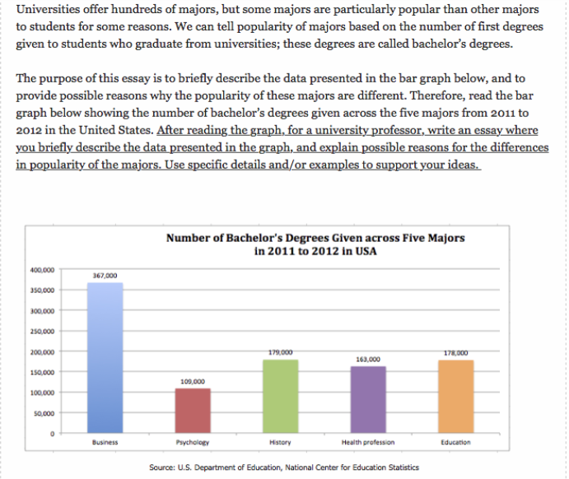

Task 2
