APPENDIX A
PsychoPy Experiment Examples
Narrative Text Display
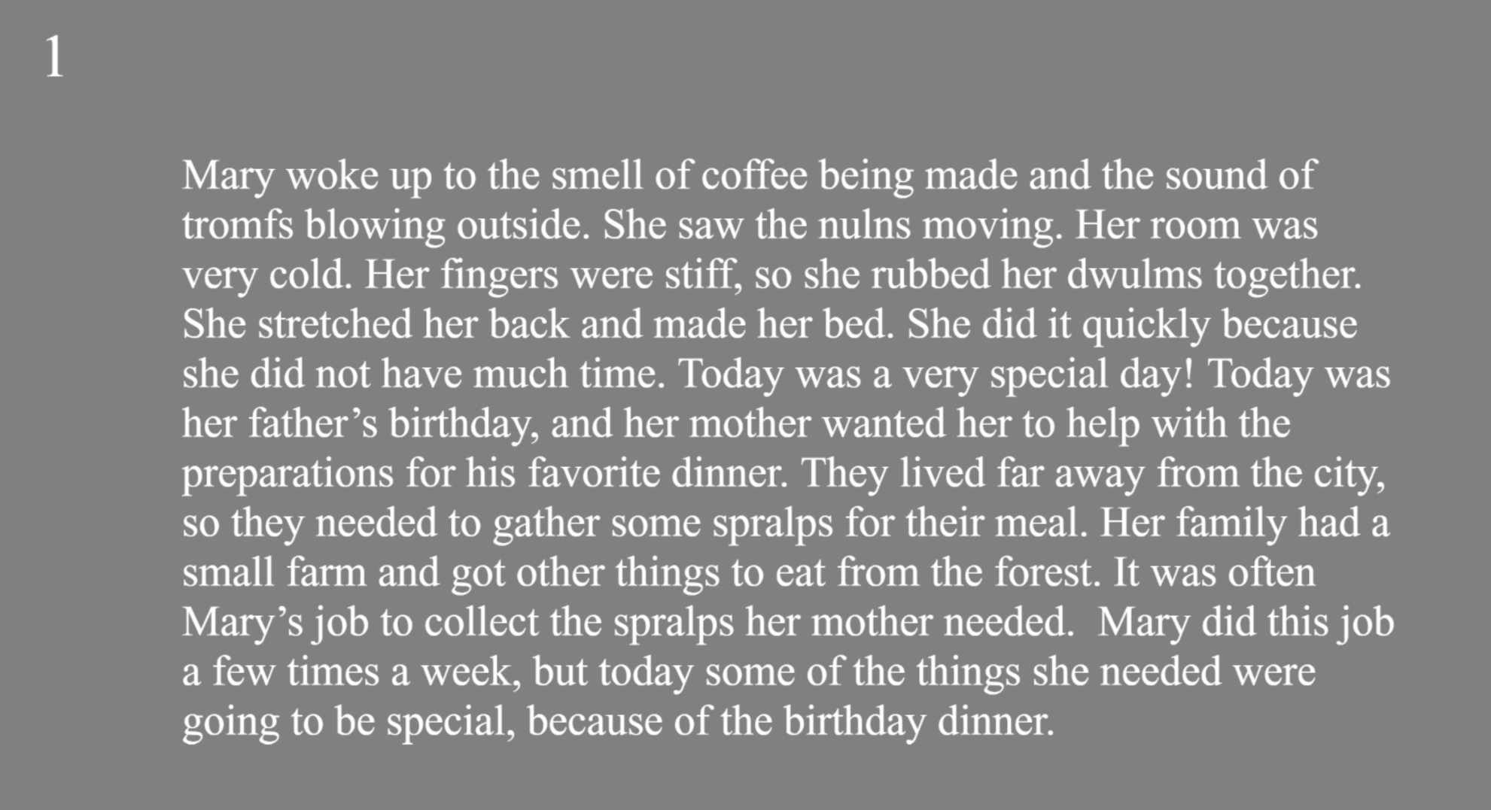

Meaning Recall Item
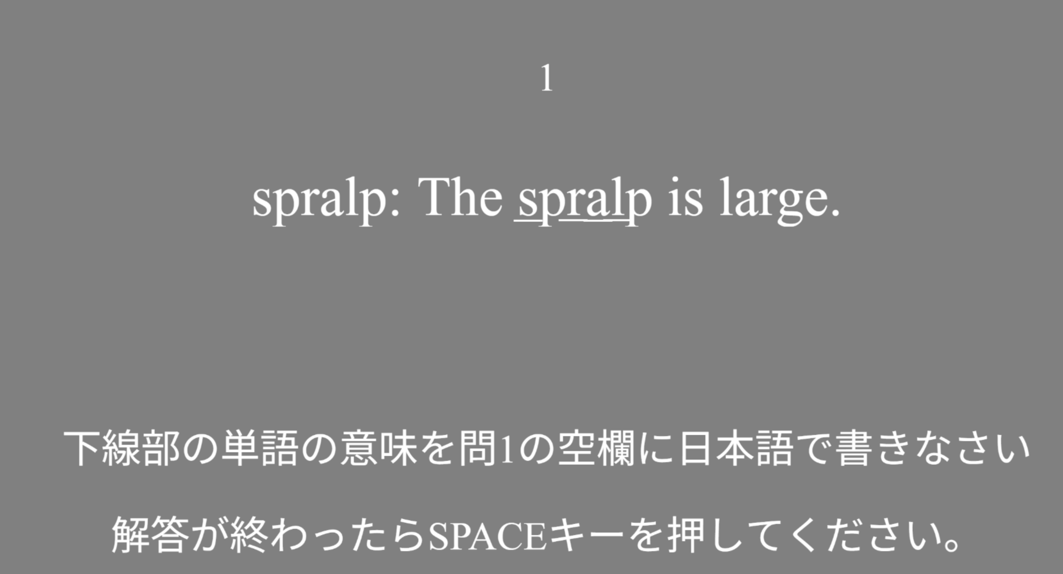
Translation: On the answer paper under question 1, please write the underlined word in Japanese. When you have completed your answer, press the SPACE key.

Meaning Recognition Item
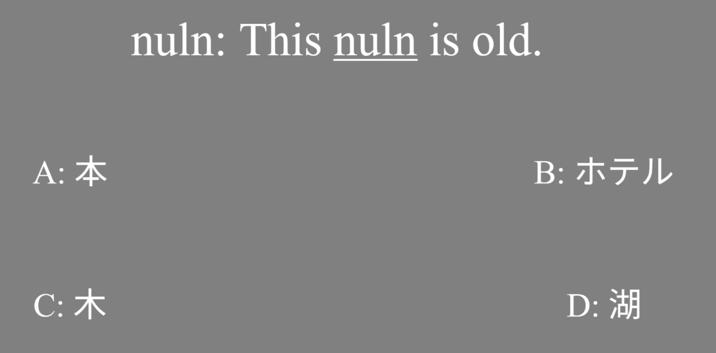
Translation: A: Book, B: Hotel, C: Tree, D: Lake

